4. Check if the app shows the list of products.

Yes.

5. Check if you can search for a product.

Yes.

6. Check if all app text and numbers are localized for Japanese audience properly.

The unit, "Litre/kg", is not translated.

Japanese people will understand "kg", but "Litre" may be confusing to understand.

It should be "L", or "リットル"

7. Try using the app in different screen orientations: portrait and landscape.

There is another issue with the unit, "Litre/kg".

At portrait orientation, the bottom of "g" is cut off, and it looks like "Litre/ka".

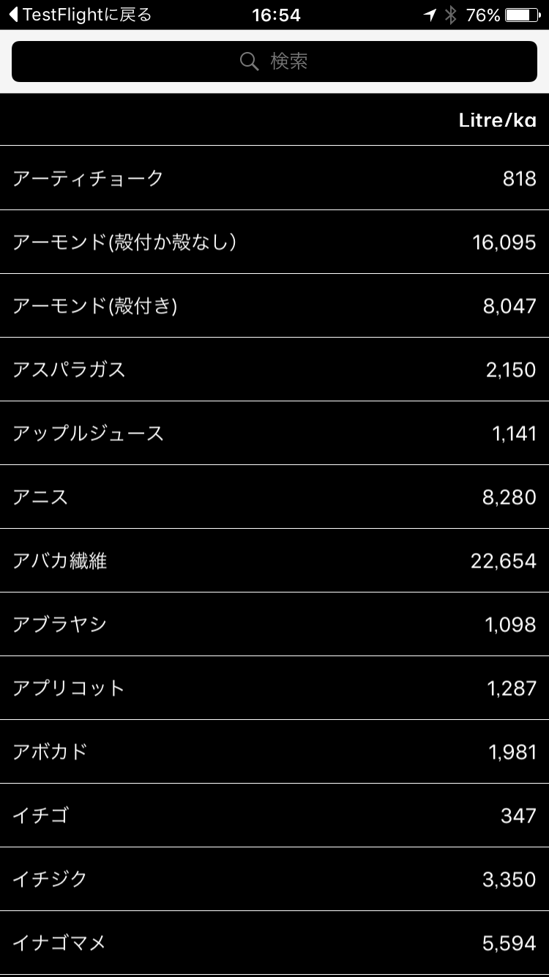

At landscape orientation, the unit is totally hidden or it disappears.

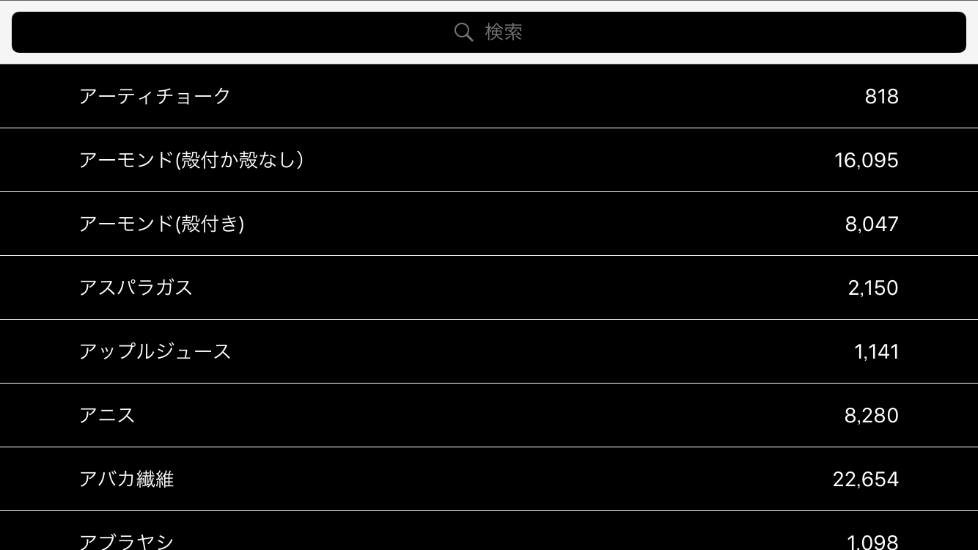

8. Send me a test report, answering three questions:

a. Was it easy to look up water footprints for various products?

I can make some suggestion of improvement.

a).

It seems to be in alphabetical order, but the names of foods written in Katanaka (One of the three character system of Japanese) and ones written in Kanji (Chinese character) are divided. That’s not common and hard to look up for Japanese. Now it is like “A1 to Z1, A2 to Z2”

b).

If it is meant to be in Japanese alphabetical order, it will be easier to look up with a bar of letters on the right, like “contact list” of iOS. (I don’t know how difficult it is to add this bar.)

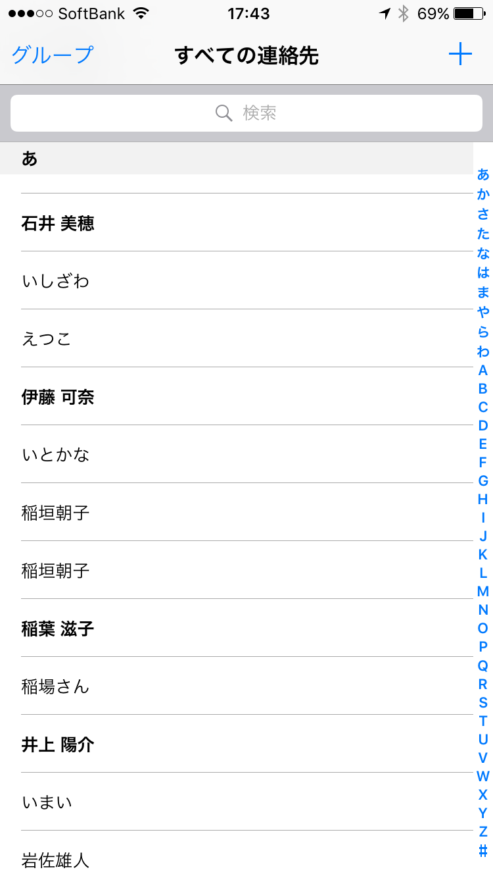

b. Was it easy to search for a particular product?

I found some issues.

a).

In this app, "あ"(Hiragana) and "ア"(Katanaka) is treated differently.

As a character, these two characters are the same character of different forms.

But, they are not treated like that in this app.

i.e.) Apple

Apple in Japanese is "Ringo".

In this app, apple is written in Katakana, "リンゴ"

If I search apple in Hiragana, "りんご", it doesn't appear.

Both "りんご" and "リンゴ" are frequently used.

b).

Some words are not properly connected to the word in different descriptions.

i.e.) Pork

Pork in Japanese is "Butaniku".

It is "豚肉" in Kanji character. This must be the most common description and this is the word used in this app.

But, "Butaniku" can be written in Hiragana character system and Katanaka character system, like "ぶたにく"（Hiragana）and "ブタニク"(Katanaka)

If I search "Butaniku" by "ぶたにく" or "ぶた" (pig in Hiragana), pork doesn't appear.

If I search "Butaniku" by "ブ" or "ブタ" (pig in Katanaka), pork appears.

If I search "Butaniku" by "ブタニク"(Katakana), pork doesn't appear.

c. What would you improve in the app?

a)

I’m not sure how this search system works, but it should search based on the sound of words. Even if there are three different character systems in Japanese, there is usually only one sound, like “Ringo” or “Butaniku.

If everything is recognized by the sound of words, the whole list will be in a single order system, like “A to Z”. Now it is like “A1 to Z1, A2 to Z2”

b)

There are some weird translations. For instance, “(Fresh)” shouldn’t be “(新鮮)”. “(生)” must be more accurate.

c)

There are some vegetables I haven’t heard of. That may be due to popularity of vegetables, or due to translation issues. On contrary, however I can’t point out exactly, there can be some popular vegetables in Japan that are not on the list.