## Problem 1 – Option Panels

Create a Web page (HTML5 + CSS3 + images) that looks and behaves like the screenshots below:

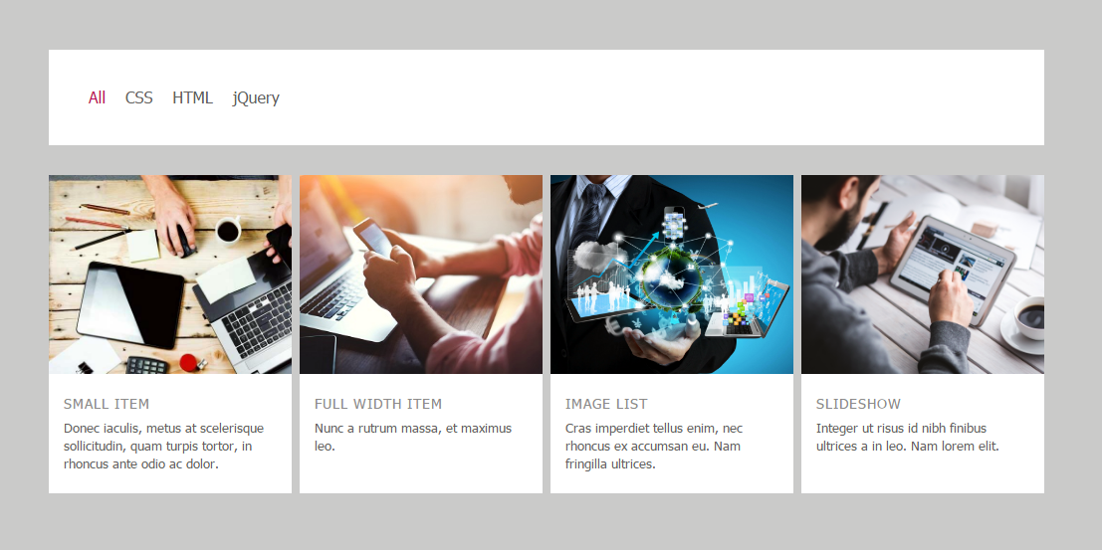



* The mouse cursors in the above screenshots explain what happens when the mouse moves over a project or a group and when the browser window resizes.

### Example

<https://invis.io/R38PWNYVP#/191477866_01-Preview-jpg>

### Input

You are given the above screenshots + all required images + the texts on the site.

### Output

The output should be valid HTML5 + CSS3 + images that implement the above Web page.

### Constraints

* The layout is body-centered and should be 1000px.
* Font: 15px Tahoma, Arial, sans-serif; Default text color is #191923;
* The links at the navigation - current state and hover-effect color: #BF1363
* There are 4 sections which are fully linkable and hover effect is transparency 0.8 of all the section.
* The site should open correctly in Chrome 35.
* Pixel-perfect implementation is not required.