## Problem 3 – Edit User Form

Create a Web form (HTML5 + CSS3 + images) that looks and behaves like the screenshots below:

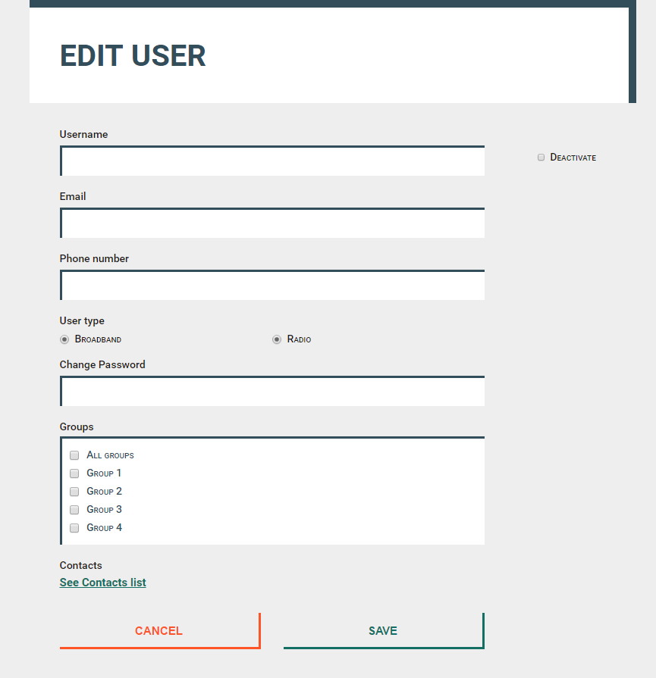

### Example

<https://invis.io/R38PWNYVP#/191482753_03-Preview>

### Input

You are given the above screenshots and all required images.

### Output

The output should be valid HTML5 + CSS3 + images that implement the above Web form.

### Constraints

* Font: 16px/20px "Roboto", Helvetica, sans-serif;
* <https://fonts.googleapis.com/css?family=Roboto:400,500,700>
* Default text: #1E1917;
* Title: 40px;
* Labels: 14px/500;
* Buttons font-size: 15px/700;
* Link: #136F63, 15px, no-hover effect
* Content max-width: 800px; Body centered, Top
* Form validation is not required.
* The site should open correctly in Chrome 35.
* Responsive design is not required.
* Pixel-perfect implementation is not required.