Hip-Hop for Tolerance!
Project Proposal for Baltic Club 2.0.

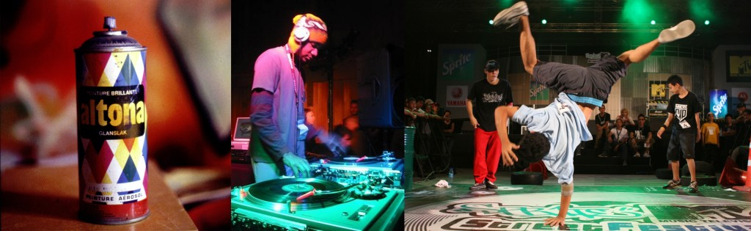
Sergey Ivanov (Moscow), Liudmila Voronova (Stockholm/Moscow), Ekaterina Kalinina (Stolckholm/St.Petersburg)
Contact details:
kalinina.a.ekaterina@gmail.com, sermen123@yandex.ru, lusyandrik@gmail.com

What is all about?
Born in the early 70-s in the big cities of the east coast in the USA Hip hop was a protest movement of the lower segregated classes, which with time became a new cultural and music philosophy that was reshaping attitudes to music and art in general as well as becoming a platform for expression for those, whose voices otherwise could not be heard.
Today hip hop together with other forms of street arts forms a new type of transnational community, where people are united not only by their love to music but also by philosophy of challenge of dominant political, cultural, social grand narratives, which leave the subaltern voices in the silent periphery. It calls for accumulation of post-subcultural practices, which could be used as creative methods for strengthening of social and cultural cohesion and building a base for cross-cultural communication with the aim to promote tolerance, mutual understanding and social inclusion.
With regard to the latest car burning and youth protests in Northern and Southern neighbourhoods of Stockholm as well as violence on the outskirts of Moscow, we suggest to open up a dialogue offering hip hop and street arts as platform for cross-cultural communication.

What do we want?
The goal of this project is to develop both the local cultural connection between disconnected youth groups as well cross-cultural exchange between young people of different countries though the socially important creative hip hop practices with the aim of promoting of the ideas of equality, tolerance and understanding. A mixed group of students will develop an improvisational project linked to actual social problems. They will use music; visual art, dance, theatre, video art, literature and hip hop practices as their media for expression of their ideas. In the project the main accent will be put on social engagement and community building.
The Pilot Project will establish cultural exchange program based on hip hop’s educational and socially engaged creative practices for school students from different neighbourhoods within the framework of hip-hop camps based in Russia and in Sweden.
In the case of successful cooperation, this project will be broadened to include other countries in the Baltic Sea Region. Parallel to the project we will run scientific investigation of the realised programs in order to study the impact and possibilities of such artistic practices in social and cultural integration to further elaborate educational methodology, which could be implemented later on municipal and city levels.

Phases of the project:
-Brainstorming and pre-production stage
-Development of individual expression and method
-Production stage
-Final presentation
-Post-production activities (idea and product can be taken as a finished art sample that could be evaluated and used for further purposes)

What do we offer?

Network of hip-hop and street-art artists with experience in similar activities
Venues in Moscow
Experience in project applications and fund-rising
Experience in running cultural-educational-exchange projects
Organisational skills and leadership
Ideas

What do we search for?
Contacts and networks in the Baltic Region with aim of developing the project
Contacts in municipalities and schools
Contacts and new funding possibilities
People willing to engage and participate in implementation of the project

