KIM Agents
A multi-agent system that builds a personal test for a teacher
Master's course project report. Thesis: Multimodal Emotional AI system for teachers' professional assessment (EmotionalAI platform)

1. Introduction and motivation
My master's thesis is about a multimodal Emotional AI system for the professional assessment of teachers. The system runs on the EmotionalAI platform. One goal of the platform is to measure how ready a teacher is for modern work, including work with digital tools.
Today the platform uses a self-assessment questionnaire. It has 22 statements based on the DigCompEdu framework. The teacher rates each statement from 0 to 4. This shows how teachers see themselves. But self-assessment is often biased. Some teachers rate themselves too high, others too low.
The course project KIM Agents tries to add a second, independent measure of the same competences. The system takes the questionnaire results and builds a personal test for the teacher. The test focuses on the teacher's weak areas. The items are based on short cases and data from school practice, not on opinions about oneself. Each item has a key with an explanation, feedback for every option, and a link to a competence and a level.
In the thesis, the platform also collects emotional signals (for example, from video and voice). We expect that three sources together (self-assessment, a test on cases, and emotional signals) can give a more objective picture of a teacher's readiness than any one source alone. This project does not prove this. It builds a working tool for the second source, so that this idea can be tested later.

2. Why a team of agents and not one agent
One large prompt could, in theory, write a whole test. We chose a team of agents for five practical reasons.
- Generation and checking are separate. A model that wrote an item does not see its own mistakes well. The Quality Verifier solves each item blind, without the key. This is only possible in a separate agent with its own context. It also runs on a different model than the writer.
- Validity has independent criteria. A methodologist checks that the item measures the right competence at the right level. A test expert checks the technical quality: one clear key, good distractors, no duplicates. In testing practice these are different people. Here they are the Alignment Reviewer and the Quality Verifier.
- Distractors are separate work. Good wrong options must look like real mistakes of teachers. The Distractor Designer uses a base of typical teacher misconceptions for this. The Item Writer can focus on the case and the correct answer.
- Different item types need different checks, and each agent has at most 5 tools. Practical items with numbers are checked by running Python code. Situational (SJT) items are checked by blind solving and reasoning. If one agent had all tools and all checks, its prompt would become too long and hard to control. The limit of 5 tools per agent is enforced in code.
- Parallel work and failure isolation. Each cell of the test plan (one competence, one level, one item type) runs in parallel. If one cell fails, the other cells still finish.

3. Architecture
Figure 1 shows the agents, the orchestrator, the data and services behind the tools, and the messages between them. Solid arrows show the main flow. Red dashed arrows show revision requests. The grey dashed box is the planned Assembler.
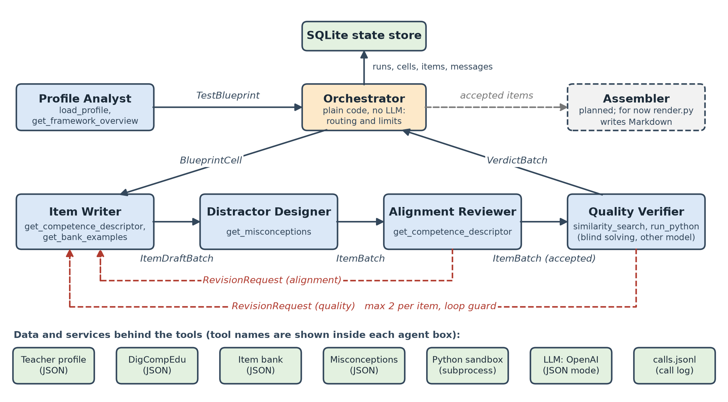
Figure 1. Agents, links, tools and message types of KIM Agents.
The pipeline works like this. The Profile Analyst reads the teacher profile and builds a TestBlueprint: a plan with cells. The orchestrator sends each cell (BlueprintCell) to the Item Writer. The writer sends draft items (ItemDraftBatch) to the Distractor Designer. The designer adds wrong options and sends an ItemBatch to the Alignment Reviewer. Accepted items go to the Quality Verifier. The verifier returns a VerdictBatch to the orchestrator. Both reviewers can send a RevisionRequest back to the Item Writer. Each item can be revised at most 2 times. A loop guard stops the process if a rewrite is unchanged.

4. Agents
Table 1 lists all parts of the system. The orchestrator is plain code. It routes messages and applies limits. It makes no LLM calls and does no subject work.
Agent | Role | Input | Output | Tools | Done when
Profile Analyst | Finds weak areas in the self-assessment and plans the test | Teacher profile (22 answers, 0 to 4) | TestBlueprint (cells: competence, level, item type, count) | load_profile, get_framework_overview | Blueprint is valid and covers the weakest areas
Item Writer | Writes the case, question, key and explanation | BlueprintCell or RevisionRequest | ItemDraftBatch | get_competence_descriptor, get_bank_examples | Required number of drafts for the cell is written
Distractor Designer | Adds plausible wrong options and feedback for each option | ItemDraftBatch | ItemBatch | get_misconceptions | Every item has full options with feedback
Alignment Reviewer | Methodologist: checks competence and level match; item must not be solvable by general skills only | ItemBatch (sees the key) | AlignmentBatch (competence_match, level_match, requires_competence, solvable_by, issues); code decides accept or revise | get_competence_descriptor | Every item has a verdict; accepted items move on
Quality Verifier | Test expert: solves blind, looks for a second defensible answer, recomputes numbers, finds duplicates | ItemBatch (blind view, no key) | VerdictBatch or RevisionRequest | similarity_search, run_python | Every item is accepted, revised, or rejected
Orchestrator (code) | Routes messages, runs cells in parallel, applies limits, stores state | All messages | Next message; final result | SQLite state store (no LLM) | All cells finished or a limit reached
Assembler (planned) | Builds the final test document | Accepted items | Test file (now render.py writes Markdown) | Not built yet | Planned
Table 1. Agents, their inputs, outputs, tools and stop conditions.

5. Message format
Agents do not send free text to each other. Every message is a typed Pydantic model, for example TestBlueprint, BlueprintCell, ItemBatch, VerdictBatch or RevisionRequest. Each message is wrapped in an Envelope with the sender, the receiver, the run and cell, and the attempt number. The orchestrator checks the type and stores every message in SQLite together with runs, cells and items. So any run can be inspected after it ends. The LLM answers in JSON mode, and the answer is parsed into the same models. If the JSON is invalid, the agent makes one repair attempt.

6. Reliability
- Limits: 80 steps per run, 10 minutes per run, 90 seconds per LLM call.
- Retries: 3 retries with backoff for LLM calls; one repair attempt for invalid JSON.
- Revisions: at most 2 per item, and a loop guard if the rewrite does not change.
- Tools: at most 5 per agent, checked in code. The API key is kept only in the .env file.
- Logging: every LLM call and tool call is written to calls.jsonl with agent, name, time and status.
- Tests: 16 test scenarios pass with pytest.
We also check that no single agent does most of the work. Table 2 shows the load in an offline demo run. In this run, a wrong key was added on purpose. The Quality Verifier found it and asked for a revision.
Agent | Calls | Share
Quality Verifier | 8 | 29%
Item Writer | 7 | 25%
Alignment Reviewer | 5 | 18%
Distractor Designer | 5 | 18%
Profile Analyst | 3 | 11%
Total | 28 | 100%
Table 2. Calls per agent (LLM and tools). The largest share is 29%, below the 40% limit.

7. Limitations
- Offline mode uses a fixed pool of scripted LLM answers. It shows that the pipeline works, but not how good real items are.
- For situational (SJT) items, the key is an expert judgment. Two experts can disagree, so the blind check can only reduce this risk.
- The Python sandbox is a separate subprocess with limits. It is a guard rail, not a security boundary.
- Duplicate search uses text similarity, not embeddings. It can miss items that say the same thing in different words.
- The Assembler is not built yet. Now the result is written as Markdown.

8. Conclusion
KIM Agents builds a personal test for a teacher from the self-assessment results. Five agents work in a fixed pipeline: one plans the test, two write items and distractors, and two check the items from different sides. The orchestrator is plain code, so routing and limits are easy to test. The system has typed messages, limits, retries, logs and a stored state. The demo run shows that a wrong key is found and fixed, and that the load is spread between agents.
For the thesis, this tool gives a second, independent measure of digital competence next to self-assessment. Next steps are the Assembler, runs with real teachers, and a comparison of test results with self-assessment and emotional signals on the EmotionalAI platform.

