**Report Guideline:**

**Introduction (reasons or motivations for creating the website for the topic):**

The website serves to provide in-depth reviews and analysis of popular anime shows such as RWBY and A Certain Scientific Railgun. This will aid users in deciding which shows to watch, and which shows to avoid.

Anime style refers to Japanese animated productions, which feature concept art drawn by hand or computer animation. In North America, we simply just call it Japanese Animation. The artwork looks noticeably different than cartoons, and other computer drafted/hand drawn styles that are employed on this side of the globe (North America in particular).

For people that are new to this style of entertainment, we will introduce them to shows that we feel are a must watch.

**Job allocation (who is doing what and for how long?):**

Tyler is responsible for the creation of the report and keeping a log of our progress.

Roger is responsible for designing the structure of the website as well as how the content will be displayed. He is to also create the information which is to be displayed on the website.

Edmund is responsible for the coding of the site, with help from Roger and Tyler to make sure the website’s design is going according to plan.

All of the jobs allocated lasted for nearly the whole duration of working on this project.

**Identify the Target audience:**

The main target audience for the webpage is viewers of Anime. The secondary target would be people who have a curiosity about anime and would like to watch a few episodes to see if they will like it.

|  |  |  |  |
| --- | --- | --- | --- |
| USER GROUPS | FUNCTIONS PERFORMED | AGE | GENDER |
| Visitors | * Browse website * Comment on review pages * “Like” on Facebook * Share on other social media * Contact webmaster | 16+   * Anime’s age range is quite large due to the various types of content available. * E.g., some are directed towards kids while others are for an adult only audience). | M/F |

**Goals:**

The primary goal of the website is to provide the number one source for Pop-Anime show reviews. Our secondary goal is to get more people interested in Anime. The main topic areas are the Anime Reviews, our contact and about us pages.

**Website Structure Diagram**

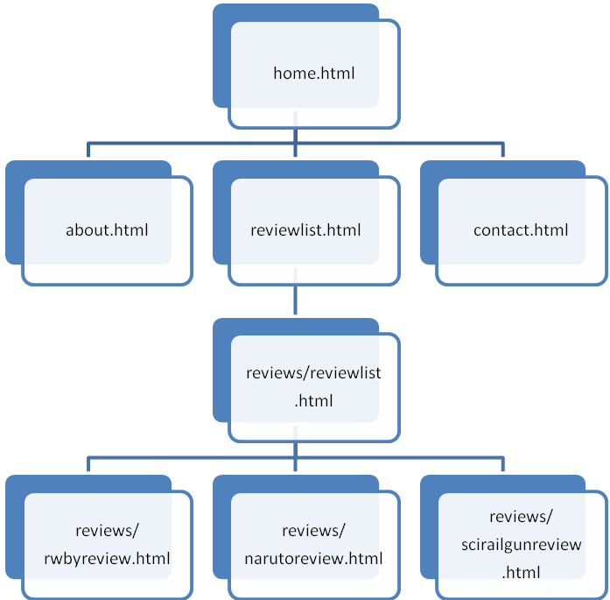

**Website Content Organization**

|  |  |
| --- | --- |
| **CATEGORY NAME** | **FOLDER NAME** |
| Naruto Review | ACS1809Project/reviews/narutoreview.htm |
| Scientific Railgun Review | ACS1809Project/reviews/scirailgunreview.html |
| RWBY Review | ACS1809Project/reviews/rwbyreview.html |
| Contact Us | ACS1809Project/contact.html |
| About | ACS1809Project/about.html |

**User Navigation:**

The website will be very easy to navigate as there will be the familiar standard navigation bar at the top of the page which easily allows users to browse our page effortlessly. Every page will have the same colour scheme, image/color background and the navigation bar will display clickable links to our reviews, about us, contact, and home page. Additionally, at there is a section anchor placed at the top of every page, with the anchor link being displayed at the bottom of the page. This clickable link does exactly what it says it will do; return the user to the top of the webpage.

**Project Log:**

Oct. 26: Decided on a topic and began thinking about site structure and content.

Nov. 4: Edmund joins the group.

Nov. 10: Finalized site structure and content and began creating basic HTML structure

for homepage and overall structure

Nov. 14: Continuing to work on homepage structure but now implementing CSS to

position elements.

Nov. 21-24: Homepage structure complete. Now adding the content to the homepage

such as pictures, site title, etc. Positioning content on homepage as well.

Nov. 25: Homepage done, now working on about, reviews, and contact us pages.

About and contact us pages very straight forward. Anime reviews were written

for their respective pages.

Nov. 27: Added multimedia to the Anime review pages, as well as a comments form for

users.

Nov. 28-30: All pages are essentially finished, now adding little details to the site overall,

such as fonts from google fonts and changing colors of the site.

Dec. 1: Site complete, as well as report.

**Problems Encountered and Solutions:**

All of the problems encountered occurred on the site’s homepage. First, positioning the pictures on the left with text directly on the right beside the pictures was not working out as expected. An hour or two fiddling around with code and we decided to try use the “float” attribute with a value of “left” to move the images to the left. This solved a portion of the problem, as images were now on the left as intended and the text was now on the right. However, images and text were overlapping with images and text below it. To fix this problem, we used the <div> tag with the purpose of clearing the float after each image. Please refer to our code to see the effect of this <div>.

Our second and final problem occurred with trying to keep the website’s footer at an absolute position at the bottom of every page. Since our homepage images were utilizing the float attribute, they were going over our “content-box” boundaries and going farther down our page and over our footer. To fix the problem with images going over our box, we set the height of our “content-box” to relative. Now that problem was solved, our footer was now half-way up our page. Comparing our code with some solutions online, we noticed that we missed one little thing in CSS, and that was setting our html with a min-height of 100%. Once we did that our problems were solved.

**Highlight(s) of our Website:**

A highlight of our website first of all would be our implementation of multimedia to our review pages. This allows for our users to have an idea about what anime is and what the show they are interested in has to offer for them visually and story-wise.

Another highlight of our site is our comments section on our review pages. This gives users a chance to interact with not just us, but also with other users of the website. They are able to provide their own input about anything anime related.

**Conclusion:**

Through proper planning and visualization of not just what but exactly HOW the website will function and look, we were able to create a neat, efficient and user friendly page which is ultimately what you want whether you are running a website for a business, or a hobby. If users are confused about your webpage or its layout, they may close the window and then a potential sale or review may have just been lost.

This assignment has allowed us to look at a website from a new perspective and understand the importance of design planning. Table of categories, tree diagram of pages, and navigational functionality planning are great planning tools for the layout, content, and how to set it all up so that when it comes time to actually make the website, you have a plan in place that you can follow.

**References:**

ACS Uwinnipeg Course Notes – http://courses.acs.uwinnipeg.ca/1809-001/

Google Fonts – https://www.google.com/fonts

Attack on Titan Image – http://www.christianpost.com/news/attack-on-titan-season-2-news-

release-date-live-action-film-news-and-updates-video-137630/

A Certain Sci. Railgun Image – http://www.fandompost.com/wp-content/uploads/2013/04/A-

Certain-Scientific-Railgun.jpg

Background Image – http://www.wallpapervortex.com/wallpaper-

36673_attack_on_titan.html#.Vl52j17wCN8

Mobile Suit Gundam Wing Image – http://www.wallconvert.com/converted/gundam-red-

1920x1080-21323.html

Naruto Image – http://wallpapercave.com/naruto-uzumaki-shippuden-wallpaper

RWBY Image – https://upload.wikimedia.org/wikipedia/en/8/85/Official_logo_for_RWBY.jpg

A Certain Sci. Railgun Video – http://www.youtube.com/embed/jL_vEw6hObw

Naruto Video – http://www.youtube.com/embed/O-QyCmzVTLQ

RWBY Video – http://www.youtube.com/embed/pYW2GmHB5xs

Wallard, Wendy. *HTML:A Beginner’s Guide*. The McGraw-Hill Companies, 2013. Print.