**International School “Evidence synthesis methods for social transformations to more sustainable and equitable futures: theory and practice”**

Registration for the Internacional School is a 2-step process using a standard registration website [via the University of Almería’s official website](https://fcontinua.ual.es/index.php/course/detail/147634). You must first ‘pre-register’ (*‘Preinscripción’)* (from 15th to 29th September 2024) and pay a deposit (150€, refundable until the 1st October 2024). After this date, we will publish a provisional list of admitted students (2nd October 2024) following a period for administrative checks (from 3rd to 4th October 2024). The final list of admitted students will be published on 8th October 2024. After this date, you will then be invited to complete your registration (*‘Matrícula’*) (from 9th to 16th October 2024) and pay the outstanding registration fee (350€). If you cancel before this date, you will be entitled to a full refund of your deposit. If you cancel after this date, we may be unable to issue a refund.

Since the website is in Spanish, we have developed the following step-by-step instructions so that non-Spanish speakers can pre-register and register correctly and easily.

**Instructions for pre-registration and registration process:**

To start the process, please click on the institutional link to the International School:

<https://fcontinua.ual.es/index.php/course/detail/147634>

You will find this screen, which includes a summary of the School’s general information

Pre-registration

You can find the translation of this information below:

**International School “Evidence synthesis methods for social transformations to more sustainable and equitable futures: theory and practice”**

**Organized by:** Grupo de Investigación de Sociología Aplicada INDALO (University of Almería)

**Duration:** 52 hours

### [**European Credit Transfer and Accumulation System**](https://education.ec.europa.eu/education-levels/higher-education/inclusive-and-connected-higher-education/european-credit-transfer-and-accumulation-system) **(ECTS)**: 7

**Registration fee:**€500

**Course format:**In-person at the University of Almería (Carr. Sacramento, s/n, 04120 La Cañada, Almería, Spain)

**Certificate: Certificate of proficiency**

**Direction and coordination**

* Directora: María Dolores López Rodríguez (University of Almería)
* Coordinator: José Luis Vicente Vicente (CSIC)

**Addressed to:**

Graduate students with an intermediate-advanced command of the English language

**Realization:**

From 25th to 29th November 2024

**Teaching modules:**

* Session 1: Introduction to evidence synthesis methods and the Collaboration for Environmental Evidence (CEE).
* Session 2: Stakeholder engagement and question formulation.
* Session 3: The Protocol, Searching for evidence, Assembling a library of evidence and reviewing management software, and Screening for relevance.
* Session 4: Data extraction and coding, Critical appraisal, Synthesis (visualisations and narrative, quantitative and qualitative methods)
* Session 5: Writing and publishing the final report and Communicating results.
* Session 6: Fieldtrip: social-ecological conflicts and initiatives for social transformations to more sustainable and equitable futures in Almería.

The official procedure to register for International School involves two different phases:

* Phase 1: Pre-registration:  From 15th to 29th September 2024. To pre-register, you must pay **150€**. This amount will be deducted from the total registration fee (€350).

After Phase 1 a provisional list of admitted students (2nd October 2024) following a period for claims (from 3rd to 4th October 2024). The final list admitted students will be published on 8th October 2024. In case you appear on this list, you must proceed to the Phase 2 (registration).

* Phase 2: Registration: From 9th to 16th October 2024. The University of Almería will confirm your registration on the International School on 8th October 2024. You will receive an email confirming this and then you must finalise the registration procedure by completing Phase 2 “Registration” (more details to proceed with Phase 2 will be provided by then). To register, you must pay **350€.**

**Phase 1: Pre-registration**

To proceed with the pre-registration, you must click “preinscripción” (highlighted within a red box in the previous screenshot) and you will proceed to the identification.

You will see the following screen in which you must provide your ID number (DNI and NIE are for Spanish and residents in Spain, Passport or others). Then you must click on “Enviar” (*send*):

Please provide your ID number

Then, you will see the following screen:

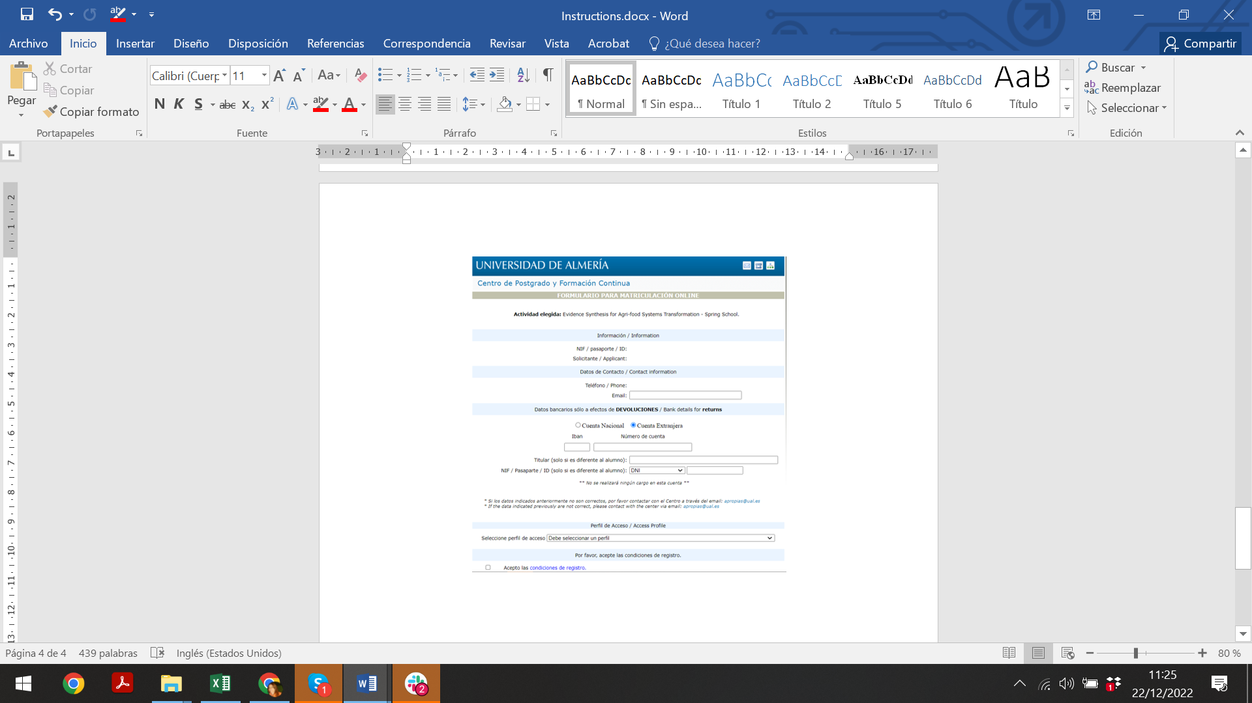

Please accept the registration conditions

Please select the profile: Graduate students with an intermediate-advanced command of the English language

Please provide your bank details

Please, tick “*cuenta extranjera*” (foreign account) and provide the IBAN (four first digits) and the account number

(Note: provide the complete name and ID details only in case it is different to the applicant’s)

Please provide your personal and contact information

Subsequently, you will see the following screen:

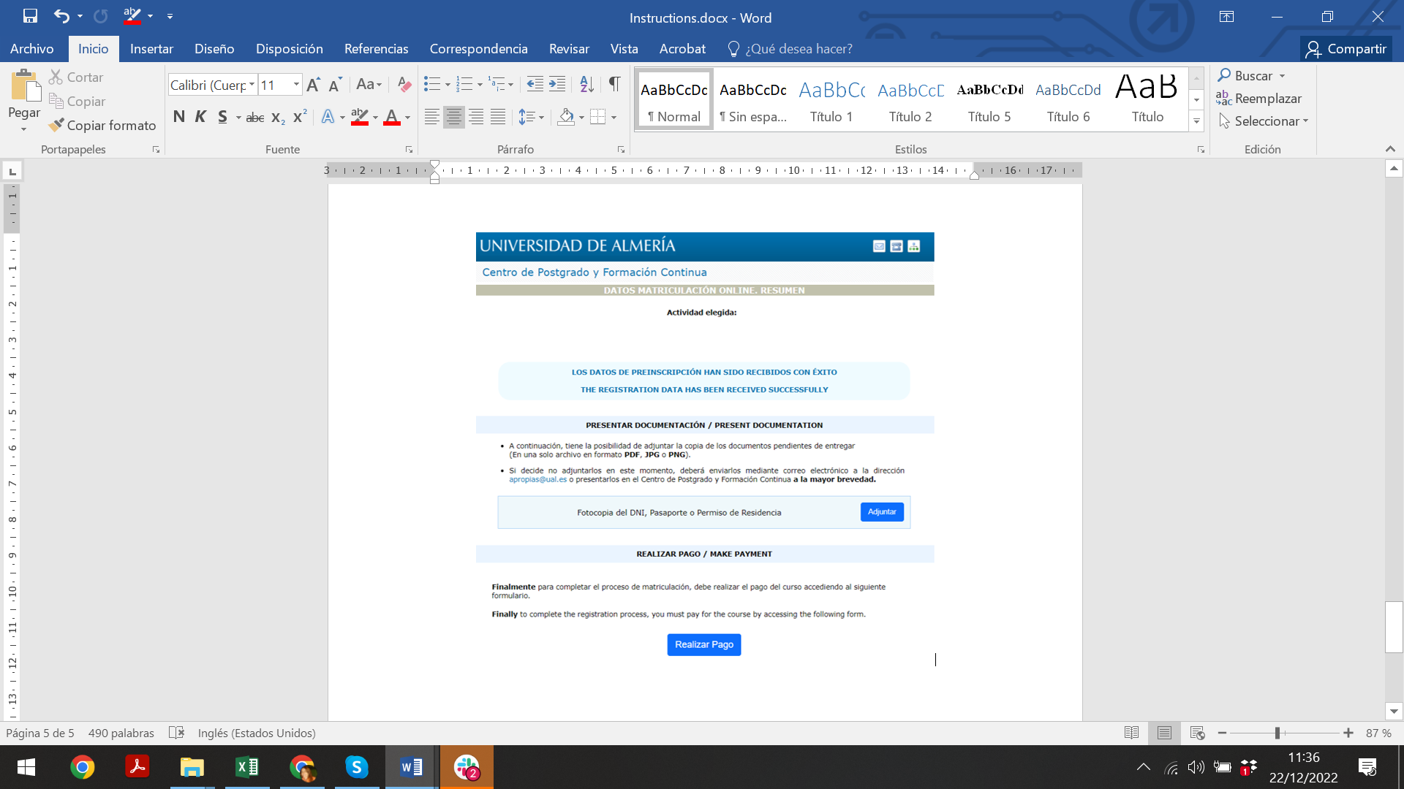

Please upload a copy of your ID or passport (PDF, JPG, PNG)

(Note: in the exceptional case you can´t do it, you will have to send it as soon as possible to the email apropias@ual.es)

Click here to proceed to the payment (pre-registration deposit) of 150€

Please note that invoices can take several days. The University of Almería sends them as soon as possible.

You can request an invoice by clicking here.

Please click here to continue with the process

Please select the payment method (Payment with card is the preferred option)

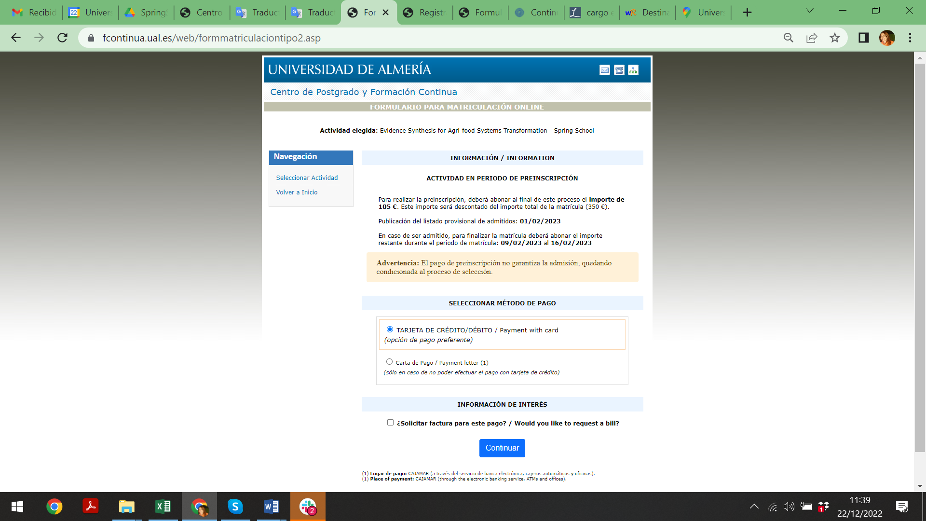

You will see a summary of the payment in the following screen:

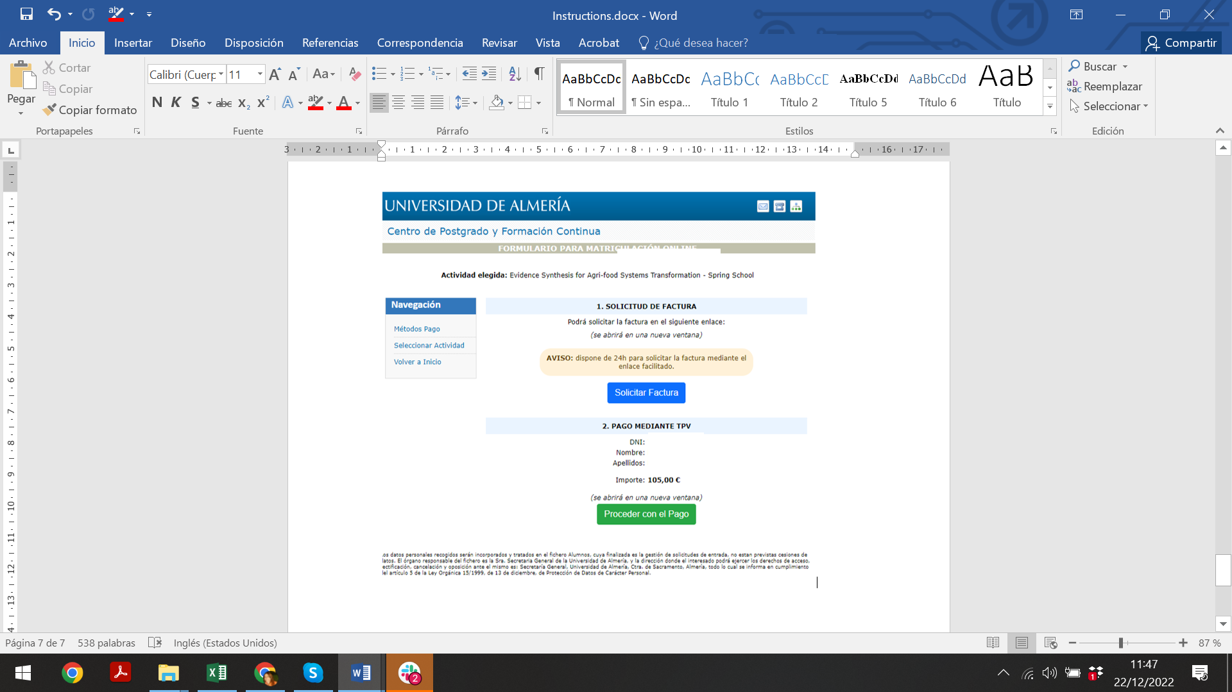

Please click here proceed to the payment of the deposit (150€)

Please click here to confirm the invoice request

You will see here your ID, name and surname(s)

**The cancellation policy for International School:**

- The repayment of the deposit can be requested before 15th October 2024 by those students who have paid the pre-registration. After this date, the deposit could not be returned.

- In the exceptional case that the International School needs to be cancelled due to unforeseen situations, the registration fee will be returned to students who have paid.

If you have any questions during the process, please contact us: [mariad.lopezrod@ual.es](mailto:mariad.lopezrod@ual.es); [joseluis.vicente@cchs.csic.es](mailto:joseluis.vicente@cchs.csic.es)

**Phase 2: Registration**

More details to proceed with Phase 2 will be provided by the University of Almería once finalise Phase 1 “Preregistration”)