**Heroku manual react deploy**

1. Create app with react

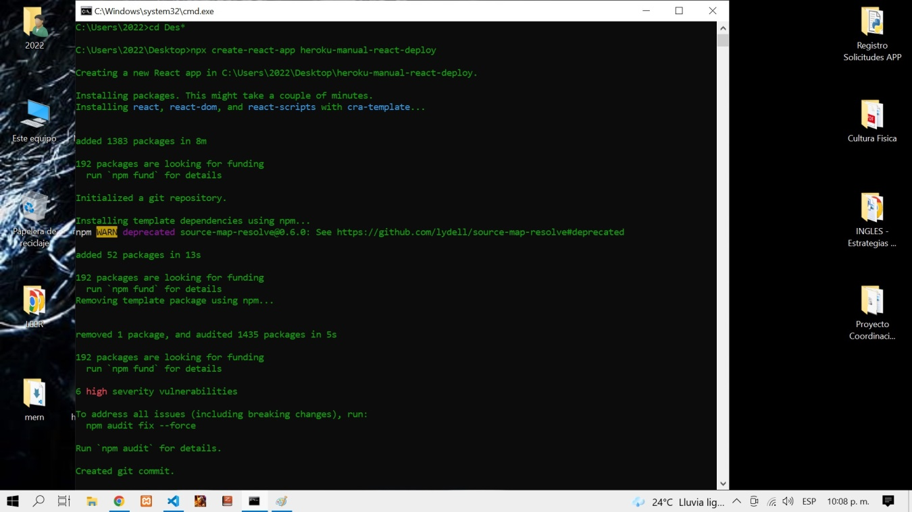

2. Create heroku account

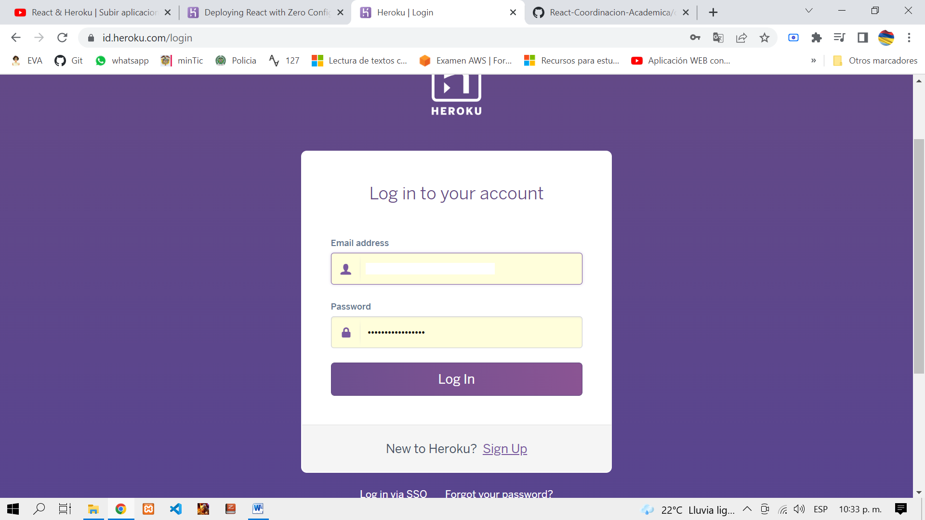

3. Open Project with visual studio code

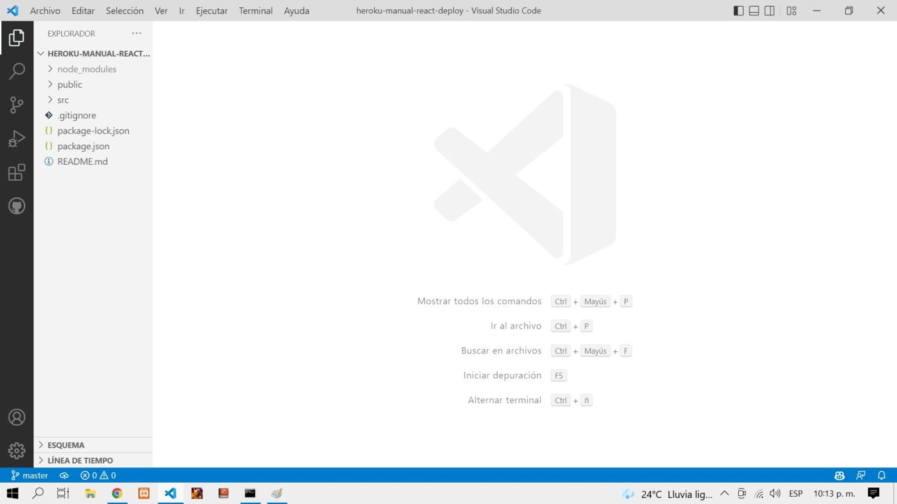

4. Install git on our computer / Install heroku cli

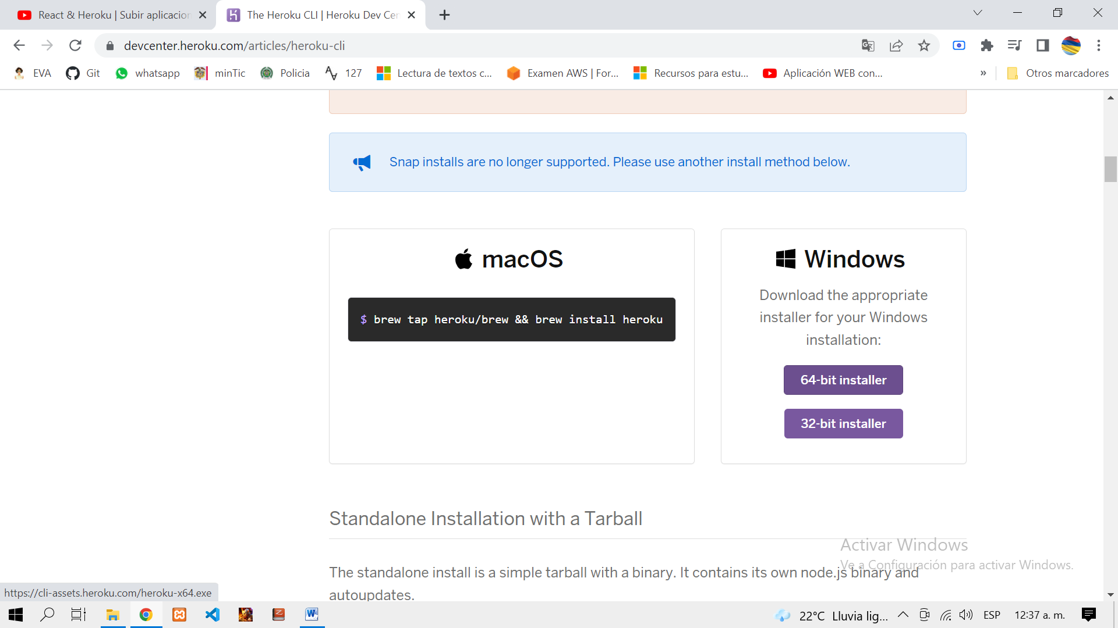

5. Verify on visual terminal # heroku –help

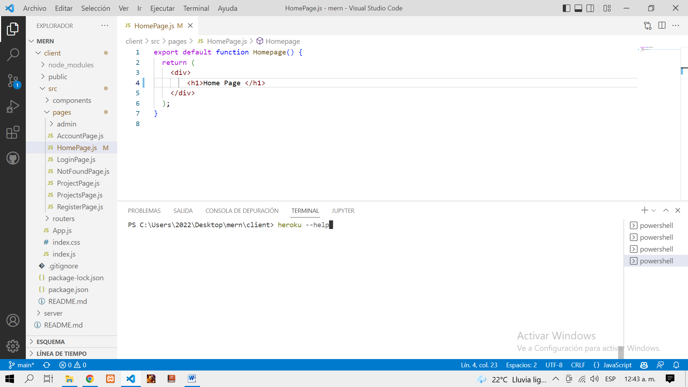

6. Edit the repository files and run # git status //view changes

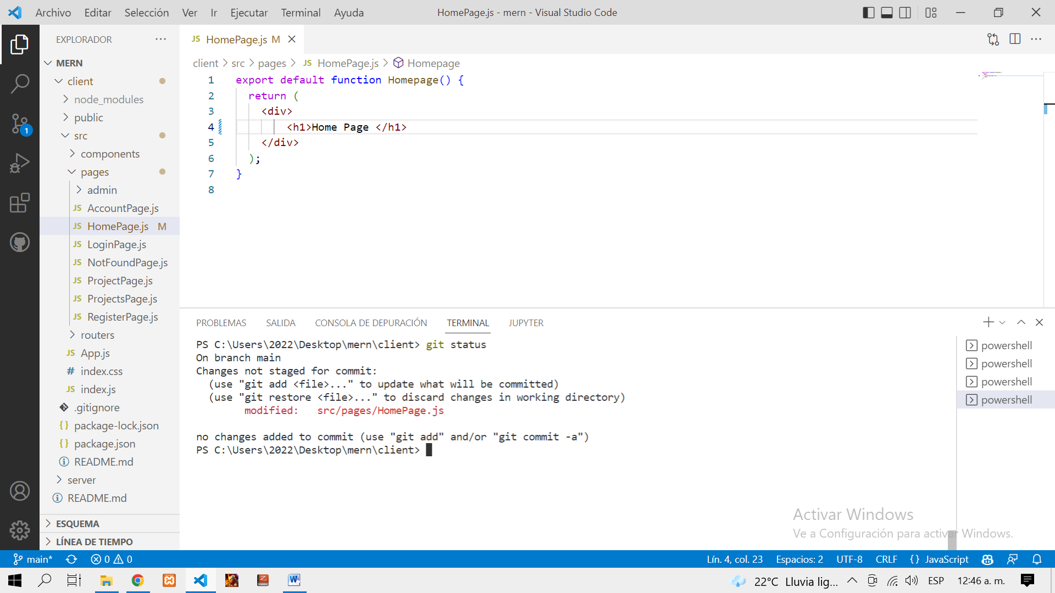

7.Do a commit # git add . // # git commit –m “my first commit”

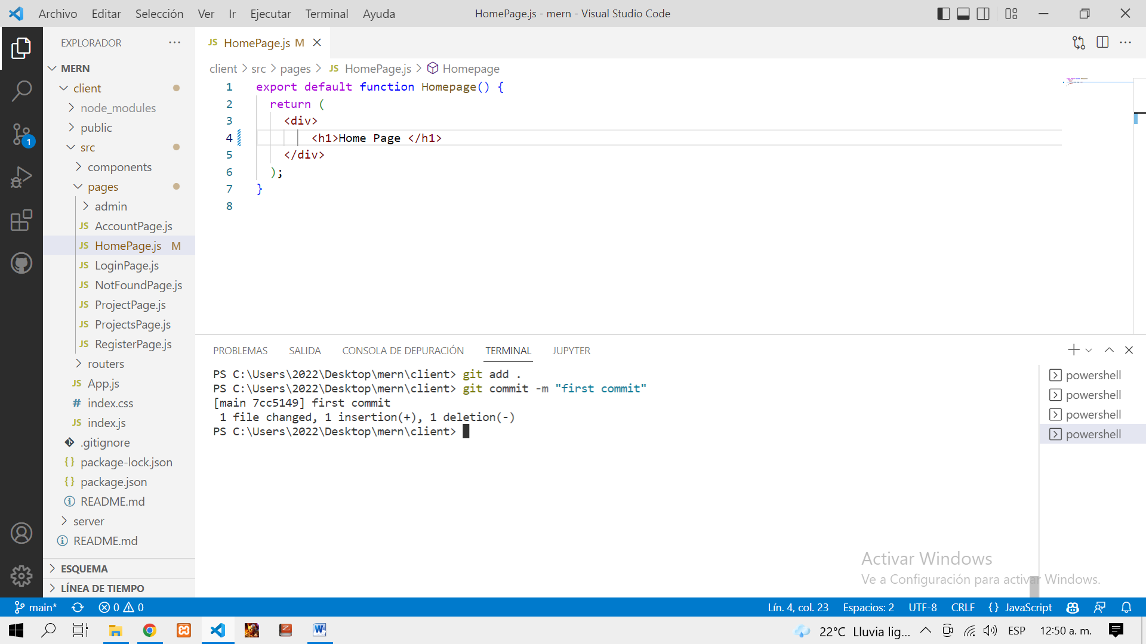

8. Run this command # heroku create -b <https://github.com/mars/create-react-app-buildpack.git> project-name

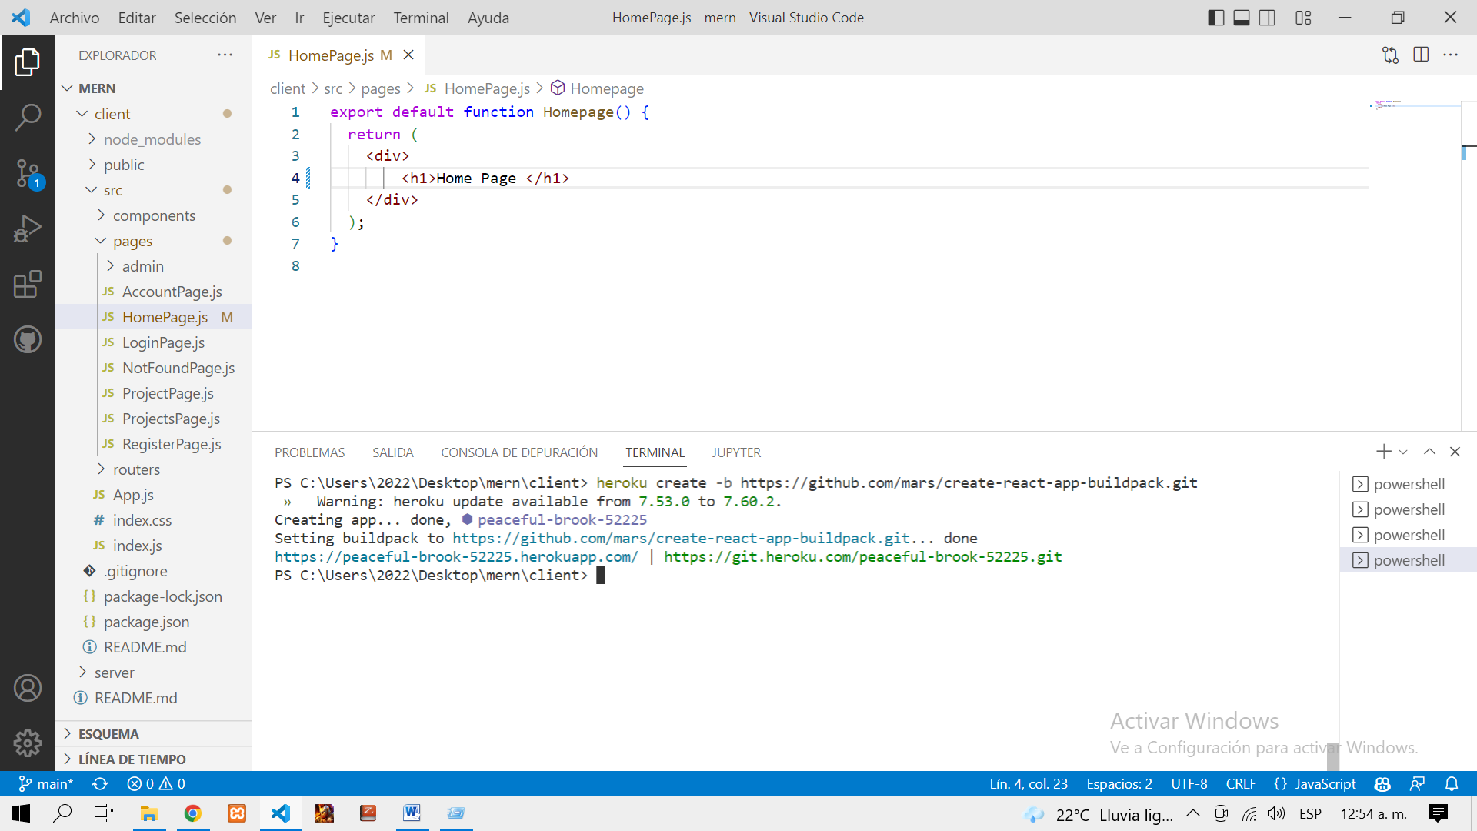

9. Run terminal # git push heroku master # or //branch-name //branch-name could be main

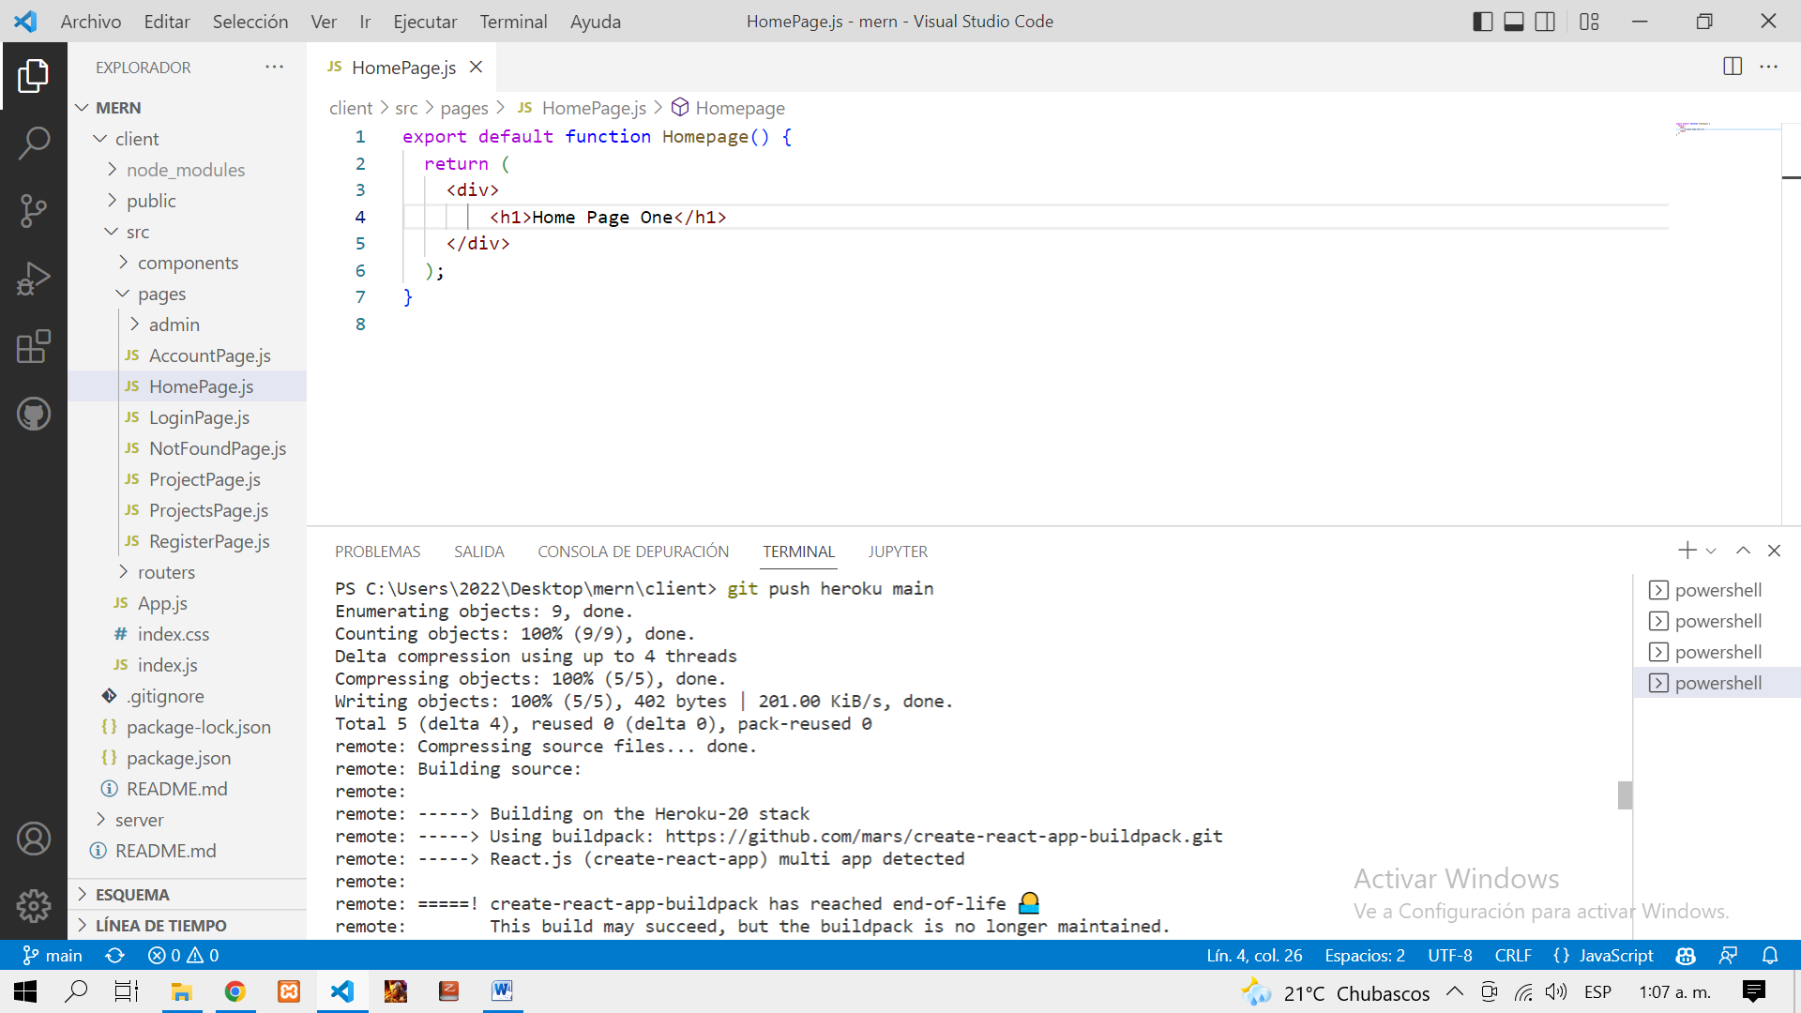

10. Run terminal # heroku open

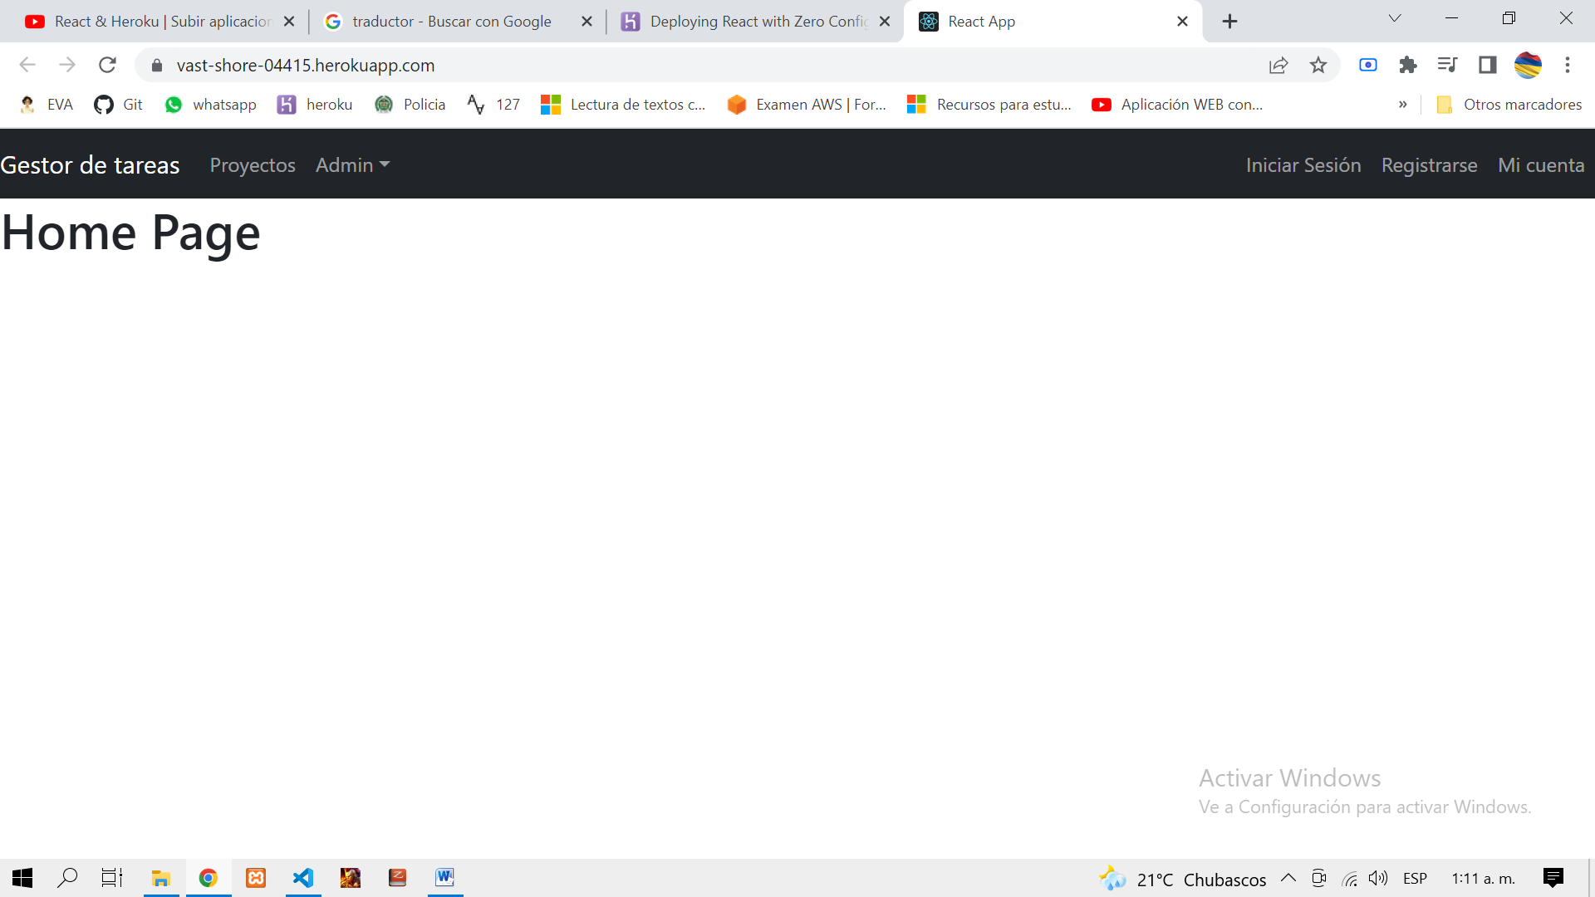

View remote # git remote –v

Delete remote # git remote remove heroku # or brach-name //