Lab Report

ECPE 170 – Computer Systems and Networks – Fall 2012

Name: Erich Viebrock

Lab Topic: Version Control (Lab # 2)
Lab

Question #1:
Take a Screenshot (using the Ubuntu Screenshot tool) showing what the BitBucket source view looks like at this point.
Answer:
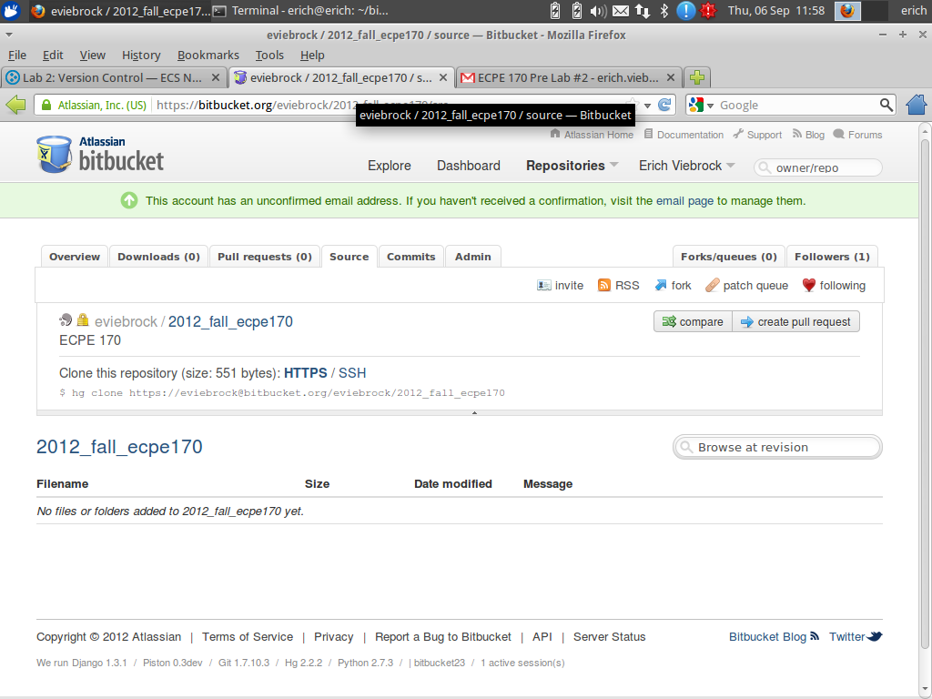

Question #2:
Take a Screenshot (using the Ubuntu Screenshot tool) showing what the BitBucket source view looks like at this point.
Answer: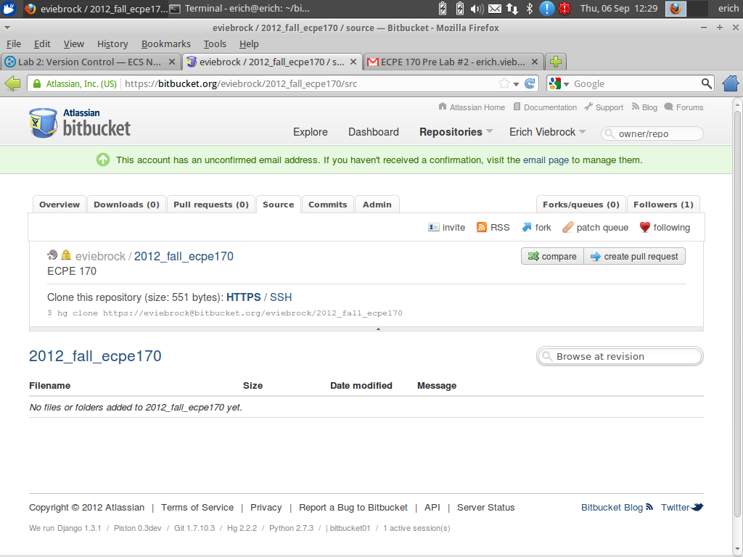

Question #3:
Take a Screenshot showing what the BitBucket source view looks like at this point.
Answer:
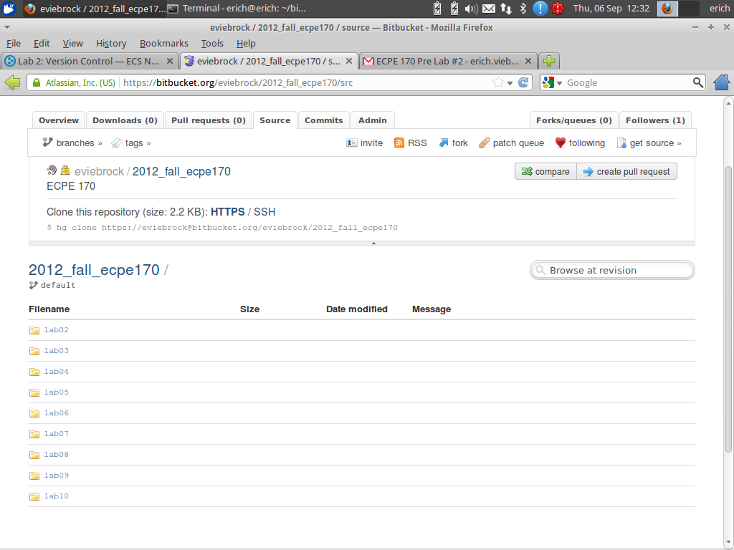

Quesion #4:
Take a Screenshot showing what the BitBucket version history looks like at this point (under the Commits tab).
Answer:
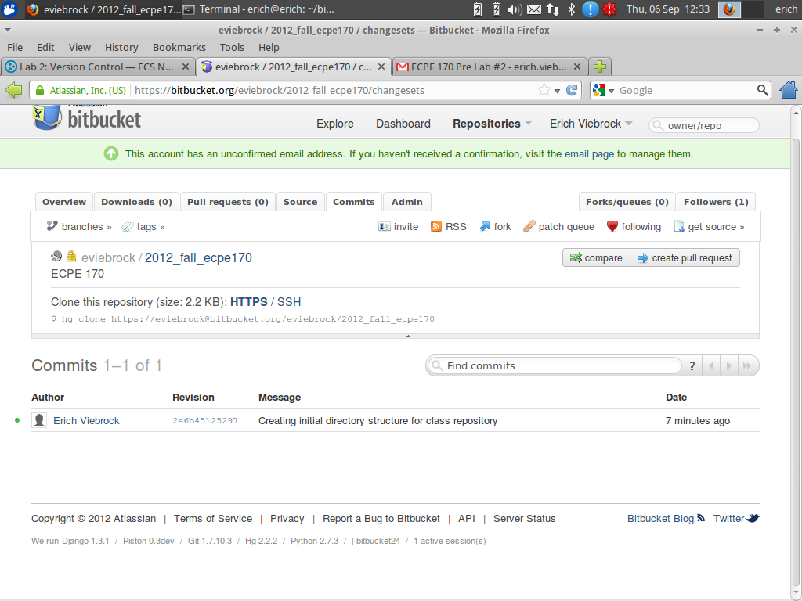

Question #5:
Take a Screenshot showing what the BitBucket version history looks like at this point.
Answer:
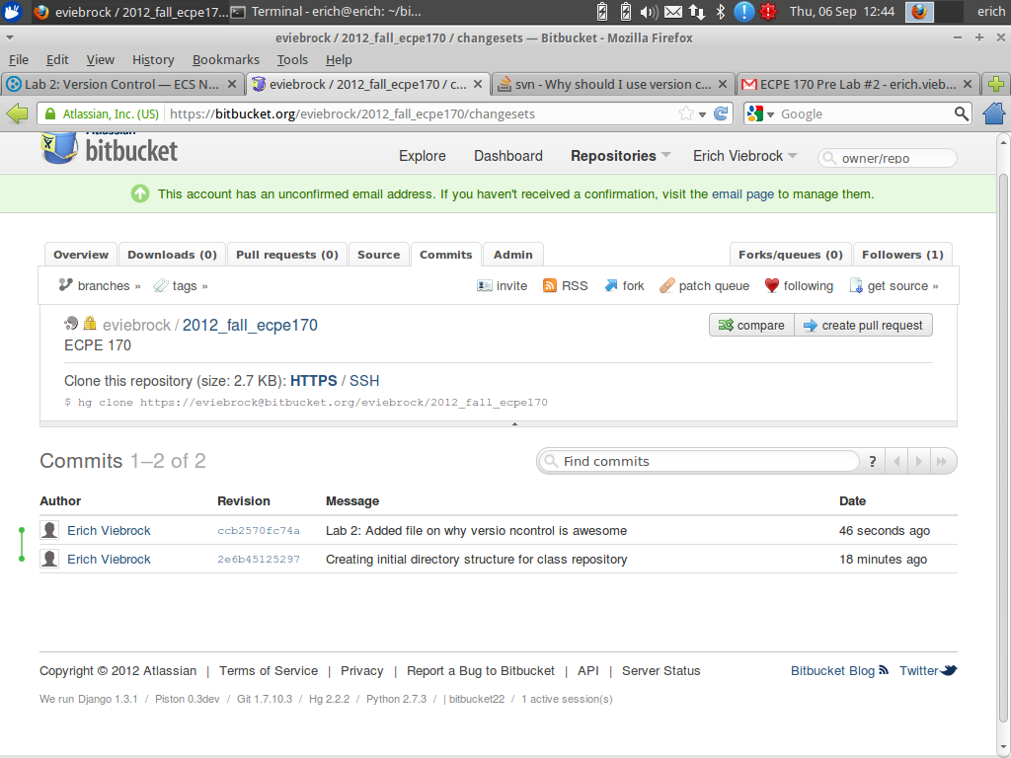

Question #6:
What does the line starting in --- represent?
Answer:
The line starting in “---” represents the version saved to Mecurial.

Question #7:
What does the line starting in +++ represent?
Answer:
The line starting in “+++” represents the version saved locally.

Question #8:
What do the lines starting in + represent?
Answer:
The lines starting in “+” represent the newly added lines to the file.

Question #9:
Can you guess what a line starting in - would represent? (Depending on the edits you made, you might have a few of these lines too).
Answer:
The lines starting in “-” represent the newly deleted lines to the file.

Question #10:
What benefits would a large team of developers get from version control? Identify at least two.
Answer:
1. Back ups
2. Multiple people working on the same files simultaneously

Question #11:
What benefits would a single developer (working alone) get from version control? Identify at least two.
Answer:
1. Back ups
2. Have multiple revisions

Question #12:
What kind of files should you put in version control?
Answer:
1. Source code files
2. VHDL and Verilog files
3. Matlab script files

Question #13:
What kind of files should you not put in version control? Why?
Answer:
1. Binary data
2. Anything auto-generated by the compiler
3. Text editor temp files
They take up space, and can be auto-generated in a split second.

Question #14:
Make a table that briefly summarizes the following fundamental hg commands:
hg help, hd add, hg commit, hg push, hg pull, hg update, hg status, hg diff, hg merge
Answer:
Command | Description
hg help | Displays a list of commands and uses for them.
hd add | Schedule files to be added to the version control repository.
hg commit | Commit changes to files to the given repository.
hg push | Push changes from local repository to cloud repository.
hg pull | Pull changes from cloud repository to local repository.
hg update | Update repository’s working directory with specified changeset.
hg status | Show status of files in repository.
hg diff | Show differences between revisions and previous files.
hg merge | Current working directory is updated with all changes made in requested revision.

Question #15:
What is the difference between a commit and a push?
Answer:
The difference between a commit and push is a commit is used for commenting on changes, whereas a push sends changes to a different repository.

Question #16:
Why is it better to use hg cp instead of plain-old regular cp to copy a file within the repository?
Answer:
It is better to use “hg cp” instead of “cp”, because hg cp preserves version history.

Lab Report - Wrapup

Question #1
What was the best aspect of this lab?
Answer:
The best part about this lab was easy workflow from directions to command prompt.

Question #2
What was the worst aspect of this lab?
Answer:
The worst part about this lab was finding a difference between hg commit and hg push.

Question #3
How would you suggest improving this lab in future semesters?
Answer:
To improve this lab for future semesters, I would recommend extending this lab to two class periods. Working with new software is always challenging.

