Lab Report

ECPE 170 – Computer Systems and Networks – Fall 2012

Name: Erich Viebrock

Lab Topic: MIPS Assembly Programming (Basic) (Lab #: 8)

Lab

Question #1:
Take two screenshots of the MIPS register panel: before your program runs, and after your program finishes. Put the register panel in Decimal mode (right-click) so it is easy to see register values.
Answer:
Before-execution:
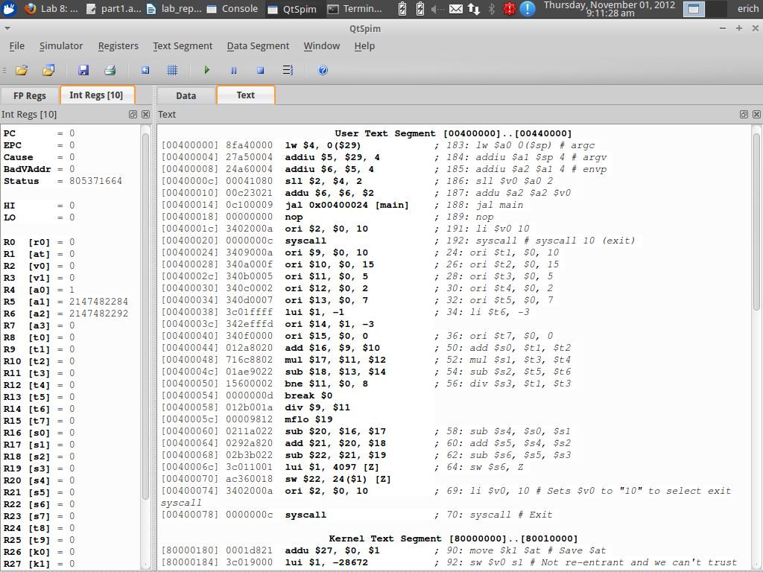

After-execution:
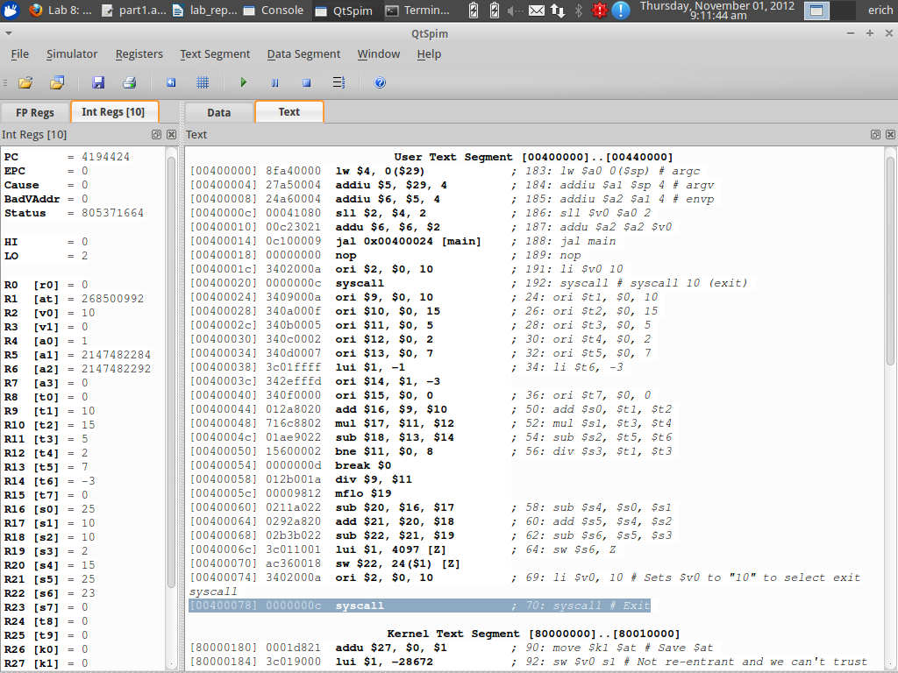

Question #2:
Take two screenshots of the MIPS memory panel (data tab): before your program runs, and after your program finishes. Put the memory panel is Decimal mode (right-click), so it is easy to see memory values. In the after-execution capture, circle the memory element that contains the final calculated value of Z.
Answer:
Before-execution:
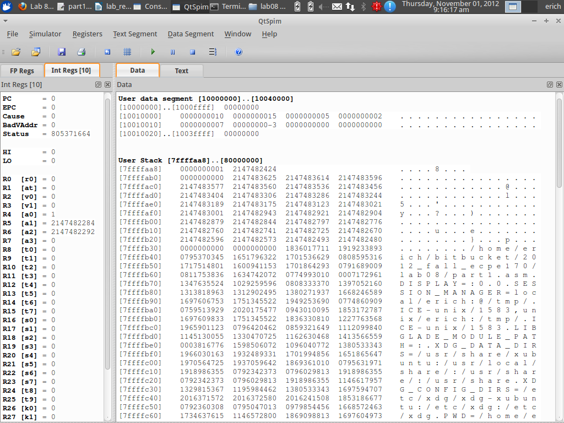

After-execution:
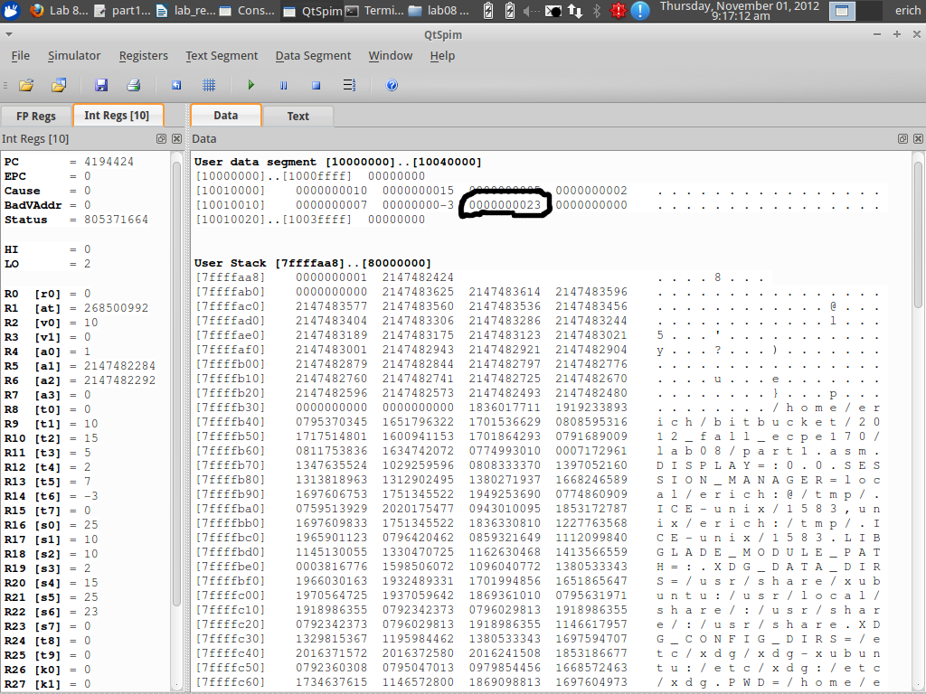

Question #3:
Take two screenshots of the MIPS register panel: before your program runs, and after your program finishes. Put the register panel in Decimal mode (right-click) so it is easy to see register values.
Answer:
Before-execution:
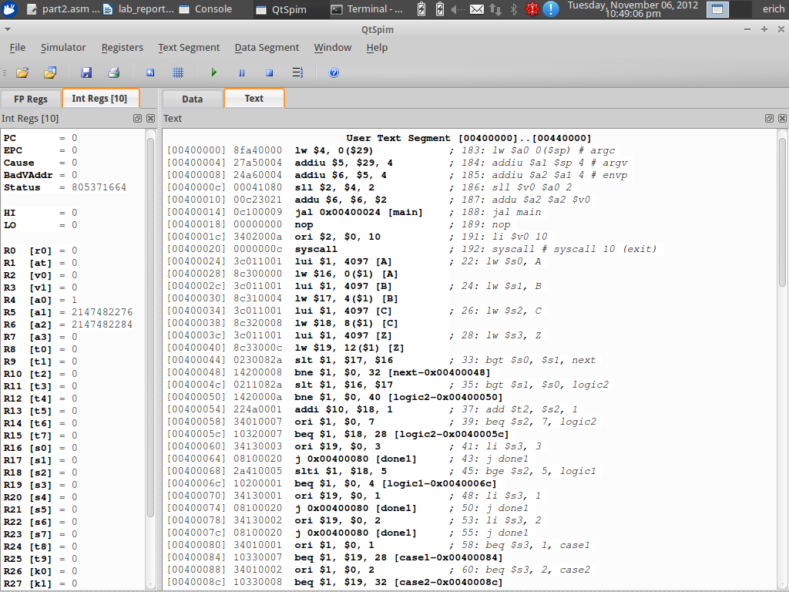

After-execution:
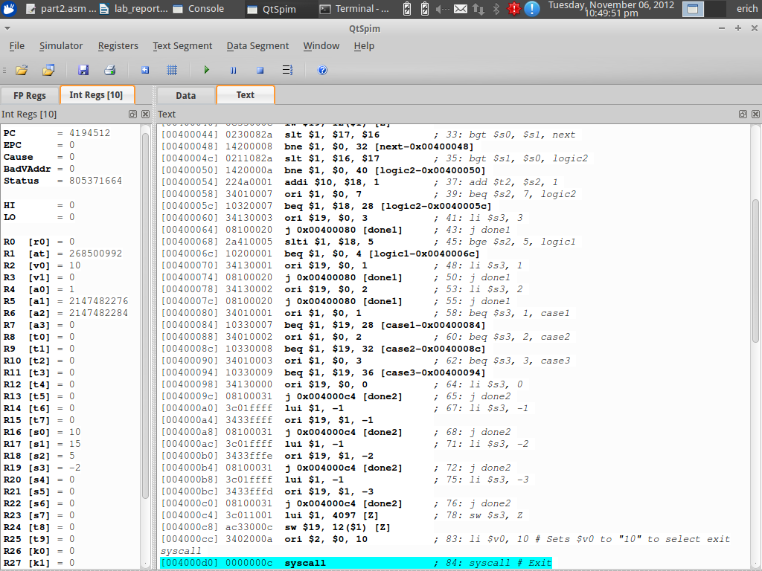

Question #4:
Take two screenshots of the MIPS memory panel (data tab): before your program runs, and after your program finishes. Put the memory panel is Decimal mode (right-click), so it is easy to see memory values. In the after-execution capture, circle the memory element that contains the final calculated value of Z.
Answer:
Before-execution:
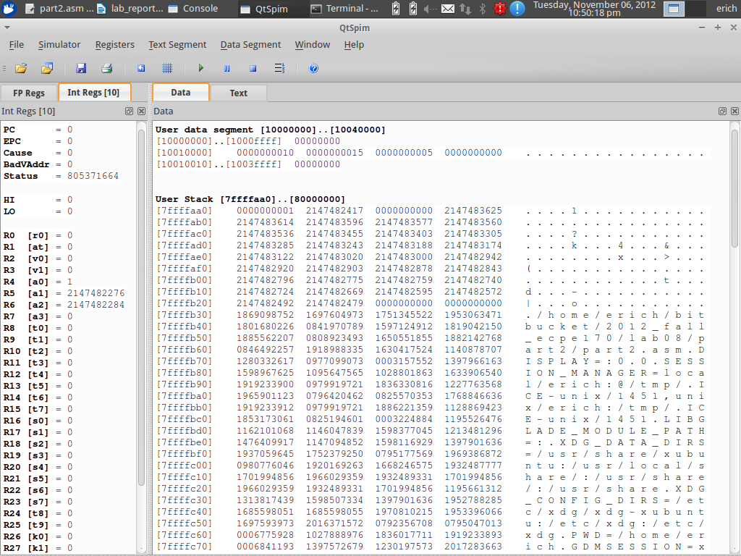

After-execution:
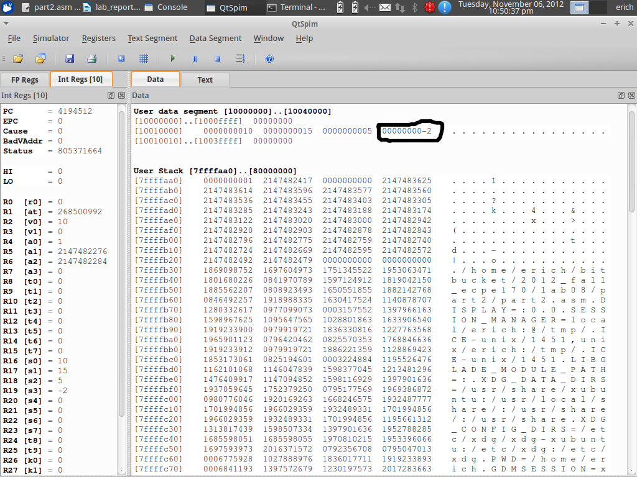

Question #5:
Take a screenshot of the MIPS register panel after your program finishes. Put the register panel in Decimal mode (right-click) so it is easy to see register values.
Answer:
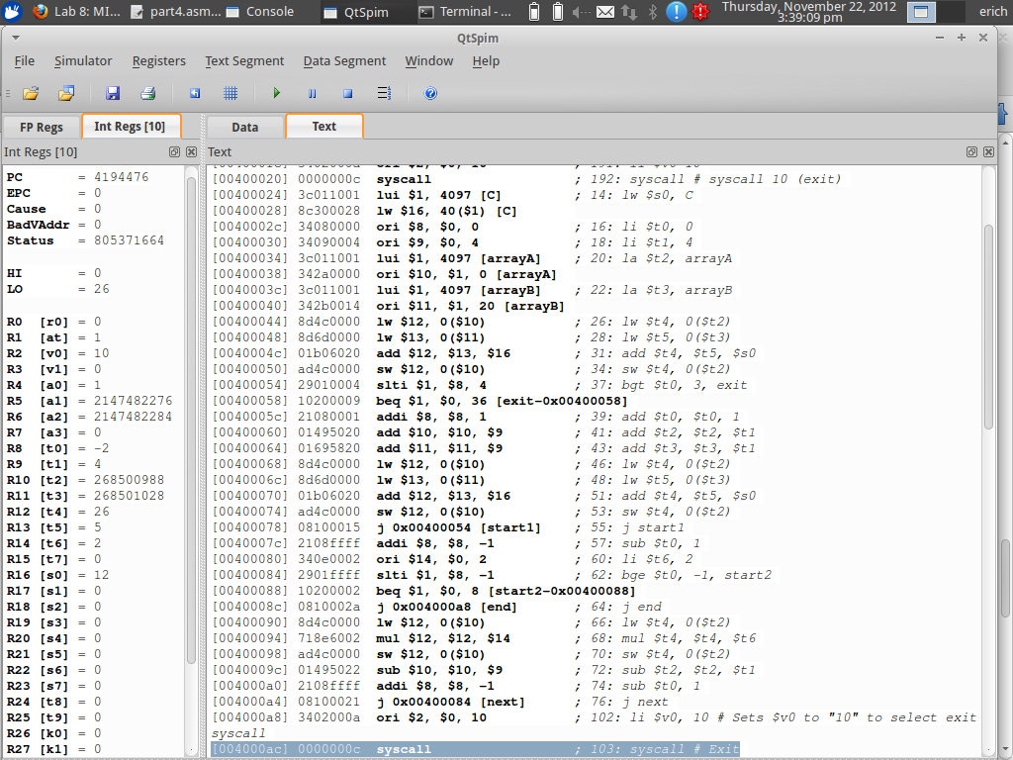

Question #6:
Take a screenshot of the MIPS memory panel (data tab) after your program finishes. Put the memory panel is Decimal mode (right-click), so it is easy to see memory values. Circle the final values of array A.
Answer:
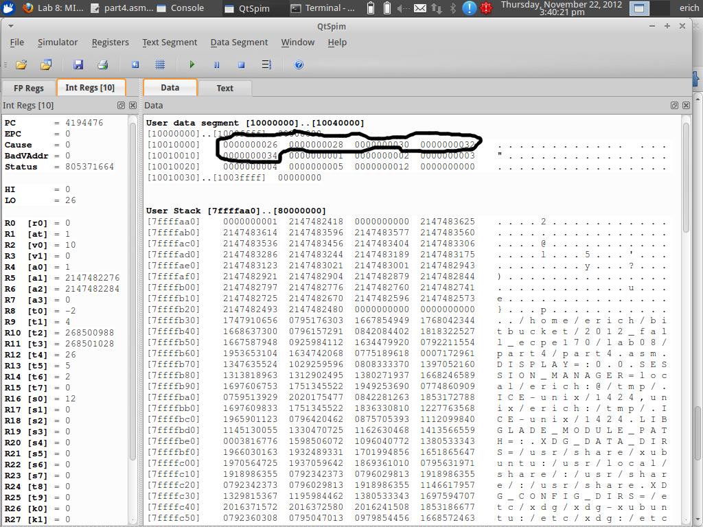

Question #7:
Take a screenshot of the MIPS memory panel (data tab) after your program finishes. Put the memory panel is Hex mode (right-click), since Decimal mode will not allow us to distinguish between bytes. Circle two things: the final value of the pointer 'result' in memory, and the corresponding location that result points to. Does that location in memory contain the ASCII code for the character 't'? (If not, you had better check your work!)
Answer:
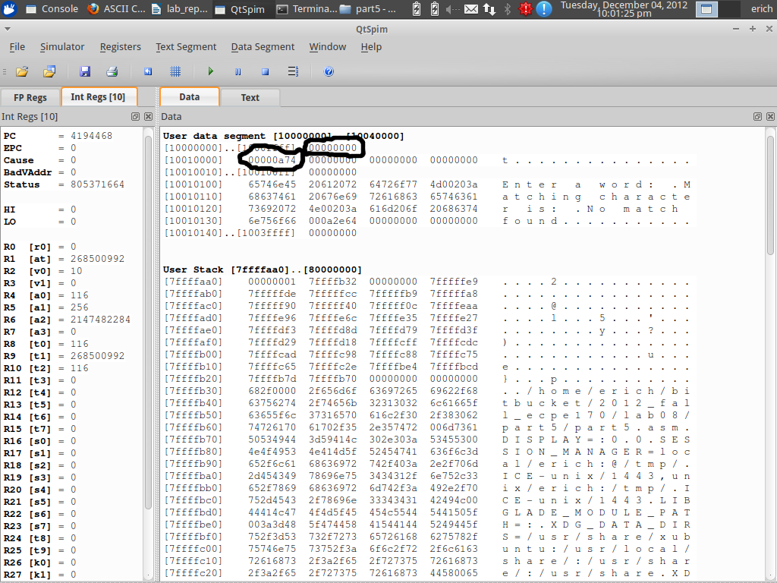

Post-Lab

Question #1:
What was the best aspect of this lab?
Answer:
Practicing an assembly language gives the programmer a closer look at how programs work behind the scenes.

Question #2:
What was the worst aspect of this lab?
Answer:
The appendixes were difficult to decipher from. Went online to find most of the help.

Question #3:
How would you suggest improving this lab in future semesters?
Answer:
More example programs similar to the assembly code asked for.

