**Programming Project: Interactive 2D Game Programming**

**Compiler:** Visual Studio 2010

**Operating System:** Windows 7

**Manual:** Breakout is an arcade game in which a player controls a paddle to direct a ball into a formation of bricks. The basic goal is to break all the bricks by hitting them with the ball.

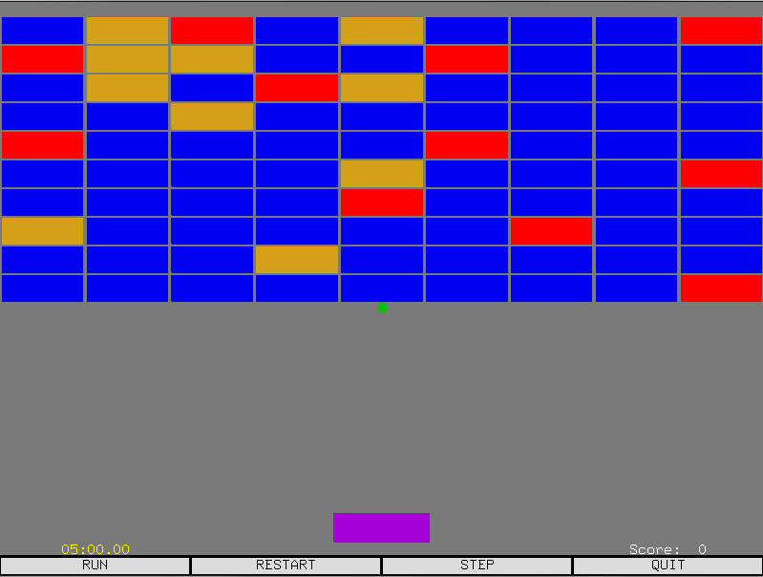

The user is greeted with a GUI of bricks, a ball, a paddle, a timer, and a score. The clickable options below allow for the game to “RUN”, “RESTART”, “STEP”, and “QUIT”. When the game begins, the timer will begin timing down from 5 minutes, and the ball will descend downwards.

Press the characters “z” and “x” to move the paddle left and right, respectively. Hitting the ball with the paddle, especially while moving, will change the ball’s direction. The ball will also change direction if it collides with the floor, however, only colliding with the paddle can change the ball’s path as desired. Try to make the ball collide with the bricks.

There are three different types of bricks in the game: blue, red, and yellow. A blue brick is a normal brick; it will disappear from a ball collision. A red brick is a concrete brick, which cannot be broken from a collision. *Hint: avoid hitting red bricks.* A gold brick is a special brick, because when a ball collides with one, it will release a gold ball. If the user catches the gold ball with the paddle, a power up will be issued. The power up will either be an additional game ball, or the deletion of nine bricks. *Note: Concrete bricks can be deleted from power up.* Whenever a brick is deleted, the score will increment by one.

Have fun!

**List of Tasks, and Where to Find Them:**

* Task 1: Break the Bricks
  + void Breakout::detectCollisions(Event event)
* Task 2: Additional Types of Bricks
  + class StrongBrick : public Brick
  + class PowerUpBrick : public Brick
* Task 3: Scoring
  + class ScoreBoard
* Task 5: Power-Ups
  + void Breakout::detectCollisions(Event event)
* Task 7: Multi-ball
  + void Breakout::detectCollisions(Event event)