DS 3001 | Fall 2026
[Project title — five-page main-content limit]
[Team member names]

Abstract
[In one paragraph of no more than 250 words, state the question, data, method, main result, and conclusion. Do not change the template format, including its page size, margins, two-column layout, fonts, font sizes, or heading styles.]
Code - [Paste the repository URL and identify the notebook path.]
Datasets - [Paste a data URL or brief access instructions.]

1. Introduction
[State the specific question, its scope, and the objectives used throughout the report. Rubric: Criterion 1, Question and scope.]

2. Data
[Identify and cite the source; define the observations, population or setting, analytic sample, preparation choices, and essential exploratory evidence. Rubric: Criterion 2, Data provenance, fitness, and analytic sample; Criterion 3, Data preparation and exploratory evidence.]

3. Methods
[Explain why each method fits the question and data, and justify important implementation and training choices. Rubric: Criterion 4, Method selection and implementation.]

4. Evaluation
[Define baselines, comparisons, metrics, validation or uncertainty procedures, and safeguards against leakage or repeated test-set use. Rubric: Criterion 5, Evaluation design.]

5. Results
[Present the figures, tables, and statistics needed to answer the question and compare relevant alternatives. Rubric: Criterion 6, Results and evidence.]
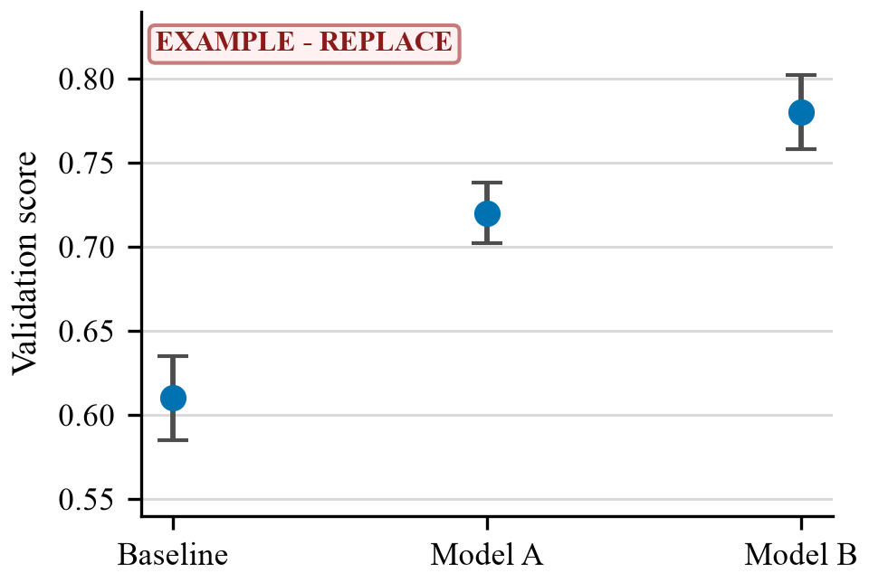
[Figure 1: Example validation performance across five folds; error bars show +/- 1 SD. Replace the figure, caption, and alt text.]

6. Discussion and Limitations
[Answer the question from the evidence; interpret uncertainty, distinguish association or prediction from causation, and state limitations that bound the claims. Rubric: Criterion 7, Interpretation and limitations.]

AI Usage Disclosure
[List any generative AI tools used, the tasks they supported, and how outputs were checked. If none were used, state that.]

References
[Provide full references in one consistent author-year style: author(s) or organization, year, title, venue or source, and DOI/URL when applicable. References do not count toward the five-page main-content limit. Rubric: Criterion 2, Data provenance, fitness, and analytic sample; Criterion 9, Required format and organization.]

Appendix
[Optional: include supplementary methods, analyses, diagnostic plots, or robustness checks that support the report but are not essential to its argument. The appendix does not count toward the five-page main-content limit. Rubric: Criterion 9, Required format and organization.]

