Starting with Python:

1. Print(“Hello I’m new to python”)
2. Name = “Arun Ragul

Print(“Name”)

1. In and Not operator:

name = "Arun Ragul"

if "z" in name:

print("Value Present")

elif "A" not in name:

print("Value not Present")

else:

print("Some other comparision")

1. names=["Arun","Ramesh","Suresh","Aruna"]

print (len(names))

print (names[0])

print(names[1:3])

List is mutable:

names=["Arun","Ramesh","Suresh","Aruna"]

names=["Arun",1]

print (names[:])

1. While loop:

num1 = 5

num2 = 8

while num1 < num2:

print(num1)

num1 += 1

1. While loop with Break:

num1 = 5

num2 = 8

while num1 < num2:

print(num1)

if num1==6:

break

num1 += 1

1. While loop with Continue:

num1 = 5

num2 = 8

while num1 < num2:

num1 += 1

if num1==6:

continue

print(num1)

1. While loop with else:

num1 = 5

num2 = 8

while num1 < num2:

print (num1)

num1 += 1

else:

print(num2)

1. names=["Arun","Suresh","Sundar","Aruna"]

for x in names:

if x=="Aruna":

print("Value is present: "+x)

1. Getting User input:

names=input("Enter the fullname: ")

print(names)

A function is a block of code which only runs when it is called.

You can pass data, known as parameters, into a function.

A function can return data as a result.

**Creating a function:**

In Python a function is defined using the def keyword:

def my_function():  
  print("Hello from a function")

**Calling a Function :** Call a function with function name and followed by parenthesis

My_function();

* Information can be passed to functions as parameter.
* Parameters are specified after the function name, inside the parentheses.
* You can add as many parameters as you want, just separate them with a comma.

Passing Parameter:

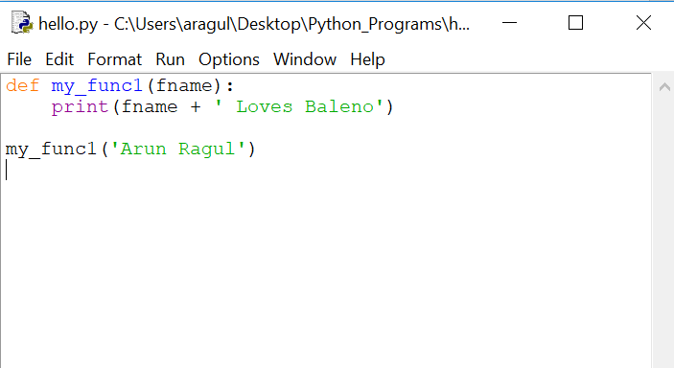

The above function is created with one parameter (fname), we can pass one value while calling the above function.

With Default value:

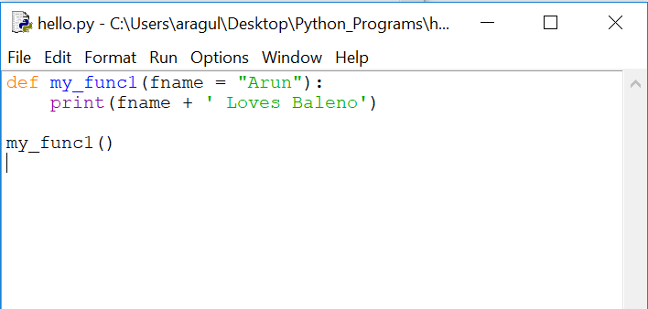From the above value if parameter is not passed fname will take “Arun”.If value is passed while calling it will take the respective data.

Using Return statement in function:

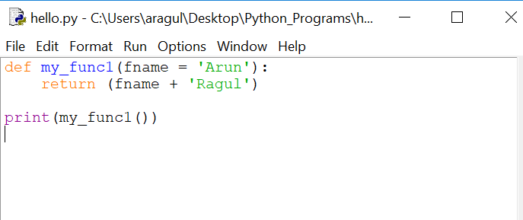

A function returns a value with a keyword ‘return’.

Lambda function:

Lambda is an anonymous function , without a name and is used for a short period of time in a program.

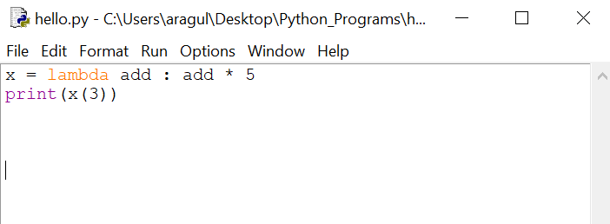

The above program is equal to :

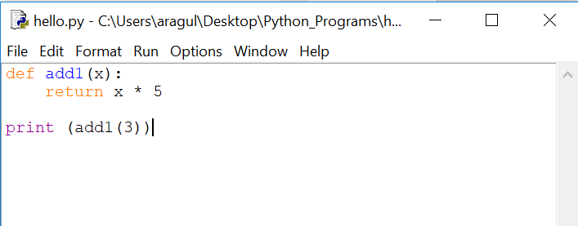

Lamda arguments: expression (lambda syntax).

Modules:

A file containing a set of functions you want to include in your application.

Create a file with .py extension and store in a folder.

def fn_name(name):

print("Hello, "+ name)

Example how we can use modules inside a program:

Import fn_name

Fn_name.name(“Arun Ragul”) #(modulename.functionname).

Python has packages for directories and [modules](https://www.programiz.com/python-programming/modules) for files.

A directory must contain a file named __init__.py in order for Python to consider it as a package.

Importing module from a package:

Packagename.modulename.functionname

Python is an object oriented programming language.

Almost everything in Python is an object, with its properties and methods.

A Class is like an object constructor, or a "blueprint" for creating objects.

Create a class:

Class Myname:

name=”Arun Ragul”

Try printing the value of print(Myname) - ---- no value is printed because class is justa blue print and not the implementation.

Creating an object:

Obj1 = Myname()

Print(Obj.name)

Object is the implementation of the class, after creating the object the values are printed.

A constructor is a special type of method (function) which is used to initialize the instance members of the class.

Constructors can be of two types.

1. Parameterized Constructor
2. Non-parameterized Constructor
3. **Note:** The self parameter is a reference to the class instance itself, and is used to access variables that belongs to the class.

class Persondet:

def __init__(self, name, city):

self.name = name

self.city = city

obj2 = Persondet("Arun Ragul", "Bangalore")

print(obj2.name)

print(obj2.city)

class Myname:

name="Arun Ragul"

print(Myname)

Obj1 = Myname()

print(Obj1.name)

----------------------------------------------

Obj1 = Myname()

print(Obj1.name)

--------------------------------------------------

class Persondet:

def __init__(self):

print("This is a non-parameterized constructor")

def fn(self,name,city):

print("Hello",name,city)

Persondet=Persondet()

Persondet.fn("Arun","Bangalore")

----------------------------------------------------

File read:

file = open("demofile.txt","r")

print (file.read())

------------------------------------

file = open("demofile.txt","r")

print (file.read(10))

----------------------------------

file =open("myfile2.txt","x")

---------------------------------------