*TERADATA*

**LAB1**

**SELECT** * **FROM** Aggregation_table**;**

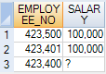

**SELECT** AVG(Salary),Count(Salary),Count(*) **FROM** Aggregation_table**;**



**SELECT** * **FROM** Employee_table**;**

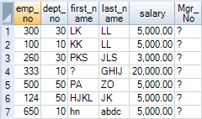

**SELECT** MIN(Salary),MAX(Salary),SUM(Salary),AVG(Salary),COUNT(*) **FROM** Employee_table**;**



**SELECT** Dept_No,MIN(Salary),MAX(Salary),SUM(Salary),AVG(Salary),COUNT(*) **FROM** Employee_table **GROUP** **BY** Dept_No**;**

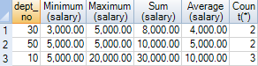

**SELECT** Dept_No,MIN(Salary),MAX(Salary),SUM(Salary),AVG(Salary),COUNT(*) **FROM** Employee_table **GROUP** **BY** Dept_No **Order** **by** 1**;**

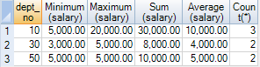

**SELECT** Dept_No,MIN(Salary),MAX(Salary),SUM(Salary),AVG(Salary),COUNT(*) **FROM** Employee_table **WHERE** DEPT_NO **IN**(30,40) **GROUP** **BY** DEPT_NO **ORDER** **BY** 1**;**



**SELECT** Dept_No,MIN(Salary),MAX(Salary),SUM(Salary),AVG(Salary),COUNT(*) **FROM** Employee_Table **WHERE** DEPT_NO **IN**(30,10) **GROUP** **BY** DEPT_NO **HAVING** Count(*)>1**;**



**SELECT** 'PRODUCT_ID' **AS** "COLUMN NAME",COUNT(*) / COUNT(**DISTINCT**(PRODUCT_ID)) **AS** "AVERAGE ROWS" **FROM** Sales_Table**;**



**SELECT** 'SALE_DATE' **AS** "COLUMN NAME",COUNT(*) / COUNT(**DISTINCT**(SALE_DATE)) **AS** "AVERAGE ROWS" **FROM** Sales_Table**;**



**SELECT** 'PRODUCT_ID' **AS** "COLUMN NAME",COUNT(*) / COUNT(**DISTINCT**(PRODUCT_ID)) **AS** "AVERAGE ROWS",'SALE_DATE' **AS** "COLUMN NAME2",COUNT(*) / COUNT(**DISTINCT**(SALE_DATE)) **AS** "AVERAGE ROWS2" **FROM** Sales_Table**;**



**SELECT** PRODUCT_ID,EXTRACT(MONTH FROM SALE_DATE) **AS** MTH,EXTRACT(YEAR FROM SALE_DATE) **AS** YR,SUM(DAILY_SALES) **AS** SUM_DAILY_SALES **FROM** Sales_Table **GROUP** **BY** **GROUPING** **SETS** (PRODUCT_ID,MTH,YR) **ORDER** **BY** PRODUCT_ID **DESC**,MTH **DESC**,YR **DESC;**

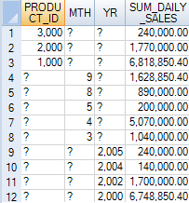

**SELECT** PRODUCT_ID,EXTRACT(MONTH FROM SALE_DATE) **AS** MTH,EXTRACT(YEAR FROM SALE_DATE) **AS** YR,SUM(DAILY_SALES) **AS** SUM_DAILY_SALES **FROM** SALES_TABLE **GROUP** **BY** **ROLLUP**(PRODUCT_ID,MTH,YR) **ORDER** **BY** PRODUCT_ID **DESC**,MTH **DESC**,YR **DESC;**

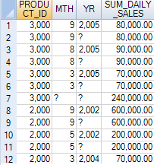

**SELECT** PRODUCT_ID,EXTRACT(MONTH FROM SALE_DATE) **AS** MTH,EXTRACT(YEAR FROM SALE_DATE) **AS** YR,SUM(DAILY_SALES) **AS** SUM_DAILY_SALES **FROM** SALES_TABLE **GROUP** **BY** **CUBE**(PRODUCT_ID,MTH,YR) **ORDER** **BY** PRODUCT_ID **DESC**,MTH **DESC**,YR **DESC;**

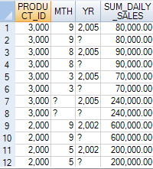

TEST QUESTION

**SELECT** DEPT_NO,AVG(Salary),SUM(Salary) **FROM** EMPLOYEE_TABLE **GROUP** **BY** DEPT_NO **WHERE** DEPT_NO **IN**(30,40,50) **HAVING** AVG(Salary)>=15000**;**



BASIC SQL FUNCTIONS

**SELECT** * **FROM** STUDENT_TABLE**;**

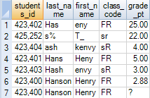

**SELECT** FIRST_NAME,LAST_NAME,CLASS_CODE,GRADE_PT **FROM** STUDENT_TABLE**;**

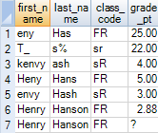

**SELECT** * **FROM** STUDENT_TABLE **ORDER** **BY** LAST_NAME**;**

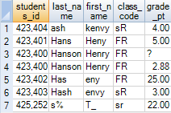

**SELECT** * **FROM** STUDENT_TABLE **ORDER** **BY** 3**;**



**SELECT** * **FROM** STUDENT_TABLE **ORDER** **BY** 5**;**

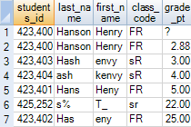

**SELECT** * **FROM** STUDENT_TABLE **ORDER** **BY** LAST_NAME **DESC;**

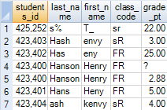

**SELECT** * **FROM** STUDENT_TABLE **ORDER** **BY** 5 **DESC;**

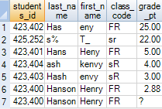

**SELECT** * **FROM** STUDENT_TABLE **ORDER** **BY** CLASS_CODE **DESC**,GRADE_PT **ASC;**

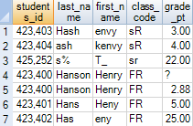

**SELECT** * **FROM** STUDENT_TABLE **ORDER** **BY** **CASE** CLASS_CODE **WHEN** 'sr' **THEN** 1 **WHEN** 'FR' **THEN** 2 **ELSE** 3 **END;**

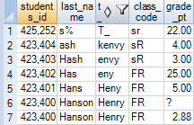

**SELECT** FIRST_NAME "FNAME",LAST_NAME "LNAME" **FROM** STUDENT_TABLE**;**

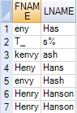

**SELECT** * **FROM** STUDENT_TABLE **ORDER** **BY** GRADE_PT**;**

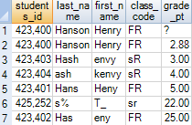

**SELECT** FIRST_NAME,LAST_NAME,CLASS_CODE **AS** "SUM",GRADE_PT **FROM** STUDENT_TABLE **WHERE** GRADE_PT>3.00**;**

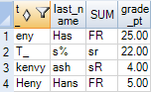

**SELECT** FIRST_NAME,LAST_NAME,CLASS_CODE,GRADE_PT **FROM** STUDENT_TABLE **WHERE** GRADE_PT>3.00**;**

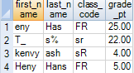

COLLECT STATISTICS

**HELP** **STATISTICS** EMPLOYEE_TABLE**;**

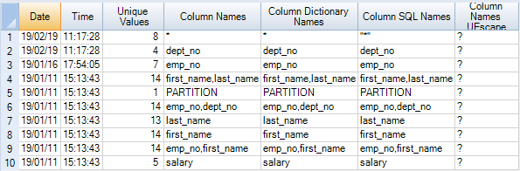

**SELECT**\***FROM** SALES_TABLE**;**

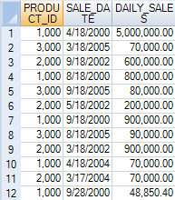

**SELECT** * **FROM** Sales_Table **WHERE** PRODUCT_ID=1000**;**

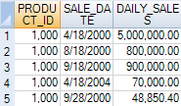

**SELECT** * **FROM** SALES_TABLE **WHERE** PRODUCT_ID=1000 **AND** DAILY_SALES=5000000**;**



**SELECT** * **FROM** ORDER_TABLE**;**

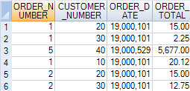

**EXPLAIN** **SELECT** * **FROM** new_employee_table**;**

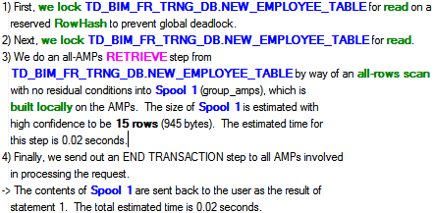

**HELP** **STATISTICS** HIERARCHY_TABLE**;**

OUTPUT WILL NOT COME FOR THIS STATISTICS BECAUSE THE TABLE DOES NOT EXIST

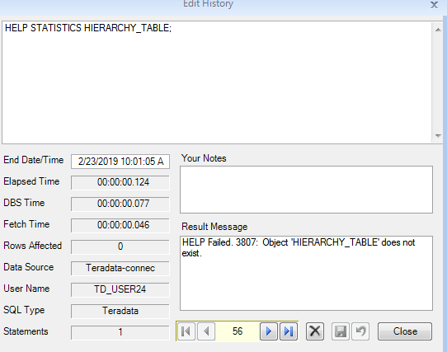

**COLLECT** **STATISTICS** **ON** NEW_EMPLOYEE_TABLE **COLUMN** EMP_NO**;**

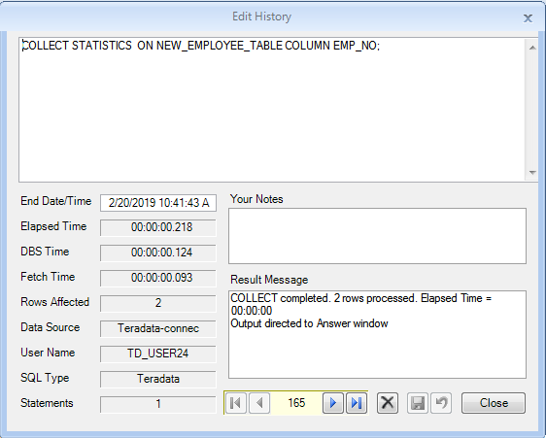

**SHOW** **STATISTICS** **ON** NEW_EMPLOYEE_TABLE**;**

**COLLECT** STATISTICS

**USING** SYSTEM **SAMPLE**

**COLUMN** ( dept_no ) ,

**COLUMN** ( first_name,last_name )

**ON** TD_BIM_FR_TRNG_DB.NEW_EMPLOYEE_TABLE **;**

**COLLECT** STATISTICS

**USING** SYSTEM **SAMPLE**

**AND** MAXVALUELENGTH 50

**COLUMN** ( emp_no )

**ON** TD_BIM_FR_TRNG_DB.NEW_EMPLOYEE_TABLE **;**

**COLLECT** STATISTICS

*-- default SYSTEM SAMPLE PERCENT*

**COLUMN** ( **PARTITION** ) ,

**COLUMN** ( emp_no,dept_no ) ,

**COLUMN** ( first_name ) ,

**COLUMN** ( emp_no,first_name )

**ON** TD_BIM_FR_TRNG_DB.NEW_EMPLOYEE_TABLE **;**

**COLLECT** STATISTICS

**USING** **SAMPLE** 20.00 **PERCENT**

**AND** MAXINTERVALS 500

**AND** MAXVALUELENGTH 500

**COLUMN** ( last_name )

**ON** TD_BIM_FR_TRNG_DB.NEW_EMPLOYEE_TABLE **;**

**COLLECT** **STATISTICS** **ON** EMPLOYEE_TABLE **COLUMN** EMP_NO**;**

**SHOW** **STATISTICS** **ON** EMPLOYEE_TABLE**;**

(OR)

**COLLECT** **STATISTICS** **ON** EMPLOYEE_TABLE **COLUMN** DEPT_NO**;**

**SHOW** **STATISTICS** **ON** EMPLOYEE_TABLE**;**

(OR)

**COLLECT** **STATISTICS** **ON** EMPLOYEE_TABLE **INDEX**(FIRST_NAME,LAST_NAME)**;**

**SHOW** **STATISTICS** **ON** EMPLOYEE_TABLE**;**

(OR)

**COLLECT** **STATISTICS** **ON** EMPLOYEE_TABLE **COLUMN**(EMP_NO,DEPT_NO)**;**

**SHOW** **STATISTICS** **ON** EMPLOYEE_TABLE**;**

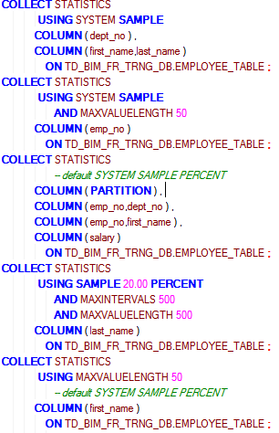

**SELECT**\***FROM** EMPLOYEE_TABLE_NEW

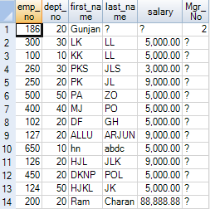

DATA MANIPULATION LANGUAGE

**SELECT** * **FROM** MY_TABLE**;**



**SELECT** * **FROM** MY_ORIGINAL_TABLE**;**

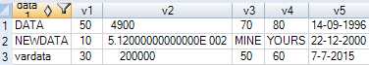

**INSERT** **INTO** MY_TABLE **SELECT** * **FROM** MY_ORIGINAL_TABLE**;**

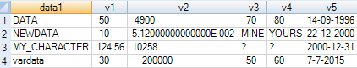

**INSERT** **INTO** MY_TABLE (v1,data1,v2,v5) **SELECT** V1,DATA1,V2,CURRENT_DATE **FROM** MY_ORIGINAL_TABLE**;**

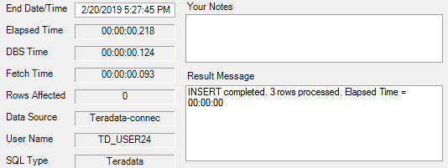

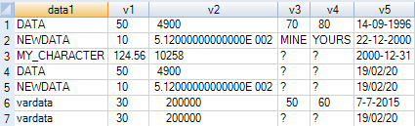

DATE FUNCTIONS

**SELECT**

DATE **AS** "DATE"

,Current_date

,TIME

,Current_time

,Current_timestamp(6)**;**



IN BTEQ

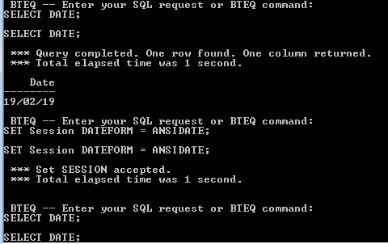

Timestamp differences

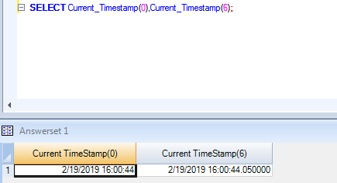

Date addition or subtractions

**SELECT** ('2019-02-23'(DATE))-('1997-06-26'(date)) AGE**;**



**SELECT** ('2019-02-23'(DATE))-('1997-06-26'(date))/365 AGE**;**



**SELECT** MONTHS_BETWEEN(('2019-02-23'(DATE)),('1997-06-26'(date)))/12 AGE**;**

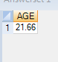

ADD_MONTHS

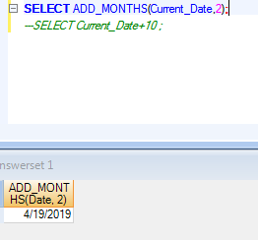

ADD_MONTHS to add years

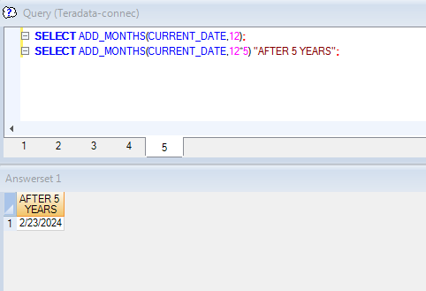

EXTRACT

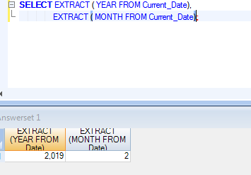

CASTING OF DATE AND INTEGERS

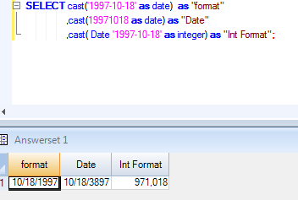

Sys_Calendar

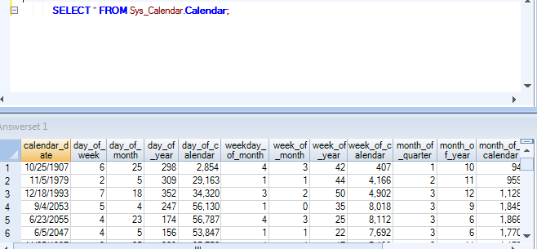

**LAB2**

DISTINCT

DISTINCT Vs GROUP BY

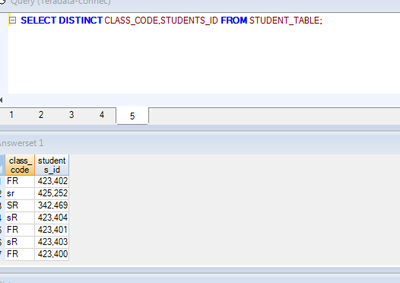

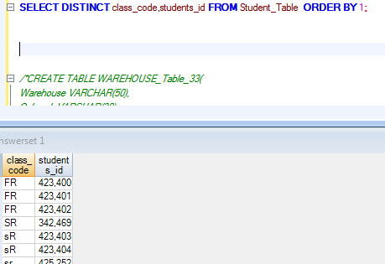

Explain

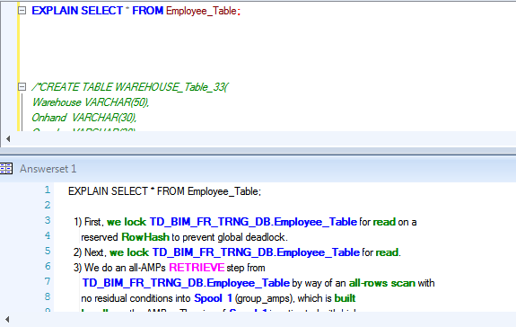

Lower command(TO LOWERCASE)

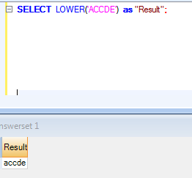

HELP AND SHOW

HELP

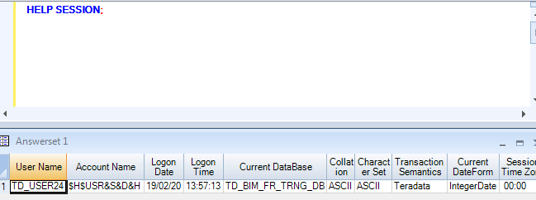

Session

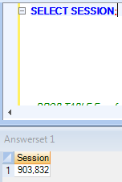

FORMAT FUNCTIONS

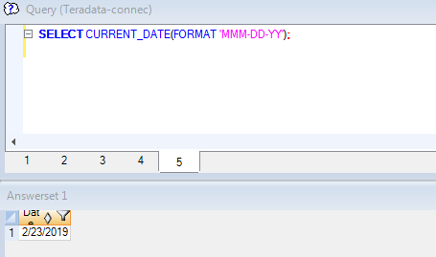

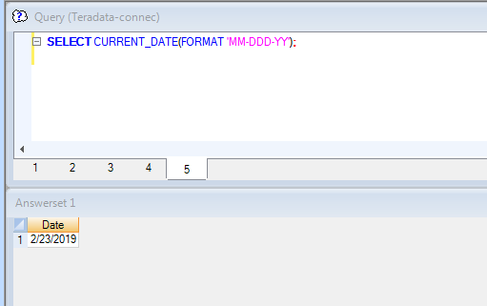

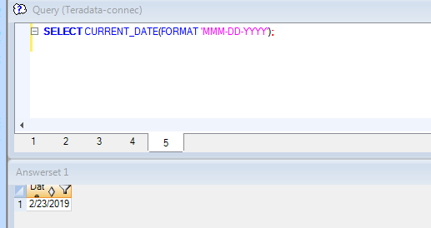

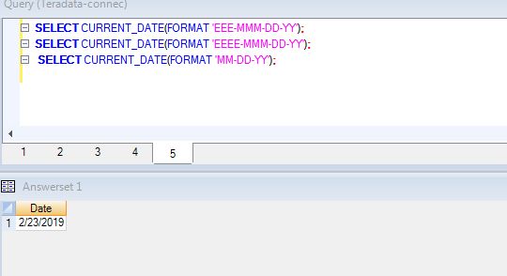

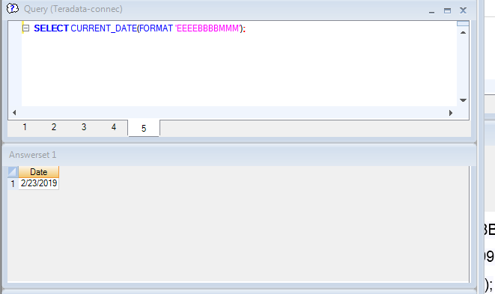 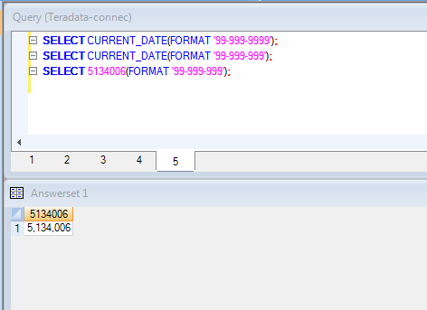

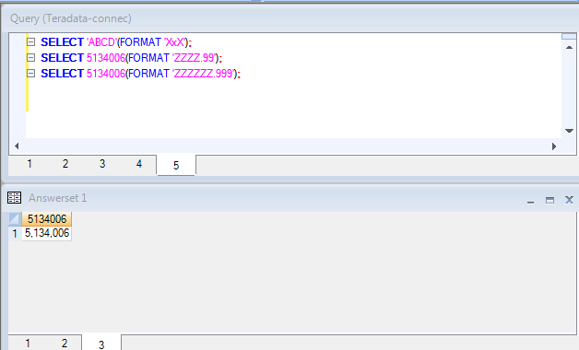 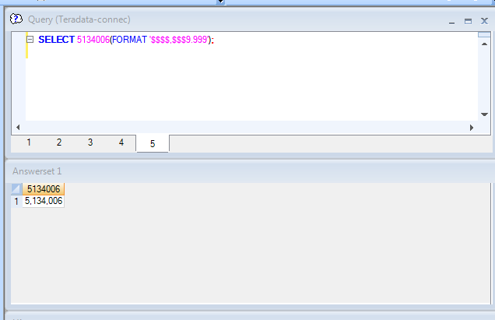 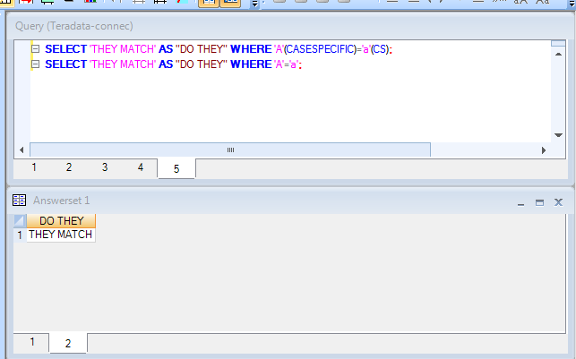

**LAB3**

MATH FUNCTIONS

**SELECT** (2+4)*5



**SELECT** 2+4/5



**SELECT** 2+4.0/5



OLAP FUNCTIONS

**SELECT** PRODUCT_ID,SALE_DATE,DAILY_SALES,CSUM(DAILY_SALES,SALE_DATE) **AS** "CSUM" **FROM** SALES_TABLE**;**

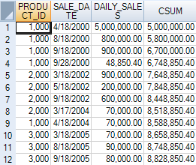

**LAB4**

QUANTILE FUNCTIONS

**SELECT** PRODUCT_ID,SALE_DATE,DAILY_SALES,QUANTILE (100,DAILY_SALES) **AS** "QUANTILE" **FROM** SALES_TABLE **WHERE** PRODUCT_ID<3000 **AND** SALE_DATE>1000030**;**

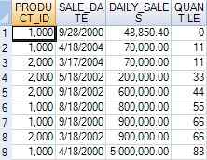

**SELECT** PRODUCT_ID,SALE_DATE,DAILY_SALES,QUANTILE (100,DAILY_SALES,SALE_DATE **DESC** ) **AS** "QUANTILE" **FROM** SALES_TABLE **WHERE** PRODUCT_ID<3000 **AND** SALE_DATE>1000030**;**

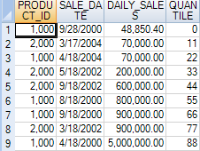

**SELECT** PRODUCT_ID,SALE_DATE,DAILY_SALES,QUANTILE (100,DAILY_SALES,SALE_DATE) **AS** "percentile" **FROM** SALES_TABLE **QUALIFY** "percentile">=60**;**

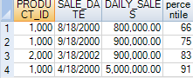

**SELECT** PRODUCT_ID,SALE_DATE,DAILY_SALES,QUANTILE (100,DAILY_SALES,SALE_DATE) **AS** "percentile" **FROM** SALES_TABLE **QUALIFY** "percentile">=60 **ORDER** **BY** "percentile" **DESC;**

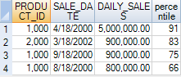

**SELECT** PRODUCT_ID,SALE_DATE,DAILY_SALES,QUANTILE (100,DAILY_SALES **ASC**,SALE_DATE) **AS** "percentile" **FROM** SALES_TABLE **QUALIFY** "percentile">=60**;**

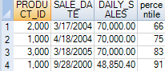

USING TERTILES

**SELECT** PRODUCT_ID,SALE_DATE,DAILY_SALES,QUANTILE (4,DAILY_SALES ,SALE_DATE) **AS** "Quartiles" **FROM** SALES_TABLE **WHERE** PRODUCT_ID **IN** (1000,2000)**;**

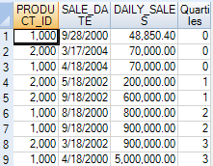

**SELECT** PRODUCT_ID,SALE_DATE,DAILY_SALES,QUANTILE (4,DAILY_SALES ,SALE_DATE) **AS** "Quartiles" **FROM** SALES_TABLE **WHERE** PRODUCT_ID=1000**;**

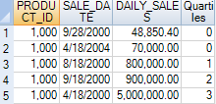

TOP SQL COMMAND CHEAT SHEET

**SELECT** **DATABASE**,**USER**,**SESSION**,**ACCOUNT**,**PROFILE**,**ROLE**



**SELECT** **TOP** 7 LAST_NAME,CLASS_CODE,GRADE_PT **FROM** STUDENT_TABLE **ORDER** **BY** GRADE_PT **DESC;**

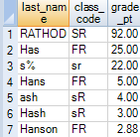

**SELECT** * **FROM** NEW_EMPLOYEE_TABLE **SAMPLE** 8

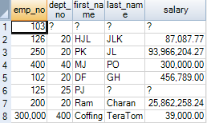

**SELECT** C.CUSTOMER_NUMBER,C.CUSTOMER_NAME,O.ORDER_NUMBER,O.ORDER_TOTAL **FROM** CUSTOMER_TABLE **AS** C,ORDER_TABLE **AS** O **WHERE** C.CUSTOMER_NUMBER=O.CUSTOMER_NUMBER**;**



**SELECT** C.CUSTOMER_NUMBER,C.CUSTOMER_NAME,O.ORDER_NUMBER,O.ORDER_TOTAL **FROM** CUSTOMER_TABLE **AS** C **INNER** **JOIN** ORDER_TABLE **AS** O **ON** C.CUSTOMER_NUMBER=O.CUSTOMER_NUMBER**;**



USING SYSTEM CALENDAR

**SELECT** CALENDAR_DATE,

DAY_OF_WEEK,

DAY_OF_MONTH,

DAY_OF_YEAR,

DAY_OF_CALENDAR,

WEEKDAY_OF_MONTH,

WEEK_OF_MONTH,

WEEK_OF_YEAR,

WEEK_OF_CALENDAR,

MONTH_OF_QUARTER,

MONTH_OF_YEAR,

MONTH_OF_CALENDAR,

QUARTER_OF_YEAR,

QUARTER_OF_CALENDAR,

YEAR_OF_CALENDAR

**FROM** SYS_CALENDAR.**CALENDAR** **WHERE** CALENDAR_DATE='1959-01-01';



**SELECT** PRODUCT_ID,SALE_DATE,DAILY_SALES,RANK() OVER(**ORDER** **BY** DAILY_SALES **DESC**) **AS** RANK1 **FROM** SALES_TABLE**;**

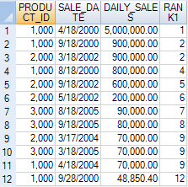

**SELECT** COURSE_NAME,CREDITS

,**CASE** CREDITS

**WHEN** 1 **THEN** 'ONE CREDIT'

**WHEN** 2 **THEN** 'TWO CREDIT'

**WHEN** 3 **THEN** 'THREE CREDIT'

**ELSE** 'CREDITS NOT FOUND'

**END** **AS** CREDITSALIAS **FROM** COURSE_TABLE **ORDER** **BY** 1**;**

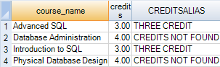

**SELECT** COURSE_NAME

,**CASE**

**WHEN** CREDITS <=1 **THEN** 'ONE'

**WHEN** CREDITS =2 **THEN** 'TWO'

**WHEN** CREDITS <4 **THEN** 'THREE'

**when** course_name like 'TERA%' **THEN** '4'

**ELSE** 'DONT KNOW'

**END** **AS** CREDITALIAS

**FROM** COURSE_TABLE

**ORDER** **BY** 1**;**

**ELSE** 'CREDITS NOT FOUND'

**END** **AS** CREDITSALIAS **FROM** COURSE_TABLE **ORDER** **BY** 1**;**

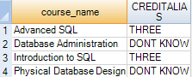

**LOCKING** **ROW** **FOR** **ACCESS** **SELECT** * **FROM** NEW_EMPLOYEE_TABLE**;**

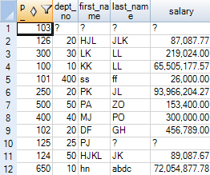

**LOCKING** **ROW** **FOR** **ACCESS**

**SELECT**

SUM(MAXPERM) **AS** "PERM"

,SUM(MAXSPOOL) **AS** "SPOOL"

,SUM(MAXTEMP) **AS** "TEMP"

**FROM** DBC.DISKSPACE **WHERE** DATABASENAME=**USER**

**;**



**SELECT** VPROC,CAST(TABLENAME **AS** CHAR(20)),CURRENTPERM,PEAKPERM **FROM** DBC.TABLESIZEV **WHERE** DATABASENAME='TD_SYSFNLIB' **ORDER** **BY** TABLENAME,VPROC**;**

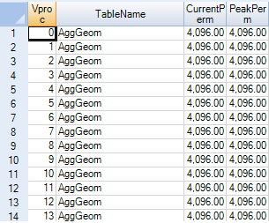

**LOCKING** **ROW** **FOR** **ACCESS** **SELECT** HASHAMP (HASHBUCKET(HASHROW(EMP_NO))) **AS** "AMP#",COUNT(*) **FROM** NEW_EMPLOYEE_TABLE **GROUP** **BY** 1 **ORDER** **BY** 1**;**

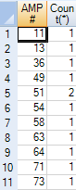

VIEW COMMANDS

**CREATE** **VIEW** DEPARTMENT_SALARIES **AS** **SELECT** DEPT_NO,SUM(SALARY) **AS** SUMSAL,SUM(SALARY)/12 **AS** MONTHSAL **FROM** EMPLOYEE_TABLE **GROUP** **BY** 1**;**

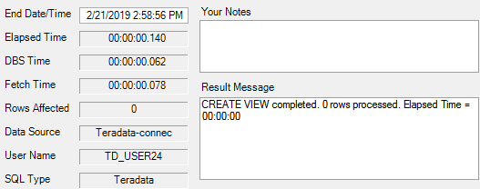

**SELECT** * **FROM** DEPARTMENT_SALARIES**;**



**CREATE** **VIEW** EMPLOYEE_V2 **AS** **SELECT** EMP_NO,FIRST_NAME,LAST_NAME,DEPT_NO,SALARY **FROM** EMPLOYEE_TABLE**;**

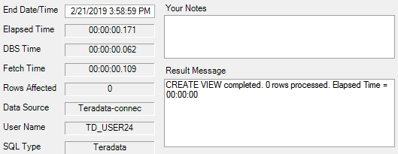

**SHOW** **VIEW** EMPLOYEE_V2

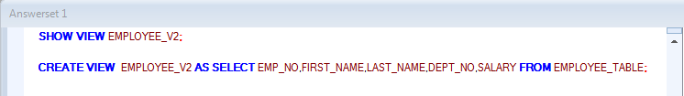

**REPLACE** **VIEW** EMPLOYEE_V2 **AS** **SELECT** EMP_NO,FIRST_NAME,LAST_NAME,DEPT_NO **FROM** EMPLOYEE_TABLE**;**

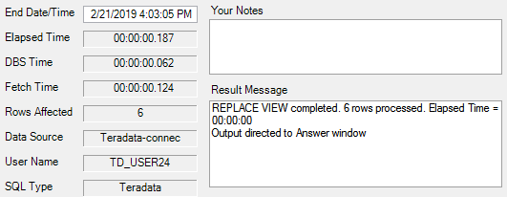

**HELP** **VIEW** EMP_VIEW**;**

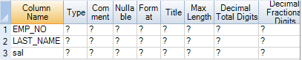

**SELECT**\***FROM** CUSTOMER_ORDER_V **ORDER** **BY** 1**;**



**CREATE** **VIEW** AGGREG_ORDER_V **AS**

**SELECT** CUSTOMER_NUMBER

,ORDER_DATE/100+100000 (FORMAT '9999-99') **AS** YR_MTH_ORDERS

,COUNT(ORDER_TOTAL) **AS** ORDER_CNT

,SUM(ORDER_TOTAL) **AS** ORDER_SUM

,AVG(ORDER_TOTAL) **AS** ORDER_AVG

**FROM** ORDER_TABLE **GROUP** **BY** CUSTOMER_NUMBER,YR_MTH_ORDERS**;**

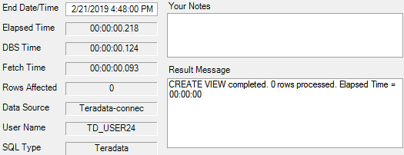

**SELECT** CUSTOMER_NUMBER,ORDER_SUM **FROM** AGGREG_ORDER_V**;**

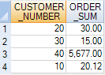

**SELECT** SUM(ORDER_SUM) **FROM** AGGREG_ORDER_V**;**



**LAB5**

**select** first_name,last_name,class_code,grade_pt **from** student_table **where** first_name='kenvy'**;**



**select** first_name **as** fname,last_name **as** lname,class_code **as** code,grade_pt **from** student_table **where** first_name='kenvy'**;**



**select** first_name **as** fname,last_name lname,class_code "code",grade_pt **as** "avg" **from** student_table **where** first_name='kenvy' **order** **by** "avg"**;**



**select** * **from** student_table **where** class_code **IS** **NOT** **NULL;**

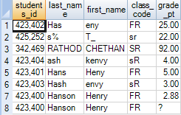

**select** * **from** student_table **where** class_code **IS** **NULL;**



**select** * **from** student_table **where** grade_pt>=3.0**;**

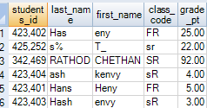

**select** * **from** student_table **where** grade_pt GE 3.0**;**

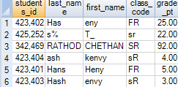

**select** * **from** student_table **where** class_code='FR' **and** first_name='Henry'**;**



**select** * **from** student_table **where** grade_pt=3.0 **or** grade_pt=4.0**;**



**select** * **from** student_table **where** grade_pt=3.0 **or** grade_pt=4.0 **and** class_code='SR'**;**



**select** * **from** student_table **where** grade_pt **IN** (3.0,4.0) **and** class_code='SR'**;**



**select** * **from** student_table **where** grade_pt **NOT** **IN** (2.0,3.0,4.0)**;**

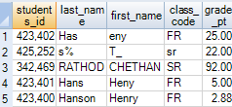

**select** * **from** student_table **where** grade_pt= ANY (2.0,3.0,4.0)**;**



**select** * **from** student_table **where** grade_pt **NOT**= **ALL** (2.0,3.0,4.0)**;**

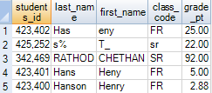

**select** * **from** student_table **where** grade_pt BETWEEN 2.0 **AND** 4.0**;**

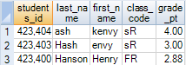

**select** * **from** student_table **where** last_name like 'S%'**;**



**select** * **from** student_table **where** last_name LIKE ANY( '%e%','%n%')**;**

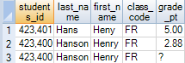

**select** * **from** student_table **where** last_name LIKE **ALL**( '%a%','%n%')**;**

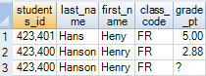

**select** * **from** student_table **where** last_name LIKE '%n'**;**



**select** * **from** student_table **where** TRIM(last_name) LIKE '%n'**;**



**select** * **from** student_table **where** first_name LIKE 's@%' **escape** '@'**;**



**select** * **from** student_course_table **SAMPLE** 9**;**

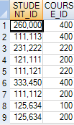

**select** * **from** student_course_table **SAMPLE** .25**;**

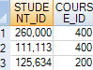

**select** student_id,course_id,**SAMPLEID** **from** student_course_table **sample** 5,6,7 **order** **by** 3,1,2**;**

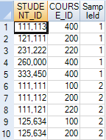

**select** student_id,course_id,**SAMPLEID** **from** student_course_table **sample** **with** **replacement** 2,2,2 **order** **by** 3,1,2**;**

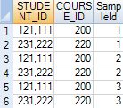

**select** student_id,course_id,**SAMPLEID** **from** student_course_table **sample** **randomized** **allocation** .1,.1,.1,.1**;**

