1)

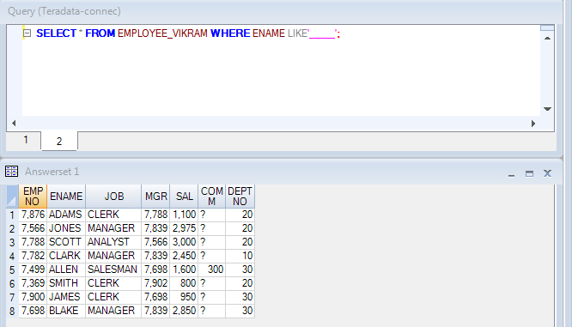

2)

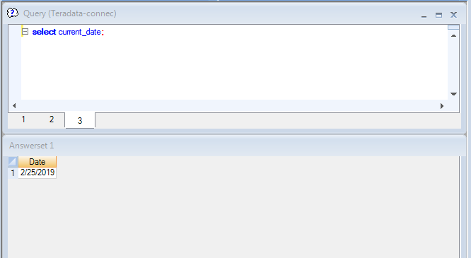

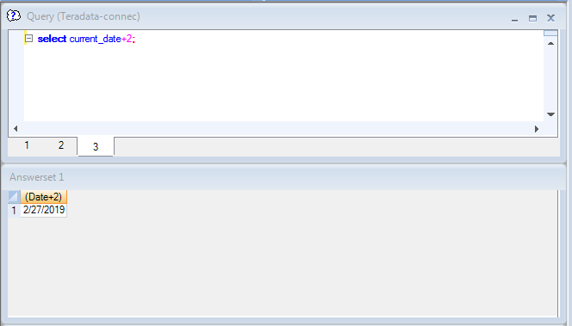

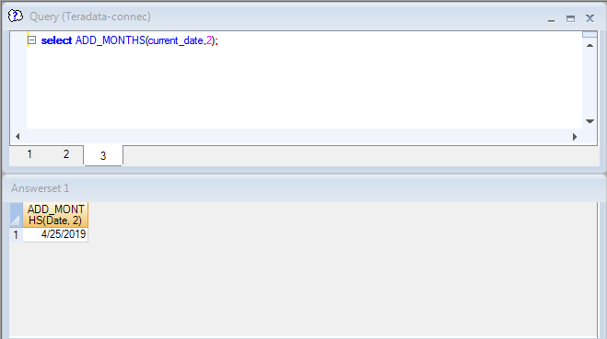

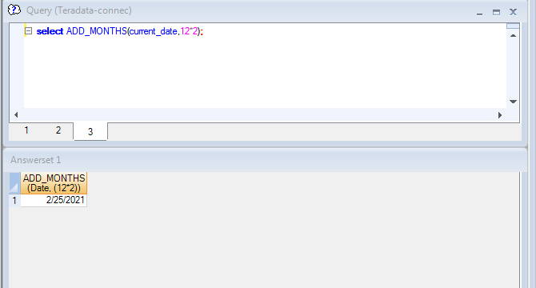

3)

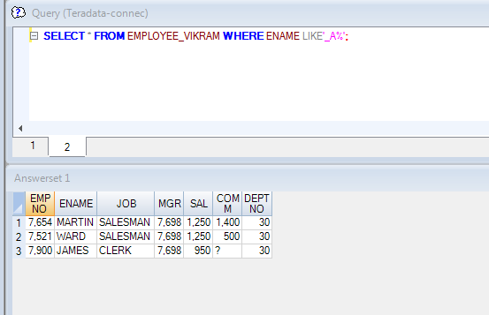

4) 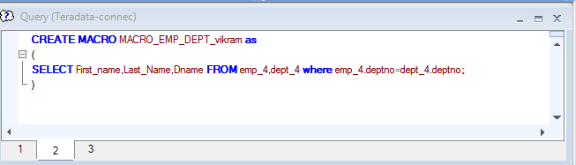

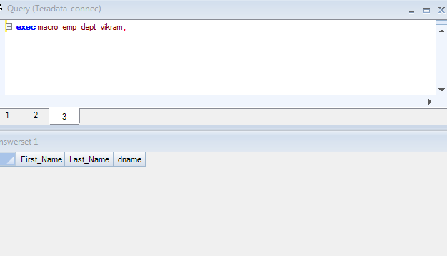

5)

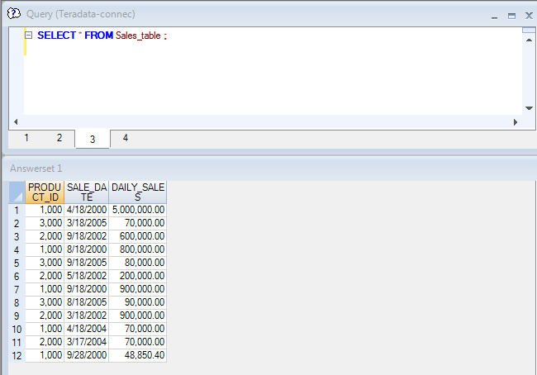

EVEN NUMBERED

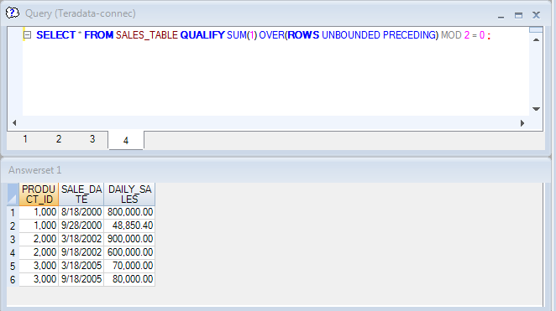

ODD NUMBERED

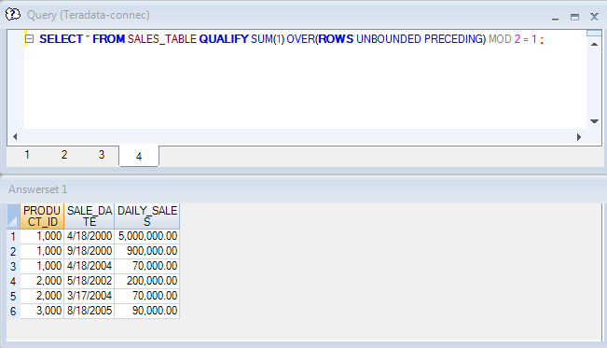

6)

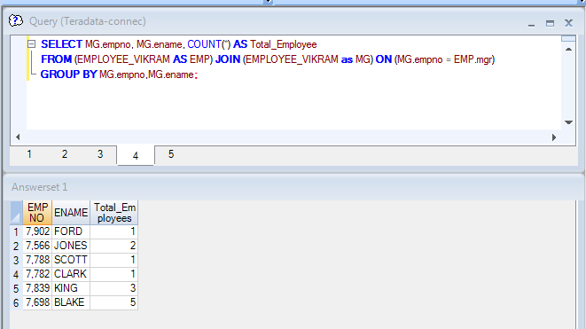

7)

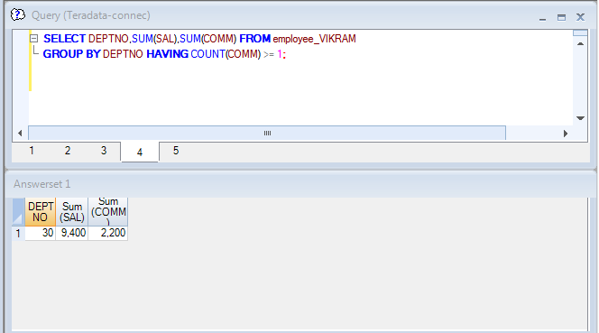

8)

A-1

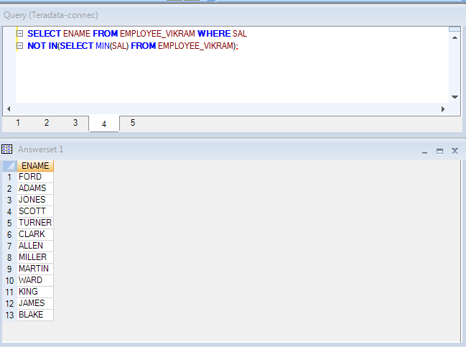

A-3



A-4

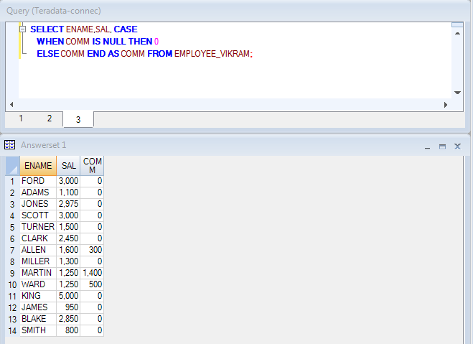

9)

10,ACCOUNTS

10,SALES

20,HR

20,PRODUCTS

.logtable td_bim_fr_trng_db.dept_log696;

.logon 10.58.0.66/TD_USER24,TD_USER24;

.begin mload tables dept_10,dept_20

worktables wt_dept_10,wt_dept_20

errortables

er_dept_10_696 uv_dept_10_696,

er_dept_20_696 uv_dept_20_696;

.layout record_layout;

.field deptno * varchar(5);

.field dname * varchar(30);

.dml label insert_values_dept_10;

insert into dept_10_696((CAST(:DEPTNO as integer)),:DNAME);

.dml label insert_values_dept_20;

insert into dept_20_696((CAST(:DEPTNO as integer)),:DNAME);

.import infile 'C:\Teradata_practice\dept_multi.txt'

format vartext ','

layout record_layout

apply insert_values_dept_10 where DEPTNO =10

apply insert_values_dept_20 where DEPTNO =20;

.end mload;

.logoff;

