PRACTICAL NO. 2: SMART HOME SIMULATION
Name :Gauri Dnyaneshwar Ranade
PRN: 202503040005
- Title
Simulate Smart Home using Cisco Packet tracer.
- Objectives
• To design a Smart Home system using Cisco Packet Tracer.
• To connect sensors and actuators through a home gateway.
• To simulate communication between IoT devices.
• To automate basic home functions like light and fan control.
• To understand real-time monitoring and control in IoT systems.
Problem Statement
Design a smart home system that enables remote monitoring and control of household devices using IoT architecture.

- Learning Outcomes
  - Apply IoT concepts in real-world scenarios
  - Analyze communication between IoT devices
  - Create a functional smart home design

- Tools Required
1. Cisco Packet Tracer

- Pre-requisites
  - Basics of IoT architecture
  - Networking fundamentals
  - Device-to-device and device-to-cloud models

- Theory
7.1 Introduction to Smart Home Systems
A Smart Home system is an application of Internet of Things (IoT) technology that enables the automation, monitoring, and control of household devices through a network. It improves convenience, security, and energy efficiency by allowing devices to communicate with each other and with a central system.
A typical smart home architecture consists of different components that work together to create an intelligent environment:

7.2 Components of Smart Home System
A smart home system consists of four major components: 1. Sensors
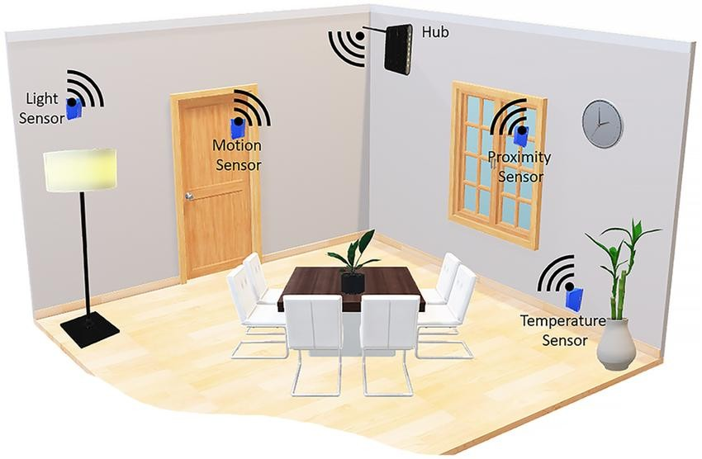
Sensors are input devices that collect data from the environment and send it to the system for processing.
Examples:
- Temperature Sensor – Measures room temperature
- Motion Sensor – Detects movement inside the house
These sensors continuously monitor environmental conditions and trigger actions when specific conditions are met.
- Actuators
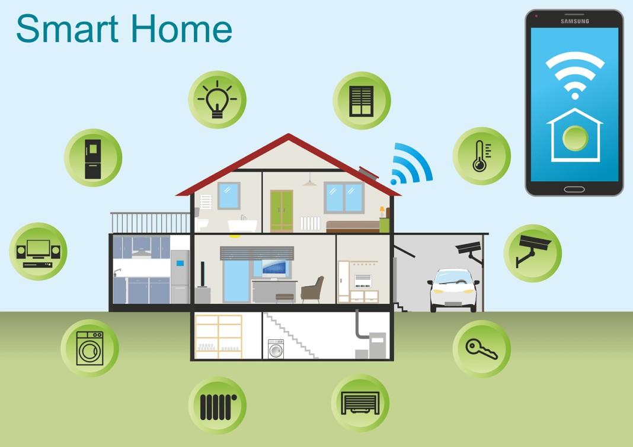
Actuators are output devices that perform actions based on commands received from the system.
Examples:
  - Light – Can be turned ON/OFF remotely
  - Fan – Can be controlled based on temperature
Actuators convert electrical signals into physical actions.

- Gateway (Router/Controller)
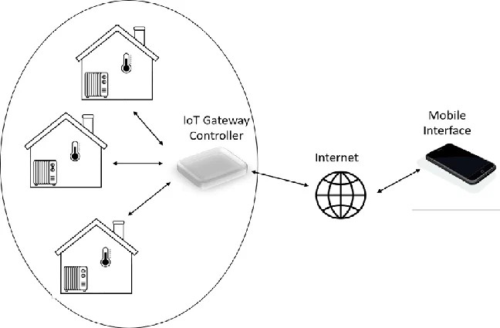

The gateway acts as the central controller of the smart home network.
Functions:
  - Connects all IoT devices
  - Manages communication between devices
  - Provides internet connectivity
  - Acts as a bridge between local devices and the cloud In this project, a wireless router is used as the gateway.

- Cloud / Server
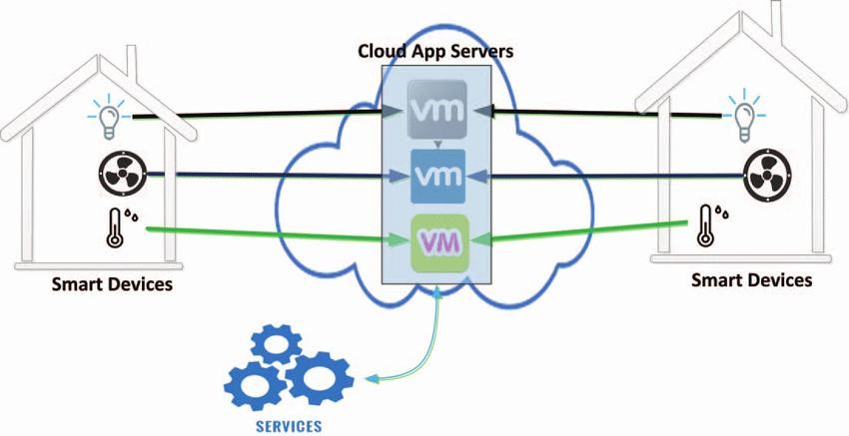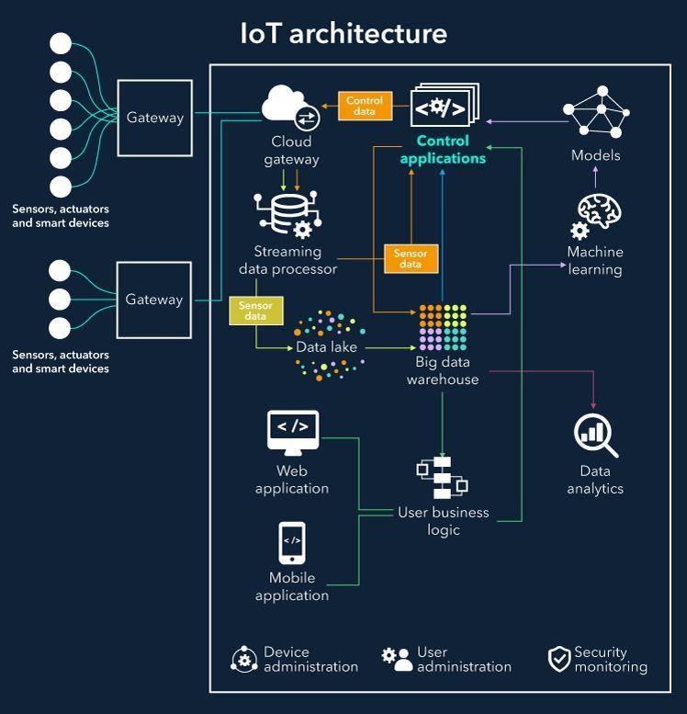

The cloud stores data and enables remote access to the smart home system.
Functions:
  - Data storage
  - Remote monitoring
  - Data analysis
  - Device control via mobile apps
IoT Communication Models
Smart home systems use different communication models:
Device-to-Device (D2D)
In this model, devices communicate directly with each other without a central server.
Example:
  - Motion sensor detects movement → directly turns ON light Advantages:
  - Faster communication
  - Less dependency on internet
Device-to-Gateway
In this model, devices send data to a gateway (router), which processes the data.
Example:
  - Temperature sensor sends data to router → router controls fan Advantages:
  - Better control and management
  - Supports multiple devices
Device-to-Cloud
In this model, devices communicate with cloud servers via the internet.
Example:
  - User controls light using mobile app from anywhere Advantages:
  - Remote access
  - Data storage and analytics
Working of Smart Home System
The working of a smart home system involves the following steps:
  - Sensors collect data from the environment
  - Data is transmitted to the gateway
  - The gateway processes the data or forwards it to the cloud
  - Based on predefined conditions, commands are sent to actuators
  - Actuators perform the required actions
  - Users can monitor and control devices remotely Example:
  - When motion is detected, the system automatically turns ON the light
  - When temperature increases, the fan turns ON
Advantages of Smart Home Systems
  - Remote access and control
  - Energy efficiency
  - Improved security
  - Automation of daily tasks
  - Real-time monitoring
Applications of Smart Home
  - Home automation
  - Security systems (alarms, cameras)
  - Energy management
  - Smart lighting systems
  - Climate control

Conclusion
Smart home systems represent the future of modern living by integrating IoT technology into everyday life. By using sensors, actuators, gateways, and cloud services, users can efficiently monitor and control their homes. This project demonstrates how IoT concepts can be applied to design a functional and intelligent smart home system using simulation tools.

8. Implementation
Step 1: Open Cisco Packet Tracer
- Launch Packet Tracer
- Click New File

Step 2: Add Devices
Add Network Devices
- Go to Network Devices → Wireless Devices and Switch
- Drag:
  - Home Gateway (or Wireless Router) o Switch 2950-24
  - Router WRT 300N wireless router .

o
Step 3: Add Remote Device
- Add:
  - Laptop
(This will be used to control devices remotely)

Step 4: Add Server
- Drag:
  - End devices o Click server
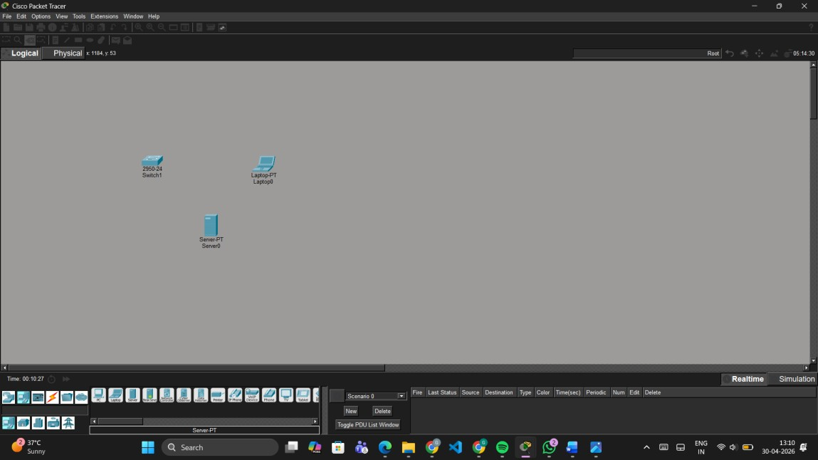

Step 3:
Add IoT actuators

- Add:
o Light
o Fan
o Door lock
o Window
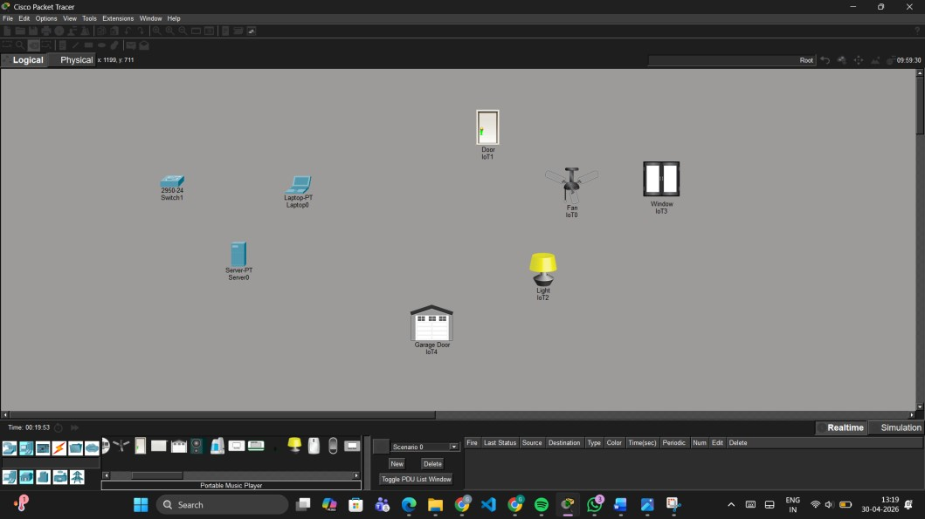
o

Garage door

Step 5: Connect all devices to the gateway using a logical connection.
- Click on the Connections (cable) icon
- select Straight-Through cable to link devices where required.

Click cable ->straight cable -> fast ethernet ->connect to all switch
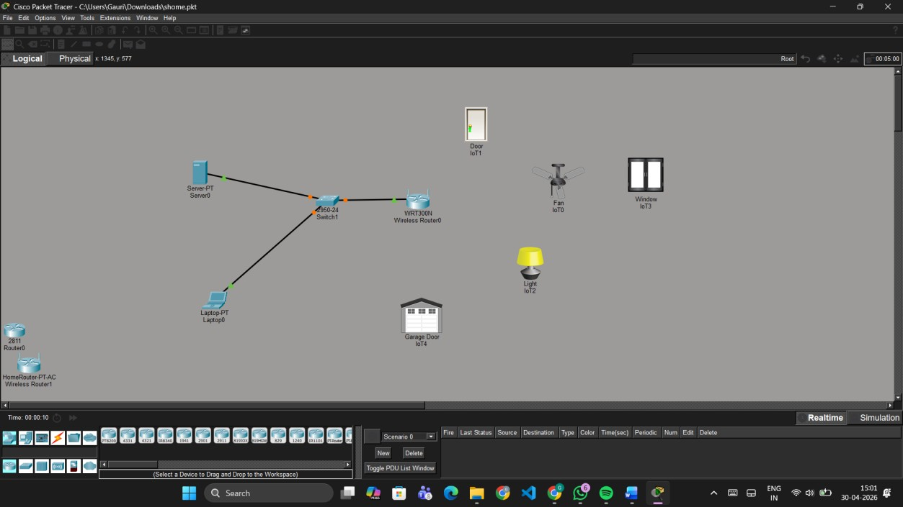

Step 6: add IP Address
1.click server -> desktop
Click IPv4 address → 192.168.0.10
Change default gateway 0.0.0.0 to 192.168.0.1
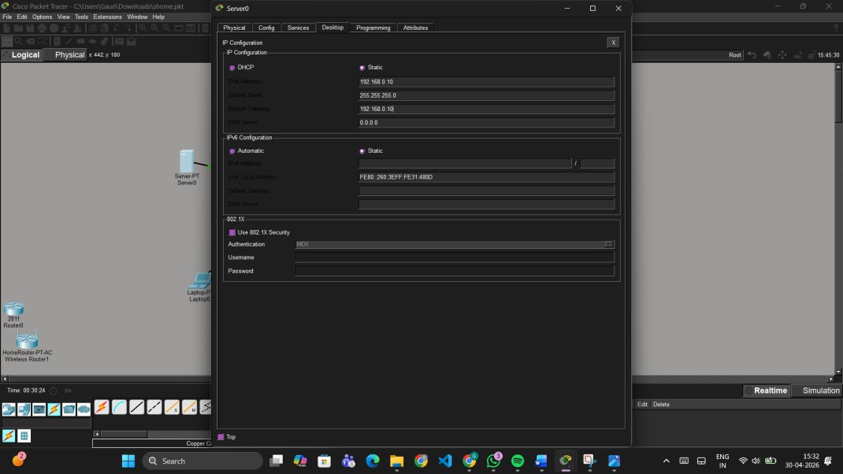

Step 7: add services
1.click server
Click services →click AAA
Client name = Home
Client IP= 192.168.0.10
Secret key = pass123
Click on add
2. add devices user setup username = devices name then password same as name . ex- username=fan and password=fan
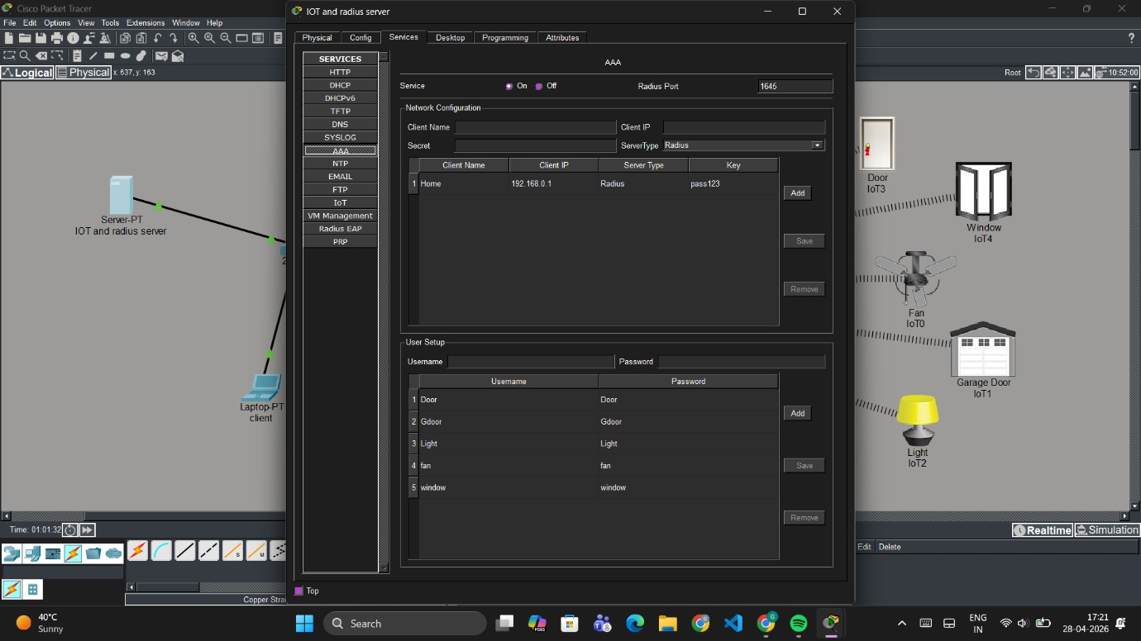
click
→
add

Step 5: Connect IoT Devices to WiFi For EACH device:
- Click device wireless router ->
- Go to Config → Wireless
- Select:
o SSID: default=Home Enter password
→Save setting
Step 6: wireless security
Wireless security →WPA2 Enterprise
Radius server → 192 168 0 10
Shared secret → pass123
Save setting
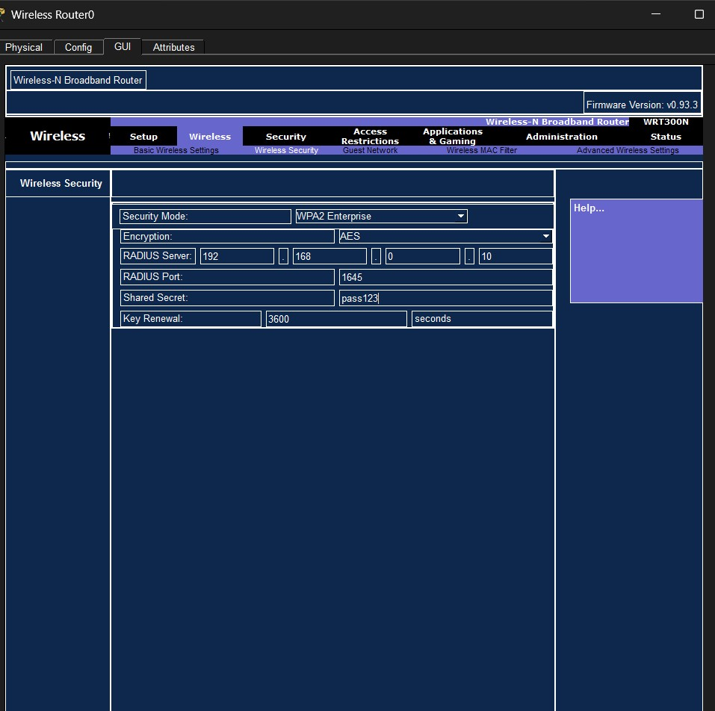
Step 9:
Click on device ex fan
Click on advanced
Click on config →wireless→ SSID=Home
WPA2= UserID and password (fan & fan)
4. Wait until:
Device shows Connected

Step 10 : click on server –>services ->IOT ->registration on
Step 11: click on laptop -> desktop ->IP configuration ->DHCP click

Step 12:click on fan ->config ->remote server ->
Save address :192.168.0.10
Username:admin
Password:admin
For all devices

Step 13: click on laptop ->desktop ->URL ->192.168.0.10
Username:admin
Password:admin then sign in

Step 14: click on laptop
Desktop -> iot monitor
Login

9. Expected Output
