Implementation
Step 1: Open Cisco Packet Tracer
- Launch Packet Tracer
- Click New File

Step 2: Add Devices
Add Network Devices
- Go to Network Devices → Wireless Devices
  - Drag: Home Gateway

o
Step 3: Add Remote Device
- Add:
  - End devices ->SMARTPHONE
(This will be used to control devices remotely)

Step 4: add lown sprinkler
Water level management

step 5: set password for home gateway
configuration->wireless-> copy SSID
tick onWPA2-PSK -> getconnect
step 6: click lowSprinkler1-> cheng name ->tick on home gateway -> advanced
IO cnfig-> NetworkAdapter =PT-IOT-NM-1W
->config-> wireless ->WPA2-PSK -> set password = getconnect

Step 7 : step 6: click home gateway-> cheng name ->tick on home gateway -> advanced
IO cnfig-> NetworkAdapter =PT-IOT-NM-1W
->config-> wireless ->WPA2-PSK -> set password = getconnect

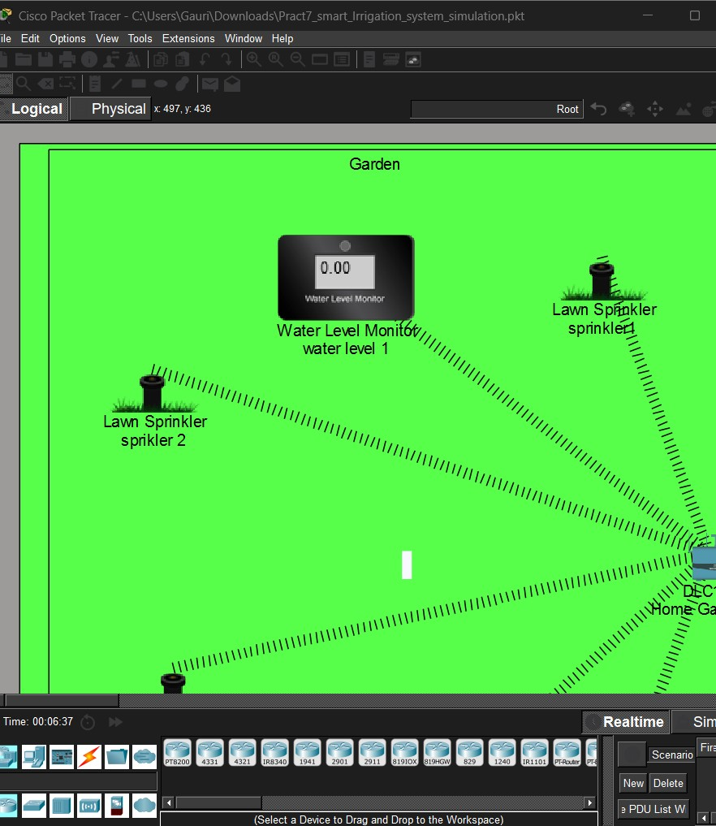

Step 8: click smartphone –>config ->wireless->SSID->HomeGateway
Set password =getconnect
Step 9: click on smartphone ->desktop -> web brower
->URL=192.168.25.1
Username=admin
Password=admin

Step 10 : click on condition
Name : topsprinklerOn
Water level 1 ->water level-><5 cm then set sprinkler 1 status to be true
set sprinkler 2 status to be true click okk
Name : topsprinklerOn
Water level 1 ->water level-> >5 cm then set sprinkler 1 status to be false
set sprinkler 2 status to be false click okk
Name : bottomsprinklerOn
Water level 2 ->water level-><5 cm then set sprinkler 3 status to be true
set sprinkler 3 status to be true click okk
Name : bottomsprinklerOn
Water level 2 ->water level-> >5 cm then set sprinkler 3 status to be false
set sprinkler 3 status to be false click okk

9. Expected Output
