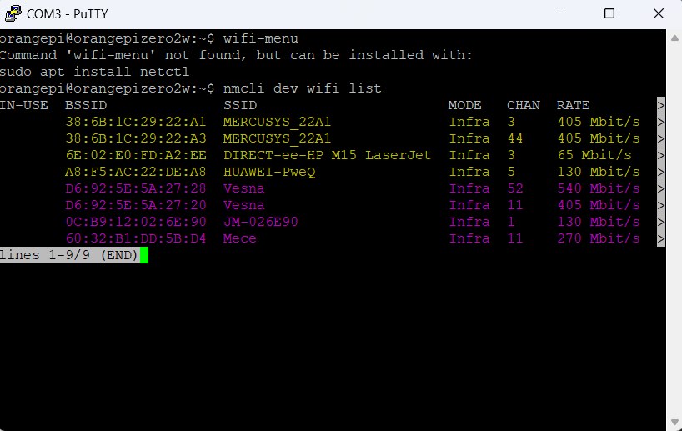

nmcli con modify WiFi wifi-sec.key-mgmt wpa-psk

nmcli con modify WiFi wifi-sec.psk myownpassword