OSDP Access Controller Proof of Concept
Databases II Course Project
Student / Team Members: Martin Velichkovski
Faculty: CNS
Mentor: Dijana Capeska Bogatinoska, Ph.D.
May 2026
Table of Contents

1 Abstract
This project presents the design and implementation of a MongoDB-backed proof of concept for an OSDP access controller and reader test bench. The system combines a Raspberry Pi 3B, a custom STM32 Blue Pill bridge, an RS-485 physical layer, relay-driving hardware, a Flask and Socket.IO backend, a React operator interface, and a MongoDB database named osdp_access. The database stores users, credentials, schedules, reader state, raw events, access decisions, and system diagnostics.
The project is suitable for the Databases II course because it uses MongoDB as a real NoSQL database in a nontrivial hardware-software system. Unlike a purely academic CRUD exercise, this project is driven by an actual engineering need: the need for a flexible controller that can be used to test readers during firmware development. The database was designed while the hardware prototype was being physically assembled and while the bridge firmware, backend, and frontend were being debugged.
The report explains the project at three levels. First, it explains the access-control context, OSDP, and the physical prototype. Second, it explains the software architecture: STM32 bridge firmware behavior, backend API logic, frontend UI workflow, and Raspberry Pi deployment. Third, it explains the MongoDB data model in detail, including collections, document structure, indexing, embedding versus referencing decisions, representative queries, and backup and restore tooling. The report also includes annotated commands and code excerpts to show how the implementation works line by line.
Keywords: MongoDB, NoSQL, access control, OSDP, RS-485, STM32 Blue Pill, Raspberry Pi, PyMongo, audit logging, embedded systems

2 1. Introduction

2.1 1.1 Background and Personal Motivation
The idea for this project came directly from practical engineering work. I work as a firmware engineer on access-control readers, and I needed a flexible controller-side tool that could help me test readers during development. Instead of treating the Databases II project as a separate academic assignment with an artificial topic, I used the opportunity to build something that solves a real problem I encounter in practice.
At the same time, I was learning MongoDB and NoSQL data modeling. That made this project a natural fit: I could learn MongoDB by building a real controller platform instead of by creating an isolated toy example. The project therefore became a combination of several parallel efforts:
- building the physical prototype on a breadboard and inside an enclosure,
- wiring and debugging the electronics,
- developing and testing the STM32 bridge firmware,
- designing the MongoDB schema,
- implementing the Flask backend and React frontend,
- deploying the final system on a Raspberry Pi.
This was not only a software exercise. The prototype was physically assembled over two very intense days of soldering, drilling, filing, wiring, flashing firmware, and debugging communication problems. That practical build process strongly influenced the database design because the database had to support real operational questions coming from real hardware.

2.2 1.2 Problem Statement
An access-control reader is only one side of the system. To test a reader correctly, an engineer also needs a controller-side environment that can:
- communicate over the correct field bus,
- send and receive real protocol messages,
- issue commands such as LED, buzzer, relay, identification, capability, and secure-channel requests,
- record card and keypad events,
- keep audit logs of access attempts,
- provide a user interface for configuration and debugging,
- persist data in a database that supports both administrative records and high-volume event logs.
The problem is that these requirements naturally mix structured administrative data and semi-structured operational data. Users, credentials, and schedules are relatively stable. Reader state changes frequently. Raw hardware events are heterogeneous and append-heavy. Diagnostic logs are useful during debugging but do not fit neatly into a fixed relational table set unless the schema becomes verbose and rigid.
This project addresses that problem by using MongoDB as the persistence layer for a real OSDP controller proof of concept.

2.3 1.3 Project Scope
The project includes:
- a MongoDB database for access-control data and logs,
- a Python backend built with Flask and Flask-SocketIO,
- a React frontend for operators,
- a thread-safe serial bridge client in Python,
- a custom STM32 Blue Pill bridge firmware interface,
- hardware deployment on Raspberry Pi,
- backup and restore scripts,
- firmware update support for the STM32 bridge.
The project does not include:
- enterprise identity management or LDAP integration,
- production-grade clustered MongoDB deployment,
- multiple site management or sharding,
- biometric template storage,
- cloud synchronization,
- the full private bridge firmware source in the public release.

2.4 1.4 Objectives
The main objectives of this project are:
- Design a MongoDB schema that matches the access patterns of an access-control controller.
- Persist both stable administrative data and fast-changing field data.
- Support card and PIN workflows with clear audit logging.
- Track reader state separately from raw event history.
- Build a controller test bench for OSDP reader development.
- Connect embedded hardware work with a practical NoSQL database design.
- Demonstrate deployment, backup, restore, and field testing.
- Produce a course project report that explains both the database and the complete system around it.

2.5 1.5 Why This Project Belongs in Databases II
The Databases II project allows a MongoDB or other NoSQL topic. This project fits that requirement well because the database is central to the platform. MongoDB is not used as an afterthought. It is used to model:
- users and credentials,
- schedules and access policy,
- reader state snapshots,
- raw hardware events,
- access decisions,
- system diagnostics,
- operational backup and restore.
The database design is driven by real runtime needs rather than hypothetical sample data. That makes the project a strong NoSQL case study.

3 2. Access Control and OSDP Context

3.1 2.1 What an Access Controller Does
In an access-control system, the reader is not the whole system. A reader is usually the field device placed near the door or gate. It reads a card, keypad input, or some other credential. The controller or control panel is the side that makes the final decision. It decides whether to grant or deny access, logs the attempt, and activates door hardware when needed.
Conceptually, the controller has four responsibilities:
- communicate with one or more field devices,
- know which users and credentials are valid,
- apply business rules such as time schedules and allowed doors,
- generate output actions such as unlock relay, LED patterns, and buzzer feedback.
This project implements that controller role as a proof of concept.

3.2 2.2 Why a Reader Test Controller Is Valuable
When developing access-control readers, it is often not enough to test them with a limited desktop tool or a protocol sniffer. A firmware engineer also needs a controller-side environment that behaves like a real panel. That means:
- the reader can be polled,
- secure channel can be attempted,
- LED and buzzer commands can be observed,
- keypad and card events can be captured,
- reader identification and capabilities can be requested,
- communication problems can be logged and analyzed.
The idea behind this project was therefore not only academic. It was driven by the practical need for a reusable test controller during reader firmware development.

3.3 2.3 What Is OSDP
The Open Supervised Device Protocol, or OSDP, is an access-control communication standard maintained by the Security Industry Association. The SIA describes OSDP as an open standard that improves interoperability among access-control and security products and supports secure-channel operation with AES-128 protection. OSDP is used between a control panel and peripheral devices such as readers.
In practical terms, OSDP gives the system several advantages over older one-way or lower-security interfaces:
- bidirectional communication,
- richer device control,
- reader supervision and status reporting,
- better interoperability,
- secure channel support,
- simpler field wiring through RS-485 multidrop communication.

3.4 2.4 OSDP Terms Used in This Project
Several OSDP terms appear throughout this project:
- CP: Control Panel. In this project, the controller side is the Raspberry Pi plus the STM32 bridge.
- PD: Peripheral Device. In this project, the reader under test is the PD.
- RS-485: The differential physical layer used for field communication.
- Secure Channel: The OSDP encryption and authentication mode.
- SCBK: Secure Channel Base Key used to establish secure communication.
- COMSET: A command used to change communication settings.
- PDID and PDCAP: Identification and capability responses from the reader.

3.5 2.5 Why OSDP Instead of Legacy Wiegand-Style Thinking
OSDP is important because it supports real command and response behavior. A controller can ask the reader for identity, capabilities, or status. It can trigger LEDs, buzzers, and other functions. It can also attempt secure channel and supervise communication health. That makes OSDP much better for testing advanced reader behavior than a purely one-way credential output interface.

4 3. Full System Overview

4.1 3.1 System Architecture
The project is best understood as a full stack embedded-access-control system. The following figure shows the main runtime architecture.
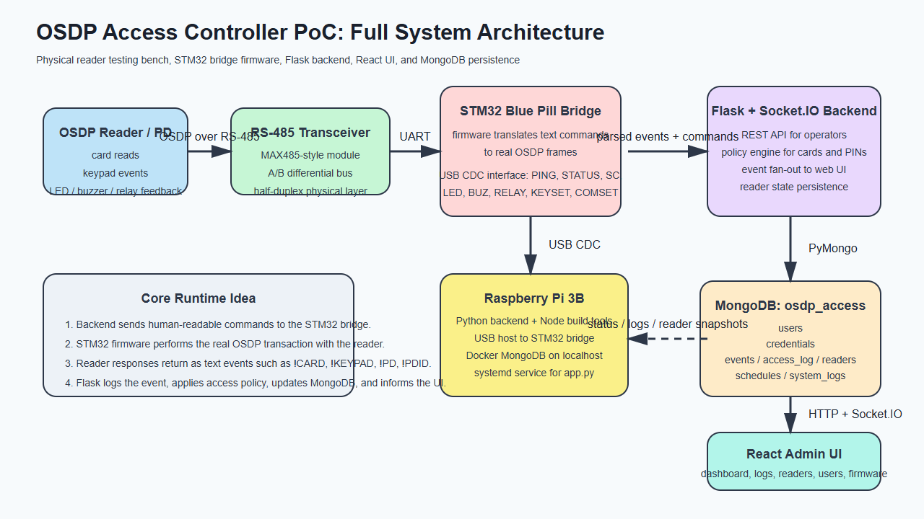
Full system architecture
The architecture has five major layers:
- the reader under test,
- the RS-485 electrical interface,
- the STM32 Blue Pill bridge firmware,
- the Raspberry Pi application stack,
- the MongoDB database and browser UI.
The key idea is that Python does not generate raw OSDP frames directly. Instead, the STM32 firmware handles the field protocol and exposes a simpler text-based interface over USB CDC. The Flask backend sends commands such as PING, STATUS, SC 0, LED 0 ..., or BUZ 0 ..., and the STM32 bridge returns text events such as !CARD, !KEYPAD, !PD, and !PDID.

4.2 3.2 Hardware Stack and Prototype Build
The hardware prototype is built from a Raspberry Pi 3B, an STM32 Blue Pill board, RS-485 transceiver hardware, power conversion hardware, and a relay-driving stage.
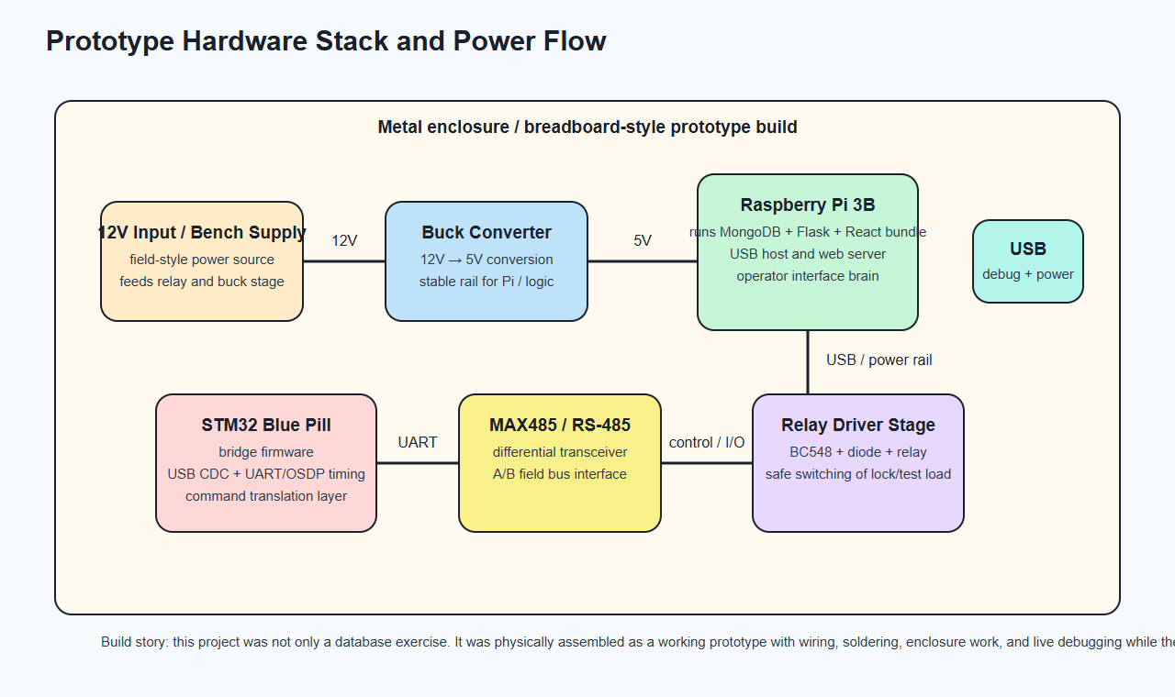
Prototype hardware stack
The physical build process matters because the software was developed against the real prototype, not against a simulated environment. This affected many design decisions:
- the backend had to survive USB reconnects,
- the database had to persist unstable field events for debugging,
- the Pi deployment script had to be practical on real ARM hardware,
- power and signal wiring needed to be reflected in the system explanation.

4.3 3.3 RS-485 and MAX485-Style Interface
OSDP is usually carried over RS-485. In this project, a MAX485-style transceiver module converts the STM32 UART signals into the differential A/B bus used by the reader.
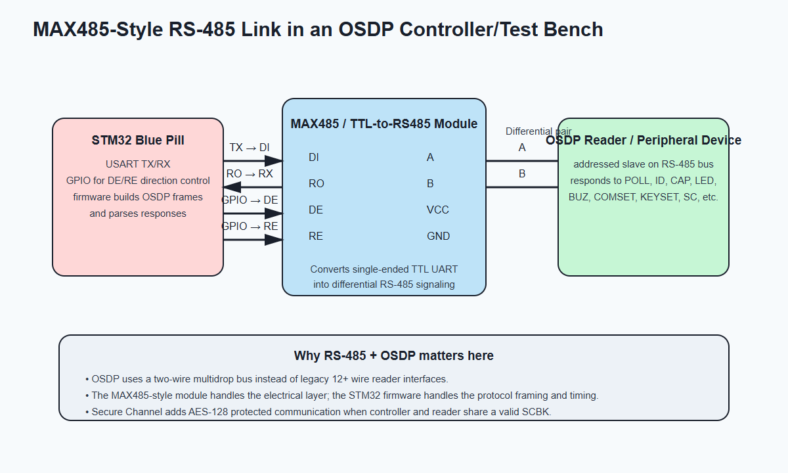
MAX485 style RS-485 path
The RS-485 layer matters because it is where electrical communication becomes field communication. The STM32 firmware is responsible for:
- controlling direction on the half-duplex bus,
- formatting OSDP frames at the protocol level,
- timing requests and responses correctly,
- translating hardware results back into textual events for the Raspberry Pi.

4.4 3.4 Relay Driver Stage with BC548
Small embedded access-control prototypes often use a transistor stage to control a relay from logic-level outputs. The following figure shows the concept relevant to this project.
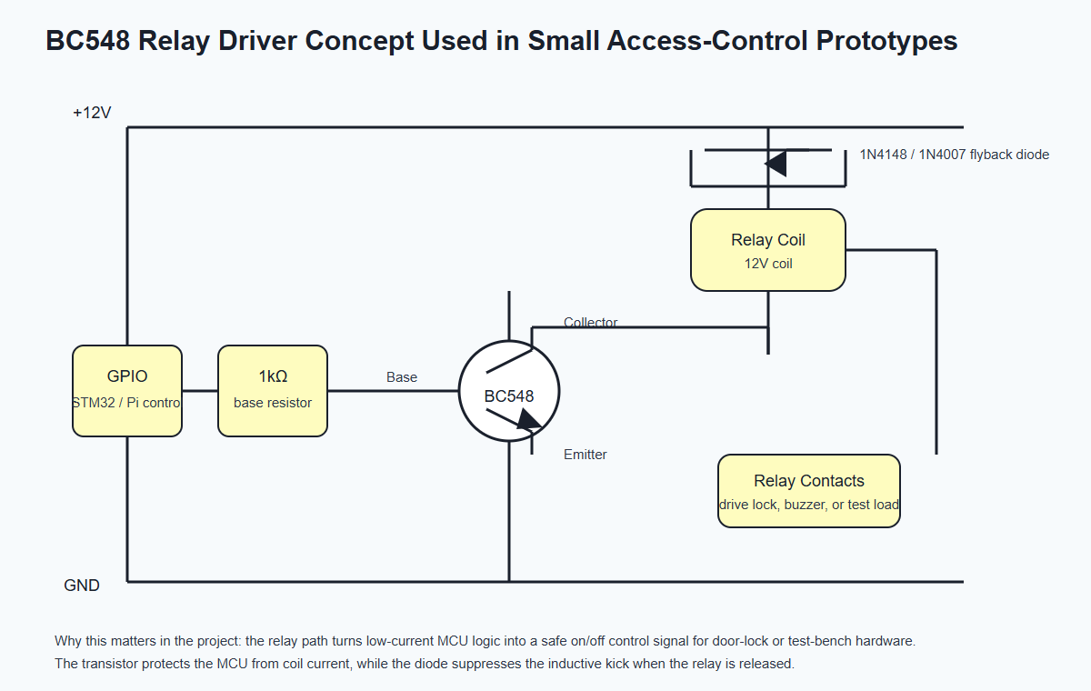
BC548 relay driver concept
The relay driver stage exists because a microcontroller output pin cannot safely drive a relay coil directly. The transistor provides current gain, and the flyback diode protects the circuit from the voltage spike generated when the relay turns off.

4.5 3.5 Visual Reference Notes
I prepared the report using original technical diagrams so the document remains self-contained and safe to redistribute. For external component photos, the following reference pages are useful:
- STM32 Blue Pill style board image reference: Wikimedia Commons board photo
- Buck converter module image reference: Wikimedia Commons LM2596 module photo
- Raspberry Pi family board image reference: Wikimedia Commons Raspberry Pi board photo
The deployed system itself uses a Raspberry Pi 3B. The external Raspberry Pi reference above is a representative family board image rather than the exact photographed unit.

5 4. Hardware and Firmware Design

5.1 4.1 Raspberry Pi 3B Role
The Raspberry Pi 3B is the main application computer in the prototype. It runs:
- the Python backend,
- the built React frontend,
- the MongoDB database in Docker,
- the systemd service used for automatic startup.
The Raspberry Pi was a useful choice because it is inexpensive, physically small, Linux-based, and realistic for a controller proof of concept.

5.2 4.2 STM32 Blue Pill Role
The STM32 Blue Pill acts as the protocol bridge. Its job is to sit between the Raspberry Pi and the reader and translate between two worlds:
- the Raspberry Pi speaks high-level ASCII commands over USB CDC,
- the reader speaks OSDP over RS-485.
This design keeps the Python backend simpler. Instead of making Python deal with low-level frame timing and bus direction switching, those responsibilities stay inside the embedded firmware.

5.3 4.3 What the Public Python Code Reveals About Firmware Behavior
The full private bridge firmware source is not part of the public repo, but its behavior is visible through the public Python interface. bridge.py shows the firmware command surface clearly. The backend sends commands such as:
- PING
- STATUS
- ID <idx>
- CAP <idx>
- LSTAT <idx>
- SC <idx>
- KEYSET <idx> <key>
- LED <idx> ...
- BUZ <idx> ...
- RELAY <idx> ...
The bridge then emits text events such as:
- !CARD
- !KEYPAD
- !STATE
- !PD
- !PDID
- !PDCAP
- !LSTAT
- !NAK
- !COM
This already tells us the firmware has three major responsibilities:
- implement transport between USB CDC and RS-485,
- translate controller requests into OSDP operations,
- normalize reader responses into line-oriented textual events.

5.4 4.4 Firmware Update Path
The project also supports firmware updating of the STM32 bridge through flasher.py. The flashing logic reveals that the Blue Pill has a custom bootloader workflow:
- the application firmware can be asked to reboot into bootloader mode,
- the bootloader enumerates on a different USB PID,
- the host uploads firmware in small chunks,
- the bootloader erases flash, writes the new image, verifies CRC-32, and boots the application.
That is a useful engineering feature because the controller prototype can be updated and improved without additional dedicated hardware every time.

5.5 4.5 Power Path and Buck Converter
The buck converter is important because the prototype combines different voltage domains. A field-style power input such as 12V is common in access control, but the Raspberry Pi and logic circuits typically require 5V. A buck converter therefore steps the voltage down efficiently. Without that stage, the Pi cannot be powered reliably from the field-side supply.

5.6 4.6 Relay Path and Test-Bench Outputs
The relay stage matters because access-control systems ultimately need to switch something in the physical world, such as a lock, strike, buzzer, or test load. Even in a test bench, that makes the system feel like a real controller rather than a passive logger.

5.7 4.7 Engineering Reality of the Prototype
What makes this project stronger than a purely academic database paper is that the hardware and database evolved together. While building the box, wiring the boards, and dealing with USB, power, and serial problems, I also had to think about:
- what should be logged permanently,
- what belongs in raw event history versus current reader state,
- how to record denied-access reasons clearly,
- how to back up the system for redeployment,
- how to expose the system to a frontend without losing field context.

6 5. Backend and Frontend Architecture

6.1 5.1 Backend Overview
The backend is implemented in app.py. It uses Flask for REST endpoints and Flask-SocketIO for real-time updates to the frontend. The backend has several responsibilities:
- connect to MongoDB,
- connect to the serial bridge,
- receive events from the STM32,
- persist important events in MongoDB,
- apply access policy for cards and PINs,
- issue reader feedback commands,
- serve the built frontend.
The code currently exposes more than forty API routes, including routes for users, credentials, schedules, events, system logs, reader commands, and firmware actions.

6.2 5.2 Event Processing Strategy
One of the most important backend design decisions is the use of an event queue between the serial thread and the business-logic path. The bridge thread pushes events into a queue, and a worker thread processes them. This matters because field communication can be bursty, and the database or UI layer must not block the serial read loop.

6.3 5.3 Access Decision Path
When a card arrives, the backend performs the following logic:
- persist the raw card event in events,
- check whether enrollment mode is active,
- if not enrolling, look up the card in credentials,
- load the referenced user from users,
- evaluate active state, allowed readers, and schedule,
- write a result to access_log,
- command relay, LED, and buzzer feedback.
The same policy idea applies to PINs, except the digits first pass through a small keypad accumulation buffer before the final credential lookup.

6.4 5.4 Reader State Tracking
The backend separates historical event logging from current reader state. Instead of reading the current state from the raw event stream every time, the application keeps the readers collection updated via upserts. This makes the dashboard and diagnostics pages much faster and easier to implement.

6.5 5.5 Frontend Overview
The frontend is built with React and Vite. frontend/src/App.jsx shows the top-level navigation and the real-time socket listeners. The interface includes pages for:
- Dashboard
- Readers
- Users
- Enrollment
- Schedules
- Events
- Access Log
- Reader Config
- Comms Monitor
- System Logs
- Terminal
- Firmware Update
This is important for the report because it shows the database is not isolated. Its collections are actively used by a real management interface.

7 6. MongoDB Database Design

7.1 6.1 Why MongoDB Was the Right Fit
MongoDB was a good choice for this project for several reasons.
First, the project stores different types of data with different stability and structure. User documents are stable and predictable. Credentials are slightly more varied. Schedules include embedded arrays. Raw events are heterogeneous. Diagnostic logs can contain optional fields. MongoDB handles this mixture naturally.
Second, MongoDB makes it easy to model data according to access patterns. The official MongoDB modeling guidance emphasizes that data accessed together should be stored together and that embedding or referencing should be chosen according to application behavior. That matches this project well.
Third, the project was evolving quickly while the prototype was being built. A flexible document model helped me iterate without constantly rewriting a rigid schema and migration logic.

7.2 6.2 Database Name and Collections
The database is called osdp_access. The main collections are:
- users
- credentials
- events
- access_log
- readers
- schedules
- system_logs
The model layer is implemented in models.py.

7.3 6.3 Collection Responsibilities

7.3.1 users
Stores each person or operator in the system. Important fields include username, full name, role, active flag, allowed readers, schedule name, and creation timestamp.

7.3.2 credentials
Stores both card and PIN credentials. A credential references a user by user_id. This collection uses references rather than embedding because users can have multiple credentials with independent lifecycles.

7.3.3 schedules
Stores named schedules such as 24/7 and Weekdays 8-18. The schedule periods are embedded because they are small, bounded, and always accessed together.

7.3.4 readers
Stores the latest state of each reader. This includes online/offline information, secure-channel state, tamper, power, and identification data.

7.3.5 events
Stores raw or normalized hardware events. This collection is intentionally flexible because different event types have different fields.

7.3.6 access_log
Stores the final result of access-control decisions and their reasons. This is the key audit collection for understanding why access was granted or denied.

7.3.7 system_logs
Stores internal diagnostics. This is particularly useful while debugging the prototype, deploying on Raspberry Pi, or tracking serial communication issues.

7.4 6.4 Sample Documents

7.4.1 User Document
{
"_id": {"$oid": "665f00000000000000000001"},
"username": "martin",
"full_name": "Martin Velichkovski",
"role": "admin",
"active": true,
"allowed_readers": [0],
"schedule": "24/7",
"created": {"$date": "2026-05-09T10:00:00Z"}
}

7.4.2 Credential Document
{
"_id": {"$oid": "665f00000000000000000010"},
"user_id": {"$oid": "665f00000000000000000001"},
"type": "card",
"card_hex": "04A1B2C3D4",
"card_dec": "19938448340",
"bits": 34,
"format": 0,
"reader": 0,
"enrolled": {"$date": "2026-05-09T10:03:00Z"},
"active": true
}

7.4.3 Schedule Document
{
"_id": {"$oid": "665f00000000000000000020"},
"name": "Weekdays 8-18",
"periods": [
{"days": [0, 1, 2, 3, 4], "start": "08:00", "end": "18:00"}
]
}

7.4.4 Reader Document
{
"_id": {"$oid": "665f00000000000000000030"},
"index": 0,
"addr": 0,
"state": "ONLINE",
"sc": 0,
"tamper": 0,
"power": 0,
"vendor": "E41E0A",
"model": 1,
"serial": "21AA0145",
"firmware": "2.83.0",
"last_seen": {"$date": "2026-05-09T10:15:00Z"}
}

7.4.5 Access Log Document
{
"_id": {"$oid": "665f00000000000000000040"},
"ts": {"$date": "2026-05-09T10:20:00Z"},
"card_hex": "04A1B2C3D4",
"user_id": {"$oid": "665f00000000000000000001"},
"username": "martin",
"granted": true,
"reader": 0,
"reason": "credential matched and schedule allowed"
}

7.5 6.5 Index Strategy
The index strategy in models.py is simple but important.
Collection | Index | Purpose
users | username unique | Prevent duplicates and support quick lookup
credentials | user_id | List credentials for one user
credentials | card_hex | Fast card lookup during access
events | ts descending | Efficient recent-event queries
access_log | ts descending | Efficient recent audit queries
readers | index unique | Exactly one reader snapshot per index
schedules | name unique | Schedule reuse by name
system_logs | ts descending | Efficient recent diagnostic queries

7.6 6.6 Embedding Versus Referencing
The project uses both patterns.
Embedding is used for:
- allowed_readers inside a user document,
- periods inside a schedule document.
Referencing is used for:
- credentials.user_id -> users._id
The rationale is straightforward:
- schedules and reader lists are small and naturally belong with the parent record,
- credentials are independent objects that can be created, revoked, queried, and filtered separately.

7.7 6.7 Business Rules Enforced by the Application
The application currently enforces the following important rules:
- usernames must be unique,
- schedule names must be unique,
- readers are uniquely identified by numeric index,
- disabled users cannot gain access,
- users with empty allowed_readers are allowed on all readers,
- users with a non-empty list are restricted to those readers,
- schedules gate access according to current time,
- raw event history is append oriented,
- access results are append oriented,
- reader state is maintained by upsert rather than append-only logging.

8 7. Implementation Walkthrough with Commands and Code

8.1 7.1 Local Development Commands and What They Mean

8.1.1 Create a virtual environment
python -m venv .venv
Explanation:
- python starts the Python interpreter.
- -m venv tells Python to run the standard-library virtual environment module.
- .venv is the directory where the isolated environment is created.

8.1.2 Install backend dependencies
.venv/bin/pip install -r requirements.txt
Explanation:
- .venv/bin/pip uses the package installer from the project-specific environment.
- install tells pip to install packages.
- -r requirements.txt reads the package list from the requirements file.

8.1.3 Build the React frontend
cd frontend
npm ci
npm run build
Explanation:
- cd frontend enters the frontend project directory.
- npm ci installs exactly the versions recorded in package-lock.json.
- npm run build executes the Vite production build and outputs the files into static/dist.

8.1.4 Run the backend
cd ..
.venv/bin/python app.py
Explanation:
- cd .. returns to the repository root.
- .venv/bin/python uses the Python interpreter from the virtual environment.
- app.py starts the Flask and Socket.IO backend.

8.2 7.2 Raspberry Pi Deployment Command and Line-by-Line Meaning
The most important deployment command is the Docker run used for MongoDB.
docker run -d \
--name osdp-access-mongo \
--restart unless-stopped \
-p 127.0.0.1:27017:27017 \
-v /home/admin/osdp-access-mongo:/data/db \
mongo:4.4.18
Explanation:
- docker run creates and starts a new container.
- -d starts it in detached background mode.
- --name osdp-access-mongo gives the container a stable name.
- --restart unless-stopped makes it restart automatically after reboot unless explicitly stopped.
- -p 127.0.0.1:27017:27017 binds MongoDB only to localhost on the Pi for safer local-only access.
- -v /home/admin/osdp-access-mongo:/data/db stores MongoDB data persistently on the Pi filesystem.
- mongo:4.4.18 chooses the MongoDB image tag.
That version choice matters. During deployment, newer MongoDB images failed on the target Pi because of ARM CPU feature requirements, so the setup was pinned to a compatible version.

8.3 7.3 Backup and Restore Commands and What They Mean

8.3.1 Backup
python backup_mongo.py --mongo-uri mongodb://localhost:27017 --db osdp_access --output-dir backups
Explanation:
- python backup_mongo.py runs the backup tool.
- --mongo-uri mongodb://localhost:27017 tells the script where MongoDB is running.
- --db osdp_access selects the database to export.
- --output-dir backups selects the root folder where the timestamped backup directory will be created.

8.3.2 Restore
python restore_mongo.py backups/mongodb_osdp_access_YYYYMMDD_HHMMSS --mongo-uri mongodb://localhost:27017
Explanation:
- python restore_mongo.py runs the restore tool.
- backups/... is the specific backup directory that contains manifest.json and collection dumps.
- --mongo-uri ... points to the target MongoDB instance.

8.4 7.4 Annotated Code Example: MongoDB Initialization
The following excerpt from models.py is the entry point into the database layer.
def get_db(uri="mongodb://localhost:27017"):
client = MongoClient(uri, serverSelectionTimeoutMS=3000)
db = client[DB_NAME]
_ensure_indexes(db)
return db
Line-by-line explanation:
- def get_db(...): defines a helper that returns the database handle used everywhere else.
- uri="mongodb://localhost:27017" provides a default local MongoDB address.
- MongoClient(uri, serverSelectionTimeoutMS=3000) creates the MongoDB client and fails quickly if the database is not reachable.
- db = client[DB_NAME] selects the osdp_access database.
- _ensure_indexes(db) creates indexes and default schedules automatically.
- return db gives the caller a ready-to-use database handle.
The initialization logic continues with _ensure_indexes():
def _ensure_indexes(db):
db.users.create_index("username", unique=True)
db.credentials.create_index("user_id")
db.credentials.create_index("card_hex")
db.events.create_index([("ts", DESCENDING)])
db.access_log.create_index([("ts", DESCENDING)])
db.readers.create_index("index", unique=True)
db.schedules.create_index("name", unique=True)
db.system_logs.create_index([("ts", DESCENDING)])
Line-by-line explanation:
- db.users.create_index("username", unique=True) prevents duplicate usernames.
- db.credentials.create_index("user_id") accelerates queries for all credentials of one user.
- db.credentials.create_index("card_hex") makes card lookups fast during access decisions.
- db.events.create_index([("ts", DESCENDING)]) makes recent-event pages efficient.
- db.access_log.create_index([("ts", DESCENDING)]) makes audit-log pages efficient.
- db.readers.create_index("index", unique=True) ensures one state document per reader.
- db.schedules.create_index("name", unique=True) prevents duplicate schedule names.
- db.system_logs.create_index([("ts", DESCENDING)]) supports recent diagnostic log queries.

8.5 7.5 Annotated Code Example: Serial Bridge Connection
The bridge connection logic in bridge.py is one of the most important pieces of the project.
def connect(self, port=None, retries=3):
if self.ser and self.ser.is_open and self.connected:
return True
self._cleanup()
port = port or self.find_port()
if not port:
log.warning("No Blue Pill port found")
return False
Line-by-line explanation:
- connect(..., retries=3) attempts to open the bridge with automatic retries.
- The first if avoids reconnecting if the bridge is already usable.
- self._cleanup() clears stale serial state before a new attempt.
- port = port or self.find_port() uses the explicitly provided port or auto-detects the Blue Pill by USB VID and PID.
- If no port is found, the method logs a warning and returns False.
This is important because real USB hardware is unreliable in the field: ports disappear, reconnect, or enumerate differently after reboot.

8.6 7.6 Annotated Code Example: Parsing Bridge Events
The bridge converts raw lines from the STM32 into structured Python dictionaries. A representative example is the card event parser.
m = re.match(r"!CARD (\d+) ([0-9A-Fa-f]+) (\d+) (\d+)", line)
if m:
return {
"type": "card",
"reader": int(m.group(1)),
"hex": m.group(2),
"bits": int(m.group(3)),
"format": int(m.group(4)),
"ts": ts,
"raw": line,
}
Line-by-line explanation:
- re.match(...) looks for a line beginning with !CARD followed by reader number, card hex value, bit length, and format.
- if m: means the parser only continues if the pattern matched.
- "type": "card" normalizes the event into an internal event type.
- "reader": int(...) records which reader generated the card event.
- "hex": ... stores the raw credential value used for lookup or enrollment.
- "bits": ... preserves bit length metadata.
- "format": ... preserves format metadata.
- "ts": ts records a backend-side timestamp.
- "raw": line preserves the original line for diagnostics.
This is a good example of why MongoDB fits the project: different event types naturally carry different fields, and a flexible document model stores them without a complicated rigid schema.

8.7 7.7 Annotated Code Example: Card Access Decision
The access-policy path in app.py is central to the controller logic.
cred = find_credential_by_card(db, ev["hex"])
if cred:
user = get_user(db, str(cred["user_id"]))
name = user["username"] if user else "unknown"
allowed, reason = _check_access_policy(user, reader) if user else (False, "user not found")
if allowed:
log_access(db, card_hex=ev["hex"], user_id=str(cred["user_id"]), username=name,
granted=True, reader=reader, reason=reason)
bridge.relay(reader, "T1500")
bridge.grant_feedback(reader)
Line-by-line explanation:
- find_credential_by_card(...) looks up the presented card in MongoDB.
- if cred: continues only if the card exists and is active.
- get_user(...) loads the user referenced by the credential.
- name = ... safely produces a display name even if the user is missing.
- _check_access_policy(...) applies business rules such as active state, allowed readers, and schedule.
- log_access(...) writes the final audit record into access_log.
- bridge.relay(...) activates the relay for a timed pulse.
- bridge.grant_feedback(...) turns that decision into LED and buzzer behavior at the reader.
This short code path demonstrates the whole idea of the project: field input becomes database lookup, policy evaluation, audit logging, and real physical output.

8.8 7.8 Annotated Code Example: Firmware Flashing
The STM32 flasher in flasher.py is a good example of tooling around the hardware platform.
resp = _send_cmd(ser, "ERASE", timeout=30)
if resp != "OK":
raise RuntimeError(f"Erase failed: {resp}")
for i in range(total_chunks):
offset = i * CHUNK_SIZE
chunk = fw_data[offset : offset + CHUNK_SIZE]
offset_hex = f"{offset:05X}"
data_hex = chunk.hex().upper()
cmd = f"W{offset_hex} {data_hex}"
resp = _send_cmd(ser, cmd, timeout=5)
Line-by-line explanation:
- _send_cmd(ser, "ERASE", timeout=30) instructs the bootloader to erase the application flash region.
- if resp != "OK": checks that the bootloader acknowledged the command.
- for i in range(total_chunks): starts chunked upload of the firmware image.
- offset = i * CHUNK_SIZE computes the byte offset for each block.
- chunk = ... slices the firmware bytes for the current block.
- offset_hex = ... converts the offset into the format expected by the bootloader.
- data_hex = chunk.hex().upper() converts binary bytes into ASCII hex.
- cmd = f"W{offset_hex} {data_hex}" builds the bootloader write command.
- _send_cmd(...) sends the write operation and waits for confirmation.
This tool makes the hardware platform maintainable and is an important part of the engineering completeness of the project.

8.9 7.9 Annotated Raspberry Pi Setup Script
The Raspberry Pi deployment script in scripts/setup_raspberry_pi.sh is worth understanding because it turns the project into a reproducible platform.
ROOT="$(cd "$(dirname "${BASH_SOURCE[0]}")/.." && pwd)"
MONGO_URI="${MONGO_URI:-mongodb://localhost:27017}"
MONGO_IMAGE="${MONGO_IMAGE:-mongo:4.4.18}"
Line-by-line explanation:
- ROOT=... computes the repository root directory automatically.
- MONGO_URI=... defines the MongoDB connection string, with a default value if none is provided.
- MONGO_IMAGE=... allows the script to override the Docker image while defaulting to a Pi-compatible tag.
Later in the script, the database container is created, the Python environment is prepared, the frontend is built, and the app is registered as a systemd service. That makes the deployment path self-documenting and repeatable.

9 8. Representative MongoDB Queries and Reports

9.1 8.1 Find All Active Users
db.users.find(
{ active: true },
{ username: 1, full_name: 1, role: 1, schedule: 1 }
).sort({ username: 1 })
This query retrieves currently active users, sorted alphabetically.

9.2 8.2 Find Credentials for a Specific User
db.credentials.find({
user_id: ObjectId("665f00000000000000000001"),
active: true
}).sort({ enrolled: -1 })
This query is useful in the UI when reviewing or revoking user credentials.

9.3 8.3 Retrieve the Latest Reader State
db.readers.find().sort({ index: 1 })
This query feeds the reader dashboard with current state snapshots instead of parsing the whole event history.

9.4 8.4 Count Events by Type
db.events.aggregate([
{ $group: { _id: "$type", count: { $sum: 1 } } },
{ $sort: { count: -1 } }
])
This query is useful when analyzing whether the system is mostly seeing card traffic, keypad traffic, status updates, or configuration events.

9.5 8.5 Count Denied Access Reasons
db.access_log.aggregate([
{ $match: { granted: false } },
{ $group: { _id: "$reason", count: { $sum: 1 } } },
{ $sort: { count: -1 } }
])
This query is valuable operationally because it explains why the system is denying access: disabled users, outside schedule, reader not allowed, unknown card, or unknown PIN.

9.6 8.6 Count Access Attempts Per Reader
db.access_log.aggregate([
{ $group: { _id: "$reader", attempts: { $sum: 1 } } },
{ $sort: { attempts: -1 } }
])
This query helps analyze which reader is most active on the test bench or in future multi-reader deployments.

10 9. Deployment, Testing, and Development Story

10.1 9.1 Local Validation
The project was validated locally through:
- backend startup tests,
- reader connection tests,
- interactive OSDP workflow tests,
- MongoDB backup generation,
- MongoDB restore validation,
- frontend build validation.

10.2 9.2 Raspberry Pi Deployment
The project was also deployed on a Raspberry Pi. This was important because it moved the project from a desktop development setup into a more controller-like environment.
During deployment, two real engineering issues appeared:
- newer MongoDB container images were incompatible with the Pi CPU,
- Flask-SocketIO required explicit allow_unsafe_werkzeug=True for the current deployment approach.
Those issues were fixed, documented, and folded back into the repository. That is a strong example of why real-world database work is inseparable from deployment and operations.

10.3 9.3 Current Working Result
At the time of writing:
- the system runs on the Pi,
- MongoDB is running in Docker,
- the frontend is served successfully,
- the backend responds on HTTP,
- the bridge connects to the STM32,
- the reader is visible and reporting status,
- data backup and restore work.

10.4 9.4 Personal Engineering Reflection
This project ended up being much more than a database assignment. The database work was learned and applied in parallel with hardware assembly and embedded debugging. That made the learning process more demanding but also much more meaningful. Instead of memorizing NoSQL concepts in isolation, I applied them while building a physical controller, wiring boards, debugging reader communication, and trying to create something I can actually use as an engineer.
That is why the project feels real: it was built under time pressure, with physical hardware, incomplete documentation, firmware iteration, Linux deployment issues, database modeling choices, and the need to keep everything working together.

11 10. Conclusion
This project demonstrates a practical MongoDB application in the domain of access control and embedded systems. The OSDP Access Controller PoC is not only a database model; it is a complete hardware-software platform that uses MongoDB as its operational memory, audit trail, and administrative data store.
The project also shows why MongoDB was a good choice. The system needed to store stable administrative documents, append-heavy event logs, flexible device telemetry, and diagnostic records. MongoDB handles this combination naturally. The final schema is easy to extend, easy to query, and aligned with the access patterns of the application.
From an educational perspective, the project achieved exactly what a Databases II project should achieve: it used a NoSQL database in a meaningful context, applied core design ideas such as embedding versus referencing and index planning, implemented queries and data operations in code, and connected the database to a real application stack. From an engineering perspective, it also produced a useful controller test platform for reader development.
Future work could include formal MongoDB schema validation, richer aggregation dashboards, multi-reader topologies, long-term log archival, and a more production-grade WSGI or ASGI deployment path. Even in its current form, however, the project already functions as both an academic NoSQL project and a practical engineering tool.

12 11. References
- Security Industry Association. “Open Supervised Device Protocol (OSDP).” https://www.securityindustry.org/industry-standards/open-supervised-device-protocol/
- MongoDB Documentation. “Data Modeling in MongoDB.” https://www.mongodb.com/docs/manual/core/data-model-design/
- PyMongo Documentation. https://pymongo.readthedocs.io/
- Flask-SocketIO Documentation. https://flask-socketio.readthedocs.io/
- pySerial Documentation. https://pyserial.readthedocs.io/
- README.md, repository overview and deployment notes.
- docs/PROTOCOL.md, OSDP protocol and project flow notes.
- docs/HANDOFF.md, operational handoff summary.
- models.py, MongoDB model implementation.
- bridge.py, USB bridge client and event parser.
- app.py, backend API and access policy implementation.
- flasher.py, STM32 firmware flashing tool.
- scripts/setup_raspberry_pi.sh, Raspberry Pi deployment workflow.
- GitHub repository: https://github.com/evilcomputer12/osdp-acess-controller-poc

13 Appendix A: Important Files in the Project
File | Role
app.py | Main backend entrypoint
bridge.py | Serial bridge client and event parser
models.py | MongoDB model helpers
flasher.py | STM32 bridge firmware updater
backup_mongo.py | Database export tool
restore_mongo.py | Database import tool
run.sh | Linux build and run helper
scripts/setup_raspberry_pi.sh | Raspberry Pi installer
frontend/src/App.jsx | Top-level React application shell

14 Appendix B: Notes for Final Submission
Before submitting the final Word or PDF version, the following can be customized if needed:
- team members and student IDs,
- exact mentor line,
- insertion of the final prototype photo if desired,
- conversion to PDF if Moodle prefers PDF,
- addition of any lecturer-specific formatting requirements.

