Required: Installation of TortoiseGit Ref: <http://code.google.com/p/tortoisegit/>

Required: Installation of Microsoft Access 2010

Required: Installation of OASIS Ref: <http://dev2dev.de/oasis.html>

Create source code folder e.g. 🡺 C:\ae\aegit\src

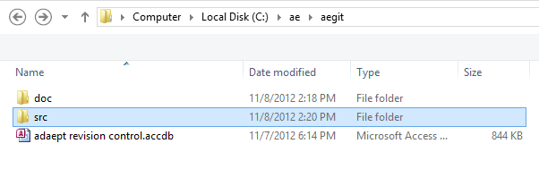

Create an empty repository in the source code folder

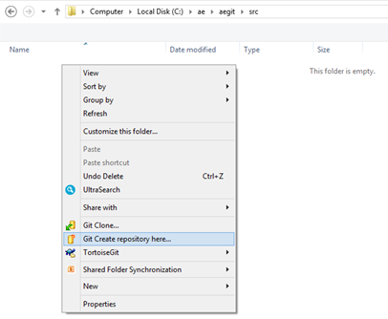

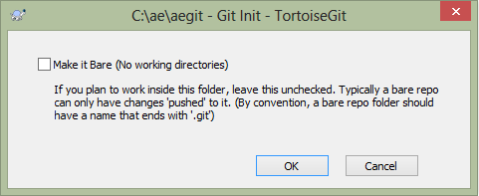

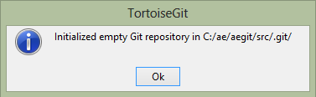

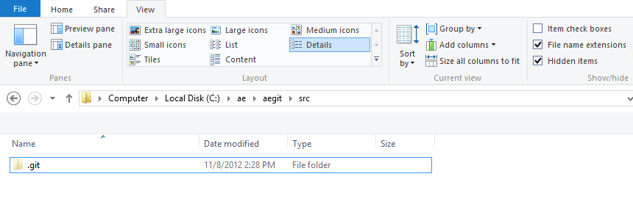

The source code repository is shown to be under revision control by the green check mark added to the folder icon:

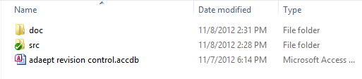

Open the database (e.g. **adaept revision control.accdb**) click on **OASIS-SVN** 🡺 **Settings 🡺 Settings** then set the source folder location and other options as desired:

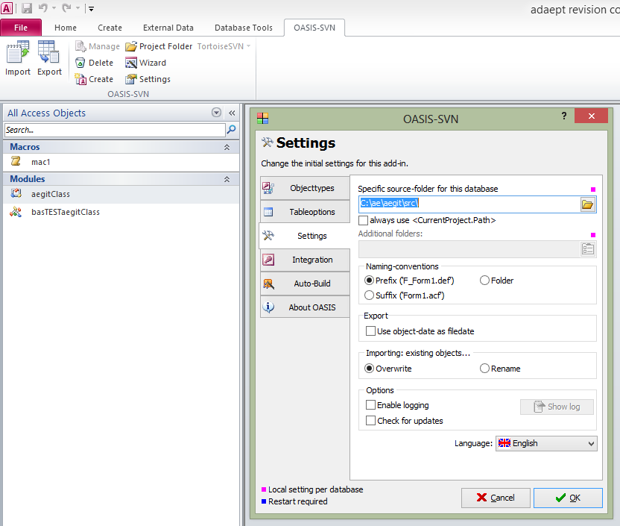

Select the Object Types tab and check the objects for revision control:

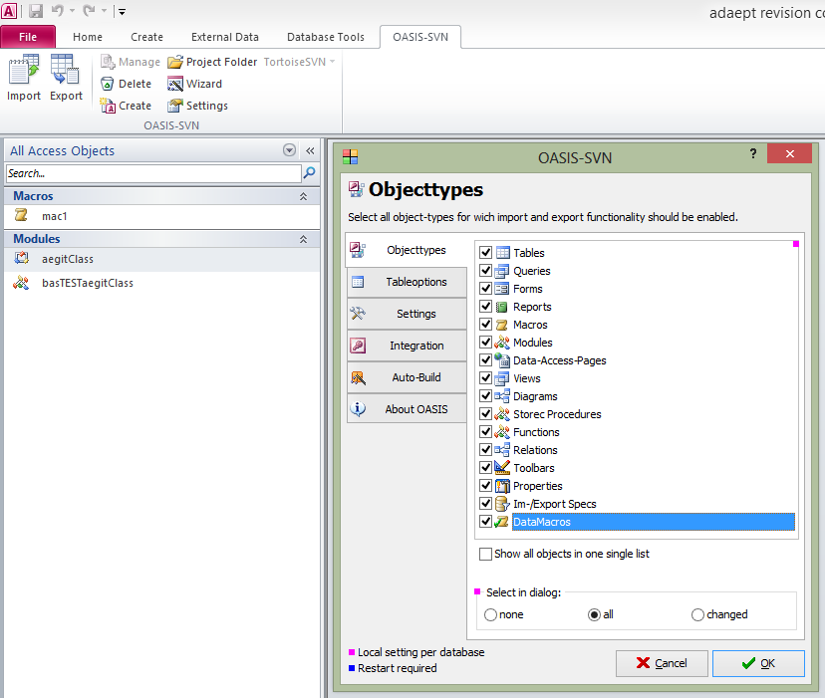

Click on **Project Folder** and it will open to the source code repository location:

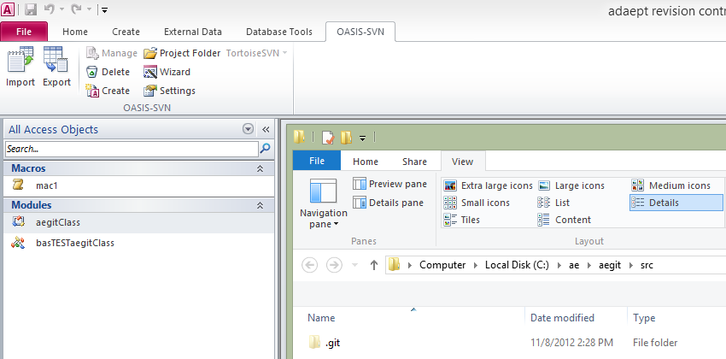

Click **Export**:

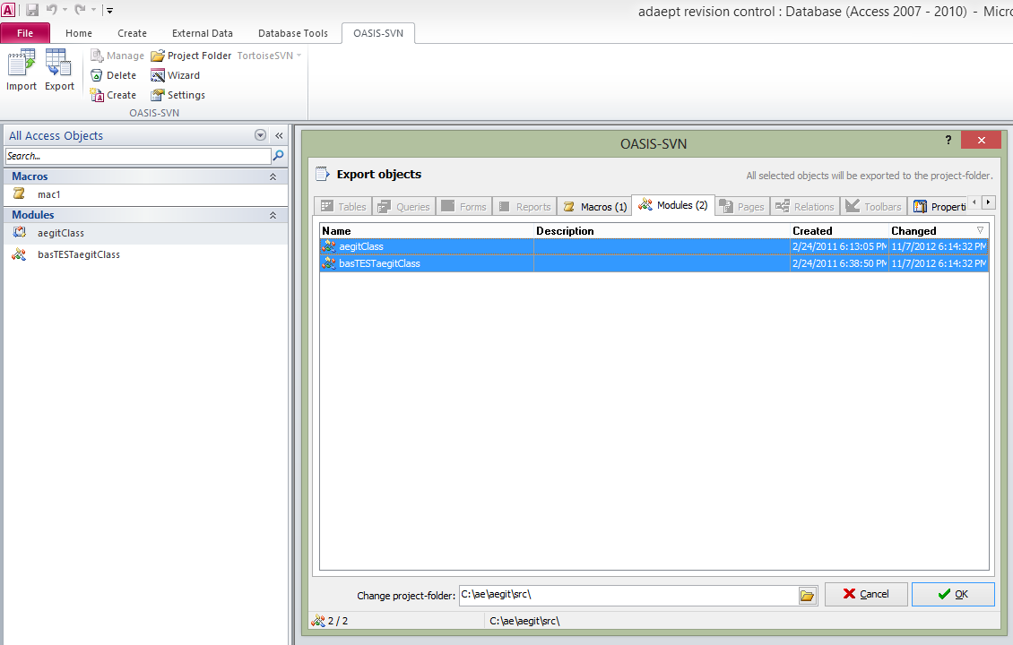

The files can be seen in the source code repository folder and managed with TortoiseGit or any other Windows git client:

