Required: Installation of TortoiseGit Ref: <http://code.google.com/p/tortoisegit/>

Required: Installation of Microsoft Access 2010

Required: Installation of OASIS Ref: <http://dev2dev.de/oasis.html>

Create source code folder e.g. 🡺 C:\ae\aegit\src

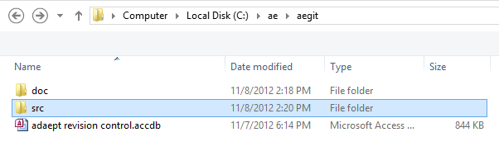

Create an empty repository in the source code folder

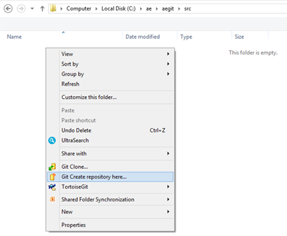

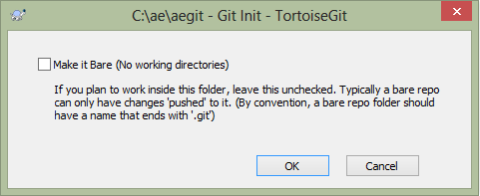

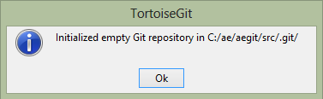

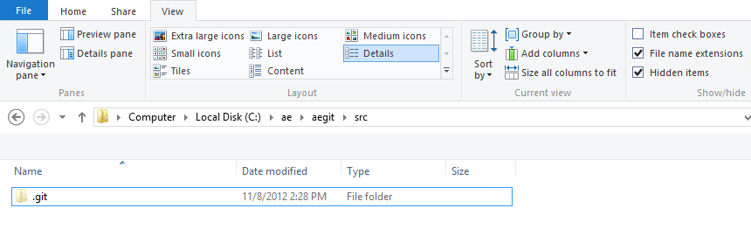

The source code repository is shown to be under revision control by the green check mark added to the folder icon:

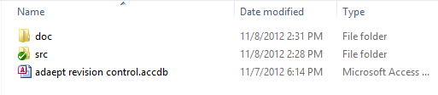

Open the database (e.g. **adaept revision control.accdb**) click on **OASIS-SVN** 🡺 **Settings 🡺 Settings** then set the source folder location and other options as desired:

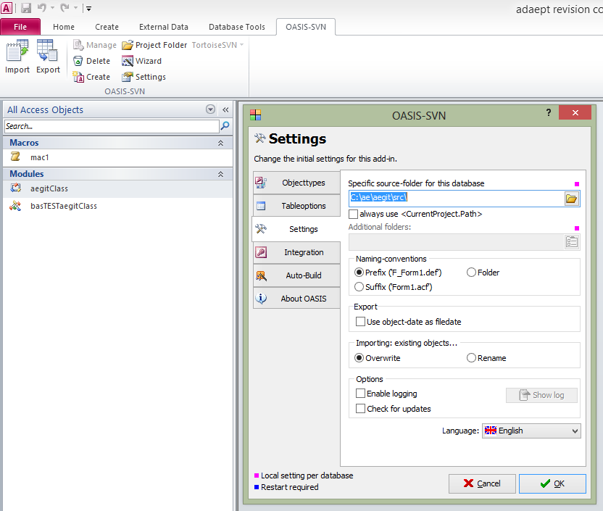

Select the Object Types tab and check the objects for revision control:

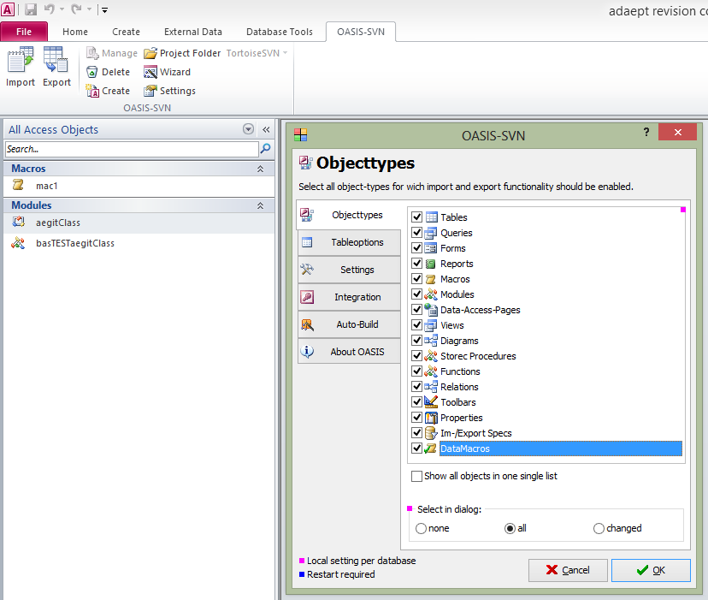

Click on **Project Folder** and it will open to the source code repository location:

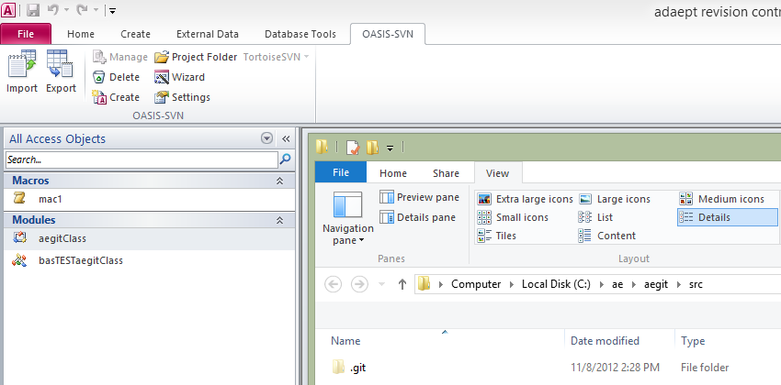

Click **Export**:

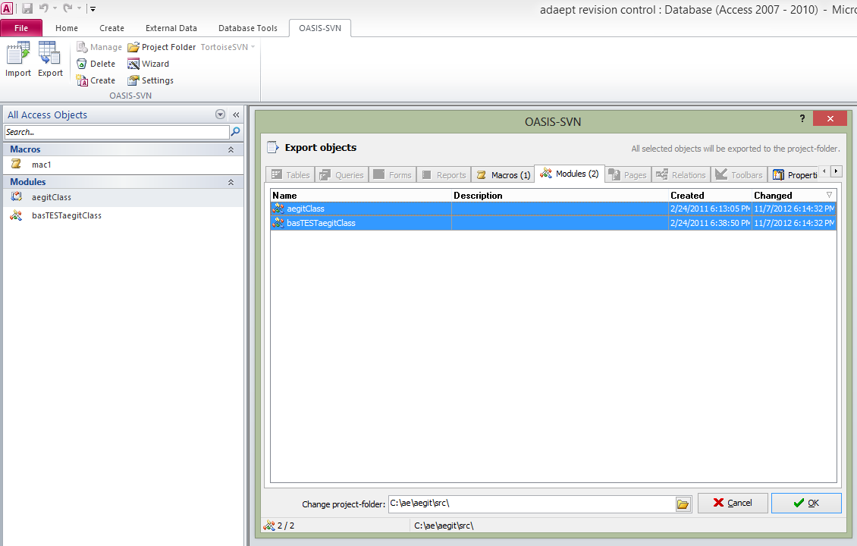

The files can be seen in the source code repository folder and managed with TortoiseGit or any other Windows git client:

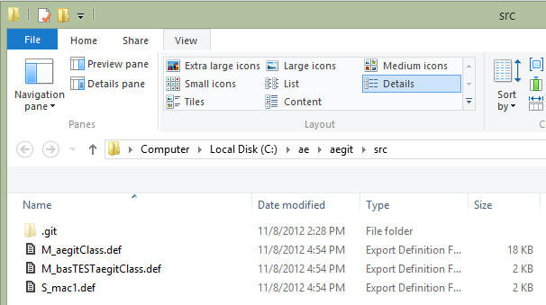

Create local repo aegit (using tortoisegit, do ***not*** make it bare as the existing files will be added)

Add the **C:\ae\aegt\.gitignore** file and exclude **\*.accdb**, **\*.laccdb**

Commit and it will look like this:

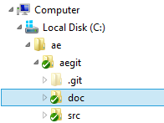

Create a repo on github

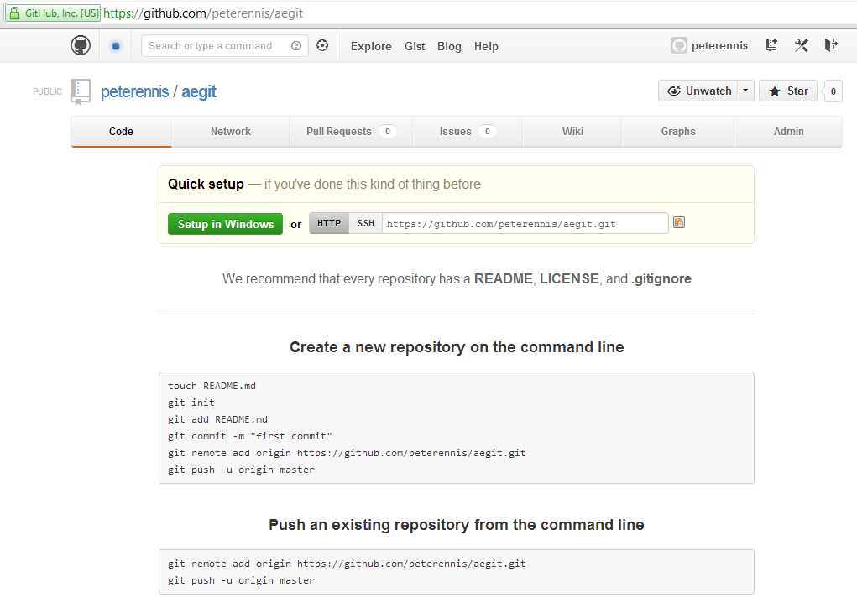

Use git bash to push the existing repo

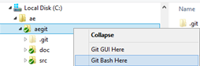

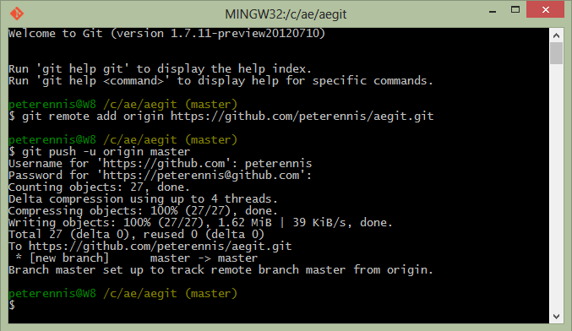

# Errors

V015 – Errors from running aegitClassTest in the immediate window – the setup details are from the old location so they need to be adjusted for the new.

