Jeff Beckley

February 3, 2000

Tips for Debugging Windows Eudora

The following is a list of ways to help find out if and why Windows Eudora is not behaving as you think it should. They are roughly in the order of how difficult they are to perform. It’s probably best to try some of the earlier methods before going on to the later ones, but as you get more comfortable with the tools you may find that for some situations it is better just to start with a later technique. Also, not every technique can be used for every problem. You have different capabilities if the problem is occurring on a machine you’re using vs. a user’s machine somewhere on the other side of the globe.

1. Logging to the Eudora.log file

Eudora has some fairly extensive logging to it, and by default Eudora logs relatively little. The log information goes in to a file called Eudora.log, located in the directory where the user’s mail is stored (often refereed to as the “mail directory”). What is logged is controlled by an entry named LogLevel in the [Debug] section of the Eudora.ini file. That value is a combination of flags that determine what events are to be logged. Here’s the current ones:

0x01 // Log sending of a message
0x02 // Log receipt of a message
0x04 // Serial login navigation (not used anymore)
0x08 // Dialog message logging
0x10 // Progress box logging
0x20 // All bytes sent to the network
0x40 // All bytes received from the network
0x80 // Check a TOC for corruption
0x100 // Basic Translator Stuff
0x200 // Advanced Translator Stuff
0x800 // Log ASSERTs & VERIFYs
0x1000 // Playlist stuff

The values on the left represent the bit used in hexadecimal. By default, Eudora logs when a message has been sent (0x01), when a message has been received (0x02), and the text and response from dialogs the user is presented (0x08). Add those together (0x01 + 0x02 + 0x08), and you get 0x0B (or 11 in decimal). So that would correspond to an entry of:
[Debug]
LogLevel=11

If you’re dealing with a relative naïve user, having them edit the Eudora.ini file may not be a wise decision. There’s a couple of ways around that. One is to use the x-Eudora-option URLs. You can send the user a message with a URL of <x-Eudora-option:LogLevel=255>, and tell them to click on the URL and click on OK in the dialog that follows. That will set the LogLevel to a value of 255. You can also use a similar technique for yourself. Create a new message, type in the URL, and then hold down the Alt key and click on the URL. Another way to have a user change log levels is to tell them to move the Esoteric.epi resource plug-in file (should be included by the installer in the ExtraStuff directory) in to their mail directory. Then when the user restarts Eudora, there will be some extra categories in the Tools->Options dialog, one of which is called “Logging” and contains checkboxes for most of the above logging flags.

As is shown in the x-Eudora-option: URL, 255 is a pretty good log level to use. Many problems are related to talking to mail servers, and logging all bytes sent and received over the network (flags 0x20 and 0x40) usually gets good information.

There’s another INI entry in the [Debug] section that can be used as well: LogFileSize. By default, Eudora will create a log file of 1 MB. Once the Eudora.log file gets bigger than that, it will copy Eudora.log to EudorLog.old, and start a new Eudora.log file. When Eudora does this, any existing EudorLog.old file will be deleted. If you’re trying to debug a problem with large attachments, you may want to increase the size of the Eudora.log file. You can use a <x-Eudora-option:LogFileSize> URL, or the Logging category of the Esoteric.epi resource plug-in as well to change the log file size.

Most of what’s in the log file should be pretty obvious, but there’s a couple of things worth noting. Here are a couple of lines out of a log file:

405 64:9.51 Rcvd: "+OK QPOP (version 2.4) at adept.qualcomm.com starting. \r\n"
405 32:9.51 Sent: "USER beckley\r\n"
342 64:9.51 Rcvd: "+OK intuity2 POP3 Server (Version iim1.1-1.7.0,30 June 1997) ready. <14555.949564479@intuity2.qualcomm.com>\r\n"
342 32:9.51 Sent: "USER 83508\r\n"
405 64:9.51 Rcvd: "+OK Password required for beckley.\r\n"
342 64:9.51 Rcvd: "+OK please send PASS command\r\n"

If you look carefully, you can see that this is a session that includes connections to two POP servers that are occurring simultaneously. The very first number is a thread ID (405 and 342 in this example) that you can use to group together all logging for a particular connection. Sometimes it’s easier to limit to just one particular POP server in order to debug a problem.

The second column contains two pieces of information. The number before the colon is the log level flag (32 is 0x20, which means that this is data that was sent over the network). The number after the flag is the number of mintues.seconds since Eudora has started.

2. Debug symbol files (.PDB files)

When Eudora is compiled in Release mode in order for people to use, there is little to no symbolic debugging information in it. Symbol information is mainly info about where in the executable a particular source code function/line is located. This is good, because symbol info can be revealing about how Eudora is implemented. It’s probably not something we’d want one of our competitors to get a hold of. However, symbol info can be a very useful tool to track down where Eudora is crashing. PDB files contains the symbol information, and are flexible in that we can ship the product without it, but we can also give PDB files to people we trust in order to help track down a bug. If you have a machine that is crashing, putting the PDB files that (this is very important!) correspond to the build being used can help to pinpoint where the problem is. We create a zip file that contains the PDB files for most of Eudora’s components for each build, and it’s put in a directory (or subdirectory) where that build is located.

Other components have PDB files as well. Microsoft provides PDB files for the MFC42.DLL and MSVCRT.DLL files, as well as some other components of the OS. Some of these can be found at file://\\fs1\eudora_src\Debug\ .

The next couple sections will show how PDB files can be helpful.

3. Illegal operation dialogs from the OS

Everyone has seen them before:

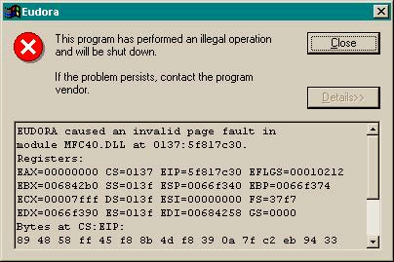
Fortunately, Microsoft made the bottom part an edit control, which means you can select the text and copy it to the clipboard, and then paste it in an email message. The most important part is the address after the module name (in this case, it’s “0137:5f817c30”). In the section below about CrashFinder, you’ll see what we can do with this address.

4. Exception.log file

When Eudora crashes, it will try to write out some helpful information to a file called Exception.log, located in the mail directory. Each time a crash (aka exception) occurs, a new entry will be written to the end of the Exception.log file. Here’s a sample entry:

//=====================================================
Mon Oct 18 21:39:17 1999
Version 4.3.0.4 (Beta)

Exception code: c0000005 ACCESS_VIOLATION
Fault address: 00452823 CEudoraApp::OnIdle+4f

Registers:
EAX:37649df5
EBX:7ffdf000
ECX:00000000
EDX:0005fe38
ESI:00000003
EDI:00000000
CS:EIP:001b:00452823
SS:ESP:0023:0005fe58 EBP:0005feb8
DS:0023 ES:0023 FS:003b GS:0000
Flags:00010206

Call stack:
Address Frame
00452823 0005feb8 CEudoraApp::OnIdle+4f
5f439fb6 0005fee0 CWinThread::Run+6a
5f43ad44 0005feec CWinApp::Run+3a
5f4346b0 0005ff08 AfxWinMain+f0

As you can see, it starts with a time/date stamp of when the crash occurred, and what version of Eudora was being run. The most important information is at the bottom: the “Call stack” (although a developer should be provided the whole file or an entire entry). It tells us what Eudora (and other components) were doing at the time when Eudora crashed. This example is a log where PDB files are present, and so symbol info is given in the file. The last part of each line is the function and offset of where Eudora crashed. If PDB files were not present, that call stack would look like this:

00452823 0005feb8 C:\CODE\EUDORA\BIN\DEBUG\EUDORA.EXE
5f439fb6 0005fee0 D:\WINNT\SYSTEM32\MFC42D.DLL
5f43ad44 0005feec D:\WINNT\SYSTEM32\MFC42D.DLL
5f4346b0 0005ff08 D:\WINNT\SYSTEM32\MFC42D.DLL

This wouldn’t be as helpful to the developer who has to track down this bug. Even without the symbol info, the numbers in the first column can be used to track down where the crash occurred. More on how to do this in the section below about CrashFinder.

5. Dr. Watson logs

Dr. Watson is a tool that comes with NT. The actual file name is DRWTSN32.EXE. It only is available for NT, not 95/98. There is an old 16-bit DRWATSON.EXE, but it will only catch crashes in 16-bit applications. I have found NT machines that don’t have it, or have an old version, so I’ve made it available in file://\\beckley\Public\DrWatson\ . It needs to be put in your C:\WINNT\SYSTEM32 directory.

Dr. Watson can be configured to log a crash when it occurs in any application. It’s what’s called a Just-In-Time Debugger, which means that it doesn’t have to be running at the time when the crash occurs. The OS will load up Dr. Watson when the crash happens, and let Dr. Watson have at it. To make Dr. Watson your JIT debugger, you run it with the –i option, like this:

C:\> drwtsn32 -i

You’ll get a dialog telling you that Dr. Watson has been installed as the system debugger.

Dr. Watson logs are similar to Exception.log files, but have much more information in them. The log file it writes to is C:\WINNT\DRWTSN32.LOG. The most important part is the “State Dump” area, but the whole file or a particular entry should be given to a developer. Here is a sample:

State Dump for Thread Id 0x168

eax=00cb1700 ebx=7ffdf000 ecx=00000100 edx=00000000 esi=00120000 edi=00650078
eip=004517e0 esp=0005fe74 ebp=0005fea0 iopl=0 nv up ei pl zr na po nc
cs=001b ss=0023 ds=0023 es=0023 fs=003b gs=0000 efl=00000246

function: CEudoraApp::PreTranslateMessage
004517b8 8bec mov ebp,esp
004517ba 83ec2c sub esp,0x2c
004517bd 894dd8 mov [ebp-0x28],ecx ss:0109e8a6=????????
004517c0 8b4508 mov eax,[ebp+0x8] ss:0109e8a6=????????
004517c3 8b4804 mov ecx,[eax+0x4] ds:01cf0106=????????
004517c6 894dfc mov [ebp-0x4],ecx ss:0109e8a6=????????
004517c9 817dfc00010000 cmp dword ptr [ebp-0x4],0x100 ss:0109e8a6=????????
004517d0 0f85ba000000 jne CEudoraApp::PreTranslateMessage+0xd9 (00451890)
004517d6 c745f400000000 mov dword ptr [ebp-0xc],0x0 ss:0109e8a6=????????
004517dd 8b55f4 mov edx,[ebp-0xc] ss:0109e8a6=????????
FAULT ->004517e0 c70200000000 mov dword ptr [edx],0x0 ds:00000000=????????
004517e6 6a10 push 0x10
004517e8 ff1594bc8a00 ds:008abc94=77e75278
call dword ptr [_imp__GetAsyncKeyState (008abc94)]
004517ee 0fbfc0 movsx eax,ax
004517f1 85c0 test eax,eax
004517f3 7c18 jl CEudoraApp::PreTranslateMessage+0x56 (0045180d)
004517f5 6a11 push 0x11
004517f7 ff1594bc8a00 ds:008abc94=77e75278
call dword ptr [_imp__GetAsyncKeyState (008abc94)]
004517fd 0fbfc8 movsx ecx,ax
00451800 85c9 test ecx,ecx
00451802 7c09 jl CEudoraApp::PreTranslateMessage+0x56 (0045180d)
00451804 c745d400000000 mov dword ptr [ebp-0x2c],0x0 ss:0109e8a6=????????

*----> Stack Back Trace <----*

FramePtr ReturnAd Param#1 Param#2 Param#3 Param#4 Function Name
0005fea0 5f43aa62 00cb1700 00650078 00120000 7ffdf000 CEudoraApp::PreTranslateMessage
0005febc 5f439fce 00650078 00120000 7ffdf000 00000001 CWinThread::PumpMessage
0005fee0 5f43ad44 00cb16c8 0005ff08 5f4346b0 00650078 CWinThread::Run
0005feec 5f4346b0 00650078 00120000 7ffdf000 ffffffff CWinApp::Run
0005ff08 00783438 00400000 00000000 00071a6c 0000000a AfxWinMain
0005ff20 00782913 00400000 00000000 00071a6c 0000000a WinMain
0005ffc0 77f1b304 00650078 00120000 7ffdf000 c0000005 WinMainCRTStartup
0005fff0 00000000 00782760 00000000 00000000 77fa5aa0 GetProcessPriorityBoost
00000000 00000000 00000000 00000000 00000000 00000000 <nosymbols>

The first part is the value of all the registers when the crash happened. The second part shows the assembly language and exact instruction where the crash occurred. The third part shows the part analagous to the “Call stack” in the Exception.log file. As you can see, Dr. Watson logs are more detailed, and thus are better for using to find a bug. This Dr. Watson entry is one where there were PDB files present. Without symbols, you’d get something like this:

0005fea0 5f43aa62 00cb1700 00650078 00120000 7ffdf000 Eudora!<nosymbols>
0005febc 5f439fce 00650078 00120000 7ffdf000 00000001 mfc42!<nosymbols>
0005fee0 5f43ad44 00cb16c8 0005ff08 5f4346b0 00650078 mfc42!<nosymbols>
0005feec 5f4346b0 00650078 00120000 7ffdf000 ffffffff mfc42!<nosymbols>
0005ff08 00783438 00400000 00000000 00071a6c 0000000a mfc42!<nosymbols>
0005ff20 00782913 00400000 00000000 00071a6c 0000000a mfc42!<nosymbols>
0005ffc0 77f1b304 00650078 00120000 7ffdf000 c0000005 msvcrt!<nosymbols>
0005fff0 00000000 00782760 00000000 00000000 77fa5aa0 kernel32!<nosymbols>
00000000 00000000 00000000 00000000 00000000 00000000 <nosymbols>

Again, even if the symbol info isn’t there, we can still get to it with CrashFinder.

6. Debugger.exe

Sometimes has a bug where it just disappears. You don’t get any OS “Illegal operation” dialog, Dr. Watson log, or entry in the Exception.log file. This is affectionately known as a “poof”. A poof is a crash so bad that no one knew how to clean up after it. It’s problematic because since the address of the crash can’t be collected from the above methods, it makes it pretty hard to figure out what’s going wrong.

Never fear, debugger.exe is here!

Debugger.exe is a little app I wrote. It’s a mini debugger that can be attached to Eudora, and actively debug it, as opposed to a JIT debugger (like Dr. Watson) which doesn’t get started up until after the program crashes.

To use it, just put debugger.exe (I’ve made it available in file://\\beckley\Public\) in the same directory as Eudora.exe. When Eudora starts up, it will note that debugger.exe is there, and tell debugger.exe to attach to it (start visualizing all sorts of symbiotic creatures embedding themselves inside your body). If any sort of crash occurs, including the dreaded poof, debugger.exe will put up a dialog saying something like this:

Access violation at location 004517e0, attempting to read virtual memory address 00000000

Sometimes that “read” may be a “write”. The important thing to do is write down the crash location, whether it was reading or writing, and what address is was reading from/writing to. Even if symbol info is installed on this machine, it won’t be used. CrashFinder will help to interpret the crash location.

7. CrashFinder

Okay, I’ve mentioned this CrashFinder guy a couple of times already. He’s seems like he’s pretty important! CrashFinder is an application that was written by a fellow named John Robbins, for an article in Microsoft Systems Journal magazine. It allows you to take a crash address that there wasn’t any symbol information from the above methods, and turn it in to a source code file and line number. This is extremely handy for tracking down bugs. You can find CrashFinder at http://builder/eudorapro/CrashFinder/ .

When you run CrashFinder, you’ll be greeted with an empty window. From there you’ll want to create a new document (click on the leftmost, blank page, toolbar button, or select File->New, or do Ctrl+N). You get an “Untitled” window with a right and left pane. Then do an Edit->Add Image (or Ctrl+A, or the funky toolbar button that I don’t know what it’s supposed to be), and you’ll get a standard file dialog. Navigate to the directory where the PDB files for the EXACT BUILD where the crash occurred. I can’t stress enough how important it is to make sure you’ve got the corresponding build. If you don’t you could make a developer spend hours looking for a crash in all the wrong places. The current spot where we keep builds is file://\\swamp\Eudora\43\Builds\ . Once you get in to the directory, you’ll see a list of familiar Eudora components (Eudora.exe, Eudora32.dll, etc.). Select all of them (Ctrl+A), and click on the Open button. It may take CrashFinder a while (maybe even a couple minutes) to complete the next step, and you’ll probably hear the hard drive grind the whole time. What CrashFinder is doing is loading up the PDB files in that directory corresponding to the EXE and DLL files you selected. If you get any error dialogs, just hit the No or OK button.

In the left pane, you’ll see a list of the components you selected, with a green checkmark or red X to indicate whether the symbols for that file were loaded or not. Selecting the file will provide information about the file in the right pane, if the symbol info was loaded up for that file. Now you’re ready to get to translatin’!

Click on the binoculars toolbar button (Ctrl+F, or Edit->Find Crash), and you’ll get a dialog that will ask you to enter a hexadecimal address. That’s where you type in (or paste) the address you got from any of the above methods. Then click on the Find button (or hit Enter), and hopefully it will be an address that matches, and the info at the bottom of the dialog will get filled in with something like this:

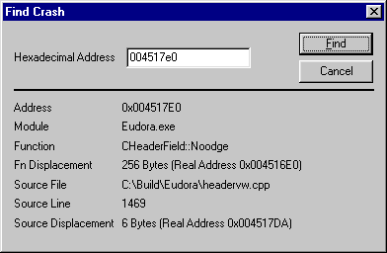

You can either copy down this info to give to the developer, or you can hit Alt+PrintScrn and a copy of the dialog will be placed on the clipboard, which can be pasted in a report.

8. Running debug builds of Eudora

Every time we make a build, we make what’s called Release and Debug builds. Release builds are what most users normally see, whereas Debug builds are generally what developers use while writing code. Debug builds have compiler optimizations turned off, are larger in size (sometimes by quite a bit!), and have extra code that checks whether or not things are behaving as expected. Because of this, Debug builds are slower and use more memory, which is why Release builds are what we ship to customers.

Because of the extra checks that Debug builds do, it can often be helpful to run them when you’re trying to track down a particular problem. It’s also not a bad idea to run Debug builds even when you’re not actively researching a specific problem, as things may come up when you weren’t expecting them. Some people argue that testing Debug builds is not a good idea because Debug builds are different from Release builds. They point out that something may work fine in a Debug build, but not a Release build, and after all it’s the Release build that your customers are going to use. I agree with that to some extent, and I’m by no means advocating that Release builds should never be tested, but testing Debug builds can sometimes warn you or lead you to bug you wouldn’t have found when running a Release build. I always run a Debug build for all of my personal mail.

To run Debug builds on Eudora, you need to have a couple extra DLLs in your System (Win 95/98) or System32 (Win NT/2000) directory. You can find those DLLs at file://\\beckley\DebugDLLs\ .

The main outward appearance difference that you’ll see in a Debug build vs. a Release build is ASSERT dialogs. An ASSERT is a piece of code that a developer puts in the program to make sure that the program is in a state that he thinks it should be in. A typical ASSERT may be to test that a variable has a particular value. In a Debug build, if an ASSERT fails, you’ll get a dialog that looks like this:

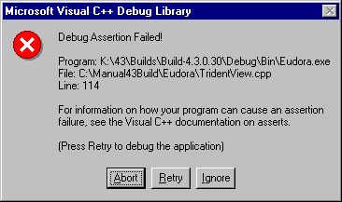
This dialog should be saved, either through Alt+PrintScrn or have the info in it written down, and then given to a developer for further review. Just because an ASSERT pops up, it doesn’t necessarily mean that Eudora has a bug. But it is something that should be looked in to.

The buttons are very confusing, and disgustingly reminiscent of the old DOS days. If you want to continue running Eudora, hit the Ignore button. If you have a debugger installed on this machine (see the Running in the DevStudio debugger section below), you can drop in to it to get more info by hitting the Retry. To shut down Eudora right then and there, no questions asked, hit the Abort button. Isn’t it nice that Microsoft made the Abort button the default? NOT!

Eudora also has a different memory manager in Debug builds. If dynamic memory is handled incorrectly in a Debug build, you might wind up seeing a dialog that looks like this:

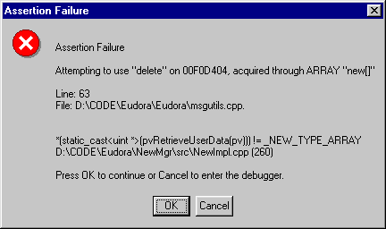
This dialog should be saved, either through Alt+PrintScrn or have the info in it written down, and then given to a developer for further review.

Debug versions output some extra information while they are running, to something called a Debug Output Window. A normal debugger (like DevStudio’s) will have a place for this to be shown. When you’re not running a Debug build in a debugger, you can still get to the debug output information with a utility called dbmon.exe (Hey, mon!). You can find it at file://\\beckley\Public\dbmon.exe . dbmon.exe appears only to work under NT, but it may be that some day we find out how to get it to work under Win 95/98.

9. Running in the DevStudio debugger

If the crash is happening on a user’s machine who happens to be a Windows programmer and has DevStudio installed on their machine, Eudora can be run inside the DevStudio debugger. This can be very helpful because if Eudora crashes there may be some extra information that can be obtained from DevStudio’s interface. The most important information is the contents of the Call Stack window. It also might be possible for a developer to interactively talk to the user who has the problem happening at that time, and be able to get some other tidbits of info from the user.

You don’t have to be running a Debug build of Eudora to run it in the DevStudio debugger. Release builds can be debugged as well. Again, it’s much more helpful if the PDB files for that specific build are installed on the user’s machine.

For a user that has a problem every once in a while, but can’t come up with reproducible steps, the user can always run Eudora in the Devstudio debugger by setting up a shortcut. In the Shortcut tab of the Properties dialog for the shortcut, set the Target field to be the full path to DevStudio (it will be something like C:\Program Files\DevStudio\SharedIDE\bin\MSDEV.EXE) surrounded in double quotes, followed by a space and then the full path to Eudora.exe. The user can then just click on that shortcut, and hit F5 to start up running Eudora inside the DevStudio debugger.

10. Running with BoundsChecker

BoundsChecker is a tool from a company called NuMega software (which was bought out by CompuWare). BoundsChecker can watch a program as it runs, and give back information about things that it thinks the program is doing wrong. These include things like calling OS-level functions with bad parameters, getting errors return from OS-level functions, corrupting memory, forgetting to initialize a variable before reading it, forgetting to release dynamically allocated memory or resources, and many other things. You can run BoundsChecker over any application, but some of the errors that it can detect are only caught when you Instrument the program (what BoundsChecker calls compiling your program and letting BoundsChecker add in some extra code).

Here’s a screen shot from a BoundsChecker session run over Eudora, with a particular error selected (this one is a place where Eudora was reading a variable that had never been initialized):

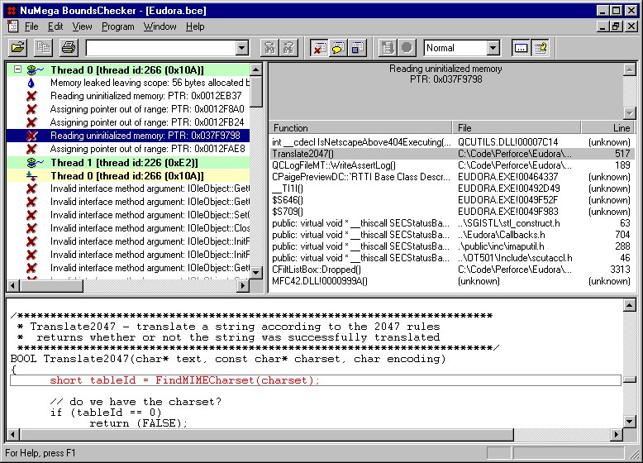

BoundsChecker can be an amazing tool. It can catch bugs that would have taken you years to find, or maybe you wouldn’t have been able to find them at all. It has a couple of big drawbacks though. The first is that to be really helpful, you need to instrument the program. That takes a long time to do. The second is that running BoundsChecker over your app can be extremely slow. A BoundsChecker instrumented build of Eudora can take about 10-15 minutes just to start up, and take a very long time to do mail checks and other operations. The third drawback to BoundsChecker is that it often times reports things as bugs that really aren’t bugs. I’m not sure why it does this, other than what it does to determine whether or not a particular practice is wrong or not is just a heuristic, and sometimes that heuristic guesses wrong.

Because of all these drawbacks, BoundsChecker is usually the tool of last resort. It’s generally used when you have exhausted all the other debugging tactics in the above sections. Someday I’d like to see us do automated BoundsChecker builds, and automated testing on those BoundsChecker builds. Automating this would take out the tedium involved with BoundsChecker, and get us the great benefits that BoundsChecker has to offer.

