Reference No: DFY/HR/2026/145 Date: 13 October 2026

To whomsoever this may concern

This is to certify that Mr. Rohan Sharma S/o Mr. Suresh Sharma R/o Flat 102, Green Park Apartments,
Sector 15, Rohini,
Delhi was working in the capacity of a (Consultant) Data Entry Operator at DFY supported Operations New Delhi from 01 April 2024 to 30 June 2025.

We highly acknowledged his hard work, perseverance, and dedication. In course of his association with us we appreciated his sincerity and professionalism.

We wish him success in all his future endeavours.

For Doctors For You,
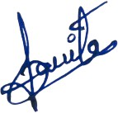

Ms. Sarita Bartwal, HR Department

