**Appendix:**

Tables 1.1, Table 1.2: Definition of Financial Crises, Thresholds pp.1-2

Table 2: Impact of Crises on Media Scores

Table 3: Testing the Causal Mechanism: Mediation Analysis p. 4

Table 4: Distance Between Proxied Base Locations and Disaster: p. 5

Utilizing Geo-Referenced Data

Table 5: Additional Control Variables: Alliances, Regime type, p. 6

GDP per capita, Repression, Mountainous Terrain

Table 6.1 Alternative Crisis Operationalizations: Sec. and Fin. Crises p. 7

Table 6.2 Alternative Crisis Operationalizations: Humanitarian Crises p. 8

Figure 1: Predicted Attacks at High-Low Values with all crises measures as p. 9

non-binary

Table 7: Financial Crisis data disaggregated p. 10

Table 8: Lagged Financial and Security Crises p. 11

Table 9: Domestic versus Transnational Attacks p. 12

Table 10.1: Alternative Model: Hurdle Model p. 13

Table 10.2: Alternative Model: Negative Binomial Model p. 14

Table 11: Clustered Standard Errors: Country Effects p. 15

Table 12: Testing Reputational Costs with Group Level Data p. 16

Figure 2: Group-Level Interaction Effect of Reputation and Humanitarian Crisis p. 17

Explanations for Variables included in Table 12 p. 18

Explanations for Including Control Variables in Table 5 pp. 19, 20

**Coding of Economic Crises:**

The following tables are taken from https://carmenreinhart.com/this-time-is-different/

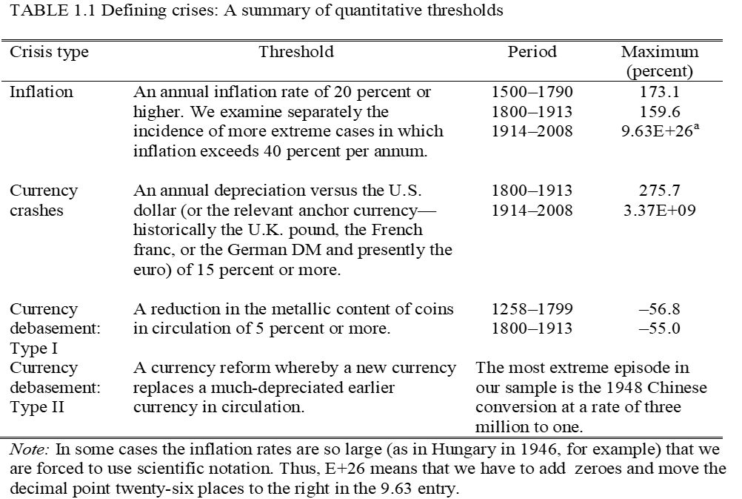

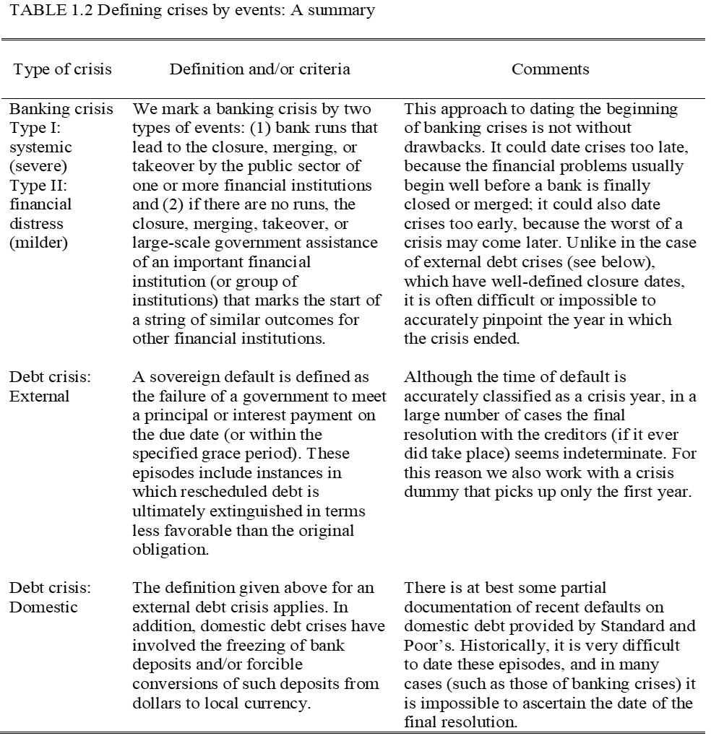



Table 3: Mediation Analysis, Indirect Effects

|  |  |  |  |  |
| --- | --- | --- | --- | --- |
| **Financial Crisis** | **NIE** | **NDE** | **TE** | **Proportion** |
| State Capacity | 3.01(0.99)*** | 1.40(3.03) | 4.39 (3.23) | 69* |
| Media Score | -0.50*(0.56) | 8.74(3.54)** | 8.23(3.38)** | -6 |
| **Humanitarian Crisis** | **NIE** | **NDE** | **TE** |  |
| State Capacity | 14.69(41.73) | -50.96(37.52) | -36.27(61.50) | -41 |
| Media Score | -227.06(108.43)** | 34.13 (47.22) | -192.93(75.73)** | 118*** |
| **Security Crisis** | **NIE** | **NDE** | **TE** |  |
| State Capacity | 3.67(1.93)* | 16.07(3.64)*** | 19.74(4.68)*** | 19** |
| Media Score | 0.62(0.90) | 16.13(4.17)*** | 16.76(4.60)*** | 4 |

Note: Because some of the models did not converge with ethnic diversity, we excluded it from all models for consistency.











This graph replicates Figure 1 from the main manuscript and presents non-binary measures for all crisis variables. It maintains consistency with the security and humanitarian crisis measures shown in Table 1 of the manuscript, while using the Number of Financial Crises (Table 2.1) as a non-binary measure.

















**Dependent Variable**: Domestic Terrorist Attacks

**Independent Variables**: Net Positive Constituency Relations is a binary variable, composed of positive-negative constituency relations. The former tests political party affiliation, media ownership, and public goods provision. The latter tests forced recruitment, forced funding, and child recruitment. Both range from 0 to 3. The net score is recoded as a binary variable in the RTG dataset. The interaction term is composed of Net Constituency Relations and presence of Humanitarian Disasters.

**Control Variables:** We used the following group-level variables: Horowitz shows that younger groups are more flexible and open to innovation on suicide bombing (Horowitz, 2010). Religious groups have an unearthly audience and the ability to engage in othering, which makes them more lethal (Asal & Rethemeyer, 2008). Berman and Laitin (2007) also concur on the lethality of religious organizations because they provide club goods, which increase commitment. Size matters because large organizational structures necessitate resources (Asal & Rethemeyer, 2008). The outbidding literature suggests that the more competition there is, the more groups will increase attacks to gain credibility and earn the loyalty of the population who is trying to find which group best represents their interests (Bloom, 2005; Nemeth, 2014; Kydd & Walter, 2006). Lastly, hierarchically organized groups can alleviate principal-agent problems. Furthermore, hierarchy brings functional differentiations and hence leads to more destructive, lethal attacks (Heger, Jung, & Wong, 2012). Lastly, we control for regime type as an aggregate level variable.

**References:**

Asal, V., & Rethemeyer, R. K. (2008). The nature of the beast: Organizational structures and the lethality of terrorist attacks. The Journal of Politics, 70(2), 437-449. The University of Chicago Press on behalf of the Southern Political Science Association.

Berman, E., & Laitin, D. (2007). Author(s). Perspectives on Politics, 5(1), 122-129.

Bloom, M. (2005). Dying to kill: The allure of suicide terror. Columbia University Press.

Heger, L., Jung, D., & Wong, W. H. (2012). Organizing for Resistance: How Group Structure Impacts the Character of Violence. Terrorism and Political Violence, 24(5), 743–768.

Horowitz, M. C. (2010). Nonstate actors and the diffusion of innovations: The case of suicide terrorism. International Organization, 64(1), 33-64. Cambridge University Press on behalf of the International Organization Foundation. http://www.jstor.org/stable/40607980

Kydd, A. H., & Walter, B. F. (2006). The strategies of terrorism. International Security, 31(1), 49-80. The MIT Press. http://www.jstor.org/stable/4137539

Nemeth, S. C. (2014). The effect of competition on terrorist group operations. Journal of Conflict Resolution, 58(2), 336-362. Sage Publications.

**Explanations for Including Control Variables in Table 5**

* **Alliances**: Scholars like Savun and Phillips (2009) associate heavy interventionist policies with an increase in terrorist attacks. Countries with robust interventionist policies are more likely to experience suicide attacks (Pape, 2003), and those aligned with the US often face greater resentment (Tessler and Robbins, 2007). We include data on alliances with the US from the Correlates of War, Formal Interstate Alliance Dataset, Version 4, 1816-2012 (Gibler, 2009).
* **Polity:** We replace executive constraints and political competition with regime type (Polity 5 dataset, Model 2).
* **Logged GDP per capita:** We had initially excluded GDP per capita from our main analysis due to its potential correlation with our independent variable, financial crisis. We now incorporate logged GDP per capita (World Development Indicators, Model 3), reflecting the diverse scholarly views on poverty and terrorism. Some scholars argue that deprivation and injustice lead to extremism (Burgoon, 2006), while others have found a positive relationship (Ross, 1993) or weak connections between economic variables and terrorism (Krueger and Maleckova, 2003).
* **State Repression:** We control for state repression (Model 4) using data from the CIRI Human Rights Database. Scholars argue that repression fuels terrorism by eroding state legitimacy and incentivizing terrorist provocations (Lake, 2002; Kydd & Walter, 2006; Walsh & Piazza, 2010; Blankenship, 2018).
* **Mountainous Terrain**: We include mean terrain ruggedness (Model 5), as forest cover and mountainous terrain may provide hiding places and sustenance, facilitating survival (Shaver et al., 2016; Rouen and Sobek, 2004; Nemeth et al., 2014). These factors can diminish state monitoring capacity, creating a permissive environment for planning and staging attacks.
* **State Capacity**: State capacity is often used as a control variable in terrorism research (Piazza, 2008; Li, 2005; Koch & Cranmer, 2007; Young & Findley, 2011; Findley, Piazza & Young, 2012; Gaibulloev, Piazza & Sandler, 2017). States with low capacity frequently provide a conducive environment for terrorist activities, primarily due to the lack of centralized control and effective governance (Newman, 2007; Lai, 2007). Such weaker states are also more likely to be targets of provocation strategies that increase terrorism (Blankenship, 2018). We use the state capacity index from Coppedge et al. (2022). The advantage of this index is that it integrates 21 indicators across coercive, extractive, and administrative dimensions (O’Reilly and Murphy, 2022). Additionally, some scholars have found that different components of state capacity—specifically military and bureaucratic capacities—affect terrorism differently; the former tends to increase attacks, whereas the latter tends to decrease them (Hendrix and Young 2014; Adam and Tsavou 2022). We recorded the state capacity index (O’Reilly and Murphy, 2022) to encompass educational equality, the state's fiscal sources of revenue, the distribution between particularistic and public goods, and the rigor and impartiality of public administration within the concept of bureaucratic state capacity, while integrating the state's authority over territory into the definition of military capacity. We control for composite state capacity, as well as for two separate components of state capacity.