BCFPD OPERATIONS AND PREPAREDNESS BUREAU
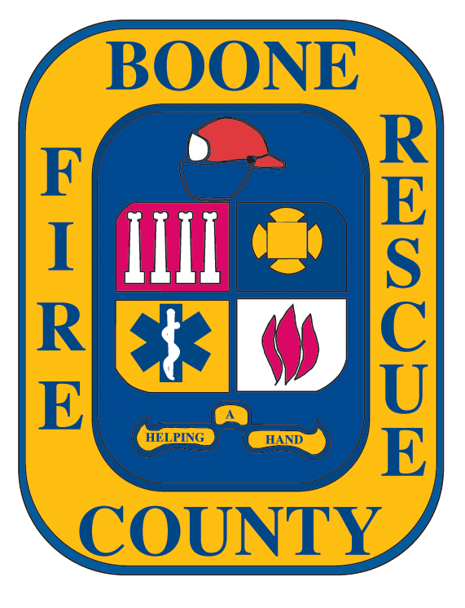

JANUARY

FEBRUARY

MARCH

APRIL
COURSE DATE HELD
EVENING EMT – 2,4,9,11,16,18,23,25,30
PARAMEDIC – 4,11,18,25
DAY EMT – 5,12,19,26
BLS INSTRUCTOR CLASS – 6,7
ACLS - 6
CPR – 8
EMT NR/ State Prac. Exam – at GCB – 13

COURSE DATE HELD
EVENING EMT – 1,6,8,13,15,20,22,27
PARAMEDIC – 1,8,15, 22
DAY EMT – 2,9,16,23
EMT NR/ State Prac. Exam at GCB – 10
CPR – 12
EMT-BASIC REFRESHER – 23, 24, 25
PALS/ACLS - 24

COURSE DATE HELD
NIGHT EMT – 1,6,8,13,15,20,22,27,29
PARAMEDIC – 1,8,15,22
DAY EMT -2,9,16,23,30
EMT NR/State Prac. Exam – at GCB – 10
CPR -12

AHA INSTRUCTOR COURSE - 19
New paramedic program postponed to May 15th

COURSE DATE HELD
EMT EVE – 3,5,10,12,17,19,24,26
CPR - 9
PARAMEDIC NR EXAM – 21
ACLS/PALS CLASSES – 28
AHA INSTRUCTOR C OURSE - 30

MAY

JUNE

JULY

AUGUST
COURSE DATE HELD
EMT NIGHT – 1,3,8,10,15,17,22,24,29,31
EMT DAY 4,11,18,25
CPR - 14
NEW PARAMEDIC – 15,22, 29
AHA INSTRUCTOR COURSE - 23

COURSE DATE HELD
DAY EMT 1,8,15,22,29
PARMEDIC – 5,12,19,26
EVENING EMT – 5,7,12,14,19,21,26,28
EMT NR State Prac. Exam – at GCB – 9
CPR – 11
AHA INSTRUCTOR COURSE – 20
ACLS/PALS CLASSES - 23
EMT NR/ State Prac. Exam at GCB – 30

COURSE DATE HELD
EMT NIGHT – 3,5,10,12,17,19,24,26,31
EMT DAY – 6,13,20,27
CPR – 9
PARAMEDIC – 10,17,24,31,
EMT BASIC REFRESHER – 20,21,22

COURSE DATE HELD
DAY EMT – 3,10,17,24,31
PARAMEDIC – 7,14,21,28
EVENING EMT – 7,9,14,16,21,23,28,30
CPR - 13
AHA INSTRUCTURE COURSE - 22
ACLS/PALS CLASSES - 25

SEPTEMBER

OCTOBER

NOVEMBER

DECEMBER
COURSE DATE HELD
PARAMEDIC – 4,11,18,25
EVENING EMT – 4,6,11,13,18,20,25,27
DAY EMT – 7,14,21,28
CPR – 10
AHA INSTRUCTOR COURSE – 19

COURSE DATE HELD
PARAMEDIC – 2,9,16,23,30
EVENING EMT–2,4,9,11,16,18,23,25,30
DAY EMT – 5,12,19,26
CPR – 8
EMT REFRESHER COURSE 26,27,28
ACLS/PALS CLASSES – 27

COURSE DATE HELD
EVENING EMT – 1,6,8,13,15,20,,27,29
DAY EMT – 2,9,16,23,30
CPR – 5
PARAMEDIC – 6,13,20,27

COURSE DATE HELD
ACLS/PALS – 1
PARAMEDIC – 4,11,18,
DAY EMT – 7,14,21,
CPR – 10
AHA INSTRUCTOR COURSE – 19

- Dates of classes are subject to change
- Current BLS (CPR) HCP card is required for all ACLS, PALS, and BLS I Classes
- A $25.00 non-refundable fee on all cancellations unless otherwise stated
- Location of classes will be at BCFPD Headquarters, 2201 I-70 Dr. NW, Columbia, MO in Classroom: NE (on north side of building)
- Other class locations will be stated above or announced during registration
- For changes and course additions…please visit at our web site: http://www.bcfdmo.com or call 573-447-5016 rev: 2/07

Any fees charged for a course, except for a portion of fees needed for AHA course materials, do not represent income to the Association.
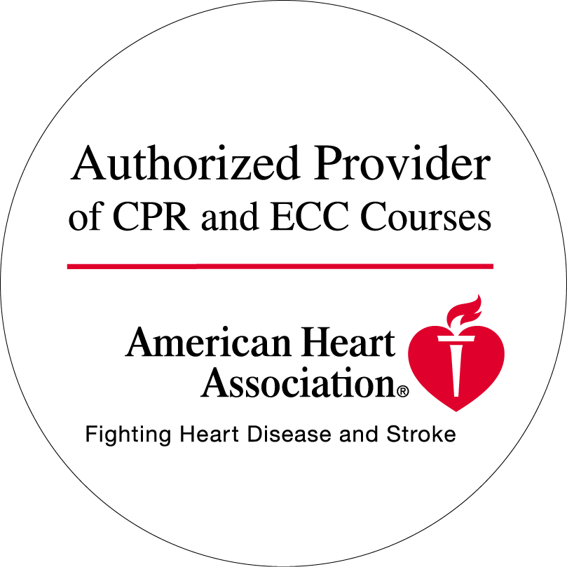

To Register, Call 573-447-5016

