ECE1779

Assignment 3 final project report

Transcription and translation of audio files to enhance language learning experience

Evgenii Krasnikov
998070135

Description of the application
Listening and understanding is one of the most important part of learning any language. When people learn a new language they tend to focus too much on expanding the vocabulary, but comprehension of speech does not improve. The purpose of this application is to help user with foreign speech comprehension and translation.
With this app users don’t have to rely on learning only from the content that is already available online. Instead, users can learn from the content that they are interested in, which can include audiobooks or simply podcasts on topics of their choice. This app provides the tools to take an audio spoken in any language (supported by Amazon Translate and Transcribe), transcribe it and translate to another language of user’s liking. In addition to that, this app provides an ability to sync speech with text and see the translation of speech as it is being played back. This way language learner will develop their listening skills and translated text should enhance their comprehension of the material.
This service can be easily updated to generate subtitles for any audio tracks including audio from movies or shows.

How to use the application
To use the application, the user first has to login (or register if he/she doesn’t have an account). Once user is logged it, they will be taken to a page where they can see a list all audio files that were uploaded and can upload new files for transcription and translation.
To upload an audio, they have to provide a file with mp3 extension, then select the source and target languages and click upload. The processing of audio file may take up to 5 minutes (depending on the audio length). Once it is done processing, users are able to click on the link to play back their file. Audio playback will be synced with transcribed and translated text.

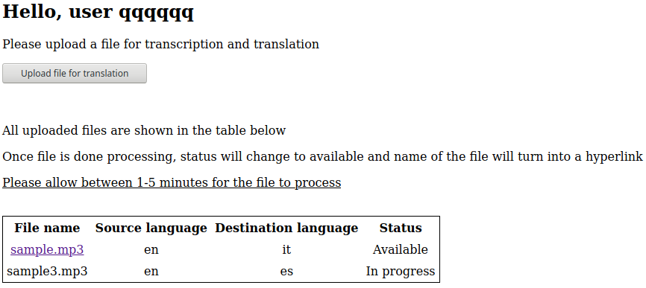Illustration 1: main application page that lists all audio files uploaded by the user and their status

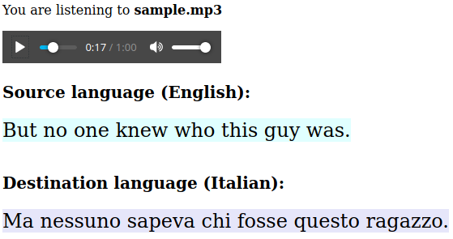Illustration 2: Web app page that syncs audio with text

Architecture of the application
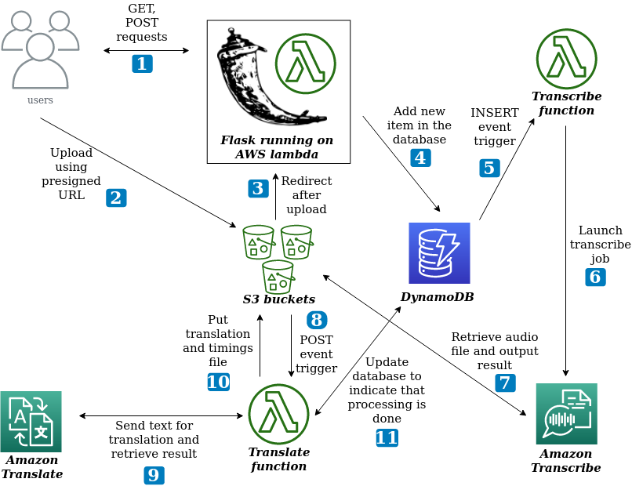

From the diagram it can be seen that this application uses the following Amazon services:
- S3
- Lambda/ API Gateway
- DynamoDB
- Translate
- Transcribe

The diagram also outlines roughly the order of events starting from user uploading a file until translated text becomes available:
- User logs in and clicks the “Upload audio file” button that sends the upload form with presigned URL
- Users selects the file, sets language parameters and uploads an mp3 file to S3
- Upon successful upload, S3 redirects a user back to the main page
- The application adds an entry to the database corresponding to the newly uploaded audio file
- This generates an event for a “Transcribe” lambda function
- “Transcribe” lambda function launches an Amazon Transcribe job
- Amazon Transcribe retrieves the audio file, performs transcription and then saves the result to an S3 bucket
- Saved result triggers another lambda function denoted as “Translate” that is configured to launch whenever an object is added to a bucket
- That function retrieves transcription result, and sends it to the Amazon Translate service and gets back the translated text
- “Translate” extracts timing information and saves transcribed text, translated text and timing info to a bucket
- It also writes to the DynamoDB database to indicate that processing is complete

Login and registration of users

Login and registration capabilities were borrowed from assignments 1 and 2. The only difference is that mySQL tables were replaced with DynamoDB tables.

Whenever a user visits the website, he is presented with the login form. Even if unauthenticated user tries to access the part of the website for logged in users, he will be redirected back to the login page. This is done by creating a login_required decorator and using it on those parts of the website that require login.

Whenever login or registration forms are provided with invalid data, the user is redirected back to the original form with a message hinting what exactly went wrong.

Valid username must contain 6 - 100 symbols all of which must be alphanumeric characters, while valid password must contain 6 - 100 symbols all of which must be alphanumeric or _ * & ^ % $ # @ ! - + =.

When valid password and login name are provided upon registration, a new item will be added to the users table with login name from the html form, random salt and hashed password. Hashed password is created by concatenating salt and plaintext login name and applying SHA-256 cryptographic hash function.

Once user provides a valid login and password that matches the one in the database, an “auth” key will be added to the session object associated with that user. Once the user is logged in, he will always be redirected to “dashboard” page from login or registration pages, until he is logged out.

Uploading files to S3
Entire Flask application is deployed on Lambda + Gateway API using zappa library. Lambda functions have a limitation on the request size that it can receive (which is currently set by Amazon at 6Mb). The audio files that users might want to translate can easily be larger than that. For example, 45 minute podcast can occupy around 50Mb of space, depending on bitrate and number of channels. Therefore, it is impossible for upload requests to go through Amazon Lambda.
It was decided to let users upload to designated S3 bucket location directly using presigned URL. When user navigates to the file upload form, web app generates a presigned URL (using boto3 library) and populates all the form fields. When user hits the upload button, mp3 file will be automatically uploaded to a designated location in S3 bucket.
Some error checking is done on the browser side with javascript code (but this is not ideal). Error checking code verifies that file has an mp3 extension and that source and destination languages are properly set. This javascript code is executed when button is pressed, but before the data is sent.
Since form is submitted to S3 rather than to the web app, web app doesn’t not know which source and target languages user has selected. Since upload form is configured to redirect back to the web app, there is a javascript code that attaches language selection information to the redirect URL as URL parameters as such:
<redirect_url>?src_lang=<language code>&dst_lang=<language code>.
Those parameters are then retrieved by the web app.

S3 file storage
Application uses 3 different buckets to store all necessary data:
- mp3 files
- transcription files
- translation/timing files

MP3 file storage
All mp3 files are stored in a bucket that is further partitioned using folders. There exists one folder per user that stores all audio files uploaded by a given user. Since usernames must be unique, there is no name collision.

Transcription file storage
All transcription files are generated by AWS Transcribe service and stored in a single bucket. There is no subdivision into folders in that bucket, since AWS transcribe can only take bucket name as an output argument. Transcription files are stored as json files.

Translation file storage
Translation files are stored as text files with custom extension. The base name will be the name of the file and the extension represents the language of the text that is contained inside. For example, if user uploaded file named sample.mp3 and indicated that source language is English and target language is French, then 2 translation files will be created named sample.en and sample.fr.
Additionally to sync the audio with text, a text file with timing information is stored with .time extension

Dynamodb databases
This application requires 2 DynomoDB tables: “files” and “users”.
Each entry in the users table contains 3 attributes: username, salt and hashed password. Username is set to be the primary key.

Each entry in the files database has 6 attributes: filename, file uuid, username, source language, destination language and status. Username is set to be the partition key and uuid as the sort key which together comprise the primary key. The reason to set username as partition key is because we want all files of any given user to reside on a single machine for faster lookup. This table is mostly used to query all files belonging to a given user.

Lambda functions
There are 2 Lambda functions that are not part of the web app, but they run in the background and do a majority of work to transcribe and translate the uploaded files

Transcribe lambda function
This function is triggered by a DynamoDB event. More specifically, it reacts to INSERT events that add new items to the “files” table. This function simply takes all the necessary information from the event and launches Amazon Transcribe job. It uses boto3 library to launch an asynchronous transcription job that outputs the transcription result in json format to an S3 bucket.

Translate lambda function
This is the most computationally heavy function. This function is triggered when object is added to S3 bucket which happens when AWS Transcribe uploads the results. Firstly, the function downloads and parses the transcription result with the following json format:
{
"jobName":"test",
"accountId":"158238500440",
"results":
{"transcripts":
[{"transcript":"<transcribed text goes here>"}],
"items":[
{"start_time":"1.85","end_time":"2.18","alternatives": [{"confidence":"1.0","content":"Barack"}],"type":"pronunciation"}, {"start_time":"2.18","end_time":"2.62","alternatives": [{"confidence":"0.5948","content":"Obama"}],"type":"pronunciation"},
....
}
Transcription result produces recognized text, but also gives timing information about when that text is spoken. Lambda function uses this information to extract the text, but also get the timing information that will be used by the app to sync text with audio. Text is saved in S3 bucket in a file with language dependent extension (as described in another section).

Timing information is extracted by splitting text into sentences. Then, start time of the first word of each sentence and end time of the last word in a sentence are obtained. Timing information for each sentence is save as a string with the following format; <start time of first word>-<end time of last word>. The timing file contains comma separated sequence of such strings. I used dot, exclamation mark and question mark as the sentence separators. However, I found that dots do not necessarily signify the end of the sentence and sometimes used in various abbreviations. As a result source and translated text end up with different number of sentences. I decided to add untranslatable “anchor” characters like ( [<any number>] ) that do not affect the translation quality, but are preserved in text even after translation. Those “anchor” character help to sync translated text with audio tremendously.

Translation job is synchronous and almost real time (takes less than 1 second) and once it is complete lambda function saves 3 files to S3 buckets: text in source language, text in target language and timings file.

To let the app know that transcription and translation jobs are done, it adds “available” attribute to the database entry for a corresponding audio file.

Web application
Web application has 4 main functions:
- login and register users
- list all files uploaded by a given user
- generate presigned URLs for uploading mp3 files
- provide synced playback of audio and transcribed + translated text

Listing all files is achieved by querying the “files” data base. Generating presigned POST forms is done using boto3 function and using jinja templating capabilities to populate the forms.
Finally, synced playback is achieved the following way:
- timings, source language and destination language files are downloaded from S3
- language files are split at the “anchor” points
- a json object is constructed having the following format:
  - [{“start_time”: < >, “end_time”: < >, “src_text”: < >, “dst_text”:< >}, ...]
The above mentioned json object is embedded into the html page (and will be used by the javascript on the page).

The html page contains 3 major components: areas where synced source and destination texts are displayed and an audio player. There is a javascript function that is bound to “timeupdate” event of the audio player. That function receives the current playback time and populates the areas for displaying synced text with the data taken from the above mentioned json object.

Cost breakdown per Amazon service
Lets assume that a typical use case for this service will be transcription and translation of podcasts. Lets also assume that the average podcast is 45 minutes in length (similar to the average lecture time) and has 4 episodes a month. This means that average user will require transcription and translation for 180 minutes of audio. In addition, assume that users only access the app when a new podcast episode comes out, which means 4 times a month.

Lambda and API Gateway cost
For Flask app running on AWS Lambda, we can see from monitoring logs, that memory usage does not exceed 100Mb per invocation. All requests sent to Flask app use less than 100ms of processing time, except the page that plays back and syncs audio with text. That processing can take up to 500ms (depending on the length of the audio and the amount of text).
Lets assume that the average user uses generates 100 requests on average while logging in / navigating the app and 10 requests for the page that syncs audio with text in one sitting. Each user will induce this type of internet traffic 4 times a month. Thus, our hypothetical user will generate 400 requests that take less than 100ms to execute and another 40 that take up to 500ms to execute per month.

Total compute time per user per month(seconds) = 0.1s * 400 + 0.5s * 40 = 60s
Total compute per user per month(Gb-s) = 60s* 128Mb/1024 = 7.5 Gb-s
Total number of requests per user per month = 440

In calculations below it is assumed that free usage tier of 1M requests and 400000 Gb-s applies.

Total compute charges per month = max(0, total compute per user * number of users - 400,000) * 0.00001667
Total request charges per month = max(0, requests per user/1,000,000 * number of users – 1) * 0.2
API Gateway request cost per month = 440 * number of users / 1000000

 | 10 users | 1,000 users | 1,000,000 users
Total cost for 1 month | 0.0044 | 0.44 | 646.157
Total cost for 6 months | 0.0264 | 2.64 | 3876.942

S3 cost
Given the assumptions that user uploads roughly 180 minutes of audio and every 45 minute episode has a file size of around 50Mb, every user will upload about 200Mb of data to S3 bucket. Lets also assume that those mp3 files will not be stored there for more than 1 month.

The web app will issue 1 POST request to upload the file, 1 POST request to put transcription output into bucket, and 3 POST requests to upload language files and timing file. Assuming 4 podcasts per month, the total is 20 POST requests per month.
Additionally, need 1 GET request to retrieve transcription data. Every time audio-text sync page is loaded we do 4 GET requests (audio file, timings file and 2 language files). We previously assumed that this page might be loaded up to 40 times a month, so in total we have 164 GET requests per month.

For simplicity assume that data transfer charges are only incurred for mp3 files when they are played back and text files have a negligible size compared to an mp3 file. A single user will transfer out 40 * 50 = 2000 Mb of data per month

Assuming S3 standard storage fees apply.

Storage cost per month = 0.023 $/Gb * 200/1024 * number of users
Requests cost per month = (20 * number of users)/1000 * 0.005 + (164 * number of users)/1000*0.0004
Data transfer costs = formula is complicated since costs are tiered, so formula is omitted

 | 10 users | 1000 users | 1000000 users
Storage cost per month | 0.045 | 4.5 | 4331.5
Cost of requests per month | 0.0014 | 0.1656 | 165.6
Cost of data transfer per month | 1.71 | 179.91 | 103891.15
Total cost over 1 month | 1.756 | 184.568 | 108548.94
Total cost over 6 month | 10.536 | 1107.4 | 651293.64

DynamoDB cost
When new file is uploaded 1 write request is generated, another write request is issued to indicate that transcription and translation jobs are done. Assuming 4 files uploaded per month, we only have 8 write requests per month.

Read requests are generated when user visits the main page and the audio-text sync page. As we assumed before this may happen about 40 times a month, so there will be a total of 80 read requests.
Lets assume that we require strongly consistent read and our requests are never larger than 1Kb.

Read requests cost = (80 * number of users)/1000000 * 0.25
Write requests cost = (8 * number of users)/1000000 * 1.25

 | 10 users | 1000 users | 1000000 users
Read requests cost per month | 0.0002 | 0.02 | 20
Write request cost per month | 0.0001 | 0.01 | 10
Total cost for 1 month | 0.0003 | 0.03 | 30
Total cost for 6 month | 0.0018 | 0.18 | 180

Amazon Transcribe cost
The assumption is that each user will upload 180 min of audio per month on average. Amazon transcribe charges 0.0004$ for every second of audio.

Transcribe costs per month= (180*60*number of users)*0.0004

 | 10 users | 1000 users | 1000000 users
Transcribe cost per month | 43.2 | 4320 | 4320000
Transcribe cost for 6 month | 259.2 | 25920 | 25920000

Amazon Translate cost
Need to determine how many characters are sent to Amazon Translate, since they charge per character. This is a difficult task, since different languages have very different average word lengths. Also it is impossible to know which language groups will use this app the most.

For this calculation assume that people will use the app to learn English. Thus, 1 minute of speech contains roughly 130 words and average length of word in English is 5.1 letters (according to wolfram alpha), so in 180 minutes of speech we will have about 119340 letters.

Translate costs per month = 119340 *number of users * 0.000015

 | 10 users | 1000 users | 1000000 users
Translate cost per month | 17.901 | 1790.1 | 1790100
Translate cost for 6 month | 107.406 | 10740.6 | 10740600

