A short description for the project.

**Client**

A WPF-Application.

Common settings are in „App.config“ xml-file.

You can type the url to requests in the ComboBox fields or select from the lists.

It loads an image after click in rows with Article-Entities (Questions 2,3,4)

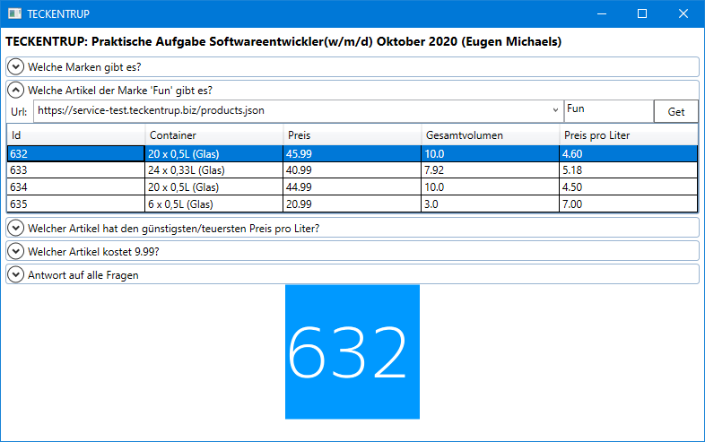

**Gateway**

The Backend application. Makes requests to url and works with data (filtering for questions).

Default settings are for working with ports 5000/5001

**DummyRestService**

Small rest service – an analogue for <https://service-test.teckentrup.biz/products.json>

By default, it works with ports 9000/9001

I used it for testing during development.

**Models**

A dll-library with classes commonly used in project’s applications.

**Tests**

A project for unit-testing.