First Survey:

Summary & Reccomendation Matrix <https://docs.google.com/a/scu.edu/spreadsheets/d/1YDH86Td2CA9uwOvyHQ4X7VZS6FhJSR4WHQjksHK6e_0/edit?usp=sharing>

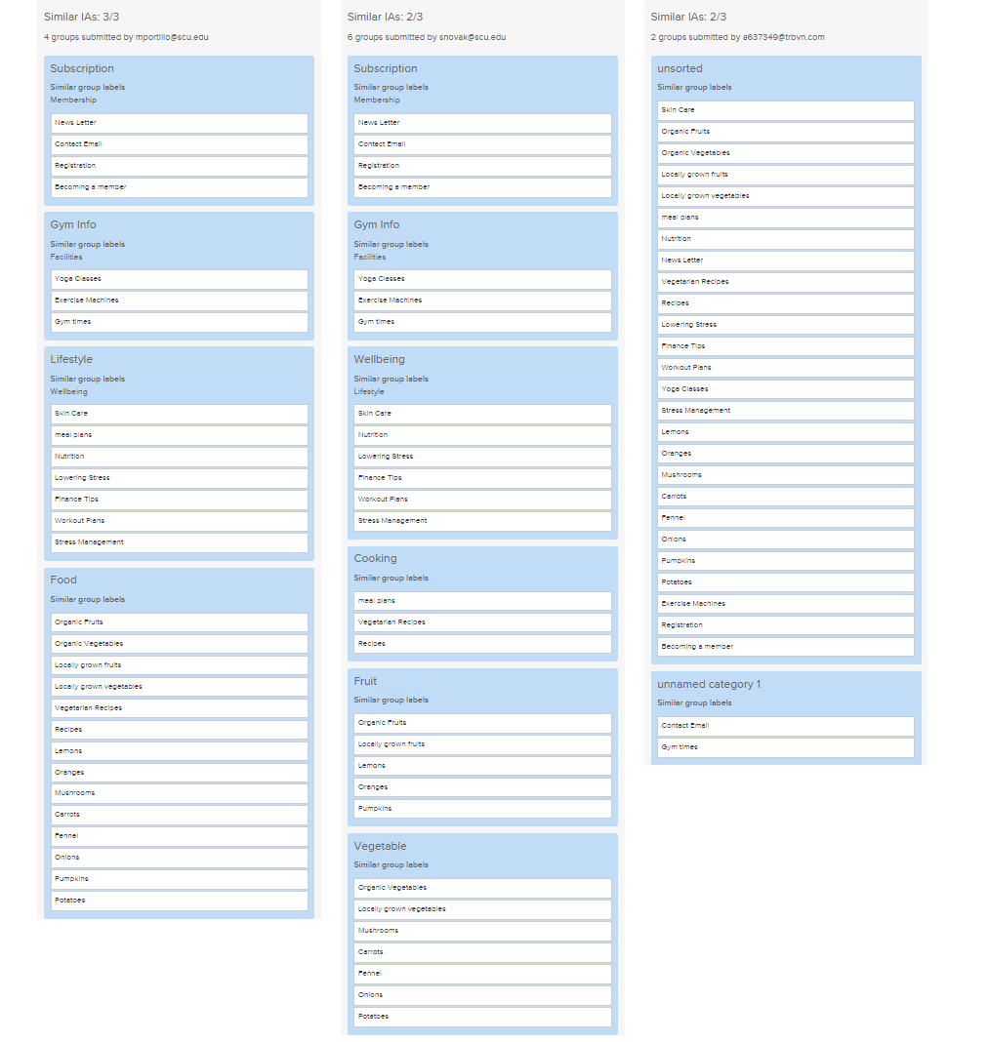

Second Survey:

Matrix:

<https://docs.google.com/a/scu.edu/spreadsheets/d/1_xuAtb8574FIT6pqpAu4oskdemTxxQcNx8tBPa27fAQ/edit?usp=sharing>

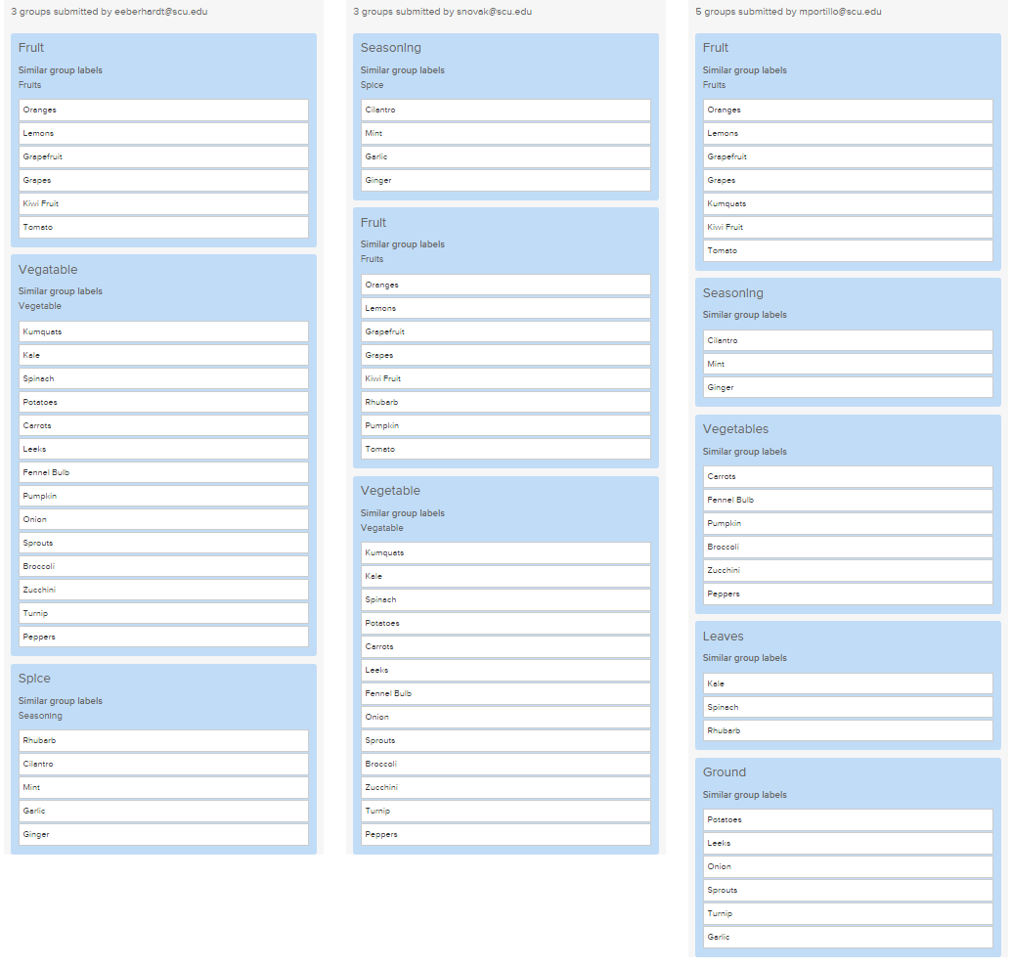

|  |  |
| --- | --- |
| **Category** | **Items** |
| Fruit | Oranges  Lemons  Grapefruit  Grapes  Kiwi Fruit  Tomato |
| Vegetable | Pumpkin  Kumquats  Kale  Spinach  Potatoes  Carrots  Leeks  Fennel Bulb  Onion  Sprouts  Broccoli  Zucchini  Turnip  Peppers |
| Seasoning Spice | Rhubarb  Garlic  Cilantro  Mint  Ginger |