ELEN 050L (Electric Circuits I): Project 1, Evan Eberhardt, Ryan Meyer 1
Initialize MATLAB Environment 2
Setup global variables 2
Problem 1 3
Problem 2 5
Problem 3 12
Problem 4 19
Program execution complete 30
MATLAB code listing 30

ELEN 050L (Electric Circuits I): Project 1, Evan Eberhardt, Ryan Meyer
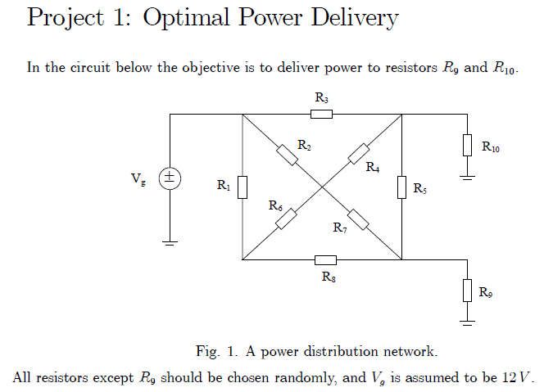
- Problem 1: Find a Thevenin equivalent with respect to . Use this result to determine conditions under which absorbs maximal power.
- Problem 2: Create an m-file in MATLAB that will compute powers , and the efficiency coefficient for different values of . Plot and on one graph and on another using a logarithmic scale for . NOTE: Your plot for should be consistent with the results obtained in Problem 1.
- Problem 3: Based on the plots obtained in Problem 2, select so that is maximized with the following additional constraint: 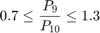
- Problem 4: Assemble the circuit in Figure 1 and measure , and over an appropriate range of values for . Plot the measured values in MATLAB and compare with your simulation results. Have the requirements for , and been satisfied with the choice of obtained in Problem 3? NOTE: Think about how you are going to measure the generated power before you come to lab!
Hard Copy Deliverables:
- A MATLAB script and publish the solution using MATLAB's publish feature.
- Turn in MATLAB scripts and a document of the run-time results.
- Turn in the Excel file with the measured results.
Hints:
- Make sure that the choices for resistors satisfy the following relationship .
- Make sure that the choices for resistors satisfy the following relationship .
- Generate 5 KCL equations, 1 at each point of the square and 1 in the middle of the square.
- Use the 5 KCL equations as a starting point to simply the calculations required for computing and .

Initialize MATLAB Environment
clear; clc; clf; cla; close all;
format short; format compact;

Setup global variables
% These element values are fixed in the circuit.
VG = 12; % Generator voltage
R1 = 510; % Ohms
R2 = 680; % Ohms
R3 = 680; % Ohms
R4 = 680; % Ohms
R5 = 1000; % Ohms
R6 = 1000; % Ohms
R7 = 1000; % Ohms
R8 = 1200; % Ohms
R10 = 1200; % Ohms
% Build an array for R1 through R8, and R10 (use if calling the function).
% Note that the index for R9 is set to 0 Ohms, but this is just a place
% holder in the array to make the code readable inside the external
% function (if it is used).
RN = [R1, R2, R3, R4, R5, R6, R7, R8, 0, R10]; % Ohms
% This element value is the R9 variable in the circuit.
R9 = [1:10:10^5]; % Ohms
% These values establish the constraints for the P9/P10 ratio.
P9_div_P10_ratio_min = 0.7;
P9_div_P10_ratio_max = 1.3;
% These values are used for plotting purposes.
fignum = 5;
symbolic_mode = true;

Problem 1
Find a Thevenin equivalent with respect to as illustrated in Figure 2, where , and .
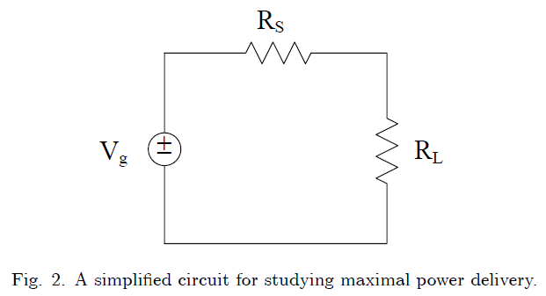
The computations for are based upon Figure 3.
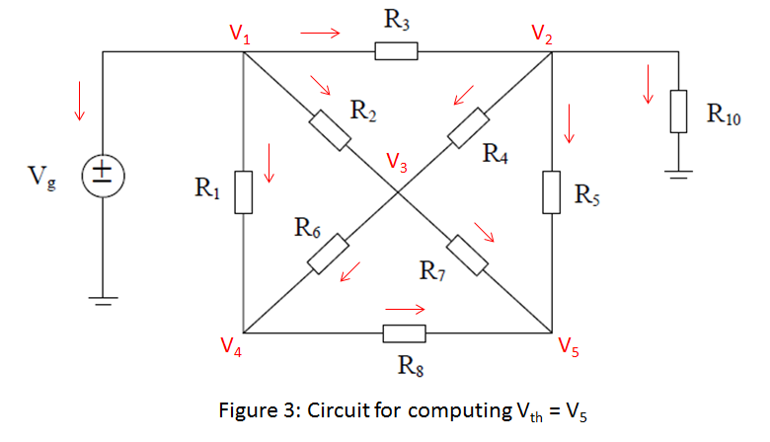
A = [ (1) (0) (0) (0) (0); ...
(-1/R3) (1/R3 + 1/R4 + 1/R5 + 1/R10) (-1/R4) (0) (-1/R5); ...
(-1/R2) (-1/R4) (1/R2 + 1/R4 + 1/R6 + 1/R7) (-1/R6) (-1/R7); ...
(-1/R1) (0) (-1/R6) (1/R1 + 1/R6 + 1/R8) (-1/R8); ...
(0) (-1/R5) (-1/R7) (-1/R8) (1/R5 + 1/R7 + 1/R8)];
b = [VG; 0; 0; 0; 0];
V = A\b;
Vth = V(5);
fprintf('\nThe Thevenin voltage is Vth = %-6.4f Volts.\n',Vth);
The Thevenin voltage is Vth = 10.3011 Volts.
The computations for are based upon Figure 4.
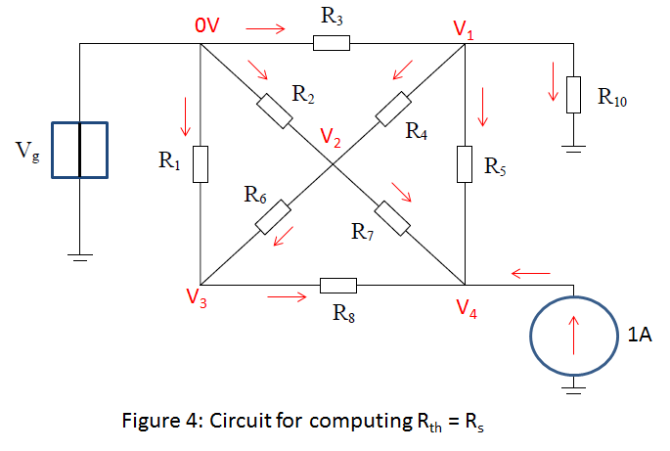
A = [ (1/R3 + 1/R4 + 1/R5 + 1/R10) (-1/R4) (0) (-1/R5); ...
(-1/R4) (1/R2 + 1/R4 + 1/R6 + 1/R7) (-1/R6) (-1/R7); ...
(0) (-1/R6) (1/R1 + 1/R6 + 1/R8) (-1/R8); ...
(-1/R5) (-1/R7) (-1/R8) (1/R5 + 1/R7 + 1/R8)];
b = [0; 0; 0; 1];
V = A\b;
Rth = V(4)/1;
fprintf('\nThe Thevenin resistance is Rth = %-6.4f Ohms.\n',Rth);
The Thevenin resistance is Rth = 529.5334 Ohms.

Problem 2
Compute powers , and the efficiency coefficient for different values of .
The computations are based upon Figure 5.
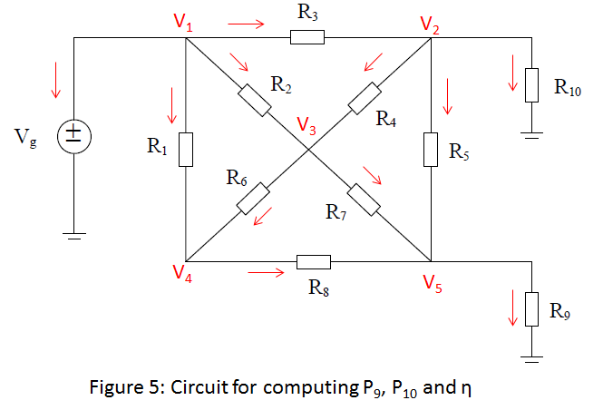
G1 = [ 1, 0, 0, 0, 0; ...
(-1/R3), ((1/R3)+(1/R4)+(1/R5)+(1/R10)), (-1/R4), 0, (-1/R5); ...
(-1/R2), (-1/R4), ((1/R2)+(1/R6)+(1/R7)+(1/R4)), (-1/R6), (-1/R7); ...
(-1/R1), 0, (-1/R6), ((1/R1)+(1/R6)+(1/R8)), (-1/R8); ...
0, (-1/R5), (-1/R7), (-1/R8), ((1/R8)+(1/R7)+(1/R5)) ...
];
G2 = [ 0, 0, 0, 0, 0; ...
0, 0, 0, 0, 0; ...
0, 0, 0, 0, 0; ...
0, 0, 0, 0, 0; ...
0, 0, 0, 0, 1 ...
];
b = [ VG; 0; 0; 0; 0];
The following block of code is an external function that has been inserted here for documentation purposes in the final solution.
% Beginning of proj1E50 function (inserted here for MATLAB publish)
P9 = []; P10 = []; eta = []; PG = [];
for iter = 1:length(R9)
% We have to solve the circuit once for each different value of R9.
% Since all these different values are stored in a vector R9,
% length(R9) determines how many times we must execute the loop.
R9_iter = R9(iter);
% R9_iter takes the next value from vector R9.
A = G1 + (1/R9_iter)*G2;
V = A\b;
% V contains the solution of the node voltage equations.
PR9 = (V(5)^2)/R9_iter;
PR10 = (V(2)^2)/R10;
IR1 = (V(1)-V(4))/R1;
IR2 = (V(1)-V(3))/R2;
IR3 = (V(1)-V(2))/R3;
IG = IR1 + IR2 + IR3;
PG_iter = VG * IG;
PG = [PG, PG_iter];
% Computation of the powers associated with R9, R10 and the generator.
P9 = [P9, PR9];
P10 = [P10, PR10];
% Powers PR9 and PR10 computed for different values of R9 are stored
% in vectors P9 and P10.
W = (PR9 + PR10) / PG_iter;
eta = [eta, W];
% Eta represents the percentage of the generated power that is absorbed
% by resistors R9 and R10.
end;
% End of proj1E50 function (inserted here for MATLAB publish)
Generate the plot for and indicate where occurs. The location should match the calculation for .
% Initialize for plot
plot_left_r9 = min(R9); plot_right_r9 = max(R9);
PG_plot_min = 0; PG_plot_max = max(PG);
P9_min = 0; P9_max = max(P9);
P10_min = 0; P10_max = max(P10);
eta_plot_min = 0; eta_plot_max = max(eta);
fignum = fignum+1; figObj = figure(fignum); % Establish a figure number
set(fignum, 'Name',['P9(R9) at Rth']); % Name the figure
P9_Rth_Plot = semilogx(R9,P9); % Generate plot
grid on; % Turn grid on
xlabel('Resistance: R_9 (\Omega)'); % Label the axis
ylabel('Power: P_9 (Watts)'); % Label the axis
axis([plot_left_r9, plot_right_r9,...
P9_min, ...
P9_max+0.01]); % Bound plot
title(['Figure ',num2str(fignum,'%-2.u'),...
': P_9(R_9) with max at R_t_h']);
legend('P_9(R_9)', 'Location', 'Best');
% Find the R9 values that satisfy max(P9)
cursor1 = 1; cursor2 = 1;
cursor1_found = false; cursor2_found = false;
R9_best = -1.0;
for iter = 1:length(R9) % Locate the left min constraint
if (~(cursor1_found) && ...
P9(iter) >= P9_max && ...
P9(iter) <= P9_max)
cursor1 = iter;
R9_left_min = R9(iter);
cursor1_found = true;
break;
end;
end;
for iter = cursor1+1:length(R9) % Locate the left max constraint
if (~(cursor2_found) && ...
(P9(iter) < P9(iter-1) || ...
P9(iter) > P9_max))
if (P9(iter-1) <= P9_max)
cursor2 = iter-1;
R9_left_max = R9(iter-1);
else
cursor2 = iter;
R9_left_max = R9(iter);
end;
cursor2_found = true;
break;
end;
end;
makedatatip(P9_Rth_Plot, [cursor1; cursor2]);
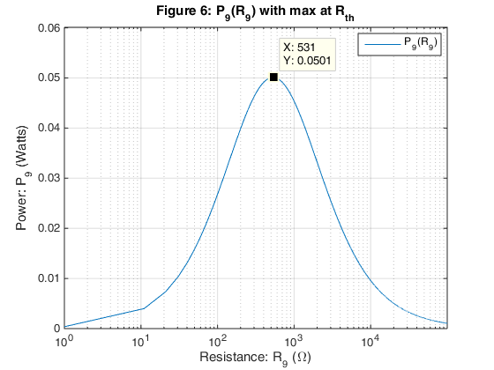
fprintf(...
'\nFrom Figure %-2.u the maximum P9 occurs at R9 = %-6.4f Ohms.\n',...
fignum, R9(floor(mean(cursor1,cursor2))));
fprintf('\nFrom Figure %-2.u the maximum P9 is = %-6.4f Watts.\n',...
fignum, P9(floor(mean(cursor1,cursor2))));
From Figure 6 the maximum P9 occurs at R9 = 531.0000 Ohms.
From Figure 6 the maximum P9 is = 0.0501 Watts.
Generate the plots for , , and .
fignum = fignum+1; figObj = figure(fignum); % Establish a figure number
set(fignum, 'Name',['PG(R9)']); % Name the figure
PG_Plot = semilogx( R9, PG); % Generate plot
grid on; % Turn grid on
xlabel('Resistance: R_9 (\Omega)'); % Label the axis
ylabel('Power: P_G (Watts)'); % Label the axis
axis([plot_left_r9, plot_right_r9,...
PG_plot_min, ...
PG_plot_max+0.01]); % Bound plot
title(['Figure ',num2str(fignum,'%-2.u'),...
': P_G(R_9)']);
legend('P_G(R_9)', 'Location', 'Best');
fignum = fignum+1; figObj = figure(fignum); % Establish a figure number
set(fignum, 'Name',['P9(R9) and P10(R9)']); % Name the figure
P9_P10_Plot = semilogx( R9, P9, R9, P10); % Generate plot
grid on; % Turn grid on
xlabel('Resistance: R_9 (\Omega)'); % Label the axis
ylabel('Power: P_9 and P_1_0 (Watts)'); % Label the axis
axis([plot_left_r9, plot_right_r9,...
min(P9_min,P10_min), ...
max(P9_max,P10_max)+0.01]); % Bound plot
title(['Figure ',num2str(fignum,'%-2.u'),...
': P_9(R_9) and P_1_0(R_9)']);
legend('P_9(R_9)', 'P_1_0(R_9)', 'Location', 'Best');
fignum = fignum+1; figObj = figure(fignum); % Establish a figure number
set(fignum, 'Name',['Coefficient eta']); % Name the figure
eta_Plot = semilogx( R9, eta); % Generate plot
grid on; % Turn grid on
xlabel('Resistance: R_9 (\Omega)'); % Label the axis
ylabel('Coefficient: \eta'); % Label the axis
axis([plot_left_r9, plot_right_r9,...
eta_plot_min, eta_plot_max+0.1]); % Bound plot
title(['Figure ',num2str(fignum,'%-2.u'),': \eta(R_9)']);
legend('\eta', 'Location', 'Best');
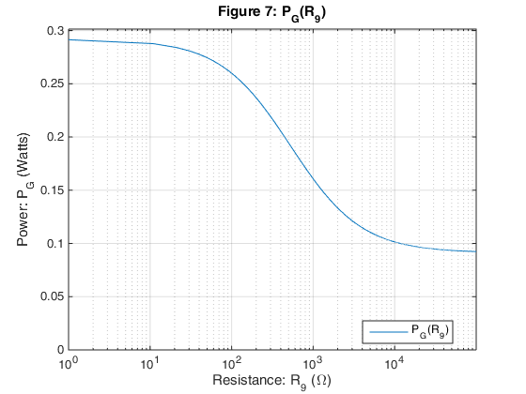
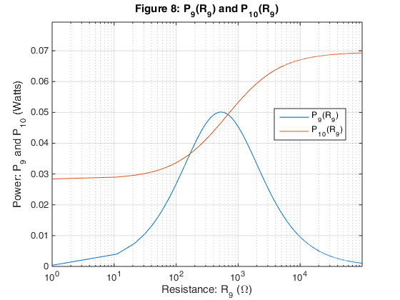
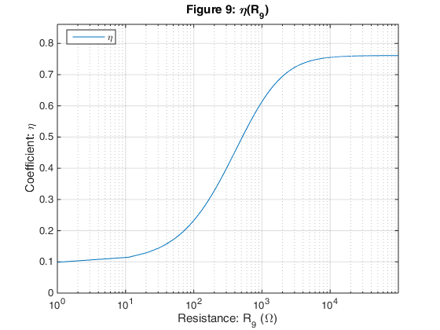

Problem 3
Select so that is maximized with the following additional constraint: .
P9_div_P10 = P9 ./ P10;
P9_div_P10_min = 0; P9_div_P10_max = max(P9_div_P10);
fignum = fignum+1; figObj = figure(fignum); % Establish a figure number
set(fignum, 'Name',['P9/P10']); % Name the figure
P9_div_P10_Plot = semilogx( R9,P9_div_P10); % Generate plot
grid on; % Turn grid on
xlabel('Resistance: R_9 (\Omega)'); % Label the axis
ylabel('Ratio: P_9/P_1_0'); % Label the axis
axis([plot_left_r9, plot_right_r9,...
P9_div_P10_min, P9_div_P10_max+0.2]); % Bound plot
title(['Figure ',num2str(fignum,'%-2.u'),': P_9/P_1_0 versus R_9']);
legend('P_9/P_1_0', 'Location', 'Best');
% Find the R9 values that satisfy the P9/P10 ratio constraints
cursor1 = 1; cursor2 = 1;
cursor3 = 1; cursor4 = 1;
cursor1_found = false; cursor2_found = false;
cursor3_found = false; cursor4_found = false;
R9_best = -1.0; eta_max = -1.0; locator = -1;
for iter = 1:length(R9) % Locate the left min constraint
if (~(cursor1_found) && ...
P9_div_P10(iter) >= P9_div_P10_ratio_min && ...
P9_div_P10(iter) <= P9_div_P10_ratio_max)
cursor1 = iter;
R9_left_min = R9(iter);
eta_left_min = eta(iter);
% Calculate the best choice for R9
if (eta_left_min > eta_max)
eta_max = eta_left_min;
R9_best = R9_left_min;
locator = cursor1;
end;
cursor1_found = true;
break;
end;
end;
for iter = cursor1+1:length(R9) % Locate the left max constraint
if (~(cursor2_found) && ...
(P9_div_P10(iter) < P9_div_P10(iter-1) || ...
P9_div_P10(iter) > P9_div_P10_ratio_max))
if (P9_div_P10(iter-1) <= P9_div_P10_ratio_max)
cursor2 = iter-1;
R9_left_max = R9(iter-1);
eta_left_max = eta(iter-1);
else
cursor2 = iter;
R9_left_max = R9(iter);
eta_left_max = eta(iter);
end;
% Calculate the best choice for R9
if (eta_left_max > eta_max)
eta_max = eta_left_max;
R9_best = R9_left_max;
locator = cursor2;
end;
cursor2_found = true;
break;
end;
end;
for iter = cursor2+1:length(R9) % Locate the right max constraint
if (~(cursor3_found) && ...
P9_div_P10(iter) >= P9_div_P10_ratio_min && ...
P9_div_P10(iter) <= P9_div_P10_ratio_max)
if (P9_div_P10(iter-1) <= P9_div_P10_ratio_max)
cursor3 = iter-1;
R9_right_max = R9(iter-1);
eta_right_max = eta(iter-1);
else
cursor3 = iter;
R9_right_max = R9(iter);
eta_right_max = eta(iter);
end;
% Calculate the best choice for R9
if (eta_right_max > eta_max)
eta_max = eta_right_max;
R9_best = R9_right_max;
locator = cursor3;
end;
cursor3_found = true;
break;
end;
end;
for iter = cursor3+1:length(R9) % Locate the right min constraint
if (~(cursor4_found) && ...
P9_div_P10(iter) < P9_div_P10_ratio_min)
if (P9_div_P10(iter-1) >= P9_div_P10_ratio_min)
cursor4 = iter-1;
R9_right_min = R9(iter-1);
eta_right_min = eta(iter-1);
else
cursor4 = iter;
R9_right_min = R9(iter);
eta_right_min = eta(iter);
end;
% Calculate the best choice for R9
if (eta_right_min > eta_max)
eta_max = eta_right_min;
R9_best = R9_right_min;
locator = cursor4;
end;
cursor3_found = true;
break;
end;
end;
fignum = fignum+1; figObj = figure(fignum); % Establish a figure number
set(fignum, 'Name',['Coefficient eta']); % Name the figure
eta_Plot2 = semilogx( R9, eta); % Generate plot
grid on; % Turn grid on
xlabel('Resistance: R_9 (\Omega)'); % Label the axis
ylabel('Coefficient: \eta'); % Label the axis
axis([plot_left_r9, plot_right_r9,...
eta_plot_min, eta_plot_max+0.1]); % Bound plot
title(['Figure ',num2str(fignum,'%-2.u'),': \eta(R_9)']);
legend('\eta', 'Location', 'Best');
% Display target cursors
makedatatip(P9_div_P10_Plot, [cursor1; cursor2; cursor3; cursor4]);
makedatatip(eta_Plot2 , [locator]);
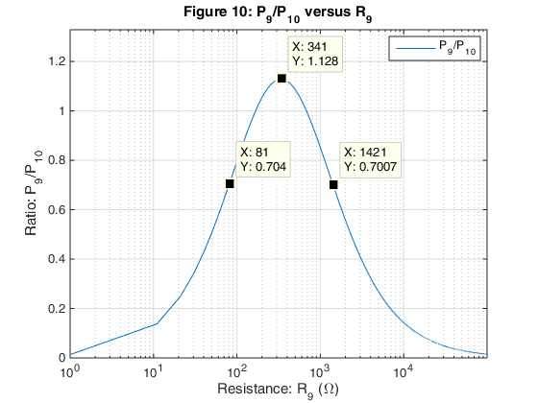
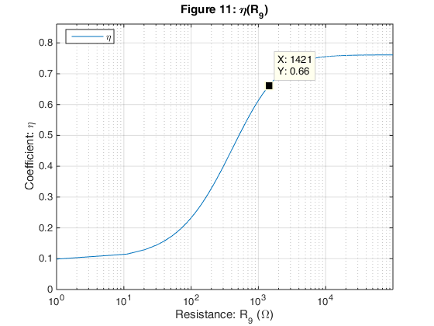
fprintf('\nThe following data is determined from Figure %-2.u.\n', fignum);
fprintf('\n The index locator into the arrays = %u.\n', locator);
fprintf('\n Given we wish to maximize the coefficient eta,\n');
fprintf(' the best result for eta = %-6.4f.\n', eta_max);
fprintf(' The best choice for R9 = %-6.4f Ohms.\n', R9_best);
fprintf(' The power dissipated in R9 = %-6.4f Watts.\n', P9(locator));
fprintf(' The power dissipated in R10 = %-6.4f Watts.\n', P10(locator));
The following data is determined from Figure 11.
The index locator into the arrays = 143.
Given we wish to maximize the coefficient eta,
the best result for eta = 0.6600.
The best choice for R9 = 1421.0000 Ohms.
The power dissipated in R9 = 0.0396 Watts.
The power dissipated in R10 = 0.0566 Watts.
Update the plots for , and with the target indicators.
fignum = fignum+1; figObj = figure(fignum); % Establish a figure number
set(fignum, 'Name',['PG(R9)']); % Name the figure
PG_Plot2 = semilogx( R9, PG); % Generate plot
grid on; % Turn grid on
xlabel('Resistance: R_9 (\Omega)'); % Label the axis
ylabel('Power: P_G (Watts)'); % Label the axis
axis([plot_left_r9, plot_right_r9,...
PG_plot_min, ...
PG_plot_max+0.01]); % Bound plot
title(['Figure ',num2str(fignum,'%-2.u'),...
': P_G(R_9)']);
legend('P_G(R_9)', 'Location', 'Best');
fignum = fignum+1; figObj = figure(fignum); % Establish a figure number
set(fignum, 'Name',['P9(R9)']); % Name the figure
P9_Plot = semilogx( R9, P9); % Generate plot
grid on; % Turn grid on
xlabel('Resistance: R_9 (\Omega)'); % Label the axis
ylabel('Power: P_9 (Watts)'); % Label the axis
axis([plot_left_r9, plot_right_r9,...
P9_min, P9_max+0.01]); % Bound plot
title(['Figure ',num2str(fignum,'%-2.u'),...
': P_9(R_9)']);
legend('P_9(R_9)', 'Location', 'Best');
fignum = fignum+1; figObj = figure(fignum); % Establish a figure number
set(fignum, 'Name',['P10(R9)']); % Name the figure
P10_Plot = semilogx( R9, P10); % Generate plot
grid on; % Turn grid on
xlabel('Resistance: R_9 (\Omega)'); % Label the axis
ylabel('Power: P_1_0 (Watts)'); % Label the axis
axis([plot_left_r9, plot_right_r9,...
P10_min, P10_max+0.01]); % Bound plot
title(['Figure ',num2str(fignum,'%-2.u'),...
': P_1_0(R_9)']);
legend('P_1_0(R_9)', 'Location', 'Best');
% Display target cursors (annotated results from Problem 3)
makedatatip(PG_Plot2 , [locator]);
makedatatip(P9_Plot , [locator]);
makedatatip(P10_Plot , [locator]);
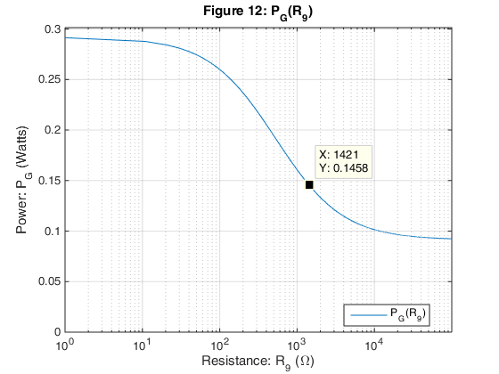
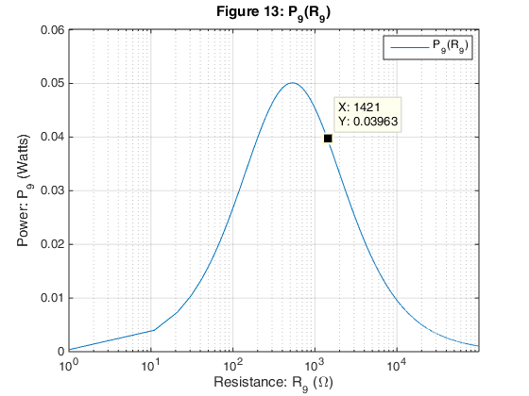
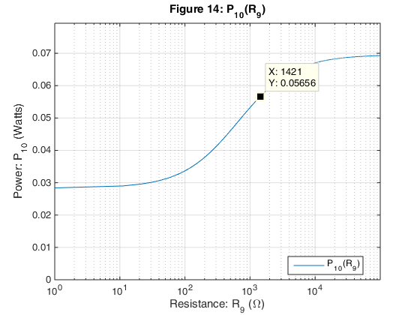

Problem 4
Assemble the circuit in Figure 1 and measure , and over an appropriate range of values for .
The measured values are contained in the external Excel spreadsheet file named "ELEN050L_Project_1_Measured_Results". These measured values are imported into MATLAB at run-time using MATLAB's Import feature. For the solution shown below, the initial "import" was executed to generate an external function file which can be called at run-time.
The measured values for the circuit elements are shown below.
display(' ');
fprintf('\nMeasured values for the voltage elements are (Volts):\n');
VG_meas = 11.995 % Generator voltage
Vth_meas = 10.288 % Thevenin voltage
Measured values for the voltage elements are (Volts):
VG_meas =
11.9950
Vth_meas =
10.2880
Compare the measured to the expected value.
Vth_diff = (Vth_meas - Vth)/Vth * 100;
fprintf('\nThe difference between measured and expected\n');
fprintf(' Vth = %-6.4f%%.\n', Vth_diff);
The difference between measured and expected
Vth = -0.1276%.
Compare the measured to the expected value.
display(' ');
fprintf('\nMeasured values for the resistive elements are (Ohms):\n');
R1_meas = 507; % Ohms
R2_meas = 676; % Ohms
R3_meas = 674; % Ohms
R4_meas = 680; % Ohms
R5_meas = 985; % Ohms
R6_meas = 980; % Ohms
R7_meas = 991; % Ohms
R8_meas = 1168; % Ohms
R10_meas = 1189; % Ohms
Rth_meas = 522; % Thevenin resistance
Measured values for the resistive elements are (Ohms):
Compare the measured to the expected value.
Rth_diff = (Rth_meas - Rth)/Rth * 100;
fprintf('\nThe difference between measured and expected\n');
fprintf(' Rth = %-6.4f%%.\n', Rth_diff);
display(' ');
The difference between measured and expected
Rth = -1.4226%.
Import the measured data for processing.
[R9_decade,Vmeas_R9,Vmeas_R10,Vmeas_R1,Vmeas_R2,Vmeas_R3] = ...
importfile(...
'ELEN050L_Project_1_Measured_Results_blank.xlsx',...
'Sheet1',2,49);
Calculate the measured , , and over the range of decade box values used for in the experiment.
% Compute generator power from measured values
I1_meas = (Vmeas_R1) ./ R1_meas;
I2_meas = (Vmeas_R2) ./ R2_meas;
I3_meas = (Vmeas_R3) ./ R3_meas;
IG_meas = I3_meas + I2_meas + I1_meas;
PG_meas = IG_meas .* VG;
% Compute P9 and P10 from measured values
P9_meas = (Vmeas_R9).^2 ./ R9_decade;
P10_meas = (Vmeas_R10).^2 ./ R10_meas;
% Compute eta from measured values
eta_meas = (P9_meas + P10_meas) ./ PG_meas;
Plot the measured values in MATLAB and compare them to the simulation results.
% Initialize for plot
plot_left_r9_decade = min(R9_decade);
plot_right_r9_decade = max(R9_decade);
PG_plot_min_meas = 0; PG_plot_max_meas = max(PG_meas);
P9_min_meas = 0; P9_max_meas = max(P9_meas);
P10_min_meas = 0; P10_max_meas = max(P10_meas);
eta_plot_min_meas = 0; eta_plot_max_meas = max(eta_meas);
fignum = fignum+1; figObj = figure(fignum); % Establish a figure number
set(fignum, 'Name',['Measured P9(R9) at Rth']); % Name the figure
P9_Meas_Rth_Plot = semilogx(R9_decade, P9_meas); % Generate plot
grid on; % Turn grid on
xlabel('Decade Box Resistance: R_9 (\Omega)'); % Label the axis
ylabel('Measured Power: P_9 (Watts)'); % Label the axis
axis([plot_left_r9_decade, plot_right_r9_decade,...
P9_min_meas, ...
P9_max_meas+0.01]); % Bound plot
title(['Figure ',num2str(fignum,'%-2.u'),...
': Measured P_9(R_9) with max at R_t_h']);
legend('Measured P_9(R_9)', 'Location', 'Best');
% Find the Decade Box R9 values that satisfy max(P9_meas)
cursor1_meas = 1; cursor2_meas = 1;
cursor1_found_meas = false; cursor2_found_meas = false;
R9_best_decade = -1.0;
for iter = 1:length(R9_decade) % Locate the left min constraint
if (~(cursor1_found_meas) && ...
P9_meas(iter) >= P9_max_meas && ...
P9_meas(iter) <= P9_max_meas)
cursor1_meas = iter;
R9_left_min_decade = R9_decade(iter);
cursor1_found_meas = true;
break;
end;
end;
for iter = cursor1_meas+1:length(R9_decade) % Locate the left max constraint
if (~(cursor2_found_meas) && ...
(P9_meas(iter) < P9_meas(iter-1) || ...
P9_meas(iter) > P9_max_meas))
if (P9_meas(iter-1) <= P9_max_meas)
cursor2_meas = iter-1;
R9_left_max_decade = R9_decade(iter-1);
else
cursor2_meas = iter;
R9_left_max_decade = R9_decade(iter);
end;
cursor2_found_meas = true;
break;
end;
end;
makedatatip(P9_Meas_Rth_Plot, [cursor1_meas; cursor2_meas]);
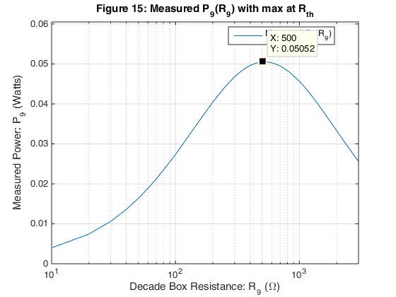
fprintf('\nFrom Figure %-2.u the maximum measured P9 occurs at\n', fignum);
fprintf(' R9 = %-6.4f Ohms.\n',...
R9_decade(floor(mean(cursor1_meas,cursor2_meas))));
fprintf('\nFrom Figure %-2.u the maximum measured P9\n', fignum);
fprintf(' is = %-6.4f Watts.\n',...
P9_meas(floor(mean(cursor1_meas,cursor2_meas))));
From Figure 15 the maximum measured P9 occurs at
R9 = 500.0000 Ohms.
From Figure 15 the maximum measured P9
is = 0.0505 Watts.
From the measured values select so that is maximized with the following additional constraint: .
P9_div_P10_meas = P9_meas ./ P10_meas;
P9_div_P10_min_meas = 0; P9_div_P10_max_meas = max(P9_div_P10_meas);
fignum = fignum+1; figObj = figure(fignum); % Establish a figure number
set(fignum, 'Name',['Measured P9/P10']); % Name the figure
P9_div_P10_Meas_Plot = ...
semilogx( R9_decade, P9_div_P10_meas); % Generate plot
grid on; % Turn grid on
xlabel('Decade Box Resistance: R_9 (\Omega)'); % Label the axis
ylabel('Measured Ratio: P_9/P_1_0'); % Label the axis
axis([plot_left_r9_decade, ...
plot_right_r9_decade,...
P9_div_P10_min_meas, ...
P9_div_P10_max_meas+0.2]); % Bound plot
title(...
['Figure ',num2str(fignum,'%-2.u'),': Measured P_9/P_1_0 versus R_9']);
legend('Measured P_9/P_1_0', 'Location', 'Best');
% Find the R9 values that satisfy the P9/P10 ratio constraints
cursor1_meas = 1; cursor2_meas = 1;
cursor3_meas = 1; cursor4_meas = 1;
cursor1_found_meas = false; cursor2_found_meas = false;
cursor3_found_meas = false; cursor4_found_meas = false;
R9_best_meas = -1.0; eta_max_meas = -1.0; locator_meas = -1;
for iter = 1:length(R9_decade) % Locate the left min constraint
if (~(cursor1_found_meas) && ...
P9_div_P10_meas(iter) >= P9_div_P10_ratio_min && ...
P9_div_P10_meas(iter) <= P9_div_P10_ratio_max)
cursor1_meas = iter;
R9_left_min_meas = R9_decade(iter);
eta_left_min_meas = eta_meas(iter);
% Calculate the best choice for R9
if (eta_left_min_meas > eta_max_meas)
eta_max_meas = eta_left_min_meas;
R9_best_meas = R9_left_min_meas;
locator_meas = cursor1_meas;
end;
cursor1_found_meas = true;
break;
end;
end;
for iter = cursor1_meas+1:length(R9_decade)% Locate the left max constraint
if (~(cursor2_found_meas) && ...
(P9_div_P10_meas(iter) < P9_div_P10_meas(iter-1) || ...
P9_div_P10_meas(iter) > P9_div_P10_ratio_max))
if (P9_div_P10_meas(iter-1) <= P9_div_P10_ratio_max)
cursor2_meas = iter-1;
R9_left_max_meas = R9_decade(iter-1);
eta_left_max_meas = eta_meas(iter-1);
else
cursor2_meas = iter;
R9_left_max_meas = R9_decade(iter);
eta_left_max_meas = eta_meas(iter);
end;
% Calculate the best choice for R9
if (eta_left_max_meas > eta_max_meas)
eta_max_meas = eta_left_max_meas;
R9_best_meas = R9_left_max_meas;
locator_meas = cursor2_meas;
end;
cursor2_found_meas = true;
break;
end;
end;
for iter = cursor2_meas+1:length(R9_decade)% Locate the right max constraint
if (~(cursor3_found_meas) && ...
P9_div_P10_meas(iter) >= P9_div_P10_ratio_min && ...
P9_div_P10_meas(iter) <= P9_div_P10_ratio_max)
if (P9_div_P10_meas(iter-1) <= P9_div_P10_ratio_max)
cursor3_meas = iter-1;
R9_right_max_meas = R9_decade(iter-1);
eta_right_max_meas = eta_meas(iter-1);
else
cursor3_meas = iter;
R9_right_max_meas = R9_decade(iter);
eta_right_max_meas = eta_meas(iter);
end;
% Calculate the best choice for R9
if (eta_right_max_meas > eta_max_meas)
eta_max_meas = eta_right_max_meas;
R9_best_meas = R9_right_max_meas;
locator_meas = cursor3_meas;
end;
cursor3_found_meas = true;
break;
end;
end;
for iter = cursor3_meas+1:length(R9_decade)% Locate the right min constraint
if (~(cursor4_found_meas) && ...
P9_div_P10_meas(iter) < P9_div_P10_ratio_min)
if (P9_div_P10_meas(iter-1) >= P9_div_P10_ratio_min)
cursor4_meas = iter-1;
R9_right_min_meas = R9_decade(iter-1);
eta_right_min_meas = eta_meas(iter-1);
else
cursor4_meas = iter;
R9_right_min_meas = R9_decade(iter);
eta_right_min_meas = eta_meas(iter);
end;
% Calculate the best choice for R9
if (eta_right_min_meas > eta_max_meas)
eta_max_meas = eta_right_min_meas;
R9_best_meas = R9_right_min_meas;
locator_meas = cursor4_meas;
end;
cursor3_found_meas = true;
break;
end;
end;
fignum = fignum+1; figObj = figure(fignum); % Establish a figure number
set(fignum, ...
'Name',['Measured Coefficient eta']); % Name the figure
eta_Meas_Plot2 = semilogx( R9_decade, eta_meas); % Generate plot
grid on; % Turn grid on
xlabel('Decade Box Resistance: R_9 (\Omega)'); % Label the axis
ylabel('Measured Coefficient: \eta'); % Label the axis
axis([plot_left_r9_decade, ...
plot_right_r9_decade,...
eta_plot_min_meas, ...
eta_plot_max_meas+0.1]); % Bound plot
title(['Figure ',num2str(fignum,'%-2.u'),': Measured \eta(R_9)']);
legend('Measured \eta', 'Location', 'Best');
% Display target cursors
makedatatip(P9_div_P10_Meas_Plot, ...
[cursor1_meas; cursor2_meas; cursor3_meas; cursor4_meas]);
makedatatip(eta_Meas_Plot2 , [locator_meas]);
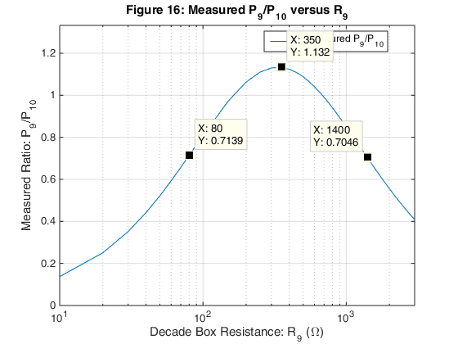
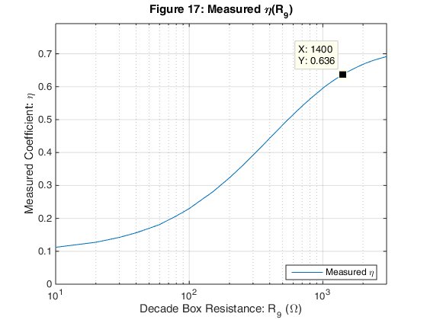
fprintf('\nThe following data is determined from Figure %-2.u.\n', fignum);
fprintf('\n The index locator into the arrays = %u.\n', locator_meas);
fprintf('\n Given we wish to maximize the coefficient eta,\n');
fprintf(' the best result for eta = %-6.4f.\n', eta_max_meas);
fprintf(' The best choice for R9 = %-6.4f Ohms.\n', R9_best_meas);
fprintf(' The power dissipated in R9 = %-6.4f Watts.\n', ...
P9_meas(locator_meas));
fprintf( ...
' The power dissipated in R10 = %-6.4f Watts.\n', ...
P10_meas(locator_meas));
The following data is determined from Figure 17.
The index locator into the arrays = 32.
Given we wish to maximize the coefficient eta,
the best result for eta = 0.6360.
The best choice for R9 = 1400.0000 Ohms.
The power dissipated in R9 = 0.0401 Watts.
The power dissipated in R10 = 0.0569 Watts.
Compare the measured best choice for to the expected value.
R9_best_diff = (R9_best_meas - R9_best)/R9_best * 100;
fprintf('\nThe difference between measured and expected\n');
fprintf(' R9_best = %-6.4f%%.\n', R9_best_diff);
display(' ');
The difference between measured and expected
R9_best = -1.4778%.
Generate the measured value plots for , , and .
fignum = fignum+1; figObj = figure(fignum); % Establish a figure number
set(fignum, 'Name',['Measured PG(R9)']); % Name the figure
PG_Meas_Plot = semilogx( R9_decade, PG_meas); % Generate plot
grid on; % Turn grid on
xlabel('Decade Box Resistance: R_9 (\Omega)'); % Label the axis
ylabel('Measured Power: P_G (Watts)'); % Label the axis
axis([plot_left_r9_decade, plot_right_r9_decade,...
PG_plot_min_meas, ...
PG_plot_max_meas+0.01]); % Bound plot
title(['Figure ',num2str(fignum,'%-2.u'),...
': Measured P_G(R_9)']);
legend('Measured P_G(R_9)', 'Location', 'Best');
fignum = fignum+1; figObj = figure(fignum); % Establish a figure number
set(fignum, 'Name',['Measured P9(R9)']); % Name the figure
P9_Meas_Plot = semilogx( R9_decade, P9_meas); % Generate plot
grid on; % Turn grid on
xlabel('Decade Box Resistance: R_9 (\Omega)'); % Label the axis
ylabel('Power: Measured P_9 (Watts)'); % Label the axis
axis([plot_left_r9_decade, ...
plot_right_r9_decade,...
P9_min_meas, ...
P9_max_meas+0.01]); % Bound plot
title(['Figure ',num2str(fignum,'%-2.u'),...
': Measured P_9(R_9)']);
legend('Measured P_9(R_9)', 'Location', 'Best');
fignum = fignum+1; figObj = figure(fignum); % Establish a figure number
set(fignum, 'Name',['Measured P10(R9)']); % Name the figure
P10_Meas_Plot = semilogx( R9_decade, P10_meas); % Generate plot
grid on; % Turn grid on
xlabel('Decade Box Resistance: R_9 (\Omega)'); % Label the axis
ylabel('Power: Measured P_1_0 (Watts)'); % Label the axis
axis([plot_left_r9_decade, ...
plot_right_r9_decade,...
P10_min_meas, ...
P10_max_meas+0.01]); % Bound plot
title(['Figure ',num2str(fignum,'%-2.u'),...
': Measured P_1_0(R_9)']);
legend('Measured P_1_0(R_9)', 'Location', 'Best');
makedatatip(PG_Meas_Plot , [locator_meas]);
makedatatip(P9_Meas_Plot , [locator_meas]);
makedatatip(P10_Meas_Plot , [locator_meas]);
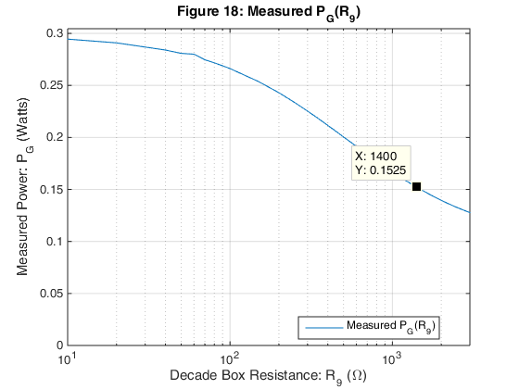
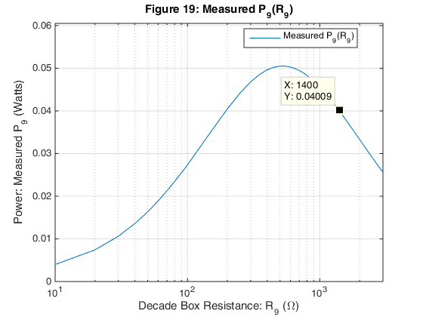
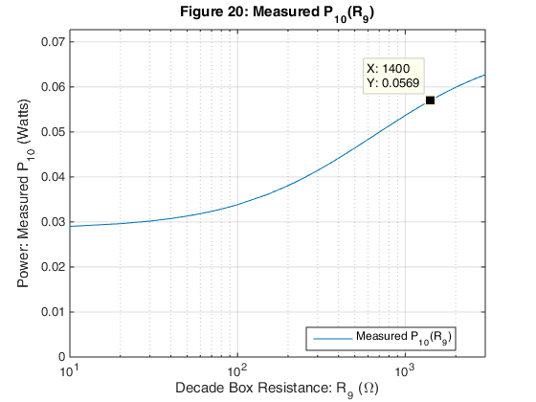

Program execution complete
display(' ');
disp('Program execution complete....');
Program execution complete....

MATLAB code listing
Published with MATLAB® R2014b

