Evan Eberhardt
9 April 2015
Lab: Thursday 2:15
Lab 1 1
Matrix Multiplication 1
Matrix Inverses 2
Solving Circuits with MATLAB 3
More About Matrix Inverses 4
Products of Time Functions 5

Lab 1
close all; clear all;

Matrix Multiplication
A=[2,1;3,2]
B=[3,1;2,2]
A_transpose= A'
B_transpose = B'
A1=A*B
A2=B*A
A3=(A'*B')'
A4=(B'*A')'
% A1=A4 and A2=A3
A =
2 1
3 2
B =
3 1
2 2
A_transpose =
2 3
1 2
B_transpose =
3 2
1 2
A1 =
8 4
13 7
A2 =
9 5
10 6
A3 =
9 5
10 6
A4 =
8 4
13 7

Matrix Inverses
A1=inv(A*B)
A2=inv(A)*inv(B)
A3=inv(B*A)
A4=inv(B)*inv(A)
A1*(A*B)
(A*B)*A1
% The two products are the Identity Matrix
A1 =
1.7500 -1.0000
-3.2500 2.0000
A2 =
1.5000 -1.2500
-2.5000 2.2500
A3 =
1.5000 -1.2500
-2.5000 2.2500
A4 =
1.7500 -1.0000
-3.2500 2.0000
ans =
1.0000 0
0.0000 1.0000
ans =
1.0000 -0.0000
0.0000 1.0000

Solving Circuits with MATLAB
C=[1,0,1;3,3,4;2,2,3]
S=[10;12;5]
V=inv(C)*S
C*V
C =
1 0 1
3 3 4
2 2 3
S =
10
12
5
V =
19.0000
-3.0000
-9.0000
ans =
10.0000
12.0000
5.0000

More About Matrix Inverses
D=[2,4;1,2]
inv(D)
% Finding the inverse requires calculating the determinant.
% The determinant of D is 1/0, which makes the elements of the inverse go
% to infinity. Thus there is no inverse of D.
D =
2 4
1 2
Warning: Matrix is singular to working precision.
ans =
Inf Inf
Inf Inf

Products of Time Functions
t=[0:0.01:10];
p = 5*cos(2*pi*3*t);
v=5*exp(-0.5*t);
plot(t,p,t,v)
b=p.*v;
plot(t,b)
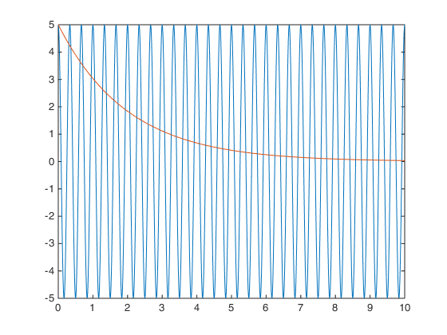
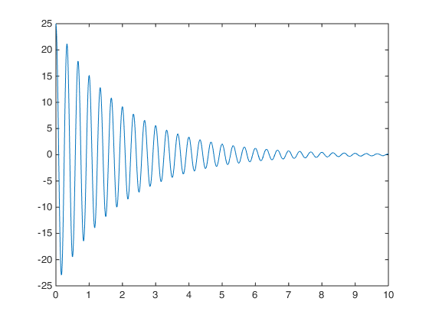
Published with MATLAB® R2014b

