CREATE TABLE sailors(

sid number primary key,

sname varchar2(30),

rating number,

age number

);

CREATE TABLE boat(

bid number primary key,

bname varchar2(30),

color varchar2(30)

);

CREATE TABLE reserve(

sid number,

bid number,

on_day date

);

INSERT INTO sailors VALUES(1,'avi',10,100);

INSERT INTO sailors VALUES(2,'ryan',10,10);

INSERT INTO sailors VALUES(3,'xyz',10,20);

INSERT INTO boat VALUES(1,'bOne','blue');

INSERT INTO boat VALUES(2,'bTwo','green');

INSERT INTO boat VALUES(2,'bThree','yellow');

INSERT INTO reserve VALUES(1,1,'12-july-2013');

INSERT IN reserve VALUES(2,2,'13-july-2013');

--display all the sailors who have reserved boats

SELECT s.sid,s.sname,r.bid

FROM sailors s

INNER JOIN reserve r

ON s.sid=r.sid;

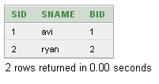

--all the sailors who have booked the boats

--as well as who have not booked or reserved any boats

--and boat information on which sailors have reserved.

SELECT s.sid,s.sname,r.bid

FROM sailors s

LEFT OUTER JOIN reserve r

ON s.sid=r.sid;

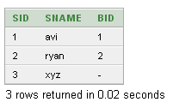

--other way around.

SELECT s.sid,s.sname,r.bid

FROM reserve r

LEFT OUTER JOIN sailors s

ON s.sid=r.sid;

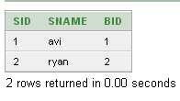

-- display information about all boats which are reserved by the sailors

-- as well as not reserved by any sailor

SELECT b.bid,b.bname,r.sid

FROM reserve r

RIGHT OUTER JOIN boat b

ON b.bid=r.bid;

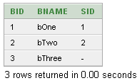

--Full outer join: on reserves and boat

SELECT b.bid,b.bname,r.sid

FROM reserve r

FULL OUTER JOIN boat b

ON b.bid=r.bid;

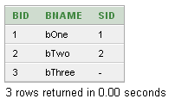

--not exists & exists

--find sailors who have not reserved any boats

SELECT s.sname FROM sailors s

WHERE NOT EXISTS(SELECT r.sid FROM reserve r WHERE r.sid=s.sid);

