**VPS details:**

**OS : Ubuntu 20.04.6 LTS**

**RAM: 1 GB**

**CPU: 1 CORE**

**Hard disk:25 GB**

############################################################################

**SWAP RAM:**

sudo dd if=/dev/zero of=/mnt/myswap.swap bs=1M count=4000

sudo mkswap /mnt/myswap.swap

sudo swapon /mnt/myswap.swap

free -h

############################################################################

**Install dependency for PIVX - 5.6.0**

sudo apt-get update && sudo apt-get -y upgrade

sudo apt-get dist-upgrade

sudo apt install make

sudo apt-get install -y curl

sudo apt install -y libc6-dev

sudo apt-get install -y build-essential

sudo apt install -y g++-mingw-w64-x86-64

sudo apt-get install -y automake

sudo apt-get install dh-autoreconf

sudo apt install -y libtool

sudo apt install -y pkg-config

sudo apt-get install git

sudo apt-get install unzip

sudo apt install -y python3.8

sudo update-alternatives --config x86_64-w64-mingw32-g++

(/usr/bin/x86_64-w64-mingw32-g++-posix) - **Choose this option**

sudo apt-get update && sudo apt-get -y upgrade

sudo apt-get install build-essential libtool autotools-dev automake pkg-config libssl-dev libevent-dev bsdmainutils python3

sudo apt-get install libboost-all-dev

sudo apt-get install software-properties-common

sudo add-apt-repository ppa:bitcoin/bitcoin

sudo apt-get update

sudo apt-get install libdb4.8-dev libdb4.8++-dev

sudo apt-get install libminiupnpc-dev

sudo apt-get install libzmq3-dev

sudo apt install libevent-dev

sudo apt install libsodium-dev

sudo apt install libgmp-dev

sudo apt-get install libqt5gui5 libqt5core5a libqt5dbus5 qttools5-dev qttools5-dev-tools libprotobuf-dev protobuf-compiler

sudo apt-get install libqrencode-dev

sudo apt install python3-pip

pip install setuptools

sudo apt install cmake

sudo apt install libcap-dev

sudo apt install libbz2-dev

sudo apt-get install python3-setuptools

############################################################################

**Depend Build guide for PIVX - 5.6.0**

wget https://github.com/PIVX-Project/PIVX/archive/refs/tags/v5.6.0.zip

unzip v5.6.0.zip

cd PIVX-5.6.0

cd depends/

sudo make HOST=x86_64-linux-gnu

cd ~

############################################################################

**Build Guide for EVO**

* git clone https://github.com/evo-nodes/EVONodes.git
* cd EVONodes
* sudo chmod +x autogen.sh share/genbuild.sh
* ./autogen.sh
* ./configure --prefix=**directory-path**/PIVX-5.6.0/depends/x86_64-linux-gnu --enable-tests=no --disable-online-rust

**OR**

* ./configure --prefix=**/root**/PIVX-5.6.0/depends/x86_64-linux-gnu --enable-tests=no --disable-online-rust
* sudo make

**======================================**

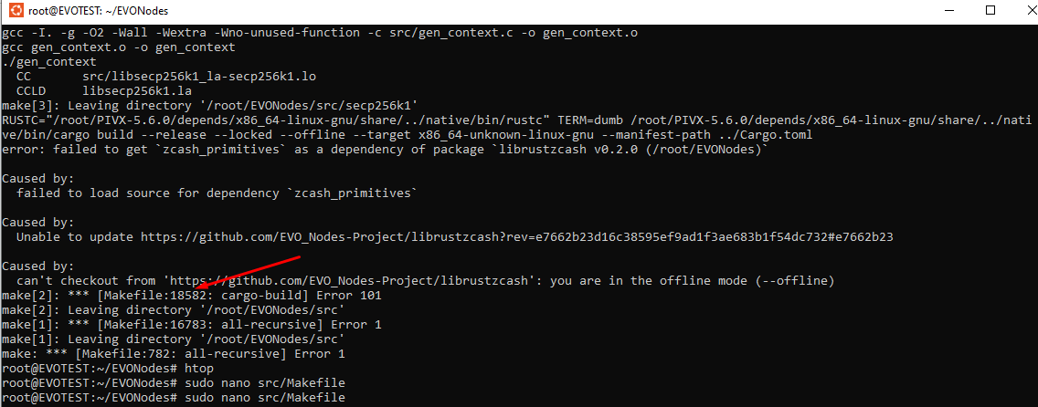

If you face this error while sudo make command, follow the below process.

* sudo nano src/Makefile

In this file go to mentioned line no. 18582 in the screenshot & set 2 lines in the comment as per the below screenshot & save that file.

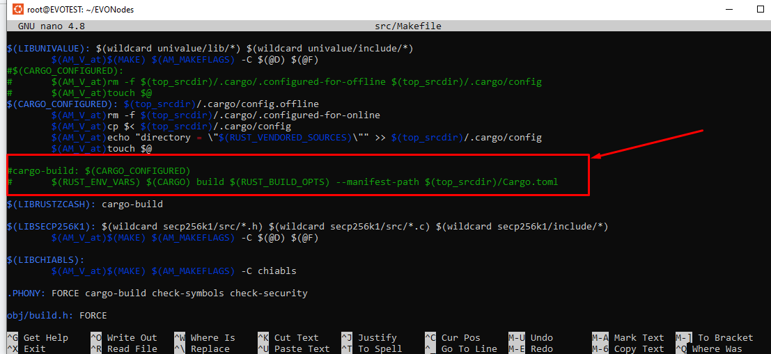

After doing this again run the below command.

* sudo make

**======================================**

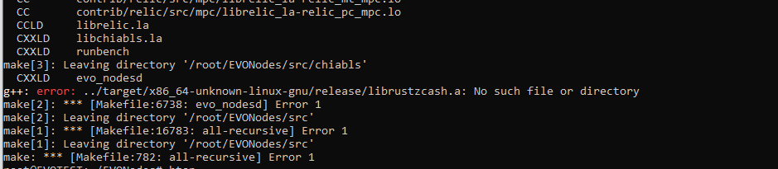

Now if you face this error, you need to upload one folder in this VPS root path with the name target.tar.gz

After Upload that folder in root path follow the below command

* cd ~
* sudo cp target.tar.gz ~/EVONodes
* cd ~/EVONodes
* ls
* tar -xzvf target.tar.gz
* sudo make

############################################################################

**After Daemon successfully build using above command you start daemon using below command:**

* cd src
* strip evo_nodes-cli evo_nodes-tx evo_nodesd
* cd /root
* mkdir .evonodes
* cd .evonodes
* sudo nano evonodes.conf

add below line in config file & save this evonodes.conf file.

**server=1**

**daemon=1**

**addnode=209.38.22.238**

**addnode=64.225.77.31**

**addnode=134.122.49.134**

**addnode=64.225.66.129**

**addnode=64.227.78.147**

**addnode=64.225.77.0**

Now Set up the params folder using the below command

* cd /root
* mkdir.evonodes-params
* cd .evonodes-params
* wget https://github.com/evo-nodes/EVONodes/raw/main/params/sapling-output.params
* wget https://github.com/evo-nodes/EVONodes/raw/main/params/sapling-spend.params

Now Start daemon using this command :

cd /root/EVONodes/src

./evo_nodesd