Manuscript WormExp Update

Title: WormExp version 2: A C. elegans-specific gene expression database for improved taxon-tailored computational analysis of function

Authors:

Affiliations:

Abstract:

Introduction:
Gene set enrichment analysis represents a powerful tool to link the identified differentially expressed gene lists to biological processes and functions. They are based on the statistical evaluation of the overlap between the generated gene set and a specified reference list of genes. WormExp provides a web resource to explore such an approach for the nematode Caenorhabditis elegans. Currently WormExp contains 2293 gene sets, based on 364 individual studies, categorized in nine categories.
These nine categories are according to the experimental designs or specific condition used. Kim Mountains is a specific category reserved for results from Kim et al., 2001. In the category Mutants all differentially expressed genes that show up in mutants or upon RNA interference-silencing of a particular gene are ordered. Datasets that show exposure or feeding of various microorganism are categorized in Microbes. TF Targets is for transcription factor targets inferred by knock-down/knock-out of the respective transcription factors. The category Tissue is for gene expressions in specific tissues. Development/Dauer/Aging includes differential expression in the various developmental stages and during aging. DAF/Insulin/food has differential expression in response to food, starvation, or insulin-like receptor activation/de-activation. The category Chemicals/stress incorporates exposure to chemical compounds or other stressors and Other includes all gene sets not categorized.
In this update, we added a high number of new studies, almost doubling the current numbers. Additionally, we added a new category to encapsulate the growing trend of epigenetic studies. Furthermore, functional updates were conducted to allow more precise gene enrichment analysis and it has been made public on GitHub to allow for greater transparency.
To show the added informational value provided by the update as well as the added functions and categories, a proof of concept has been conducted and will be described in more detail in the following sections.

Methodology:
All mentioned additional documentation and scripts can be found in the GitHub repository https://github.com/evoecogen/WormExp. For a detailed description on the update procedure of WormExp, please read the added documentation in “./03_Documentation/SOP-01_A2_Updating_WormExp.pdf”.
Data
Gene sets for every cluster (C1-C10) for WormExp gene enrichment analysis have been taken from Supplementary Table S1, sheet Bt247&Bt679_Bt407 in Zarate-Potes (2020). WormExp version 1 (v1) output has not been repeated but can be found in Supplementary Table S3 in the same paper. Genes for each cluster have been uploaded into WormExp version 2 (v2) and all categories besides Kim Mountains checked for gene enrichment analysis. The results have been downloaded and all found gene sets with p>0.05 deleted. The file can be found in “./05_QualityManagement/OQ_PQ/Zarate-Potes/data/cluster_analysis_new.xlsx”.
R analysis:
To analyze if similar genes are activated in found gene sets, a gene overlap between all gene sets compared to all other gene sets has been calculated. The overlap is given in percentages. For this, R has been used and the provided script can be found in “./04_Scripts/heatmaps.R”.
As the number of hits for each cluster was too high for a good visualization, it has been decided to only use the top 30 significant hits of the WormExp output. For that, R packages “tidyverse” and “reshape2” have been used to order the hits by increasing FDR and only top 30 hits are kept. Afterwards, found gene sets and their respective genes are assembled in a binary table and the overlapping percentages calculated via cross product. The same procedure has been used when analyzing only a specific category, but before sorting by FDR, the table is filtered by the respective category.
For visualization, a dendrogram clustered heatmap has been constructed with “ComplexHeatmaps” and colored with “RColorBrewer”. Naturally, calculating percentages leads to asymmetrical heatmaps. Therefore, heatmaps were clustered column-wise and the order of columns given to the rows to exactly match it. This omits the dendrogram for the rows automatically.

Results:
In this update we curated a total of 223 new studies and altogether added 1508 new gene sets, based on launch 2015. This leads to a total amount of 583 experiments overall, almost doubling number of studies contained in WormExp v1. Furthermore, the number of total gene sets now adds up to 2965, incorporating mostly high-throughput sequencing data of important studies up until 2019. We allowed categorization of gene sets into multiple categories to enable a more defined and specialized enrichment analysis, inflating the number of total gene sets to 3350 overall. WormExp v2 is now based on WormBase version WS283.
In addition, a new category Epigenetics has been added, to incorporate the growing trend of chromatin studies and sequencing of epigenetic markers. To make the project more accessible, it has been structured and uploaded to https://github.com/evoecogen/WormExp. This allows for greater transparency and possible additions from the community. There, one can also find additional helpful documentation for e.g., all changes made by Wormbase over the last versions and useful R scripts for an initial analysis on the WormExp output table.
The following analysis has the goal to show the impact of the new functions and studies added to WormExp v2. To test the update, it has been decided to repeat a gene enrichment analysis from the paper by Zarate-Potes (2020). There, the scientists analyzed the C. elegans response to two strains of Bacillus thuringiensis (Bt), MYBt18247 (Bt247) and MYBt18679 (Bt679), which produce different pore forming toxins (PFTs) and vary in infection dynamics. Amongst other experiments, they used WormExp to functionally analyze genetic responses of C. elegans to these pore forming toxins. For that, they combined all found genes into functional clusters (C1-C10) depending on the main function of the inherent genes and found significantly different genes mainly in clusters 2 and 8. Genes with immunity and lipid metabolism annotation terms were significantly enriched in these two strain-specific clusters.

To compare the performance of the WormExp update, the same gene sets for all clusters have been used and a new gene enrichment analysis conducted with WormExp v2. WormExp v1 output has not been repeated but taken from the Supplementary of Zarate-Potes (2020). In a first proof of concept, the top 30 significant hits of cluster 8 have been compared to a re-run with WormExp v2. In order to compare similarities between gene sets we decided to focus on the number of overlapping genes between gene sets. Additionally, we added a hierarchical clustering approach in order to assess the similarities among the enriched categories. It should be noted that due to the nature of calculating gene overlaps, the following heatmaps are asymmetrical, and the heatmaps have to be read column-wise.

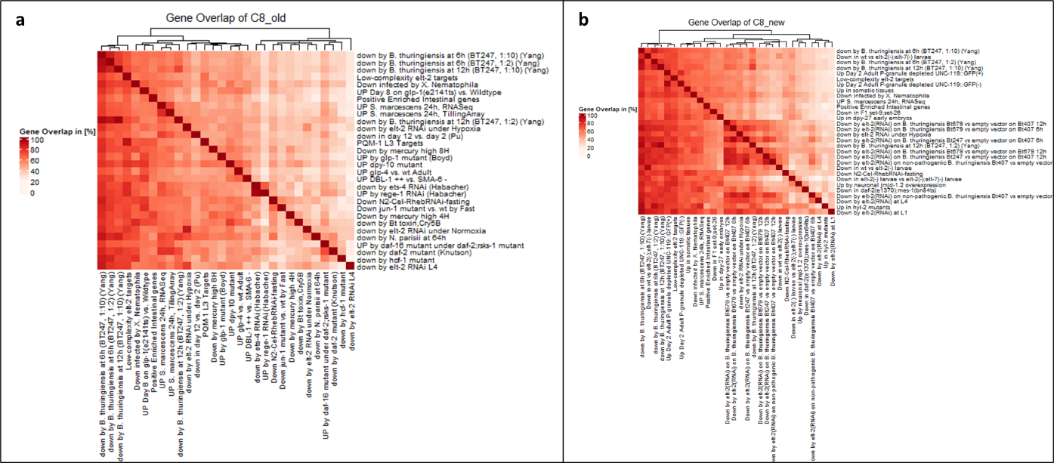
Figure 1: Comparison of WormExp output of C8
The heatmaps show gene overlaps in C8 from WormExp v1 (a) and from WormExp v2 (b). Gene overlap is calculated in percentages. Top 30 significant hits have been used, sorted by increasing FDR and all categories taken into consideration.
Comparing Fig. 1a and Fig. 1b directly shows the added amount of information in WormExp v2. High overlap in Fig. 1a can be seen between gene sets upregulated by BT247 at 6h/12h and all other data sets as well as low complexity elt-2 targets. The same information is still present in the re-run, however additional information is provided. WormExp finds reliably the datasets belonging to the uploaded genes (various forms of down by elt-2(RNAi) on Bt strains) and added them as a separate bigger cluster in Fig.1b, clearly sorting similar gene sets to one another. Additionally, more elt-2 gene sets are visible in Fig.1b that come from other, independent studies and support the claim of elt-2 being a key player in intestinal responses in C. elegans.
As the experiments by Zarate-Potes (2020) focus on genetic responses on pathogens, we filtered the WormExp outputs from boths runs and only take hits with category Microbes into account for the next heatmaps (Figure 2).
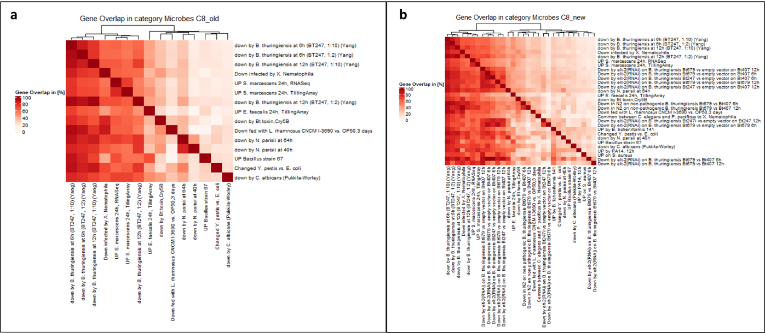
Figure 2: Comparison of C8 only category Microbes
The heatmaps show gene overlaps in C8 from WormExp v1 (a) and from WormExp v2 (b). Gene overlap is calculated in percentages and only category Microbes has been used in gene enrichment analysis. Top 30 significant hits have been used, again sorted by increasing FDR.
Staying with C8, we only compared gene sets in category Microbes, taking again top 30 significant hits. First thing to notice is, that in WormExp v1, only 15 hits for category Microbes were found, whereas after the update, the total number of hits has increased significantly. Additionally, the trend seen in Fig. 2a is again found and supported further. Gene sets upregulated by BT247 at 6h/12h appear again, now next to gene sets affected by other pathogens such as X. Nematophila and S. marcescens. These gene sets also appear again in Fig. 2b in addition to Zarate-Potes (2020) gene sets. The focus on Microbes however now allows a direct comparison of gene set overlaps, e.g., genes downregulated in elt-2 knockout worms show a high overlap with genes downregulated in N. pariisi, which is a new information not visible before the update.
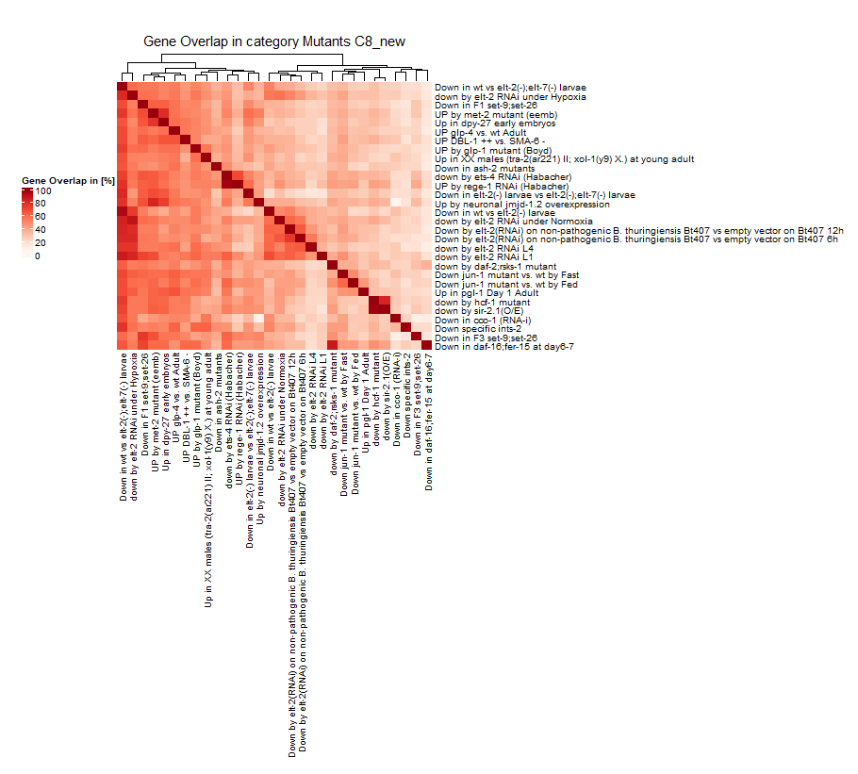
Figure 3: Comparison of C8 only category Mutants
The heatmaps show gene overlaps in C8 from WormExp v1 (a) and from WormExp v2 (b). Gene overlap is calculated in percentages and only category Mutants has been used in gene enrichment analysis. Top 30 significant hits have been used, again sorted by increasing FDR.
As a last proof of concept, the heatmaps shows the ability of multiple categories in WormExp v2. Gene sets down by elt-2 are categorized in Microbes and Mutants and appear in Figure 2, focusing on Microbes, as well as Figure 3 only using category Mutants. This gives the advantage of directly seeing overlaps to other highly significant gene sets, like elt-2 under normoxia or hypoxia. Independent of elt-2, the genes from this cluster also show high overlap between ets-4 and rege-1 mutants.

Conclusion:
The proof of concept shows that WormExp v2 produces reproducible results (see Fig. 1) but also now has more information value to better supports scientists in their research (see Fig. 2). Furthermore, the project has been re-structured and organized to give a better overview over the function of the database, with added documentation to encourage public discourse and collaboration in the future of this project.
To aid in the interpretation of WormExp outputs, R scripts were added that produce the same heatmaps as seen in the results section, using the hierarchical clustering approach for better comparison of gene overlaps in gene enrichment analysis.
Although the number of added studies is very high, the database only includes studies up until 2019 and therefore newest studies are still missing. As high-throughout sequencing becomes more available and cheaper, experiments using this methodology increased drastically, making it difficult to keep the database updated.
To keep up with the increasing number of publications, an automated script could be helpful, for example a paper picker, that regularly searches known databases for new publications and notifies the group via e-mail. With that, another big backlog could be avoided, and the database updated more regularly. Such APIs are already available by e.g., Google, using Google Scholar. However, they are only available via subscription. APIs like GEO would be a good choice to build a data/paper picker as it includes a big data library, however, not all studies make their data available there, which means that on this way studies may go unnoticed.
Additionally, as long as there is no fixed system for supplementary data and the layout of differential gene analysis, it will be impossible to automate this step at the moment.

Bibliography:
Zarate-Potes A, Yang W, Pees B, Schalkowski R, Segler P, Andresen B, et al. (2020) The C. elegans GATA transcription factor elt-2 mediates distinct transcriptional responses and opposite infection outcomes towards different Bacillus thuringiensis strains. PLoS Pathog 16(9):e1008826. https://doi.org/10.1371/journal.ppat.1008826

Yang W, Dierking K, Schulenburg H, et al. (2015) WormExp: a web-based application for a Caenorhabditis elegans-specific gene expression enrichment analysis. Bioinformatics Advance Access

