Manuscript WormExp Update

Introduction:
Gene set enrichment analysis represents a powerful tool to link the identified differentially expressed gene lists to biological processes and functions. They are based on the statistical evaluation of the overlap between the generated gene set and a specified reference list of genes. WormExp provides a web resource to explore such an approach for the nematode Caenorhabditis elegans. Currently WormExp contains 2300 gene sets in nine categories, after four additional updates in 2016 and 2017, respectively.
The gene sets are designed according to the experimental designs or specific condition used. Kim Mountains is a specific category reserved for results from Kim et al., 2001. In the category Mutants all differentially expressed genes that show up in mutants or upon RNA interference-silencing of a particular gene are ordered. Datasets that show exposure or feeding of various microorganism are categorized in Microbes. TF Targets is for transcription factor targets inferred by knock-down/knock-out of the respective transcription factors. The category Tissue is for gene expressions in specific tissues. Development/Dauer/Aging includes differential expression in the various developmental stages and during aging. DAF/Insulin/food has differential expression in response to food, starvation, or insulin-like receptor activation/de-activation. The category Chemicals/stress incorporates exposure to chemical compounds or other stressors and Other includes all gene sets not categorized.
In this update we added 52 new studies with overall 645 new gene sets with the current Wormbase version WS283. With this all studies up until 2019 have been added with a total of 2965 gene sets. In addition, a new category Epigenetics has been added, which now includes all gene sets that came from chromatin studies or epigenetic markers. Furthermore, with this update new gene sets were categorized in multiple categories which allows for a more defined and specialized enrichment analysis. The total number of gene sets displayed by WormExp is therefore currently 3150 gene sets, as several gene sets are counted multiple times.
To make the project more accessible, it has been structured and uploaded to https://github.com/evoecogen/WormExp. This allows for greater transparency and additions by the community. There, one can also find additional helpful documentation for e.g., all changes made by Wormbase over the last versions and useful R scripts for an initial analysis on the WormExp output table. To show the added informational value provided by the update as well as the added functions and categories, a proof of concept has been conducted and will be described in more detailed in the following sections.

Methodology:
For a detailed description on the update procedure of WormExp, please read the added documentation in 03_Documentation.
Data
Gene sets for every cluster (C1-C10) for WormExp gene enrichment analysis have been taken from Supplementary Table S1, sheet Bt247&Bt679_Bt407 in Zarate-Potes (2020). WormExp v1 output has not been repeated but can be found in Supplementary Table S3 in the same paper. Genes for each cluster have been uploaded into WormExp version 2 (v2) and all categories besides Kim Mountains checked for gene enrichment analysis. The results have been downloaded and all found gene sets with p>0.05 deleted. The file can be found in 05_QualityManagement/OQ_PQ/Zarate-Potes/data/cluster_analysis_new.xlsx.
R analysis:
To analyze if similar genes are activated in found gene sets, a gene overlap between one gene set compared to all others has been calculated. The overlap is given in percentages. For this, R has been used (see 04_Scripts/heatmaps.R).
As the number of hits for each cluster was too high for a good visualization, it has been decided to only use the top 30 significant hits of the WormExp output. For that, R packages “tidyverse” and “reshape2” have been used to order the hits by increasing FDR and only top 30 hits are kept. Afterwards, found gene sets and their respective genes are assembled in a binary table and the overlapping percentages calculated via cross product.
For visualization, a dendrogram clustered heatmap has been constructed with “ComplexHeatmaps” and colored with “RColorBrewer”. Naturally, calculating percentages leads to asymmetrical heatmaps. Therefore, heatmaps were clustered column-wise and the order of columns given to the rows to exactly match it. This omits the dendrogram for the rows automatically. The same procedure has been used when analyzing only a specific category, but before sorting by FDR, the table is filtered by the respective category.

Results:
The following analysis has the goal to show the impact of the new functions and studies added to WormExp version 2. To test the update, it has been decided to repeat a gene enrichment analysis from the paper by Zarate-Potes (2020). There, the scientists analyzed the C. elegans response to two strains of Bacillus thuringiensis (Bt), MYBt18247 (Bt247) and MYBt18679 (Bt679), which produce different pore forming toxins (PFTs) and vary in infection dynamics. Amongst other experiments, they used WormExp to functionally analyze genetic responses of C. elegans to these pore forming toxins. For that they clustered all found genes into functional clusters (C1-C10) depending on the main function of the inherent genes and found significantly different genes mainly in clusters 2 and 8. Genes with immunity and lipid metabolism annotation terms were significantly enriched in these two strain-specific clusters, with cluster 2 contains genes that are exclusively up-regulated upon Bt247 exposure.

To compare the performance of the WormExp update, the same gene sets for all clusters have been used and a new gene enrichment analysis conducted with the new WormExp database, the old WormExp output has not been repeated but taken from the Supplementary of Zarate-Potes (2020). In a first proof of concept, the top 30 significant hits of cluster 8 from the first run have been compared to a re-run with WormExp version 2. The resulting heatmaps can be seen in Figure 1:
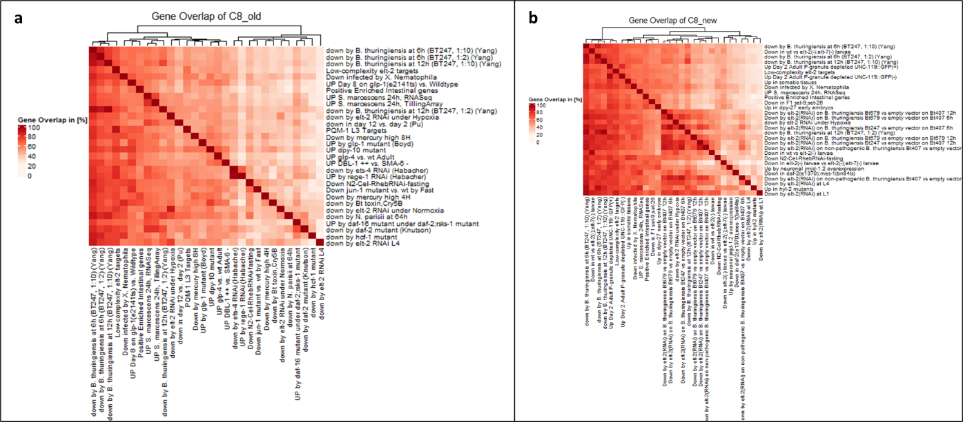
Figure 1: Comparison of WormExp output of C8
The heatmaps show gene overlaps in C8 from the old WormExp run (a) and with the newly added gene sets (b). Gene overlap is calculated in percentages. Top 30 significant hits have been used, sorted by FDR and all categories taken into consideration.
It should be noted that due to the nature of calculating gene overlaps, the following heatmaps are asymmetrical, and the heatmaps have to be read column-wise.
Comparing (a) and (b) directly shows the added amount of information in the new WormExp version. High overlap in (a) can be seen between gene sets upregulated by BT247 at 6h/12h and all other data sets as well as low complexity elt-2 targets. The same information is still present in the re-run, however additional information is provided. WormExp finds reliably the datasets belonging to the uploaded genes (various forms of down by elt-2(RNAi) on Bt strains) and added them as a separate bigger cluster in (b). Additionally, more elt-2 gene sets are visible in (b) that come from independent studies and support the claim of elt-2 being a key player in intestinal responses in C. elegans.
As the experiments by Zarate-Potes (2020) focus on genetic responses on pathogens, we filtered the WormExp output and only take hits with category Microbes into account for the next heatmaps (Figure 2).
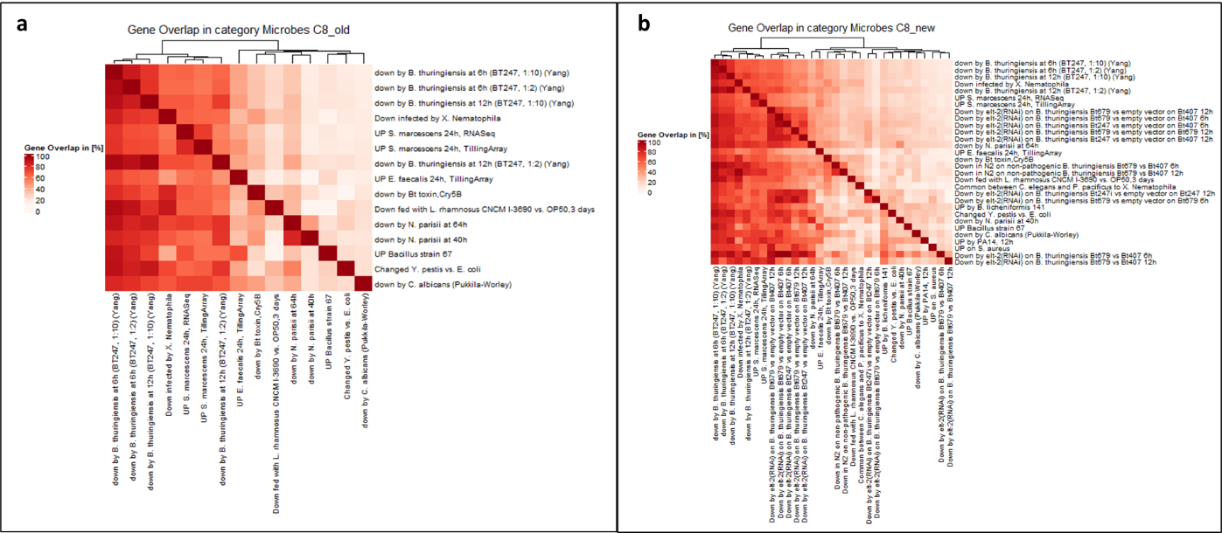
Figure 2: Comparison of C8 only category Microbes
The heatmaps show gene overlaps in C8 from the old WormExp run (a) and with the newly added gene sets (b). Gene overlap is calculated in percentages and only category Microbes has been used in gene enrichment analysis. Top 30 significant hits have been used.
Staying with C8, we only compared gene sets in category Microbes, taking again top 30 significant hits. First thing to notice is, that in the old WormExp run, only 15 hits for category Microbes were found, whereas with the new version, the total number of hits has increased significantly. Additionally, the trend seen in (a) is again found and supported further. Gene sets upregulated by BT247 at 6h/12h appear again, now next to gene sets affected by other microbes such as X. Nematophila and S. marcescens. These gene sets also appear again in (b) in addition to Zarate-Potes (2020) gene sets. The focus on microbes however now allows a direct comparison of gene set overlaps, e.g. genes downregulated in elt-2 knockout worms show a high overlap with genes downregulated in N. pariisi, which is a new information not visible without the update.

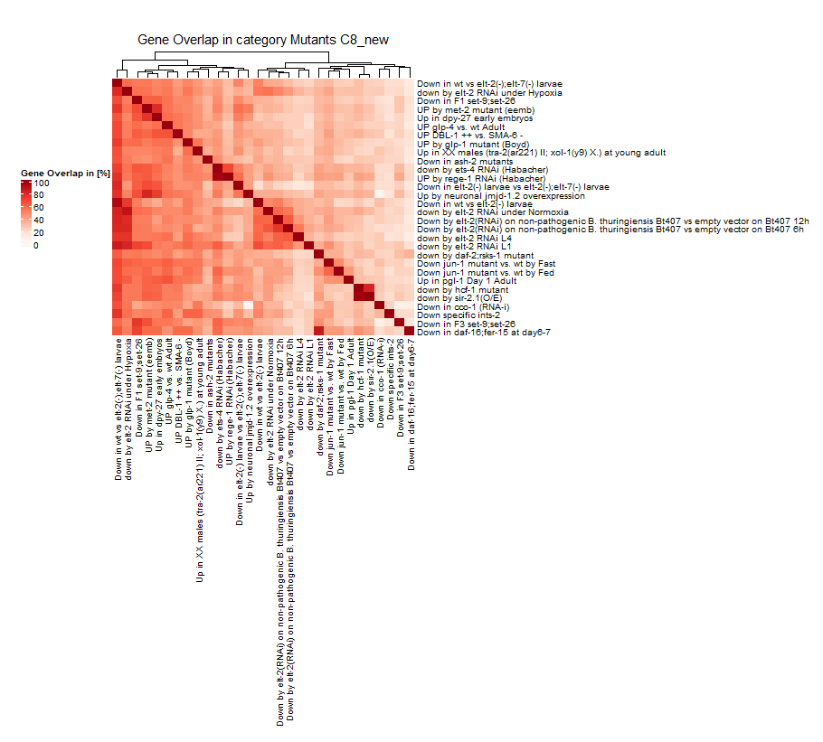
Figure 3: Comparison of C8 only category Mutants
The heatmap shows gene overlaps in C8 with new WormExp version 2. Gene overlap is calculated in percentages and only category Mutants has been used in gene enrichment analysis. Top 30 significant hits have been used.
As a last proof of concept, the heatmaps shows the ability of multiple categories in WormExp version 2. Gene sets down by elt-2 are categorized in microbes and mutants and appear in Figure 2, focusing on Microbes, as well as Figure 3 only using category Mutants.

Conclusion:
The proof of concept shows that WormExp v2 produces reproducible results but also now has more information value to better supports scientists in research. Furthermore, the project has been re-structured and organized to give a better overview over the function of the database, with added documentation to encourage public discourse and collaboration in the future of this project. It can be found under: https://github.com/evoecogen/WormExp.
To aid in the interpretation of WormExp outputs R scripts were added that produce the same heatmaps as seen in results.
As mentioned, even with the new update, the database only includes studies up until 2019 and therefore newest studies are still missing. Additionally, GEO includes a big data library, but not all studies make their data available there, which means that on this way studies may also go unnoticed.

Bibliography:
Zarate-Potes A, Yang W, Pees B, Schalkowski R, Segler P, Andresen B, et al. (2020) The C. elegans GATA transcription factor elt-2 mediates distinct transcriptional responses and opposite infection outcomes towards different Bacillus thuringiensis strains. PLoS Pathog 16(9):e1008826. https://doi.org/10.1371/journal.ppat.1008826

Yang W, Dierking K, Schulenburg H, et al. (2015) WormExp: a web-based application for a Caenorhabditis elegans-specific gene expression enrichment analysis. Bioinformatics Advance Access

