UNITED STATES BANKRUPTCY COURT

KING COUNTY SUPERIOR COURT

.

IN RE: . Case No. 545-1-544326

. Supreme Court Cause No.

RICKY MARTIN . 12-1-15788

RICKY MARTIN, . Court of Appeals No.

. 12-1-15788

Plaintiff. .

. Day of week, 4/15/2016

. . . . . . . . . . . . . . . 9:45:00 AM

.

RICKY MARTIN . Case No. 545-1-544326

RICKY MARTIN, .

. Adv. Case No.

Plaintiff, . 12-1-15788

.

v. .

.

MICHAEL BUBLE, . Day of week, 4/15/2016

. 9:45:00 AM

Defendant. .

. . . . . . . . . . . . . . .

TRANSCRIPT OF BENCH TRIAL

BEFORE THE HONORABLE JUDGE HAWTHORN

UNITED STATES BANKRUPTCY JUDGE

APPEARANCES:

For the Plaintiff:

By: Francisco Pérez-Olaeta, ESQ.

123 6th Street

Milwaukee, WI 99999

(123)555-0100

For the Defendant:

By: Peter Krschne, ESQ.

123 11th Street

Miami, FL 99999

(123)555-0100

For the Plaintiff:

By: John Edwards, ESQ.

123 12th Street

Las Vegas, NV 99999

(123)555-0100

For the Defendant:

By: Carlos Grilo, ESQ.

456 14th Street

Denver, CO 99999

(123)555-0100

For the Plaintiff:

By: Daniel Goldschmidt, ESQ.

456 16th Street

San Francisco, CA 99999

(123)555-0100

For the Defendant:

By: Catherine Autier Miconi, ESQ.

456 18th Street

Boston, MA 99999

(123)555-0100

Transcription Service: A Quo Co.

320 West Republican, Suite 207

Seattle, Washington 98119

inquiries@aquoco.co

(206) 478-5028

Proceedings recorded by electronic sound recording;

transcript produced by transcription service. Case law/rules hyperlinked; table of authorities on last page.

INDEX

OPENING STATEMENT BY THE U.S. TRUSTEE 3

COURT'S RULING 3

OPENING STATEMENT BY THE DEBTORS 3

PHILIPPE NADEAU, DEBTOR 3

CROSS-EXAMINATION 3

CROSS-EXAMINATION 3

RECROSS-EXAMINATION 3

DAVID QUINN, MOVANT'S WITNESS 3

DIRECT EXAMINATION 3

CROSS-EXAMINATION 3

REDIRECT EXAMINATION 3

U.S. TRUSTEE RESTS 3

DEBTORS REST 3

CLOSING BY THE U.S. TRUSTEE 3

CLOSING BY THE DEBTORS 3

COURT'S RULING 3

, DAY OF WEEK, ,

(Hearing adjourned at .)

CERTIFICATE OF TRANSCRIBER

I certify under penalty of perjury under the laws of the State of Washington that the following is true and correct, that I am an authorized transcriptionist; that I received the electronic recording directly from the trial court conducting the hearing; that this transcript is a true and correct record of the proceedings to the best of my ability, including any changes made by the trial judge reviewing the transcript; I am in no way related to or employed by any party in this matter, nor any counsel in the matter; and I have no financial interest in the litigation.

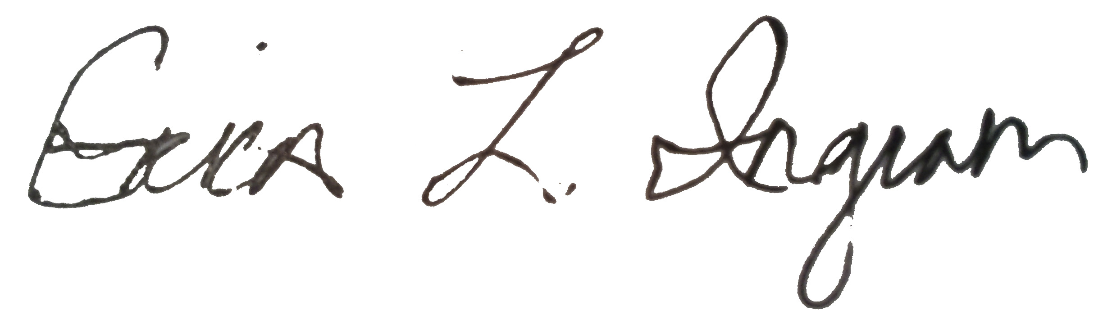

November 5, 2017

___________________ __________________

Signature Date

TABLE OF AUTHORITIES

Gomez, 21, 148, 151, 152

Krohn, 11, 146

Lamanna, 11