UNITED STATES BANKRUPTCY COURT

.

IN RE: . Case No. «CaseNumber1»

. Supreme Court Cause No.

«PARTY1» . «CaseNumber2»

«PARTY1», . Court of Appeals No.

. «CaseNumber2»

«Party1name». . «Jurisdiction»

. Day of week, «HearingDate»

. . . . . . . . . . . . . . . «HearingStartTime»

.

«PARTY1» . Case No. «CaseNumber1»

«PARTY1», .

. Adv. Case No.

«Party1name», . «CaseNumber2»

.

v. . «Jurisdiction»

.

«PARTY2», . Day of week, «HearingDate»

. «HearingStartTime»

«Party2name». .

. . . . . . . . . . . . . . .

TRANSCRIPT OF «HearingTitle»

BEFORE THE HONORABLE «JUDGE»

UNITED STATES BANKRUPTCY JUDGE

APPEARANCES:

For the «Party1name»:

By: , ESQ.

«Address»

«City», «State» «ZIP»

«BusinessPhone»

«Next Record»

For the «Party2name»:

By: , ESQ.

«Address»

«City», «State» «ZIP»

«BusinessPhone»

«Next Record»

For the «Party1name»:

By: , ESQ.

«Address»

«City», «State» «ZIP»

«BusinessPhone»

«Next Record»

For the «Party2name»:

By: , ESQ.

«Address»

«City», «State» «ZIP»

«BusinessPhone»

«Next Record»

For the «Party1name»:

By: , ESQ.

«Address»

«City», «State» «ZIP»

«BusinessPhone»

«Next Record»

For the «Party2name»:

By: , ESQ.

«Address»

«City», «State» «ZIP»

«BusinessPhone»

«Next Record»«Next Record»

Transcription Service: A Quo Co.

320 West Republican, Suite 207

Seattle, Washington 98119

inquiries@aquoco.co

(206) 478-5028

Proceedings recorded by electronic sound recording;

transcript produced by transcription service. Case law/rules hyperlinked, double-underlined; table of authorities on last page.

INDEX

OPENING STATEMENT BY THE U.S. TRUSTEE 3

COURT'S RULING 3

OPENING STATEMENT BY THE DEBTORS 3

PHILIPPE NADEAU, DEBTOR 3

CROSS-EXAMINATION 3

CROSS-EXAMINATION 3

RECROSS-EXAMINATION 3

DAVID QUINN, MOVANT'S WITNESS 3

DIRECT EXAMINATION 3

CROSS-EXAMINATION 3

REDIRECT EXAMINATION 3

U.S. TRUSTEE RESTS 3

DEBTORS REST 3

CLOSING BY THE U.S. TRUSTEE 3

CLOSING BY THE DEBTORS 3

COURT'S RULING 3

«LOCATION», DAY OF WEEK, «HEARINGDATE», «HEARINGSTARTTIME»

(Hearing adjourned at «hearingendtime».)

CERTIFICATE OF TRANSCRIBER

I certify under penalty of perjury under the laws of the State of Washington that the following is true and correct, that I am an authorized transcriptionist; that I received the electronic recording directly from the trial court conducting the hearing; that this transcript is a true and correct record of the proceedings to the best of my ability, including any changes made by the trial judge reviewing the transcript; I am in no way related to or employed by any party in this matter, nor any counsel in the matter; and I have no financial interest in the litigation.

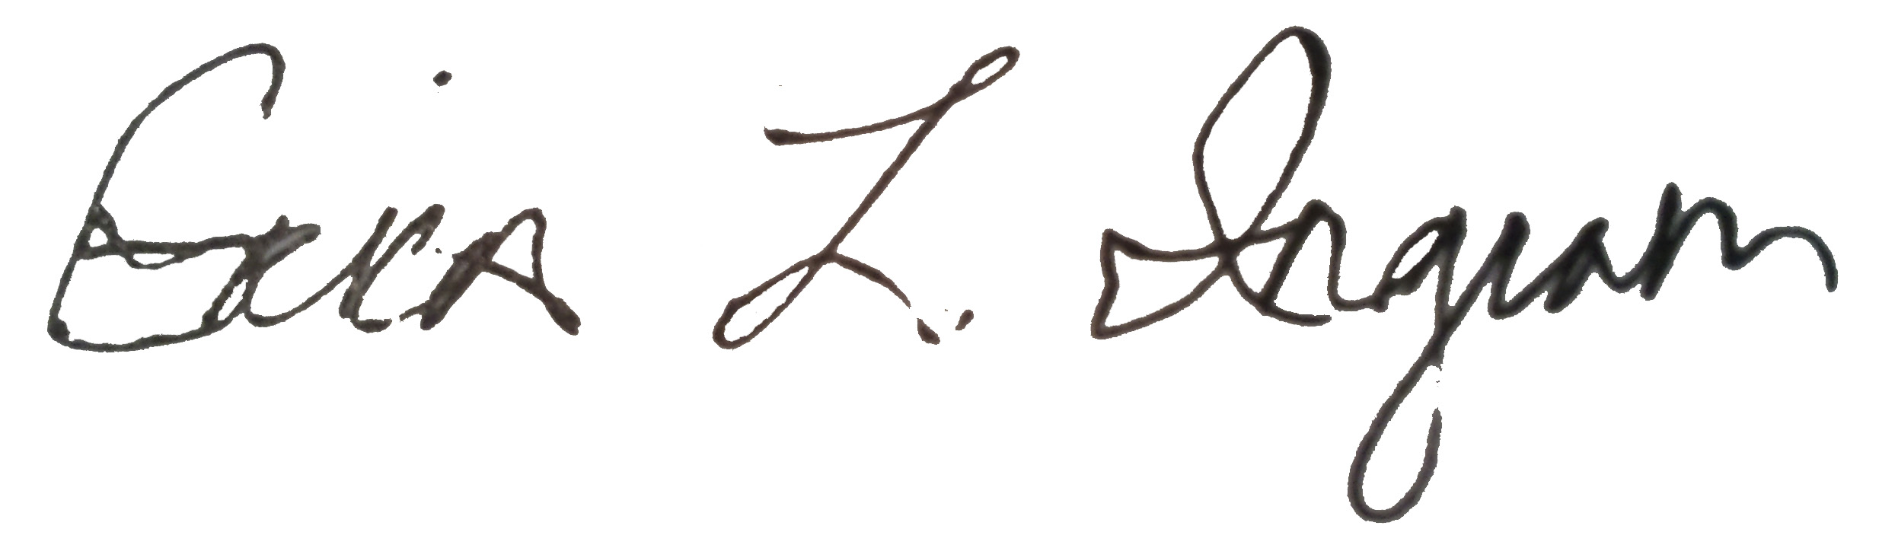

January 2, 2018

___________________ __________________

Signature Date

TABLE OF AUTHORITIES

Gomez, 21, 148, 151, 152

Krohn, 11, 146

Lamanna, 11