«PARTY1»

**«Party1» v. «Party2»**

**«CaseNumber1» | «CaseNumber2»**

**«Hearingdate»**

**«hearingstarttime».m. to «hearingendtime».m.**

**Transcribed For:**

«Company»

«FirstName» «LastName»

«Address»

«City», «State» «ZIP»

«TRAppAddrQID»

**Transcribed By:**

A Quo Co.

320 West Republican, Ste. 207

Seattle, Washington 98119

inquiries@aquoco.co

http://www.aquoco.co

PROCEEDINGS

#RBMK#

MS. ZINK:  I certify under penalty of perjury under the laws of the State of Washington that the following is true and correct, that this transcript is a true and correct record of the proceedings to the best of my ability; I am in no way related to or employed by any party in this matter, nor any counsel in the matter; and I have no financial interest in the litigation.

(Proceedings concluded at «hearingendtime».m.)

# #CBMK#CERTIFICATE OF TRANSCRIBER

I certify under penalty of perjury under the laws of the State of Washington that the following is true and correct, that I am an authorized transcriptionist; that I received the electronic recording directly from the trial court conducting the hearing; that this transcript is a true and correct record of the proceedings to the best of my ability, including any changes made by the trial judge reviewing the transcript; I am in no way related to or employed by any party in this matter, nor any counsel in the matter; and I have no financial interest in the litigation.

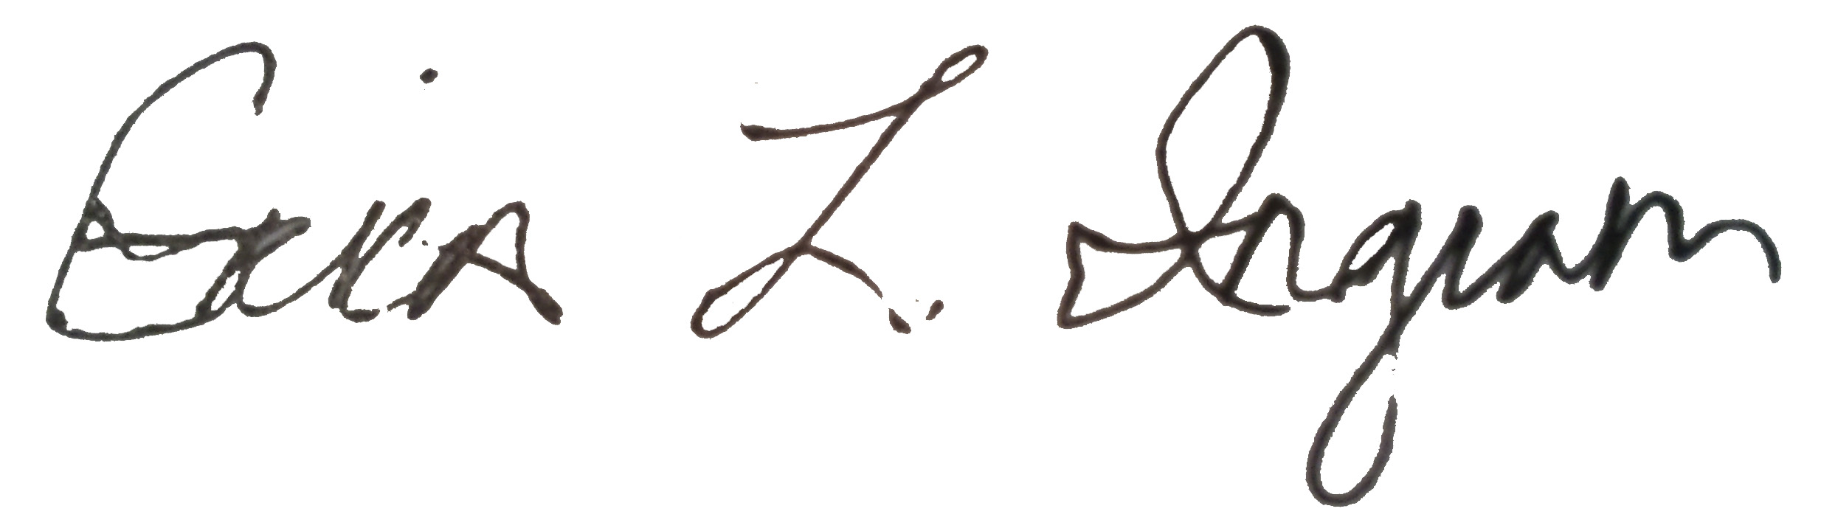

August 2, 2019

___________________ __________________

Signature Date

# #TBMK#TABLE OF AUTHORITIES

**Cases**

**No table of authorities entries found.**

**Rules, Regulation, Code, Statutes**

**No table of authorities entries found.**

**Other Authorities**

**No table of authorities entries found.**