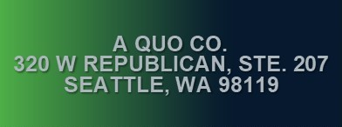

Associated Counsel for the Accused

110 Prefontaine Place S., Suite 200

Seattle, WA 98104

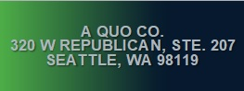

Northwest Defenders Association

1109 1st Ave, Suite 300

Seattle, WA 98101



Seattle-King County Public Defender Association

810 Third Avenue, Suite 800

Seattle, WA 98104



Snohomish County Public Defender

1721 Hewitt Avenue, #200

Everett, WA 98201



Society of Counsel Representing Accused Persons

1401 E. Jefferson St., Suite 200

Seattle, WA 98122



Washington Appellate Project

1511 Third Avenue, #701

Seattle, WA 98101



Spokane County Public Defender

1033 West Gardner

Spokane, WA 99260