«AddressBlock»

Monday, June 17, 2019

Hello there,

I am writing because I believe A Quo Co. can help provide you quality court transcription services at a reasonable rate with unique features you won't find anywhere else. Our rates start at $2.65/page.

First, every transcript is proofed to the audio to ensure the highest quality possible. AQC is the only company that hyperlinks authority in transcripts and produces tables of authority with every applicable transcript. This means, when someone mentions an authority such as an RCW or case law during the hearing, wherever possible, we hyperlink it to the actual text of the authority at a .gov website or freely publicly accessible websites such as Court Listener and Justia. It is also linked in the table of authorities at the end of the document on the certification page.

Here is a picture of a linked authority within a transcript. The field codes are showing so you can see the TA entry:

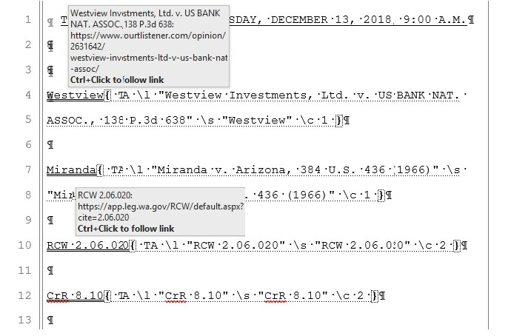

We are approved for court transcription in several counties in Washington, including King, Snohomish, and Spokane as well as both Washington bankruptcy court districts. You may have 28 days to pay your invoice interest free. If you have special forms that need filled out or if you need a different arrangement, please contact me and we'll try our best to accommodate. We will bill OPD when provided with both an order of indigency and a statement of arrangements.

Our transcripts include tables of content and headers hyperlinked to their place in the document.

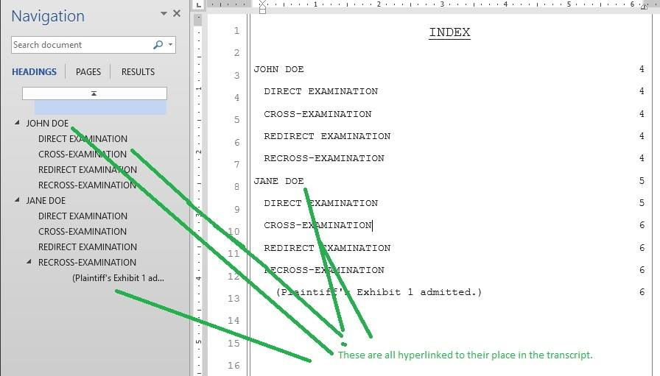

Word indexes and condensed transcripts are provided with every transcript for free.

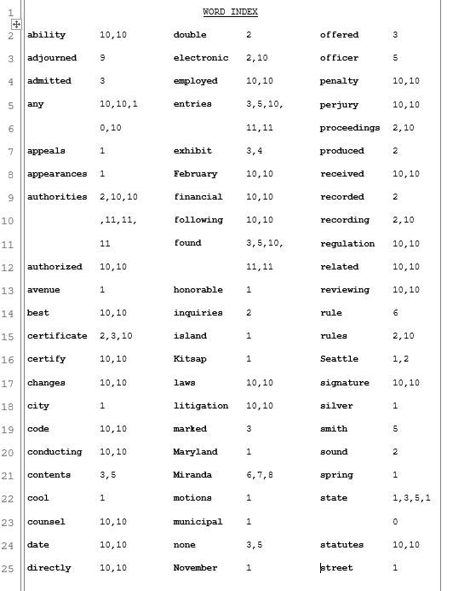

A full list of what is included in our rates may be found at https://www.aquoco.co/Court-Transcription.html. Our rates include:

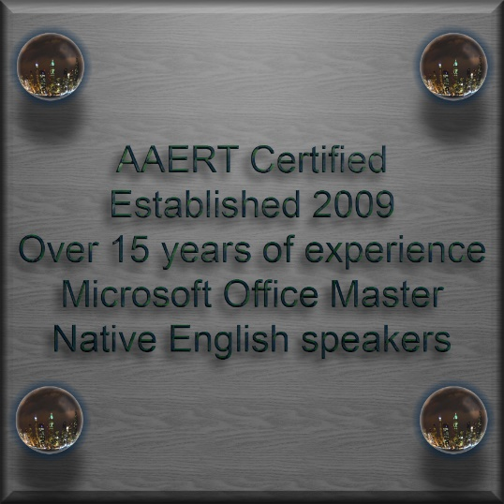

* Velobound 28-lb paper copies (unless electronic only)
* Color, custom weather-proof labeled CD of your

transcript + audio where allowed (unless electronic only)

* Hyperlinked headings & tables of content
* Hyperlinked case law & authorities where possible
* Table of authorities
* Condensed version, both 2/page and 4/page
* Word index
* Certified PDF version
* Certified Word Version
* “working” copy, Word version where you can use all the

regular features of Word with the transcript such as

highlight and bold.

There are about 45 pages per audio hour. There are no additional charges, just a page rate. There is a $50 minimum order charge.

Now, with **electronic-only delivery**, then we offer these rates for **15+ audio hours/month**:

* 30 calendar-day turnaround, **$2.65**/page
* 14 calendar-day turnaround, **$3.25**/page
* 07 calendar-day turnaround, **$3.75**/page
* 03 calendar-day turnaround, **$4.25**/page

For **everything else**, we offer the following::

* 30 calendar-day turnaround, **$3.00**/page
* 14 calendar-day turnaround, **$3.50**/page
* 07 calendar-day turnaround, **$4.00**/page
* 03 calendar-day turnaround, **$4.75**/page
* same day/overnight, **$5.25**/page

In terms of file transmission, we have a website where you can upload it or we can order it from the court on your behalf and there may or may not be an additional charge for that, depending on the jurisdiction (most places are free, some aren't). We also have secure FTP as an option.

For ease of ordering, there are several things we offer to make it as easy as possible. We have an online form at https://www.aquoco.co/Price-Quote.html. We also have an email form available. If you'd rather do none of that, simply uploading the audio and providing paperwork such as log notes, a statement of arrangements, the hearing notice, minute entry, or other related documents to us will also suffice.

Thank you very much and have a great day.

Sincerely,

Erica L Ingram

[CERT**D-521](https://www.aaert.org/member/aquocotranscripts)   |   [Notary Public](https://fortress.wa.gov/dol/dolprod/bpdLicenseQuery/lqsLicenseDetail.aspx?RefID=332790)    |   [Microsoft Office Master 2016](https://www.youracclaim.com/user/erica-ingram)

VBA/Office productivity blog [https://transcription.aquoco.co/](http://www.facebook.com/aquocotranscripts)

