

ISO 27001 Formal Audit Report
ComplianceEye Audit Documentation

Reporting Date: 2026-05-01
Company Name: DamnArt
Auditor Name: Sonu Kumar

1. Company and Auditor Information
- Organization Name: DamnArt
- Business Nature: AI, Digital Marketing
- Services / Products: yv
- Information Security Mission: jvb
- Information Security Importance: bi
- Key Stakeholders: ub
- Stakeholder Expectations: iu
- Auditor Name: Sonu Kumar
- Auditor Role: AI Intern
- Auditor Email: evoke0611@gamil.com
- Auditor Contact: 1234586958
- ISMS Responsible: hiy
- ISMS Core Group: u
- Management Commitment: u

2. ISMS Policy Questions and Answers
Q1. What is your Organization Name?
Answer: DamnArt
Q2. What is your Organization Email?
Answer: damnart@gmail.com
Q3. What is the Nature of your Business?
Answer: AI & Digital Marketing
Q4. What are your Office Location(s)?
Answer: Mohali
Q5. How many Employees does your organization have?
Answer: 30
Q6. What is your IT Infrastructure type? (On-Premise / Cloud / Hybrid)
Answer: cloud
Q7. What type of audit is this? (Internal / External)
Answer: Internal
Q8. What is the Audit Date?
Answer: 01/05/2026
Q9. What is the Auditor's Name?
Answer: Compliance Eye
Q10. Which Department is being audited?
Answer: Cyber Security
Q11. What is the Name of your CEO / Director?
Answer: Mr. Manish is the CEO
Q12. Which Department is the CEO / Director in?
Answer: He is a IT Head of this company
Q13. What is the CEO / Director's Contact (email/phone)?
Answer: manish@gmail.com
Q14. What is the Name of your ISMS Manager?
Answer: Sonu Kumar
Q15. Which Department is the ISMS Manager in?
Answer: AI
Q16. What is the ISMS Manager's Contact (email/phone)?
Answer: sonu@gmail.com
Q17. What is the Name of your HR Head?
Answer: Shweta
Q18. Which Department is the HR Head in?
Answer: HR
Q19. What is the HR Head's Contact (email/phone)?
Answer: shweta@gmail.com
Q20. What is the Name of your System Administrator?
Answer: Rohan
Q21. Which Department is the System Administrator in?
Answer: AI
Q22. What is the System Administrator's Contact (email/phone)?
Answer: 0123456789
Q23. What is the Name of your Technical Head?
Answer: Shanu
Q24. Which Department is the Technical Head in?
Answer: SFT
Q25. What is the Technical Head's Contact (email/phone)?
Answer: 1236547890
Q26. For the ISMS Core Group — what is the Name of the person in the HR role?
Answer: Shweta
Q27. What is their Responsibility in the ISMS?
Answer: They can handle the new Employee training
Q28. How many years of Experience do they have in this role?
Answer: 5
Q29. For the ISMS Core Group — what is the Name of the System Admin?
Answer: Sonu
Q30. What is their Responsibility in the ISMS?
Answer: They can handle the BYOD devices and the system Security
Q31. How many years of Experience do they have?
Answer: 5
Q32. For the ISMS Core Group — what is the Name of the Technical Head?
Answer: vikash
Q33. What is their Responsibility in the ISMS?
Answer: They ensure that all the devices are work properly
Q34. How many years of Experience do they have?
Answer: 4
Q35. For the ISMS Core Group — what is the Name of the CEO?
Answer: Manish
Q36. What is the CEO's Responsibility in the ISMS?
Answer: Handle the company reponsibilty
Q37. How many years of Experience does the CEO have in this role?
Answer: 20
Q38. For the ISMS Core Group — what is the Name of the Auditor?
Answer: Sumit
Q39. What is the Auditor's Responsibility in the ISMS?
Answer: They ensure the ISMS policy inside the company
Q40. How many years of Experience does the Auditor have?
Answer: 4
Q41. What is the Physical Location covered under the ISMS scope?
Answer: Mohali
Q42. Which Departments are covered under the scope?
Answer: IT, Digital Marketing, SFT
Q43. Which Systems are included in the scope?
Answer: Servers, databases, cloud services, and network equipment supporting operations.
Q44. What types of Data are handled? (Client / Internal / Both)
Answer: Both
Q45. Who are your Third-Party Dependencies? (cloud providers, vendors, etc.)
Answer: Cloud Provider
Q46. What is explicitly excluded from the ISMS scope?
Answer: Employee personal devices – BYOD laptops, phones, or tablets not enrolled in corporate security management.
Q47. Contact Details — what is the Name of your ISMS Manager?
Answer: Sumit
Q48. What is the ISMS Manager's Email?
Answer: sumit@gmail.com
Q49. What is the ISMS Manager's Phone number?
Answer: 54789658745
Q50. Contact Details — what is the Name of your System Administrator?
Answer: Sonu
Q51. What is the System Administrator's Email?
Answer: sonu@gmail.com
Q52. What is the System Administrator's Phone number?
Answer: 45987456935
Q53. Contact Details — what is the Name of your HR?
Answer: Shweta
Q54. What is the HR's Email?
Answer: Shweta@gmail.com
Q55. What is the HR's Phone number?
Answer: 785451230125
Q56. Escalation Matrix — what is the Expected Response Time for Level 1 (System Admin - Initial Response)?
Answer: 1 day
Q57. What is the Expected Response Time for Level 2 (ISMS Manager - Investigation)?
Answer: imediate
Q58. What is the Expected Response Time for Level 3 (Management - Final Decision)?
Answer: After GD
Q59. Risk Register — describe this Risk (threat or vulnerability):
Answer: ok
Q60. What is the Impact level? (1=Very Low, 2=Low, 3=Medium, 4=High, 5=Critical)
Answer: 4
Q61. What is the Likelihood? (1=Very Low, 2=Low, 3=Medium, 4=High, 5=Very High)
Answer: 3
Q62. What is the Treatment Plan for this risk?
Answer: Un
Q63. Who is the Risk Owner?
Answer: Metadata is often accessible within systems but requires specific access rights.
Q64. Risk Register — describe this Risk (threat or vulnerability):
Answer: threat
Q65. What is the Impact level? (1=Very Low, 2=Low, 3=Medium, 4=High, 5=Critical)
Answer: 3
Q66. What is the Likelihood? (1=Very Low, 2=Low, 3=Medium, 4=High, 5=Very High)
Answer: 4
Q67. What is the Treatment Plan for this risk?
Answer: Ristrict Unauthorized disclosure or misuse of browser session metadata
Q68. Who is the Risk Owner?
Answer: Sonu
Q69. Asset Register — what is the Asset Name?
Answer: Laptop
Q70. What Type of asset is it? (Hardware / Software / Data / People / Service)
Answer: Hardware
Q71. Who is the Asset Owner?
Answer: sonu
Q72. Where is it Located?
Answer: mohali
Q73. What is its Classification? (Public / Internal / Confidential / Restricted)
Answer: Restricted
Q74. Policy Register — who is the Owner of the ISMS Policy?
Answer: Shanu
Q75. When was the ISMS Policy Last Updated?
Answer: Jan
Q76. What is the ISMS Policy current Status? (Active / Under Review / Outdated)
Answer: Outdated
Q77. Who is the Owner of the Access Policy?
Answer: Manish
Q78. When was the Access Policy Last Updated?
Answer: Jan
Q79. What is the Access Policy current Status? (Active / Under Review / Outdated)
Answer: Active
Q80. Who is the Owner of the Backup Policy?
Answer: Sonu
Q81. When was the Backup Policy Last Updated?
Answer: March
Q82. What is the Backup Policy current Status? (Active / Under Review / Outdated)
Answer: Under Reviwed
Q83. Backup Register — which System is being backed up?
Answer: All pc
Q84. What is the Backup Frequency? (Daily / Weekly / Monthly)
Answer: Monthly
Q85. Where is the Backup stored?
Answer: Cloud
Q86. Who is the Responsible Person for this backup?
Answer: Rohan
Q87. Has the backup been Tested? (Yes / No)
Answer: yes
Q88. Technical Controls — is Firewall implemented? (Yes / No)
Answer: yes
Q89. Who is Responsible for the Firewall?
Answer: Rahul
Q90. Any Remarks about the Firewall?
Answer: Good
Q91. Is Antivirus implemented? (Yes / No)
Answer: yes
Q92. Who is Responsible for Antivirus?
Answer: Dev
Q93. Any Remarks about Antivirus?
Answer: Good
Q94. Is Encryption implemented? (Yes / No)
Answer: yes
Q95. Who is Responsible for Encryption?
Answer: Danish
Q96. Any Remarks about Encryption?
Answer: Fair
Q97. Is Patch Management implemented? (Yes / No)
Answer: no
Q98. Who is Responsible for Patch Management?
Answer: N/A
Q99. Any Remarks about Patch Management?
Answer: BAD
Q100. Approval & Sign-Off — who is the Auditor signing off this report?
Answer: ComplianceEye
Q101. Who is the ISMS Manager approving this report?
Answer: Manish
Q102. Who is the CEO / Director approving this report?
Answer: Manish

3. Gap Assessment
Overall Gap Maturity: 60%
Total Gaps Identified: 1
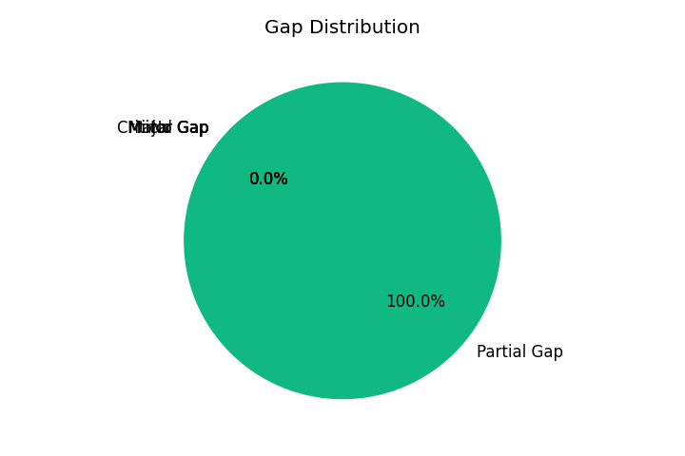
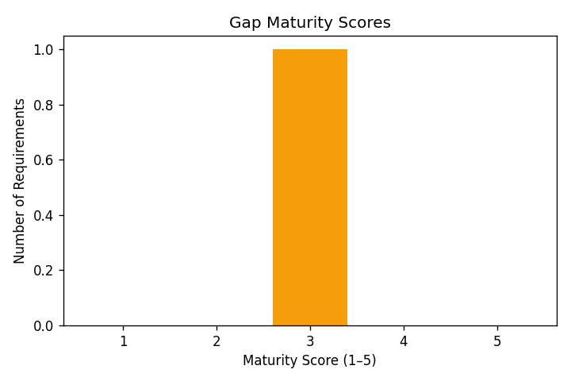
Gap Assessment Findings (MCQ → Maturity Score → Suggested Actions)
Q# | Matched Clause | Selected | Gap Status | Score | Action Plan (Immediate/Short/Long)
1 | 1 - Scope | why | Partial Gap | 3 | Immediate: Close documentation/evidence gaps for Scope. Short-term: Standardize the process and verify implementation. Long-term: Improve maturity through monitoring and reviews.

4. Risk Assessment
Overall Risk Exposure: 36%
High Risks: 0
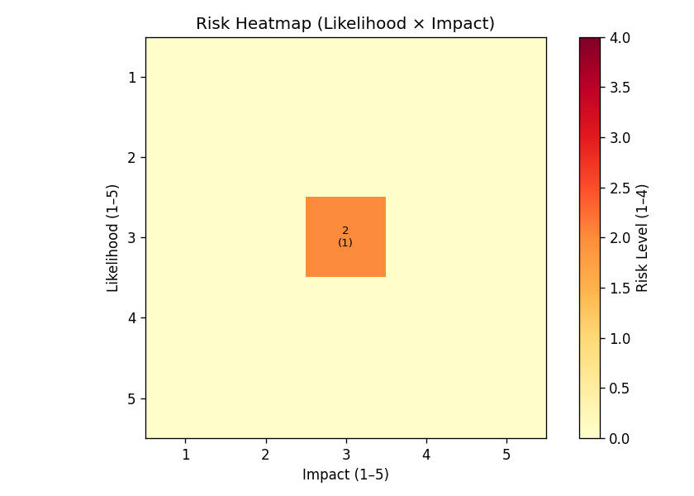
Risk Register (Likelihood × Impact → Score → Level)
Matched Clause | Threat (MCQ Question) | Likelihood | Impact | Score | Risk Level | Action Plan (Immediate/Short/Long)
1 - Scope | No assessment questions found. | 3 | 3 | 9 | Medium | Immediate: Document risks and assign ownership for Scope. Short-term: Plan control improvements and start evidence collection. Long-term: Monitor trends and update risk treatment actions.

5. Executive Summary
Gap Maturity: 60%
Risk Exposure: 36%
This audit report translates questionnaire answers into measurable maturity and risk indicators, and provides improvement actions aligned with ISO/IEC 27001 clause requirements.

