Producing a paper using MS-Word

Anonymous Author 1*1,2, Anonymous Author 22,3, and Anonymous Author 33

*Corresponding Author: name@domain.com

1This Department, University X, City, Country

2That Department, University Y, City, Country

3Other Department, University Z, City, Country

If preparing a short submission (2 pages excluding references), omit the abstract entirely and use body text only. If preparing a long submission, (6 pages excluding references) , this is where the abstract should be placed. It should be in 8pt font and consist of one paragraph giving a concise summary of the material in the article body. Note that the review process is double-blind, so initial submissions should be anonymous and no author details should be added above. To avoid problems with page limits, please do include the appropriate number of placeholders for authors. Each affiliation should be designated with a superscript number - indicate author affiliations by adding the appropriate superscript number next to the author name in the initial list of authors. Designate a single corresponding author using a superscript “*”. Avoid footnotes in the abstract or title – acknowledgements for funding bodies etc. are to be placed in a separate section at the end of the text.

**1. Guidelines**

We have provided a file showing the layout required when producing a paper using Word (this is likely to be the document you are currently reading). This is the body text and should be 10pt font. The title should be all capitals, bold, 11pt font. The list of authors should be all capitals 9 point font, and the list of affiliations should be regular 9 point font. You can delete our sample text and replace it with your own contribution to the volume, although we recommend that you keep an initial version of this file for reference.

## 1.2. Double-Blind Peer Review

The review process is double-blind. Authors will not be told who reviews their paper and reviewers will not be told who the authors of the papers are. Please keep in mind these guidelines for keeping your paper anonymous:S

**1. Do not include the names and affiliations of authors in the paper**

Authors will add names and affiliations after the paper has been reviewed and accepted. However, keep in mind that names and affiliations will take up space. We suggest that authors include anonymous placeholders for names and affiliations to avoid problems with page limits (e.g. “AUTHOR BBBBB & AUTHOR CCCCC”).

**2. Try not to reveal the identity of the authors indirectly**

This can include the following steps:

* Use third person to refer to previous work by the authors. e.g. instead of “As we have previously shown, language is a complex system (Jones, 2012)” use “As was previously shown, language is a complex system (Jones, 2012)”, or more simply “Language is a complex system (Jones, 2012)”.
* Do not eliminate essential self-references or other references but limit self-references only to papers that are relevant for those reviewing the submitted paper.
* Make sure figures do not contain any affiliation related identifier.

If the paper is accepted the authors will be required to submit a camera-ready version. In the camera-ready version, the steps above can be reversed and author names, affiliations and acknowledgements etc. may be added. **Again, please make sure that the papers will adhere to the space limitations once these changes are made**. Of course, given the small size of the field it may not be possible to completely prevent reviewers from guessing the identity of the authors.

## 1.3. Headings and Text

Please preserve the style of the headings, text font and line spacing in order to provide a uniform style for the proceedings volume. Note that page numbers should not be included – the final pagination of the volume will be done by the editors.

## 1.4. References and Citations

References and citations should be in the APA style. We have included examples of reference style for various publication types in the References section.

**Citation Example 1:** Pinker and Bloom (1990) argue that …

**Citation Example 2:** It has been argued (Pinker & Bloom, 1990) that …

## 1.5. Footnotes

Footnotes are denoted by a character superscript in the text.[1]

## 1.6. Equations

Equations should be centered and numbered consecutively, as in Eq. (1).

*p* = *q* + *r* (1)

## 1.7. Tables

Tables should have a uniform style throughout the paper. We would prefer the border lines to be of the style shown in Table 1 – single lines at top and bottom, no vertical lines at left or right. Placement of inner lines is left to your judgement, but it generally looks better if they are kept to a minimum.

Table captions should be placed at the top of the table. Text within the table should be 8pt.

Table 1. An example table. The text within the table is of 8pt size.

|  |  |  |  |
| --- | --- | --- | --- |
|  | *Column1* | *Column 2* | *Column 3* |
| Row 1 | entry | entry | entry |
| Row 2 | entry | entry | entry |
| Row 3 | entry | entry | entry |

## 1.9. Figures/Illustrations/Images

It is best to embed the figures in the text where they are first cited, e.g. see Fig. 1. Please ensure that all labels in the figure are legible regardless of whether they are drawn electronically or manually. Very large figures and tables should be placed on a page by themselves.

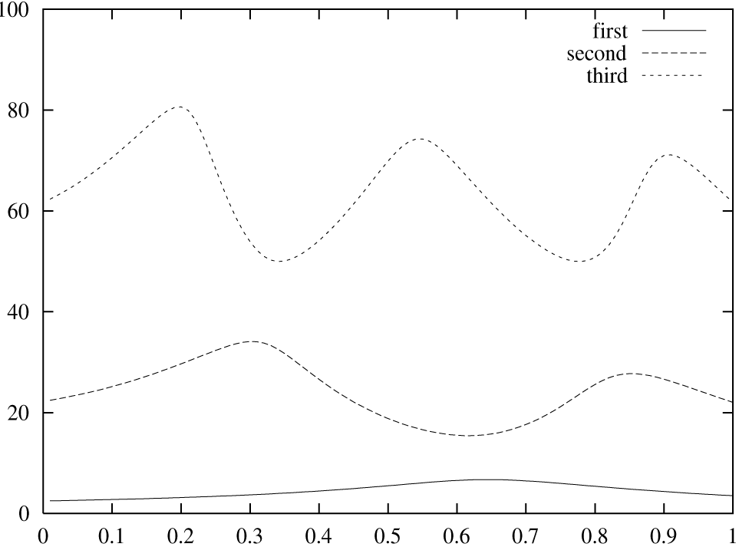

Figure 1. An example graph. All labels are legible.

The caption heading for a figure should be placed below that figure. The caption text should be in 8pt font.

# 2. Supplementary Materials

There will be some support for supplementary materials. All information necessary to understand and evaluate the submission should be included in the main paper. Reviewers will not see the supplementary materials. However, authors are encouraged to make data or code available for the final publication. All supplementary materials should be submitted within a single zip file, which should also include a README.txt file describing the contents. Supplementary materials should be referenced in the main text (e.g. “see supplementary materials”).

Acknowledgements

If you wish to acknowledge funding bodies etc., the acknowledgements may be placed in a separate, unnumbered section at the end of the text, before the Appendices. Please replace acknowledgements with filler text for the submission stage to preserve anonymity. Please avoid appendices in the text and provide additional information in the supplementary materials instead. These will be hosted online along with the final proceedings but will not be considered during the review process.

References

Hauser, M. D., & Fitch, W. T. (2003). What are the uniquely human components of the language faculty? In M. H. Christiansen and S. Kirby (Eds.), *Language evolution* (pp. 158-181). Oxford: Oxford University Press.

Pinker, S., & Bloom, P. (1990). Natural language and natural selection. *Behavioral and Brain Sciences*, *13*, 707-784.

Tomasello, M. (2003). *Constructing a language: A usage-based theory of language acquisition.* Cambridge, MA: Harvard University Press.

1. This is a footnote. Footnotes are 8pt font.