Final Project
Erica Volden
Data Mining (DS 260)

Introduction
10 pts
Many companies are actively searching for ways to lower energy costs, one of which is to use occupancy detection as an input for HVAC control algorithms. Given a dataset collected with various sensors and cameras within an office room, I created three machine learning classification models to determine the best features to use to predict if the room is occupied. The features to choose from were:
Features:
Temperature – Room was heated to stay above 19 degrees C and data readings were taken by a DHT22 sensor with the door both open and closed to test for differences within the models.
Humidity – Humidity levels in the room, collected by the same DHT22 sensor as Temperature
Light – Light levels in the room, collected by sensor
CO2 – Level of carbon dioxide in the room, collected by sensor
Humidity Ratio – The content of water vapor in the air, collected by sensor.
Occupied (Target variable being predicted) – Digital camera to monitor if the room was occupied, shown in the dataset as 1 for yes or 0 for no.
The sensor readings were recorded at time intervals of 14s then averaged to get the value for that corresponding minute. The video was timestamped every minute and viewed for occupancy results against the same minute.

Data Preparation
15 pts
Looking at the dataset with the df command, I saw that the values in the ‘Occupied’ column were categorical and would need to be replaced with numeric values in order to be processed and used with the rest of the data. I also saw that the values were inconsistent, so I used the code df["Occupied"].unique() to see what unique variables were being used in the column. This command returned the array (['yes', 'no', nan, 'Yes', 'Y', 'N ', 'No', 'Y '] showing there were multiple ways people entered data to mean ‘yes’ or ‘no’. This output also showed that there was at least one null value, shown here as ‘nan’, meaning no data was entered in that row. I needed to find out just how many null values there were in the dataset before I changed any variables.
To find null values in a data frame, the command: df.isnull().sum(), gives you a list of all the columns and the number of null values in each. The output showed there were 3 null values in the dataset. Since they were in the Occupied column (the target variable), I chose to delete those 3 entries using the dropna function, df.dropna(axis=0, inplace=True). Since there were over 8,000 rows of data, deleting 3 wouldn't be a significant loss. The pictures show the output data before and after the drop function was executed.
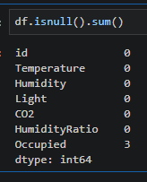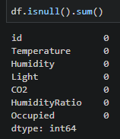
After taking care of the null values, I turned my attention back to the categorical values that needed to be replaced with either a 0 for any entry with a version of ‘No’ or a 1 for entries with a version of ‘Yes’. The command: df['Occupied'] = df['Occupied'].replace( {'N': 0, 'Y': 1, 'yes': 1, 'no': 0, 'Yes': 1, 'N ': 0, 'No': 0, 'Y ': 1 } ).astype(int), where I mapped every unique variable I found previously with a corresponding 0 or 1, was used to accomplish this task. Then I ran the df[‘Occupied’].unique() code again, which returned an array of ([1, 0]), meaning all the variables were now a 1 or 0.
From there, I decided to look at some statistical information about the dataset to ensure there weren’t any obvious outliers by using the df.describe() command. The output showed a table that contained the count, min and max values, standard deviation and quartile values for each column. The main values I considered in the table were count, min and max. The count value should be the same for each column, indicating there were no missing values. Min and max would show if there were any values that were out of normal range for the feature in that column. The count, min and max for the dataset showed everything the same or withing range, meaning there were no missing values or outliers that needed to be taken care of. The df.describe command is useful when you want to get a quick snapshot of the data for cleaning purposes, but, as stated above, it also provides statistical information. In particular, the table shows the mean, or average, of each column as well as the median, or middle value of the data within each column.
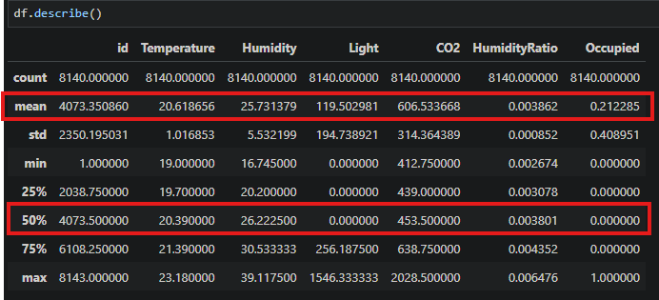

Training Set Exploration
15 pts.
The data is cleaned and ready to be explored to figure out what useful information can be pulled from it to make our models and predictions. I took another look at the df.describe command, as it is not only useful when you want to get a quick snapshot of the data for cleaning purposes, but it also provides statistical information. In particular, the table shows the mean, or average, of each column as well as the median, or middle value of the data when listed in ascending order, labeled in the table as 50%. The mean and median for the id column are not useful because the id column does not contain aggregate information only a unique number for each row in the dataset. Even though the data in the Occupied column is useful, the values for mean and median are comprised of ones and zeros which represent either yes or no, so the mean and median don’t tell us anything. The other five columns, Temperature, Humidity, Light, CO2 and HumidityRatio, do provide useful statistical information. The averages and medians for those columns respectively are as follows:
Temperature: 20.618656, 20.39
Humidity: 25.731379, 26.2225
Light: 119.502981, 0.0
CO2: 606.533668, 453.5
HumidityRatio: 0.003862, 0.003801
While statistical information about data does give some insight into the relationships between the features, being able to see the data can help to narrow down which features will drive the intended results. Since the data was collected over time, I used KNIME to view each feature as a time series graph. The graph for the Occupied feature, labeled Occupancy, showed when the room was occupied (line at the top of the graph) and when the room was empty (line at the bottom of the graph). This presented a baseline for comparison with the graphs for the other five features. The graphs for Temperature, Humidity and HumidityRatio can be seen gradually decreasing, then slowly increasing before gradually decreasing again, compared to the sudden increases and decreases of the Light and CO2 graphs. While the changes in the features coincide with Occupancy, the sharp changes shown in Light and CO2 match more consistently. This make sense given that when the room is empty, lights are off and no one is breathing out CO2 and when the room is occupied, the opposite is true. Taking the other features into consideration, temperature and humidity can’t change suddenly so it makes sense that the changes in these values are more gradual.
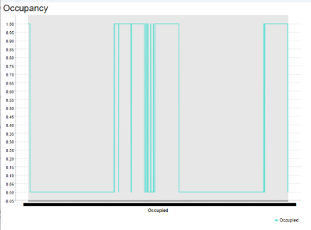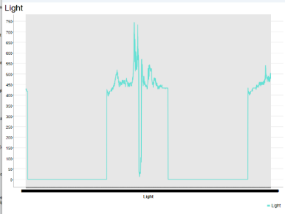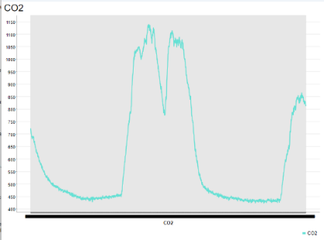
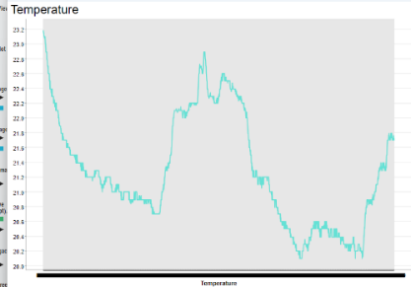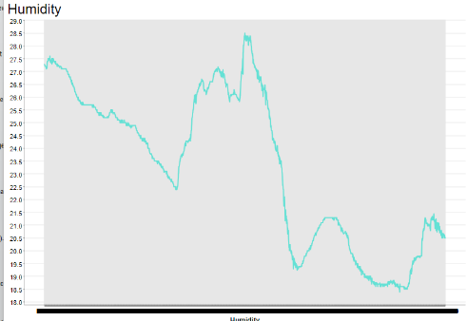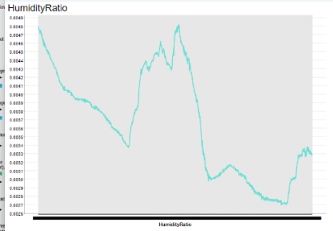

These graphs showed the data relationships more clearly and helped guide my decision in using Light and CO2 as the features for building machine learning classification models to predict room occupancy.

Predicting Occupancy
50 pts
When it comes to machine learning, classification is a type of supervised learning where values of categorical variables are predicted based on past data. This means that a model predicts a value from a category based on what it knows to be true from data gathered previously. For a model to “know” about previous data it is trained using a dataset with the same information it is meant to be predicting. For example, a bank might use loan information from previous customers to predict whether or not a new customer will default on a loan. To determine the accuracy of a model, it needs to be tested. Training and testing of a model is done using the same dataset that has been split either manually, as with this dataset, or by using functions within coding libraries. This split provides a training dataset containing typically 70-80% of the data and a testing dataset containing the remaining 20-30%. The testing dataset already has the correct values for the target variable, so introducing the trained model to the features of the testing dataset to make predictions allows for checking the model’s predictions against the actual values for accuracy.
To test the theory that light and CO2 levels are the best features from the dataset to predict room occupancy, I built three Decision Tree classification models using the Occupancy dataset from above and tested their accuracy against the testing data that was previously split and set aside. Decision tree models sort each row for the given features (Light, CO2) into the predefined categories of the target feature (Occupied).
For all three models, I used the Light and CO2 columns of the dataset as my X variable for both training and testing purposes. The target y variable, or the feature being predicted, for all three models was the Occupied column, shown above being replaced with ones and zeros since machine learning models require numerical values to work. Below is the code used for each model, the accuracy score and a brief description of the different predictors used to create the model:

Model 1:
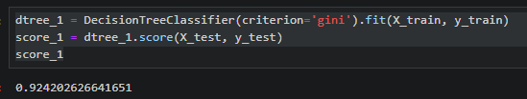
Score: 0.924202626641651 or 92%
Parameters: The parameter I used for the first model was criterion=’gini’, which looks at the features and decides which one to use to make the purest split within the decision tree.

Model 2:
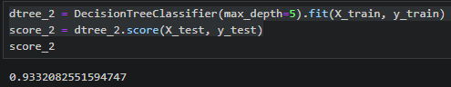

Score: 0.9332082551594747 or 93%
Parameters: For the second model I used the max_depth parameter set to 5 meaning that the nodes of the tree can expand at maximum five times.
Model 3:
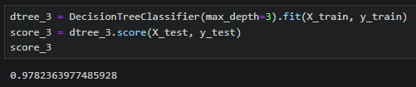
Score: 0.9782363977485928 or 98% (rounded up)
Parameters: I used the max_depth parameter set to 3 for the third model, only allowing the tree’s nodes to expand three times.
I chose to use Model 3 for my final model because it has an accuracy of 98%, meaning that it correctly predicted if the room was occupied 98% of the time. Here is my final tree:
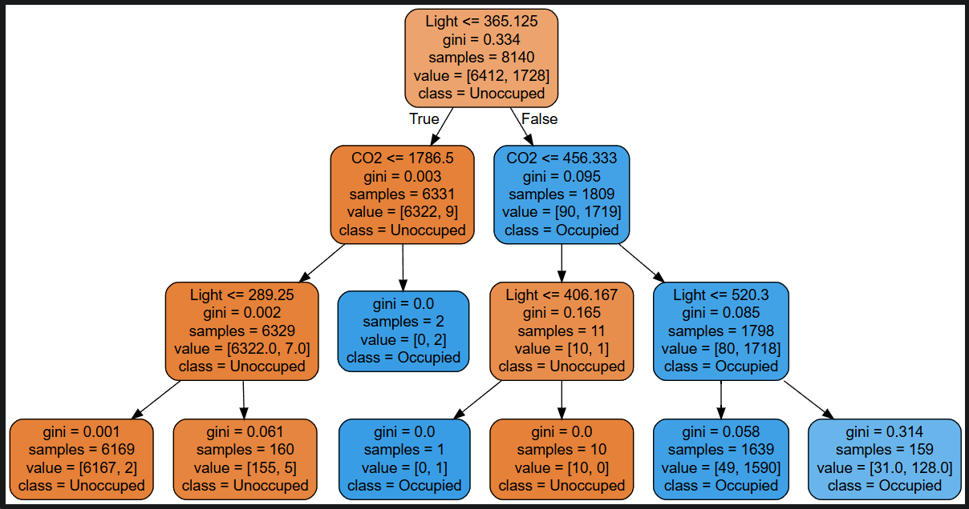

Conclusion
10 pts
In this project, I used data preparation techniques to clean the Occupancy dataset, getting rid of null values and changing categorical values to numeric so the data could be further explored. After cleaning, I began my exploration of the dataset, first viewing statistical information such as mean and median, then using KNIME to graph each feature to help decide which would be the best to use for predicting the target variable. I chose Light and CO2 for the feature columns and Occupied for the target column to use to train and test the models. From there, I created and trained three decision tree models using the parameters criterion and max depth, then got predictions using the testing dataset, checking for accuracy. I selected the most accurate model, model 3, for my final decision tree and printed the tree to show how the model works.
Model 1 had an accuracy of 92% which showed how using light and CO2 levels to predict room occupancy was a good choice. I decided to continue using light and CO2 for the predictive features for the remaining two models and just dial in the accuracy using the parameter max depth. Setting the max depth to 5, allowing the model to expand up to five times, for the second model gave me a better accuracy of 93%. I could have stopped there; however, I wanted to see how further restricting the model would change the accuracy. For the third model, I set max depth to 3, meaning the model could only expand 3 times. Comparing models 2 and 3, the larger max depth allowed the model to expand too much, leading to it having more incorrect predictions. The smaller max depth forced the model to make its predictions sooner without letting it try to further evaluate the data. This technique may not always work out as there are times when the data needs to be broken down further, in which case raising the max depth is a viable option. However, the smaller max depth of model 3 worked well and raised the accuracy to 98%, which is why I ultimately chose it as my final model.

