Curve Fitter: Open source software for the analysis of growth curves.

Contents

Introduction 3

Generating high quality growth curves 3

Input Data Format 3

Blanking Data and Removing Wells 4

Blanking with initial readings 4

Blanking with a known value 5

Deleting or removing wells 5

Selecting Data to Fit 5

Fit data over a range of OD values 6

Fit data up to a percentage of the maximum OD 6

Fit a particular range of measurements 6

Manually including or excluding points 6

List of Growth Curve Models Fit 7

Visualizing Individual Growth Curves 8

Zooming, copying or saving any of the plots 8

Doubling time between reads plot 8

Visualizing Multiple Growth Curves 9

Using the microtiter plate tab 9

Using the plot different groups tab 10

Defining groups by pre-set buttons 10

Defining new groups in the GUI 10

Defining new groups by importing a CSV file 10

Examining Model Fit and Performing Sensitivity Analysis 11

Grouped visualizations 11

Sensitivity tab 12

Outputting Data 12

How to output 12

Output Format 13

Header Section 13

Raw Data Section 13

Reimporting Already Fit Data 13

Manual v. 1.0

# Introduction

Curve Fitter is a program designed to fit microbial growth curves, in particular those generated by periodically reading OD measurements of cultures growing in microtiter plates. It provides methods to visualize the data and to fit different growth models and to visualize those fits. The program is composed of two parts. The first is a graphical user interface (GUI) program which interactively displays the data, different model fits and allows one to inspect these things. The program has a number of features to plot and display data, as well as to show various diagnostic plots and groupings by different treatments. The second component of the program is a scripting environment console which allows one to rapidly process large amounts of data and generate custom plots using the tools in Curve Fitter.

For a quick introduction to the program, you can work through the tutorial and example data shown at this [website.](http://www.evolvedmicrobe.com/CurveFitter/index.html) More detailed information on each of the programs components is available in this manual.

# Generating high quality growth curves

We have found there are several critical factors in generating meaningful growth curve data that must take place before the data are fit in Curve Fitter. First, the cultures must be adequately aerated and mixed. 96-well plates are usually not able to do this, but 48 well plates can. Second, regular calibration of the instruments is a necessity. All moving parts should be checked to ensure micro-titer plates are being positioned properly and are not being scratched. It is also strongly advised that any plate reader be calibrated yearly.

# Input Data Format

Data can be input in to Curve Fitter in three ways all of which are available from the File menu in the GUI program. The two commonly used options available are shown highlighted below. 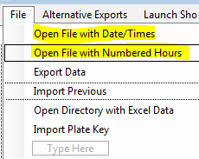

These options both use Comma Separated Value files to input data. These are tabular files that can be edited with Excel and a variety of other programs. Each file has a time column, followed by a column for each well or culture with a reading at that time. They differ in how the Date/Time value is entered. In the first option “Open Directory with Excel Data” the time is entered in a very specific date/time format. Such as: “5/25/2012 2:18:07 PM”. In the second option, “Open File with Numbered Hours.” The time is simply entered as hours from the start, e.g. 0, 1, 2 etc.

In practice, the easiest thing to do is download an [example data file](http://www.evolvedmicrobe.com/CurveFitter/ExampleData.csv) and simply change it to match your data. Any problems loading the data are likely due to either the date/time format being incorrect, or the CSV file containing empty lines at the end of the file (this can be checked for by opening the file in an editor such as notepad and scrolling to the bottom, any lines with only commas should be deleted from the file.

# Blanking Data and Removing Wells

This is performed using the “Remove Blanks From Plate Data” tab. To delete a well on this tab, simply click to delete it, or from the main tab select the well

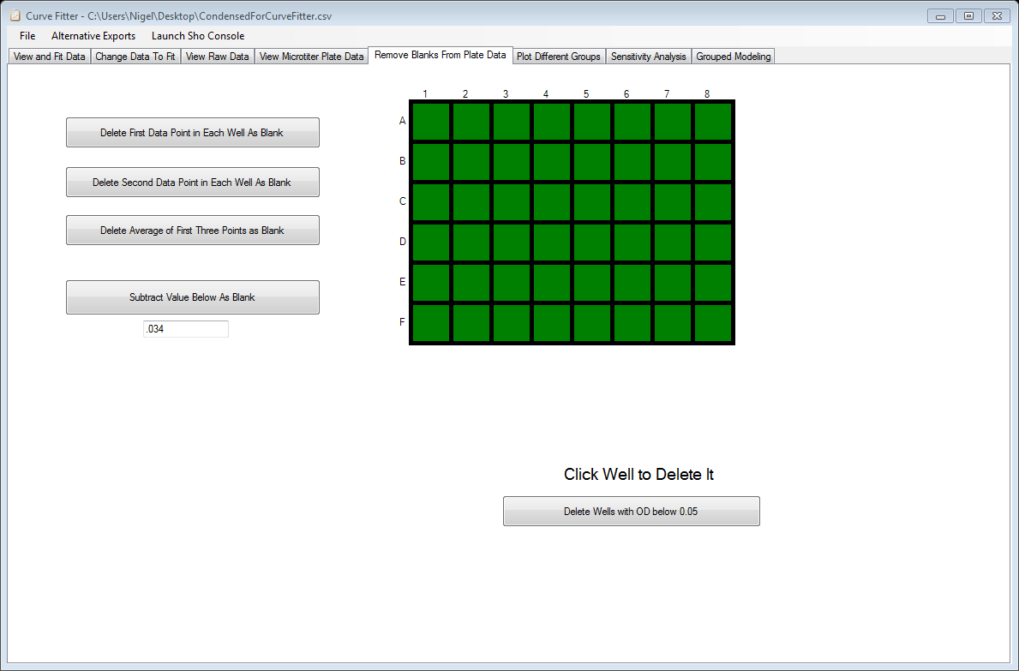

### Blanking with initial readings

Simply click any of the three large buttons to delete all measurements in a well by the first reading for that well or any other option shown.

### Blanking with a known value

To remove a set amount from the reading for each well, simply type this value in to the text box on this tab, then click the button above the box. This value will then be deleted from every measurement currently loaded in to the program.

### Deleting or removing wells

To delete a well on this tab, simply click the well on the green plate map shown. Alternatively, the well may be removed by selecting it on the first tab and pressing the delete key or the “Delete this Curve” button.

# Selecting Data to Fit

Inside the GUI on the main tab a number of methods are available to select a range of points to fit.

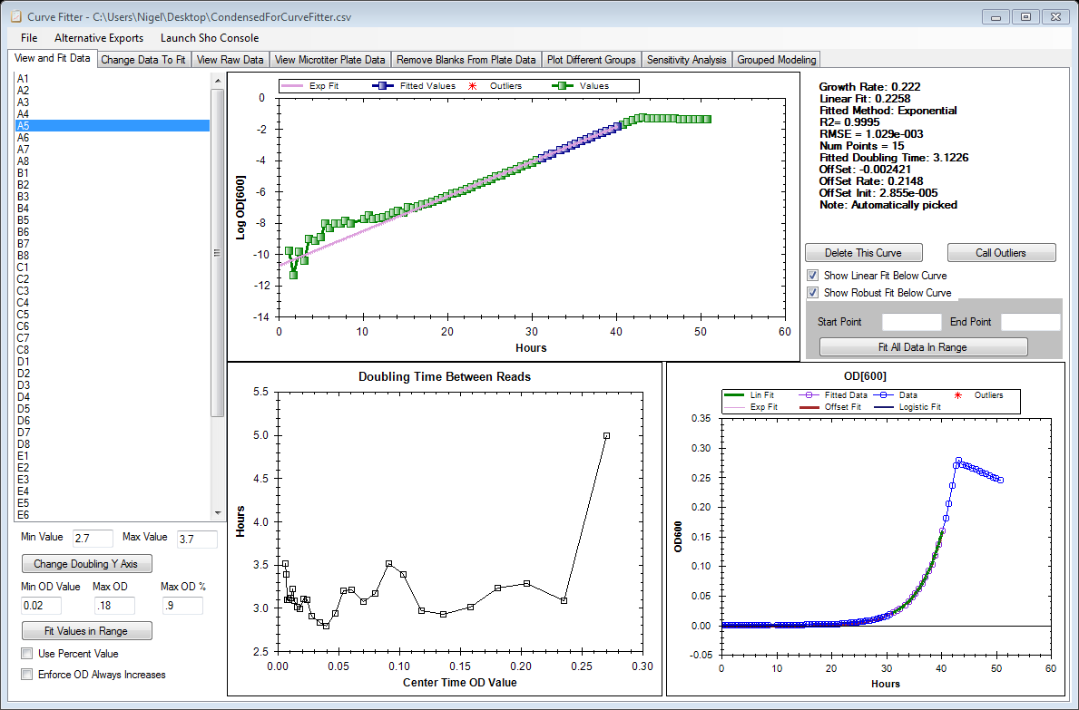

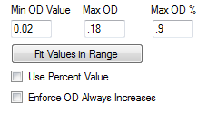

### Fit data over a range of OD values

To fit data over an absolute value of the OD value, fill the minimum and maximum of the range to be fit, and click the button as shown. The option “Enforce OD Always Increases” can be selected so that no additional points are fit if the OD readings start to decrease, indicating that growth has ended.

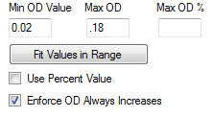

### Fit data up to a percentage of the maximum OD

Same as above, but now instead of an absolute range, one enters a percentage to fit up to. Each well will then be fit using all readings from the minimum OD value up to this percentage of the highest value in 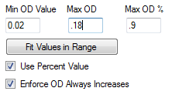that well.

### Fit a particular range of measurements

To fit all curves with a range of measurements (say the 10th measurement through the 20th measurement). Simply use the box shown below.

### Manually including or excluding points

Points can be manually included or excluded from the fit by selecting the point on the Log plot on the first tab, or by selecting the point on the “Change Data To Fit” tab. And selecting points there. Simply click the point with your mouse.

# List of Growth Curve Models Fit

Curve Fitter fits a variety of exponential growth models, and contains non-linear fitting routines that make it easy to add additional models. The 5 types of models fit and reported by curve fitter are given below. Models LIN, EXP and OFFSET are fit by default, while ROBUST can be fit on all curves by pressing the “Call Outliers” button on the View and Fit Data tab.

|  |  |  |  |
| --- | --- | --- | --- |
| Model | Short Name | Equation | Notes |
| Linear Growth Model | LIN | $$\log{OD}=a+rt$$ | The classic growth equation after the logarithmic transformation. |
| Exponential Growth Model | EXP | $$OD=ae^{-rt}$$ | The exponential growth equation fit on the original scale. This is the primary equation used in Curve Fitter. |
| Off Set Exponential Growth Model | OFFSET | $$OD=ae^{-rt}+C$$ | Same as EXP but with an offset term ($C$) that can be inferred if one is uncertain of the blank value to use. |
| Robust Exponential Growth Model | ROBUST | $$OD=ae^{-rt}$$ | The exponential growth model, but fit with a model for the error that accounts for outlier values (see section on the mixture model). |
| Group Fit Exponential Growth Rate | GROUP | $$OD=ae^{-rt}$$ | The exponential growth model, but with many cultures simultaneously used to fit the estimated growth rate. For advanced users only. |
| Quadratic Growth Model | QUAD | $$\log{OD}=a+rt+rt^{2}$$ | If this model is a significantly better fit than the LIN model, it indicates that the exponential growth model is inappropriate. |
| Logistic Growth Model | LOGI | $$OD=Kae^{r*t}/(K+a{(e}^{r*t}-1)$$ | For modeling the entire growth curve, usually inappropriate as it predicts fastest growth and intermediate OD values. |

# Visualizing Individual Growth Curves

The growth curve fitter contains several plots that are produced to help visualize single curves. This section explains how to interact with the plots.

### Zooming, copying or saving any of the plots

The plots in curve fitter can be copied or saved by right clicking on them. To zoom simply draw a rectangle by clicking or use the scrolling ability of your mouse.

### Doubling time between reads plot

Although most plots in curve fitter are self-explanatory, this one requires explanation. This plot estimates a local doubling time at a point $i$ by estimating the growth rate from the two neighboring points ($i+1, i-1)$. It can be used to look for a systematic increase or decrease in the observed growth 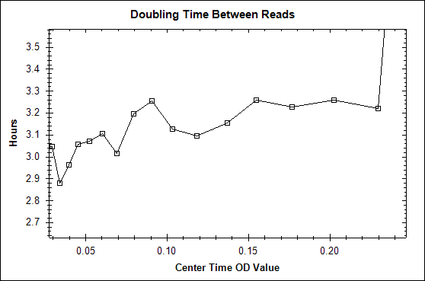rate through time.

# Visualizing Multiple Growth Curves

## Using the microtiter plate tab

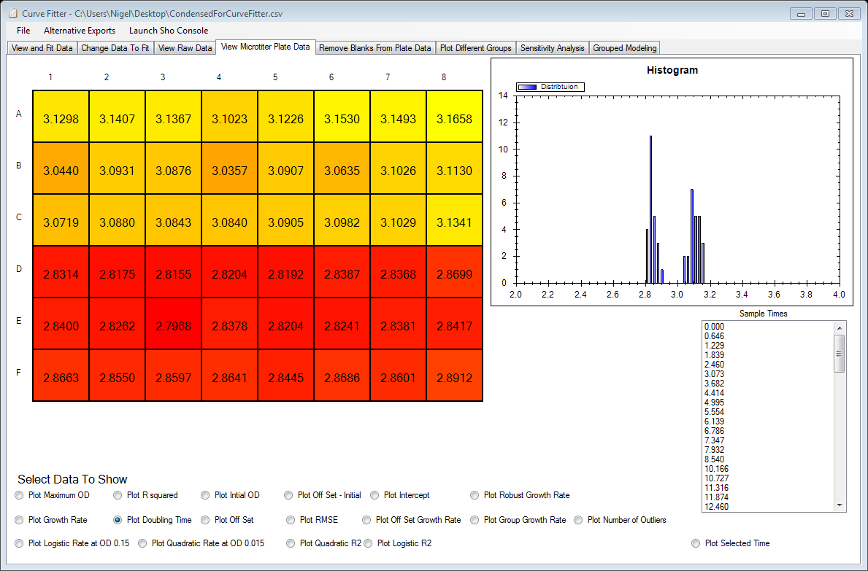This tab can display a heat map of various summary statistics. When a radio button is selected, the corresponding value for each well in addition to a histogram of the entire distribution are shown. To view the OD readings at a particular time, simply click the “Plot Selected Time” box and select a time in the scroll box.

## Using the plot different groups tab

This tab allows one to assign types of wells to groups and then plot them as they appear. Groups are numbered from 1 to 16 and can be defined in a variety of ways as described below.

### Defining groups by pre-set buttons

You can click on “Assign Everyone” to assign all wells to the first group. Clicking assign Cols to Group will assign wells based on which column they are in, and this button toggles between assigning wells based on column or row.

### Defining new groups in the GUI

To make arbitrary group assignments within the GUI, simply click a group in the scroll box and then click that group in the plate map shown above the box. Clicking once assigns the well to that group, clicking twice removes the assignment.

### Defining new groups by importing a CSV file

Groups can also be defined by going to the import plate key option from the file menu. From the menu that appears select a CSV file with as many rows and columns as you have in your plate. The number in the respective row/column in the CSV file is interpreted as the group assignment of the corresponding well.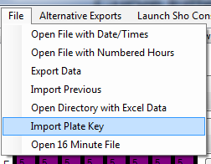

# Examining Model Fit and Performing Sensitivity Analysis

### Grouped visualizations

From the “Plot Different Groups” tab you can examine several plots to see how the growth rate changes. The QQ Plot can be checked for normality, the residuals plot can be examined to verify that they do not have a pattern.

### Sensitivity tab

This tab shows for each growth curve how the estimated growth rate changes as the low end and high end of the fitted range varies. The value at a given position is the instantaneous growth rate obtained by fitting from all values from the start of the range defined on the y axis to the end of the range defined on 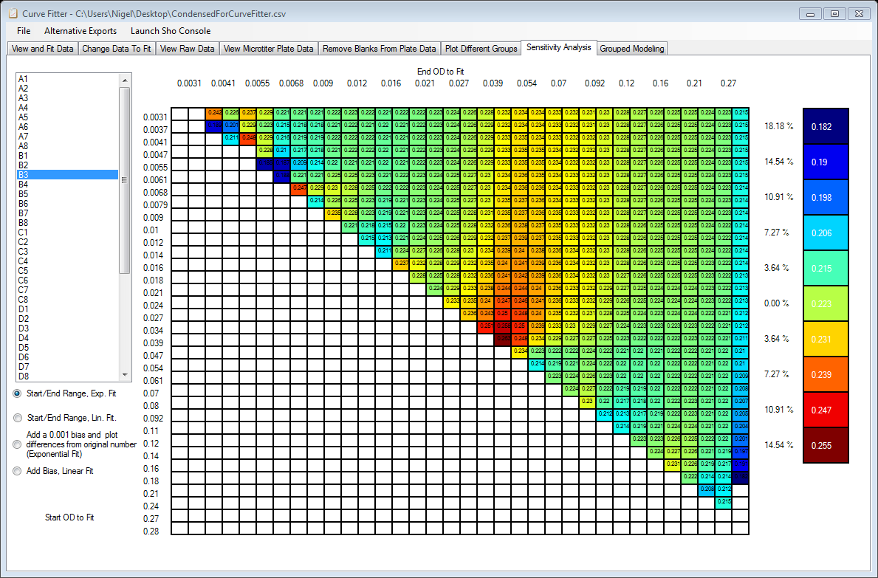the x axis. Ideally the estimated rate should not be sensitive the exact range chosen, i.e. the color should be flat.

# Outputting Data

## How to output

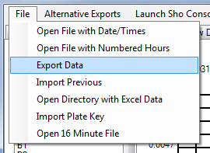To output data simply select Export Data as shown below and select a location to save a csv file.

## Output Format

### Header Section

The header section of the file has a line for each well that was fit, and a column corresponding to various values calculated from the fit. The different parameters are prefixed by the model using the short-names described in the model section.

### Raw Data Section

The section below the “Complete Data Listing” line contains data for each column the OD value recorded and a 0 or 1 flag depending on if the data was used in the fit.

# Reimporting Already Fit Data

Simply select the “import previous” from the file menu and navigate to the file you previously exported as a CSV.