# Curve Fitter Tutorial

A Quick Start Guide

## Tutorial Summary

In this tutorial we will download and install curve fitter, use the program to fit growth curves to sample data and then use the visualization abilities in curve fitter to discover a systematic bias in this data.

## Installation

To install Curve Fitter, simply go to the website listed below and select the link to download the installer.

<http://www.evolvedmicrobe.com/CurveFitter/Download.html>

This will download a file InstallCurveFitter.msi. Double click this file to run it. Once the installation completes you should see a new folder called Curve Fitter in your start menu as shown below.

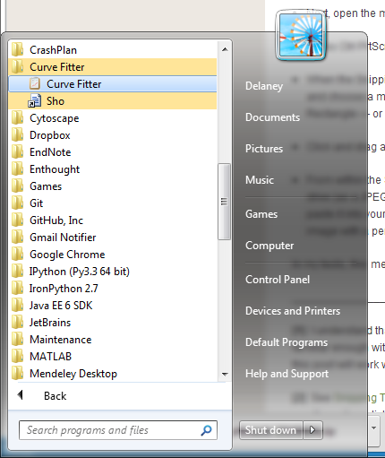

## Loading data into Curve Fitter

Open the program, and select File-> Open File with Date/Times.

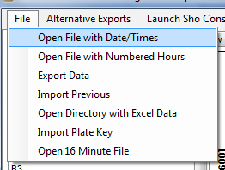

Navigate to the directory with the tutorial data, and select “ExampleData.csv”

## Blanking and Fitting

First we will remove the first OD reading for each well as the “blank” value for that well. Go to the “Remove Blanks From Plate Data” tab and select “Delete First Data Point in Each Well as Blank.”

Now go back to the “View and Fit Data” tab, notice how all the wells now start at 0 as their first reading. 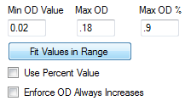Let’s fit all the data in the OD range from 0.02 to .18 using the exponential growth model. In the lower right, click “Fit Values in Range” after inputting these values.

Notice how the fit lines are now displayed. Select different curves in the scroll box above, and push the up or down arrows to scroll them. Try selecting a point in the top graph in this plot to change whether or not it is included in the fit and view how the fit changes.

## Examining the Fit

Go to the “View Microtiter Plate Data” tab and click “Plot Doubling Time” to view the distribution of doubling times. Do you notice a pattern? Select Plot R squared next. What do you think of the quality of these fits?

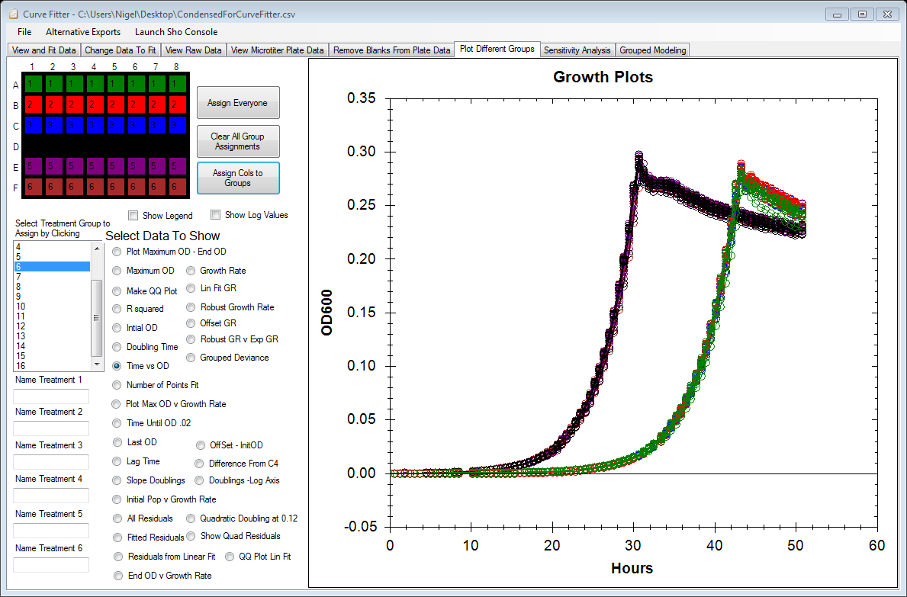Next let’s go to the “Plot Different Groups” tab.

Click on the “Time vs OD” Button, and next click the “Assign by Rows” button, then select the “Doubling Time” radio button. Click the “Assign by Cols” button, to toggle between the two. Feel free to try other options.

Try clicking “Fitted Residuals” these are the errors around each measurement at the time they were taken. Do they look independent to you?

Next, let’s assign all the wells to one of two groups, click “Assign Everyone” to assign all wells to the first group, next select “2” from the scrollbox and start clicking all the wells on rows D through F (graphic below shows us halfway through this process).

## 

## Exporting Data

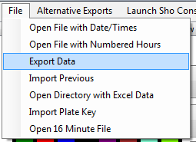Simply click File->Export Data. Save it in a location, and open it with excel.

## Using Sho for Plotting and Statistics (slightly more advanced)

Click “Launch Sho Console” from the top menu. This will load all of the curves you have fit into a collection of curves named as the variable gcc. Try typing the following commands.

(Hint: Try hitting tab while typing to use the autocomplete feature).

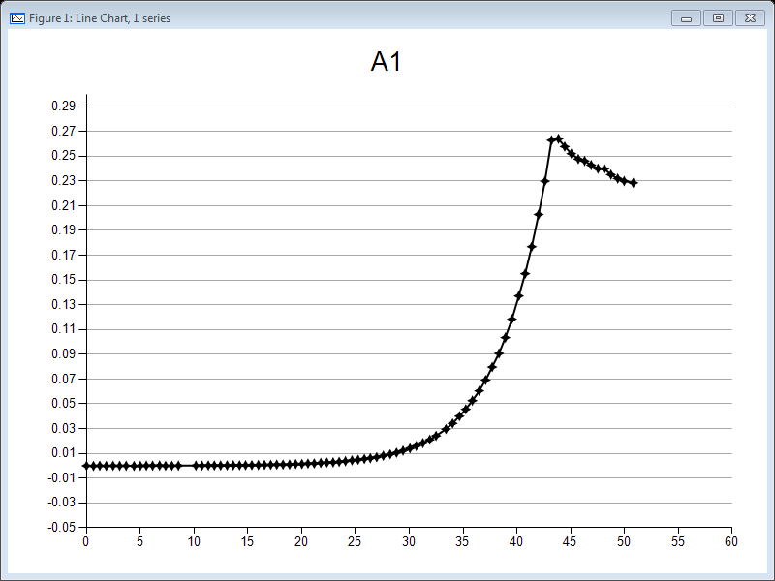You should now have a plot as shown.

Next let’s make a histogram of every curve in the list, try the following commands

You should obtain a histogram which after playing with the slider bar some, should look like the picture 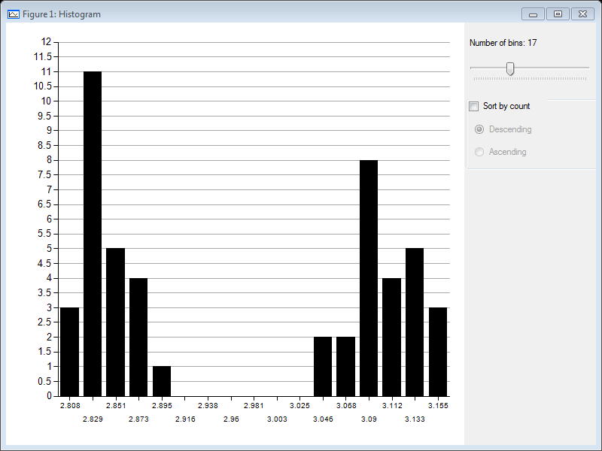below.

Are these two significantly different? Let’s find out with a t-test, comparing the first 24 curves to the 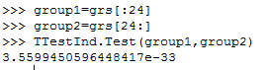last. Try this code below:

The value returned 3.55e-33 is the p-value on the t-test, shockingly, they are significantly different! Similarly, you can do ANOVAs, regressions, change the fitting range or anything else you want in this environment. Check the Curve Fitter website for more examples.

Congratulations! You have finished the tutorial.

## More Information or Help

The manual that came with this tutorial has more information about the program. For help or any other issues, please use the discussion and issue tracking pages on <http://curvefitter.codeplex.com/> or feel free to send and email.