Project Name
“TGC Integrated Automation & Departmental Integration”

Business Requirements Document (BRD) Template

Prepared by: Adarsh Ankur
Prepared for: TEJUS Group of Companies (TGC)
Date Submitted: 20th Dec 2025

Project Sponsor: TEJUS Group of Companies (TGC)
Client Acceptor: Abc
Project Manager: Abc

Document Number: Version: 1.1
Last Updated: 20th Dec 2025
Creation Date: 17th Dec 2025

Table of Contents

Table of Contents 2
1. Introduction 3
1.1. Document Purpose 3
1.2. Intended Audience 3
1.3. Project Background 4
1.4. Business Goals/Objectives to be achieved 4
1.5. Stakeholders 4
1.6. Dependencies on existing systems 4
1.7. References 4
1.8. Assumptions 5
2. Requirements Scope 5
2.1. In Scope (features/modules/screens/use cases) 5
2.2. Out of Scope (features/modules/screens/use cases) 6
3. Functional Requirements 6
3.1. Actor/User Profile Specification 6
3.2. Use Case Diagram/Features list 7
3.3. Use Case/Feature Specification 7
3.4. Business Rules 8
4. Data Requirements 9
4.1. Data Volumes 9
4.2. Data Conversion 9
4.3. Data Retention and Archiving 10
4.4. Privacy Implications 10
5. Non-Functional requirements 10
5.1. Security Requirements 11
5.1.1. Authentication 11
5.1.2. Authorization and Access Controls 11
5.2. Availability Requirements 11
5.3. Usability Requirements 12
5.4. System Help Requirements 12
5.5. Performance Requirements 12
5.6. Scalability Requirements 13
5.6.1. User Scalability 13
5.6.2. Application Scalability 13
6. Interface Requirements 13
6.1. User Interface Requirements 13
6.2. System Interface Requirements 13
7. Business Glossary 14
Approval 15

Introduction

Document Purpose

The purpose of this Business Requirements Document (BRD) is to clearly define the business needs, scope, and high-level requirements for the “TGC Integrated Automation & Departmental Integration” initiative.

This document:
- Describes why TEJUS Group of Companies (TGC) is undertaking this project.
- Outlines the expected business outcomes from automating and integrating key departments.
- Provides a common understanding of scope, priorities, and expectations for all stakeholders.
- Serves as the baseline against which the solution will be designed, implemented, and validated.
- Acts as the primary reference for stakeholder review and formal sign-off before solution design begins.

Intended Audience

This document is intended for all stakeholders involved in the planning, decision-making, implementation, and oversight of the TGC automation and integration project, including:

- Executive Leadership / Promoters of TGC
  - Managing Director / CEO
  - Board of Directors / Business Owners

- Business and Operations Stakeholders
  - Heads of Admin, Sales & Marketing, Consultants, Delivery, Manufacturing, and Accounts
  - Regional / Branch Managers
  - Senior Consultants and Project Managers

- Support and Enabling Functions
  - HR and Training representatives (where applicable)
  - IT / Technology Manager or external IT partner

- Implementation Partners
  - Business Analysts, Project Managers
  - Solution Architects and Implementation Consultants
  - Change Management and User Adoption Leads

Each of the above audiences will use this document to validate that their department’s needs are correctly captured and that the proposed scope is aligned with TGC’s business direction.

Project Background

TEJUS Group of Companies (TGC) is a 21-year-old organization operating in the construction domain. Over the years, TGC has expanded its service offerings and customer base, resulting in increased complexity of operations and information flow.
TGC’s services currently include:
- Construction Consultation – Advising clients on construction projects, feasibility, planning, and project management.
- Manufacturing and Sales of Machines – Producing construction-related machinery and selling to clients and channel partners.
- Hiring and Rental Service – Providing machines and equipment to clients on a rental basis.
- Servicing of Machines – Offering maintenance, repair, and servicing for machines sold or rented to clients.
The key departments involved in delivering these services are:
- Admin
- Sales and Marketing Executives
- Consultants
- Delivery
- Manufacturing
- Accounts
At present, many of TGC’s processes are:
- Semi-manual or driven by spreadsheets and emails
- Managed in silos, with limited integration between departments
- Dependent on individual knowledge and manual follow-ups
This leads to challenges such as:
- Lack of end-to-end visibility across the lead-to-cash and service lifecycle
- Delayed or inconsistent information sharing between departments
- Duplicate data entry and errors
- Difficulty in tracking performance of services, machines, rentals, and service contracts
- Limited ability to generate timely and accurate management reports

To address these challenges, TGC wants to undertake a structured automation and integration initiative that connects all key departments on a common, streamlined platform.

Business Goals/Objectives to Be Achieved

1.4.1 Overall Business Goal

To improve productivity, transparency, and control across the organization by integrating and automating core business processes spanning Admin, Sales & Marketing, Consultants, Delivery, Manufacturing, and Accounts departments.
1.4.2 Business Objectives

The following business objectives will guide the project:
- Improve Cross-Department Integration
  - Enable seamless flow of data from lead generation to order booking, manufacturing, delivery, rental, servicing, and billing.
  - Reduce manual handoffs and follow-up dependencies between departments.
- Enhance Productivity and Process Efficiency
  - Reduce duplicate data entry by capturing information once and reusing it across processes.
  - Standardize key workflows (e.g., quotation, order, rental agreement, service request) to reduce processing time and errors.
  - Minimize time spent on manual tracking and reporting.
- Increase Transparency and Traceability
  - Provide real-time visibility of the status of leads, opportunities, orders, rentals, service jobs, and payments.
  - Allow management and department heads to track workloads, bottlenecks, and pending actions.
  - Maintain a clear audit trail for key business activities and approvals.
- Strengthen Financial Control and Revenue Assurance
  - Ensure accurate and timely invoicing for machine sales, rentals, and service charges.
  - Reduce revenue leakage due to missed billing, inaccurate rates, or incomplete data.
  - Improve monitoring of receivables and outstanding payments.
- Improve Customer Experience and Service Quality
  - Provide faster response times for quotations, order confirmations, and service requests.
  - Offer clear commitments on delivery timelines, rental periods, and service SLAs.
  - Maintain a consolidated view of each customer’s interactions across sales, rentals, and service.
- Enable Better Management Reporting and Decision-Making
  - Provide management dashboards and reports on sales pipeline, order book, utilization of machines, service volumes, and financial performance.
  - Help leadership make informed decisions on capacity, pricing, discounts, credit terms, and investment in machinery.
- Lay the Foundation for Future Digital Initiatives
  - Implement a scalable and modular solution that can be extended to other areas over time (e.g., vendor management, inventory optimization, HR).
  - Enable integration with external systems such as banking portals, GST/Tax systems, and third-party tools in future phases.
These objectives will be used later to validate whether the solution meets TGC’s expectations.

Stakeholders

The following stakeholders are identified as primary participants in the project:
- Project Sponsor / Executive Sponsor
  - Senior-most business leader responsible for approving budget, providing strategic direction, and removing roadblocks.
- Steering Committee (if constituted)
  - Select members of leadership representing key departments to review progress and make critical decisions.
- Department Heads / Functional Owners
  - Admin Head – Responsible for general administration, documentation standards, and internal coordination.
  - Sales & Marketing Head – Owner of lead management, opportunity pipeline, quotations, and customer acquisition processes.
  - Consultants Lead / Head of Consulting – Represents consulting engagements, project proposals, and consulting deliverables.
  - Delivery Head – Responsible for order fulfillment, machine dispatch, rental delivery, and related logistics.
  - Manufacturing Head – Represents planning, production, and quality control for machine manufacturing.
  - Accounts / Finance Head – Owner of billing, collections, financial controls, and statutory compliance.
- Process Owners and Subject Matter Experts (SMEs)
  - Senior executives and supervisors who manage day-to-day operations within each department and provide detailed process knowledge.
- IT / Technology Stakeholders
  - Internal IT representative (if available) and/or external technology partner supporting implementation, integration, and maintenance.
- End Users
  - Sales executives, marketing staff, consultants, planners, dispatch coordinators, service engineers, manufacturing supervisors, accounts executives, and administrative staff who will use the new system in daily operations.
Each stakeholder group will participate in requirement validation, user acceptance, and final sign-off relevant to their area.

Dependencies on existing systems

TGC currently uses a combination of tools and practices to run its operations. While the exact technology landscape will be confirmed during detailed discovery, the project is expected to have dependencies on the following types of existing systems:
- Spreadsheets and Manual Trackers
  - Excel or similar tools used by Sales, Admin, Delivery, Manufacturing, and Accounts to track leads, orders, rentals, and payments.
  - These will be important sources of historical data for migration and process standardization.
- Accounting / Finance Software
  - Existing accounting package (for example, Tally, Busy, or similar) used for:
    - Sales invoice posting
    - Purchase and expense booking
    - Tax (e.g., GST) compliance and statutory reporting
  - The new solution may need to either integrate with the current accounting system or provide structured data exports/imports.
- Communication Channels
  - Email, phone calls, and messaging apps used for coordination between departments and communication with customers.
  - Automation may rely on notifications and alerts that integrate with existing communication methods.
- Document Repositories
  - Shared folders or drives storing contracts, quotations, purchase orders, rental agreements, and service reports.
  - The solution may need to reference or store such documents in a structured manner.
- Legacy Practices and Policies
  - Informal, people-dependent practices that have evolved over 21 years of operations.
  - Process changes and training will be necessary to align people with the new standardized workflows.
Any integration, data migration, or phased rollout plan will need to consider these dependencies to ensure a smooth transition and minimal disruption.

References

The preparation of this BRD is informed by:

- Internal discussions with TGC’s leadership and department representatives.

- Industry best practices in business requirements documentation, scope definition, and stakeholder sign-off for automation projects.

- TGC’s internal policies, where available (e.g., credit policy, pricing guidelines, approval matrices).

Specific system documentation, standard operating procedures (SOPs), and policy documents will be attached as appendices or referenced as supporting documents during later phases.

Assumptions

The following assumptions have been made while preparing this BRD:
- Stakeholder Availability
  - Key stakeholders from each department (Admin, Sales & Marketing, Consultants, Delivery, Manufacturing, Accounts) will be available for periodic workshops, clarifications, and approvals.
- Management Commitment
  - TGC’s leadership is committed to sponsoring the project, providing decision-making support, and driving change across the organization.
- Process Standardization Will Be Accepted
  - Departments are willing to review and refine their existing ways of working to adopt standardized processes required for automation and integration.
- Data Quality and Ownership
  - Each department will take responsibility for validating its master data (customers, products, machines, price lists, tax codes, etc.) before migration into the new system.
- Phased Implementation Approach
  - The solution may be rolled out in phases (e.g., starting with core sales and order management, followed by manufacturing, rentals, and service) to manage risk and change.
- Technology Constraints and Choices
  - The final choice of technology platform, whether on-premise or cloud-based, will be made considering TGC’s budget, scalability needs, and IT capacity.
  - This BRD remains technology-agnostic and focuses on business outcomes rather than specific products.
- Compliance and Regulatory Requirements
  - The solution will comply with applicable local laws and regulations (e.g., taxation, invoicing standards, data retention).
  - Any additional compliance requirements identified later will be assessed and addressed during design.
- Training and Change Management
  - Adequate time and resources will be allocated for user training and change management to ensure adoption of the new processes.
These assumptions will be revisited and refined during subsequent phases of the project.

Requirements Scope

In Scope (Modules)

    - Corporate Website (Digital Presence)
The website (www.tgcinfra.com) will serve as the primary digital store-front and lead generation engine.

- Corporate Identity: Highlighting TGC’s 25-year legacy and status as a fastest-growing real estate development company.
- GenX Windoors Showcase: A dedicated product catalog for the uPVC manufacturing division, featuring:
- Casement Doors: Highlighting glass panes and steel reinforcement.
- Folding Doors: Showcasing utility for patios/large gatherings.
- Sliding & Combination Windows: Detailed product specifications.

- Service Portfolio: Informational sections for General Contracting (subcontractor management, schedule coordination) and Design-Build Services (single-entity accountability).

- Dynamic Project Gallery: A filterable portfolio allowing visitors to view projects by status: Completed, Ongoing, and Upcoming.

- Lead Capture Engine: "Contact Us" forms integrated directly with the internal Sales Module to capture inquiries.

- Sales & CRM Automation

- Lead Management: Centralized ingestion of leads from the Website, Phone, and Walk-ins. Auto-assignment of leads based on interest (e.g., "uPVC Inquiry" goes to GenX Team, "Construction Inquiry" goes to Contracting Team).
- Quotation Management:
- uPVC Quotes: Calculation based on dimensions (Height x Width), profile type, and glazing.
- Construction Quotes: BOQ (Bill of Quantities) based estimation for contracting jobs.
- Customer 360: A unified view of client interactions across Manufacturing and Construction services.

    - Manufacturing Management (GenX Windoors)
- Job Order Processing: Converting confirmed Sales Orders for windows/doors into Production Job Cards.
- Material Planning: Tracking inventory of uPVC profiles, glass, steel reinforcements, and hardware.
- Production Tracking: Monitoring stages (Cutting -> Reinforcement Insertion -> Welding -> Glazing -> Quality Check).
    - Construction Project Management

- Project Milestones: High-level tracking of construction sites (corresponding to the "Ongoing" status on the website).
- Contractor Management: Managing subcontractor details for General Contracting services.

    - Rental & Service Management

- Rental Calendar: Tracking availability of heavy machinery for hiring services.
- Service & Maintenance: Ticketing system for machine repairs and uPVC window post-installation support.
- AMC Management: Tracking Annual Maintenance Contracts.

    - Finance & Accounts Integration

- Billing & Invoicing: Automated GST-compliant invoicing for Sales, Rentals, and Service.
- Receivables Management: Tracking payment milestones for Design-Build contracts.

In Scope (Use Cases)

This list defines the specific interactions users will have with the system.

1. Website (Public User)
- UC-01 Browse Product Catalog: Visitor views details of uPVC products (e.g., Casement Doors, Sliding Windows).
- UC-02 View Services: Visitor reads about General Contracting and Pre-Construction services.
- UC-03 Filter Projects: Visitor filters the project gallery by status (Completed, Ongoing, Upcoming).
- UC-04 Submit Inquiry: Visitor fills the "Contact Us" form; system validates input and pushes data to CRM.

B. Internal System (Staff)
- UC-05 Lead Qualification: Sales Executive updates lead status (New -> Qualified -> Proposal).
- UC-06 Generate Quotation: Sales Executive creates a PDF quote with version control.
- UC-07 Create Job Card: Production Manager converts a Sales Order into a manufacturing Job Card.
- UC-08 Check Stock/Availability: Delivery Coordinator checks if a machine is available for rent on specific dates.
- UC-09 Update Project Status: Project Manager marks a construction project as "Completed," triggering a website update task.
- UC-10 Generate Invoice: Accounts Head triggers an invoice generation based on Delivery Challan or Service Report.

In Scope (Screens)

Screen 1: HOME Page

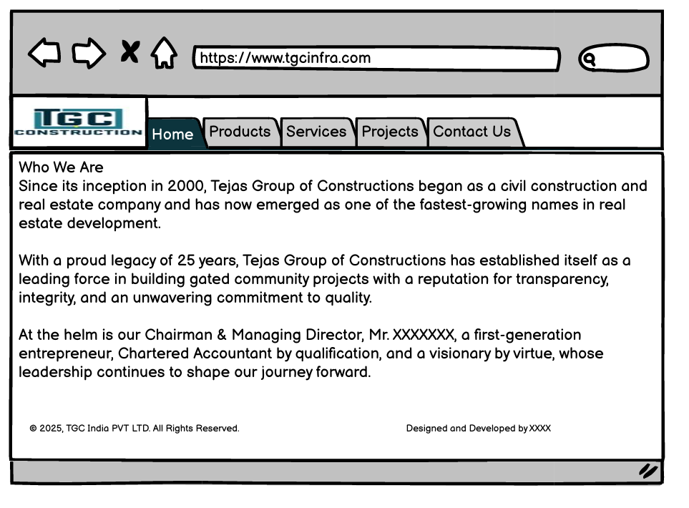

Screen 2 - Products:

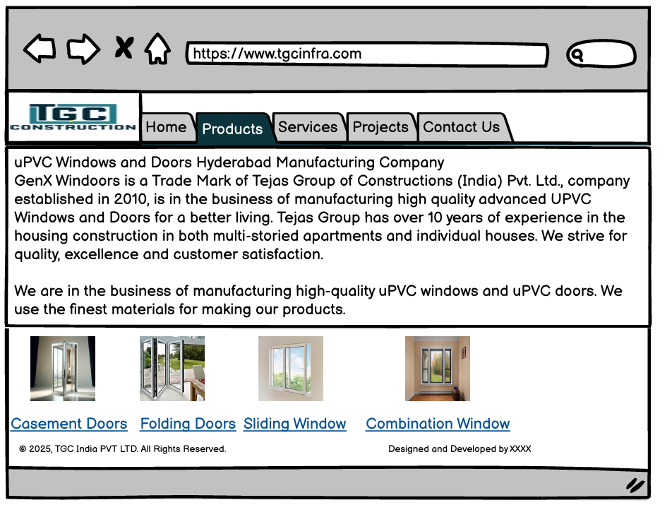

Screen 3 – Product Info:

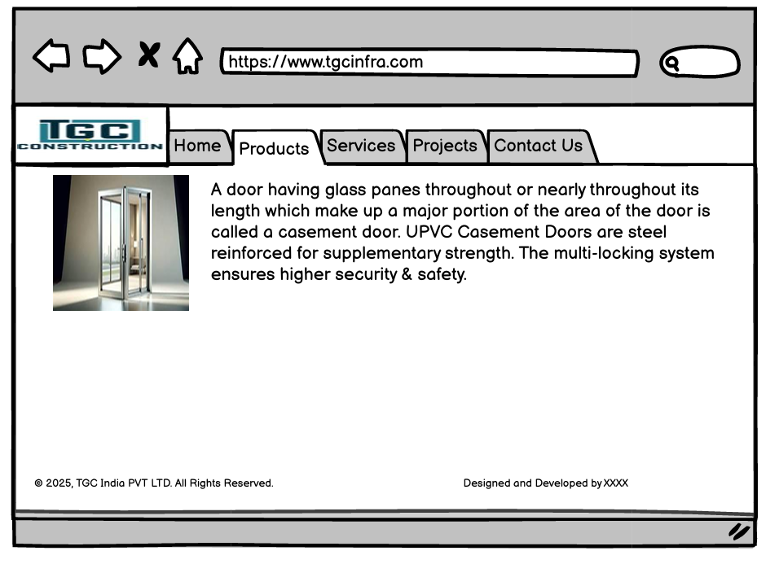
Screen 4 – Services:

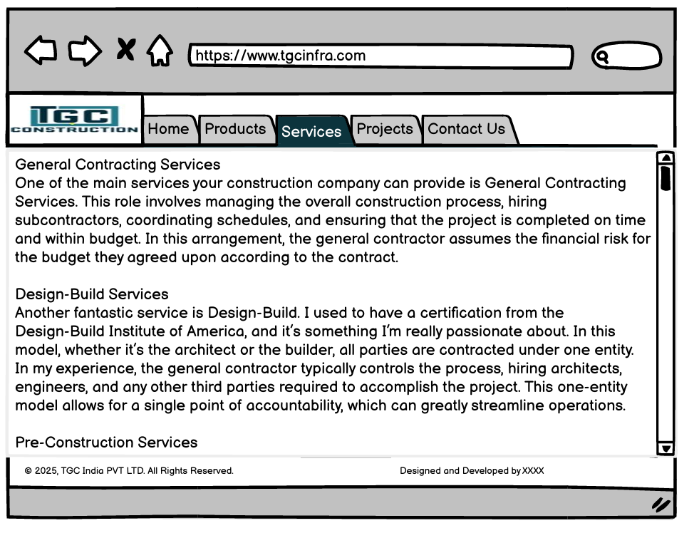

Screen 5 – Projects:

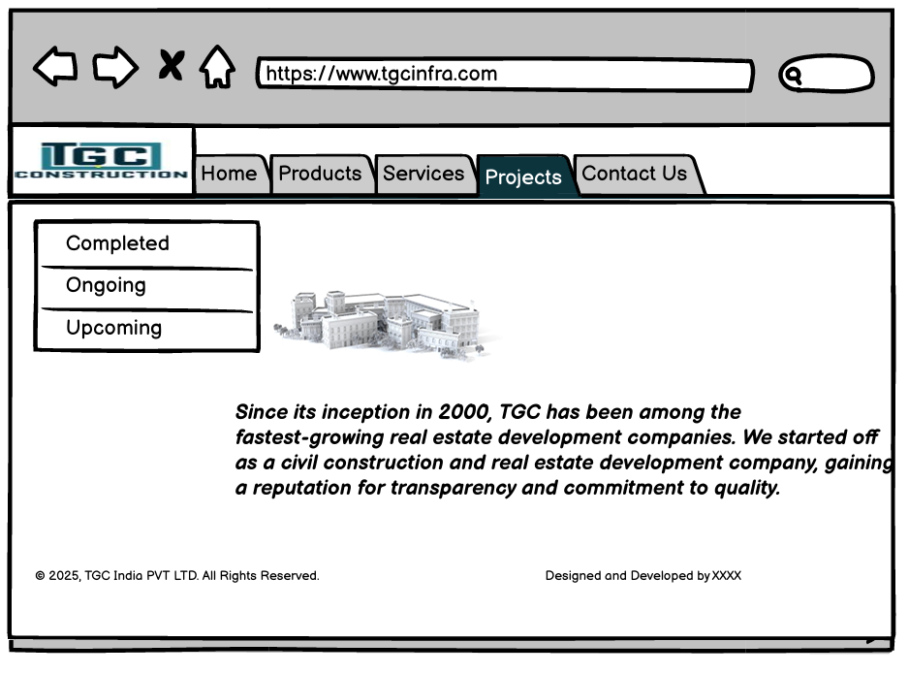
Screen 6 – Completed Projects:

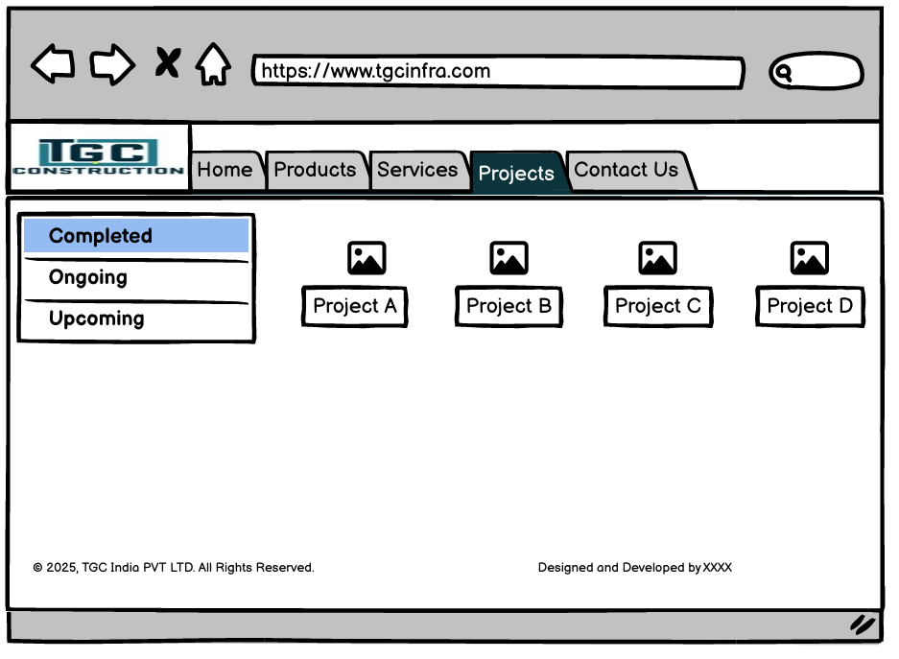

Screen 6 – Ongoing Projects:

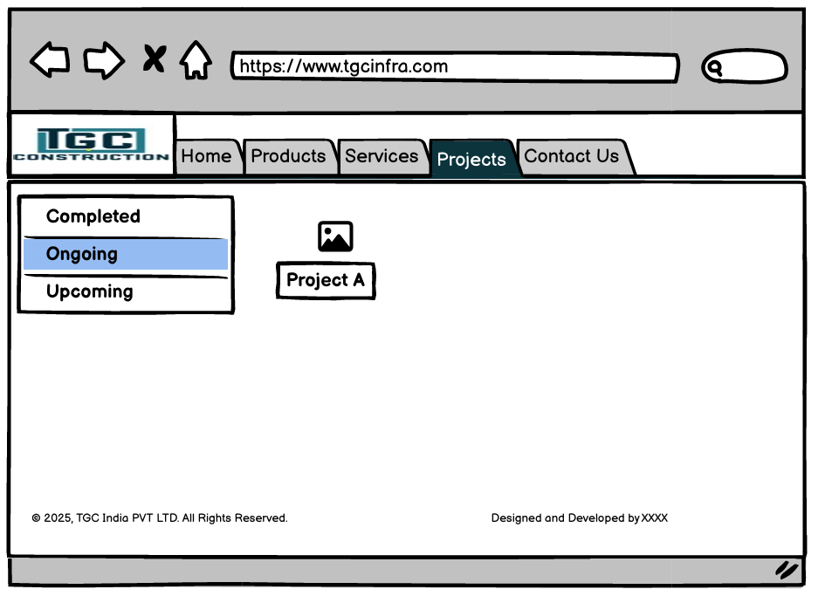
Screen 7 – Upcoming Projects:

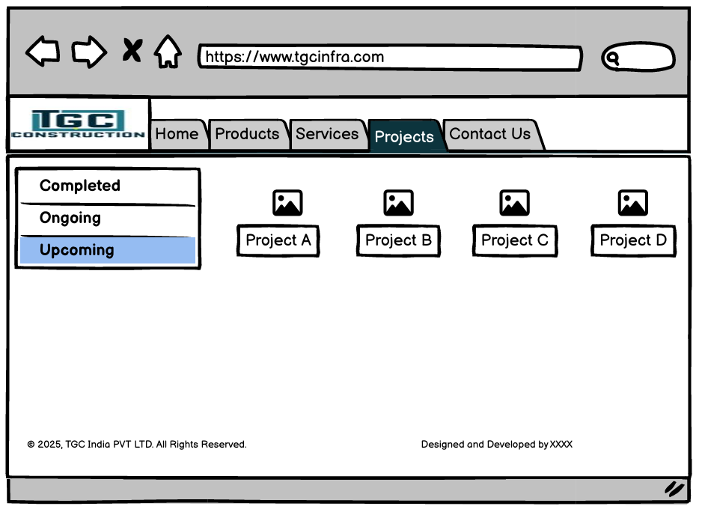

Out of Scope (Features)
To maintain focus and achieve timely delivery, the following items are explicitly out-of-scope for this phase of the project:
1. Mobile Application Development: Developing standalone mobile applications for iOS or Android platforms is not included within this project's scope. The focus is on optimizing the web- based application process.
2. Multi-Language Support: Implementing multi-language support for the application process, including translating the interface and customer communications into languages other than English, is not within the scope of this project.
3. Advanced Analytics and AI-Driven Insights: The scope does not cover the implementation of advanced analytics features, such as predictive modeling or AI-driven insights into customer behavior. The project focuses on the core application and verification processes.
4. Comprehensive HR and Payroll Management: The scope does not cover end-to-end HR management including recruitment, performance appraisal, payroll processing, and attendance/biometric integrations. Detailed competency management and training lifecycle tools.
  - Full-fledged Inventory and Warehouse Management System (WMS): The scope does not cover granular inventory bin/location management, barcode/RFID scanning, and warehouse optimization algorithms. Detailed spare parts inventory planning beyond summary-level tracking required for service billing. Separate warehouse optimization projects (these can be considered for future phases).
2.5 Scope Clarifications

To further avoid ambiguity, the following clarifications apply:
- Business vs. Technical Requirements
  - This BRD focuses primarily on business requirements, processes, and expected outcomes.
  - Detailed technical specifications, system architecture, and performance criteria will be handled in separate technical documents.
- Phase-Wise Approach
  - The scope described here is for the first major phase of automation and integration focused on core processes.
  - Additional capabilities (e.g., advanced inventory, portals, mobile apps) can be planned for subsequent phases based on budget and priorities.
- Customization vs. Configuration
  - Where possible, business needs will be met through configuration of standard solution capabilities.
  - Only critical needs that cannot be met by configuration will be considered for custom development, subject to approval.
- Change Requests and Scope Adjustments
  - Any change to the agreed scope after sign-off will follow a structured change control process, including impact assessment on effort, timeline, and cost.

Functional Requirements

1. Public Digital Presence & Lead Capture: The system shall provide a public-facing corporate website (`tgcinfra.com`) showcasing TGC’s 25-year legacy, "GenX Windoors" product catalog, and "Construction Services”. Visitors shall be able to filter projects by status (Completed, Ongoing, Upcoming) and submit inquiries via a "Contact Us" form, which automatically generates a lead in the internal system.

2. Quotation & Order Management: The system shall provide a standardized interface for Sales Executives to generate quotations. For "GenX Windoors," the system must calculate pricing based on dimensions (Height x Width) and profile type. Upon customer acceptance, the system shall allow one-click conversion of a Quote into a Confirmed Sales Order, assigning a unique Order ID for tracking.

3. Manufacturing Job Card Processing: For confirmed uPVC orders, the system shall automatically generate a "Job Card" detailing technical specifications (glass type, steel reinforcement, hardware). The system must validate inventory levels for raw materials before releasing the Job Card to the production floor.

- Rental Availability & Logistics: The system shall integrate a "Rental Calendar" feature, allowing Delivery Coordinators to check the real-time availability of heavy machinery. The system shall generate "Outward Gate Passes" for dispatch and "Inward Inspection Reports" upon return, ensuring accurate billing for the rental period.

- Project & Order Status Tracking: Internal users shall be able to track the lifecycle of an order or project in real-time. This includes stages such as "Lead Received," "Quote Approved," "In Production," "Ready for Dispatch," and "Delivered." For Construction projects, high-level milestones (e.g., Foundation, Structure, Finishing) shall be trackable.

- Notification and Communication: The system shall send automated notifications to customers and internal staff at critical stages. This includes "Quote Generated" emails to clients, "Low Stock" alerts to the Store Manager, and "Service Ticket Assigned" SMS/WhatsApp alerts to Service Engineers.

- Service & Maintenance Ticketing: The system shall provide a module for logging service requests for rented machines or installed windows. It shall track Annual Maintenance Contracts (AMC) and flag warranty status (Under Warranty vs. Paid Service) to assist Service Engineers in billing.

- User Authentication and Access Control: The system shall implement secure role-based access control (RBAC). Specific permissions shall be defined for Sales (View/Create Quotes), Accounts (View Financials), and Production (View Job Cards), ensuring data privacy and operational security.

- Admin & Master Data Portal: The system shall provide an admin portal for authorized personnel to manage master data, including Product Price Lists, Tax Rates (GST), User Accounts, and Website Content (e.g., uploading photos of "Completed Projects").

- Finance & Accounting Integration: The system shall act as the operational sub-ledger, automatically generating Tax Invoices upon dispatch or service completion. It shall allow the export of financial data (Sales/Purchase Vouchers) in a format compatible with external accounting software (e.g., Tally/Busy).

- Security and Data Integrity: The system shall implement robust security measures, including SSL encryption for the website and secure database storage for client data. Regular backups of the Lead Database and Order History shall be automated to prevent data loss.

- User Interface and Usability: The interface shall be responsive and web-based, accessible via standard browsers (Chrome/Edge). It shall feature role-specific dashboards (e.g., a "Pending Tasks" view for Sales) to minimize the number of clicks required to perform daily operations.

- Scalability: The system architecture shall be designed to scale efficiently, supporting an increase in transaction volume (Orders/Invoices) and the addition of new users as TGC expands its branch operations.

- Audit and Compliance Logging: All critical actions performed within the system—such as approving a discount, deleting a lead, or modifying a confirmed invoice—shall be logged with a timestamp and user ID for audit and compliance purposes.

Actor/User Profile Specification

Primary Actors

  - Website Visitor:

- Browse the "GenX Windoors" product catalog (Casement, Folding, Sliding).
- Read about "General Contracting" and "Design-Build" services.
- Filter and view the "Projects" gallery (Completed, Ongoing, Upcoming).
- Submit inquiries via the "Contact Us" form.

2. Sales Executive:

- Receive and qualify leads from the website and other sources.
- Draft and send PDF quotations for Window Sales or Construction Contracts.
- Convert approved quotes into Sales Orders.
- Track payment follow-ups and customer communication history.

3. Production Manager (Manufacturing):

- View "Pending Orders" and convert them into Manufacturing Job Cards.
- Request raw materials (Profiles, Glass, Hardware) from the store.
- Update the status of production (e.g., "Cutting," "Welding," "Ready").
- Ensure quality checks are recorded before dispatch.

4. Service Engineer:

- Receive notification of assigned service tickets (Breakdowns/Installations).
- Log site visit details and spare parts consumed.
- Update ticket status to "Resolved" for ticket closure.

Secondary Actors

1. System Administrator (Admin):

- Manage user roles, credentials, and access permissions.
- Configure master data (Product Catalog, Price Lists, Tax Rules).
- Monitor system health and ensure backups are running.
- Oversee the "Content Management" for the public website.

2. Accounts Head:

- Validate and approve Invoices generated by Sales/Service teams.
- Manage customer credit limits and block orders for defaulting clients.
- Export financial data for statutory reporting and tax filing.
- Monitor "Receivables" and "Cash Flow" dashboards.

3. Delivery Coordinator:

- Manage the "Rental Calendar" to prevent double-booking of machines.
- Generate "Outward Gate Passes" for dispatched items.
- Conduct physical inspections upon item return and log damages (if any).
- Coordinate logistics for window delivery to client sites.

4. Content Manager (Marketing):

- Update the website with new "Project" case studies and photos.
- Publish blogs or news regarding TGC’s milestones.
- Ensure "Upcoming" projects have necessary regulatory details displayed.

Use Case Diagram/Features list

This section is applicable only to Use case approach. This section depicts the Business Requirements in the form of Essential Use case diagram. In the Use case approach, the Functional Requirements are decomposed into a number of Essential Use cases. Essential use cases are of primary importance early in a project’s requirements/analysis phase. Their purpose is to document the business process that the Application must support without bias to technology and implementation.

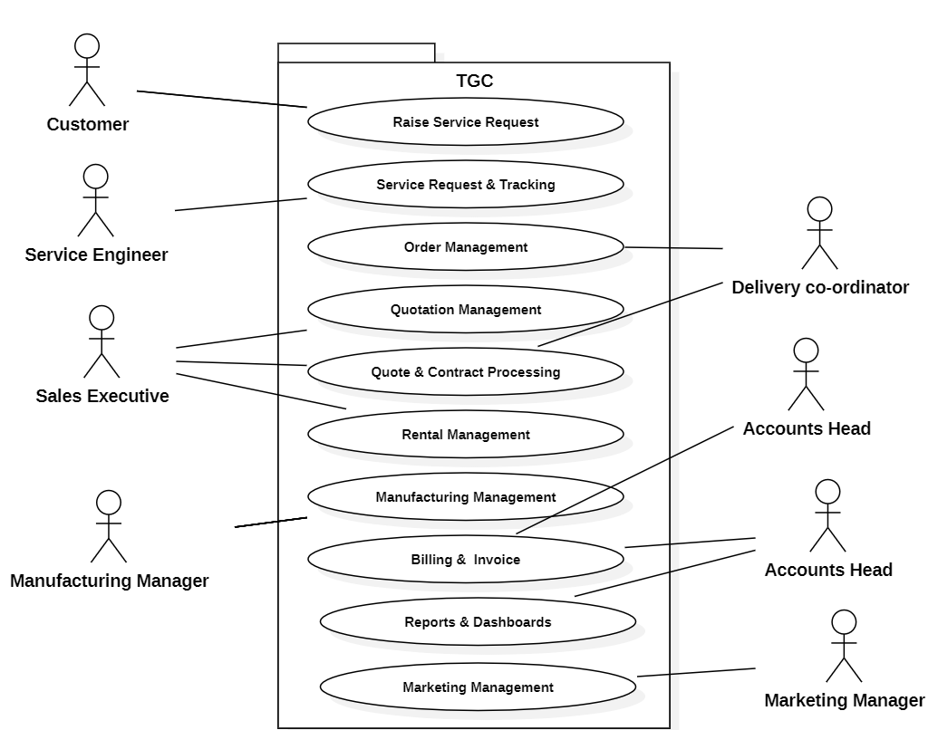

Data Requirements (To be Filled by Tech BA’S)

Data Volumes

This section describes the expected approximate Data volumes (initial volume and annual growth %) for each conceptual Class or Entity.

Data Conversion

This section describes the high-level Data Conversion Requirements.

Specify any requirements / rules for data conversion. Also, if there are any regulatory requirements around data conversion, then mention them explicitly.

Data Retention and Archiving
This section describes the Data retention (time frames for online Data retention before archiving) and also the archiving requirements.

Privacy Implications
This section describes the sensitivity levels of each class of data. The following criteria are used in determining the sensitivity level of each conceptual class/entity).

- Non-sensitive information that would not reasonably be expected to cause injury (harm) if released to the public;

- Protected A: information that, if compromised, could reasonably be expected to cause injury (harm), e.g. loss of privacy;

- Protected B: information that, if compromised, could reasonably be expected to cause serious injury (harm), e.g. the conduct of a court proceeding would be adversely affected;

- Protected C: information that, if compromised, could reasonably be expected to cause extremely grave injury (harm), e.g. loss of life.

Conceptual Class / Entity Name | Data Sensitivity Level  (Non-sensitive,  Protected A,  Protected B,  Protected C)

Non-Functional requirements

Security Requirements

The system shall implement robust security measures to protect proprietary business data (Cost Estimates, Client Lists) and public website integrity. Defenses against common vulnerabilities such as SQL injection, Cross-Site Scripting (XSS), and Cross-Site Request Forgery (CSRF) shall be standard.

Authentication
- The system shall require unique username and complex password credentials for all internal staff.
- Password policies must enforce a minimum length of 8 characters, including alphanumeric and special characters, with a mandatory reset every 90 days.
- Sessions shall automatically time out after 30 minutes of inactivity to prevent unauthorized access on shared workstations.

Authorization and Access Controls

- The system shall implement Role-Based Access Control (RBAC) to ensure users only access data relevant to their function:

- Sales Executives: Can create Quotes but cannot view "Manufacturing Cost Prices."

- Service Engineers: Can view assigned tickets but cannot access "Financial Ledgers."

- Admins/Directors: Have full system access.

- Sensitive actions, such as "Deleting a Lead" or "Approving a Discount >15%," shall require elevated permissions.

Availability Requirements

- Public Website (tgcinfra.com): Shall maintain a minimum uptime of 99.9% to ensure uninterrupted digital presence and lead capture.
- Internal ERP: Shall maintain 99.5% uptime during core business hours (09:00 AM – 07:00 PM IST, Mon-Sat). Scheduled maintenance and patches shall be deployed during off-peak hours (Sundays or late nights).

Usability Requirements

- The user interface (UI) shall be intuitive, minimizing the learning curve for non-technical staff (e.g., Factory Floor Managers, Site Supervisors).

- Navigation shall be menu-driven and consistent across modules (Sales, Rentals, Production).

- Data entry forms (e.g., Job Cards) shall follow a logical flow (Top-to-Bottom, Left-to-Right) to reduce input errors.

System Help Requirements

- The system shall include field-level tooltips for complex manufacturing parameters (e.g., "Profile Thickness," "Glazing Type").
- A downloadable "User Manual" (PDF format) shall be available within the Help section, covering standard operating procedures for Sales Entry and Stock Management.

Performance Requirements

- Website Load Time: The public website home page must load within 2.5 seconds on standard 4G networks to optimize SEO and user retention.
- Internal System Latency: Search queries (e.g., "Find Customer by Name") and Record Saves (e.g., "Save Order") shall complete within 2 seconds.
- Concurrency: The system shall support up to 50 concurrent internal users and 500 concurrent website visitors without performance degradation.

Scalability Requirements

The architecture shall be modular to support TGC's growth over the next 5 years.

User Scalability

- The system shall support the addition of new users (e.g., new Sales staff or Branch Managers) without code changes, capable of scaling to 200+ internal users.

Application Scalability
- The backend shall be designed to allow the future addition of modules—specifically HRMS (Payroll) and Vendor Management—without rewriting the core Sales/Inventory logic.

Approval
This document has been approved as the official Business Requirements Document for the Project Name project.
Following approval of this document, changes will be governed by the project’s change management process, including impact analysis, appropriate reviews and approvals, under the general control of the Master Project Plan and according to Project Support Office policy.
Prepared by | Signature | Date
Author's Name
[Title]
[Organization]
Approved by | Signature | Date
[Client Acceptor’s Name]
[Title]
[Organization]

