Case Study: Tejus Group of Companies (TGC)


Tejus Group of Companies (TGC) is 21 years old organisation into construction domain having only branch in Pune, India. TGC have almost 500 employees working in different departments: manufacturing, marketing and sales, account and admin, Service and delivery. TGC major services includes: Manufacturing of construction equipment’s, selling construction machinery, providing consultation for construction solutions, providing equipment on rental basis and providing servicing of the machinery. The current operation is manual and time consuming. It includes: All quotation, Invoice and other essential reports are prepared manually; tasks to each department are allocated individually. TGC has started losing business due to delay in customer trust and lack of transparency.
The management have decided to tackle this challenge very effectively hence they discussed the issues within the organisation. TGC came up with the vision of providing quick service, making operation transparent, automate operations, enabling feedback mechanism for customer.
Hence it is urgent need to develop software solution for TGC within 1 year or else they will replace the CEO, defining requirements which align with the objective and vision of TGC.
TGC is now looking for solution to cater to its requirement.

Process Modelling
Scenario:
You have analysed the business process of TGC after meeting with various departmental stakeholder. After analysis you have created the Business process model for current state of TGC Specifically for “Repair/ Servicing of machinery” which is mentioned below.
Now you are looking to improve the existing process (Current state)
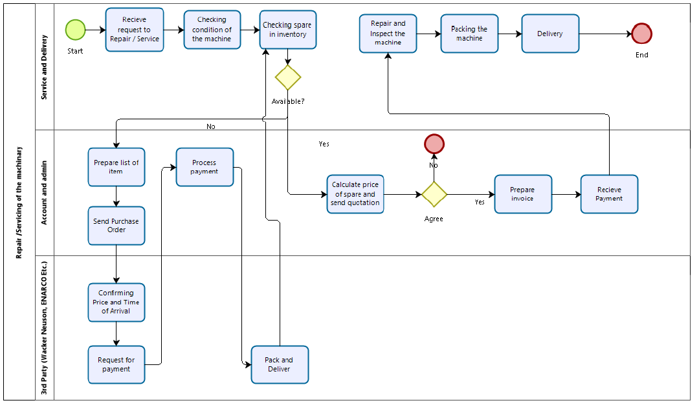
As BA, model an Improvised Process Model for Recommending to Biz Stakeholders.

