1. Customer Use Case
- Request Quotation
- Place Order
- Request Consultation
- Request Equipment Rental
- Request Service / Repair
- Submit Feedback
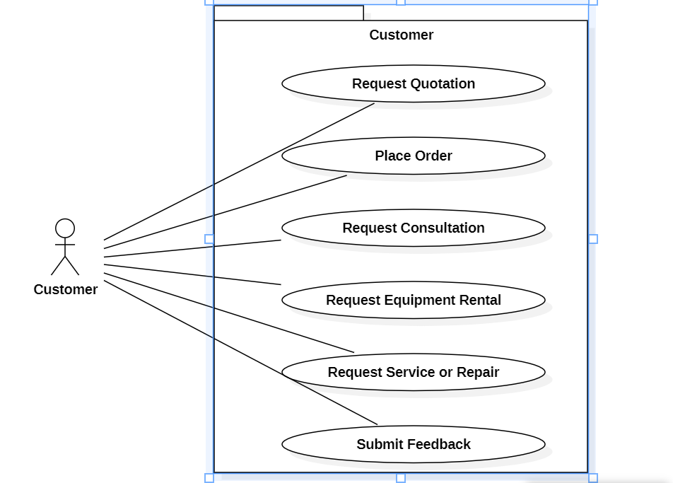

2. Sales Executive Use Case
- Create Quotation
- Update/Approve Quotation
- Create Sales Order
- Track Customer Orders
- Generate Invoice
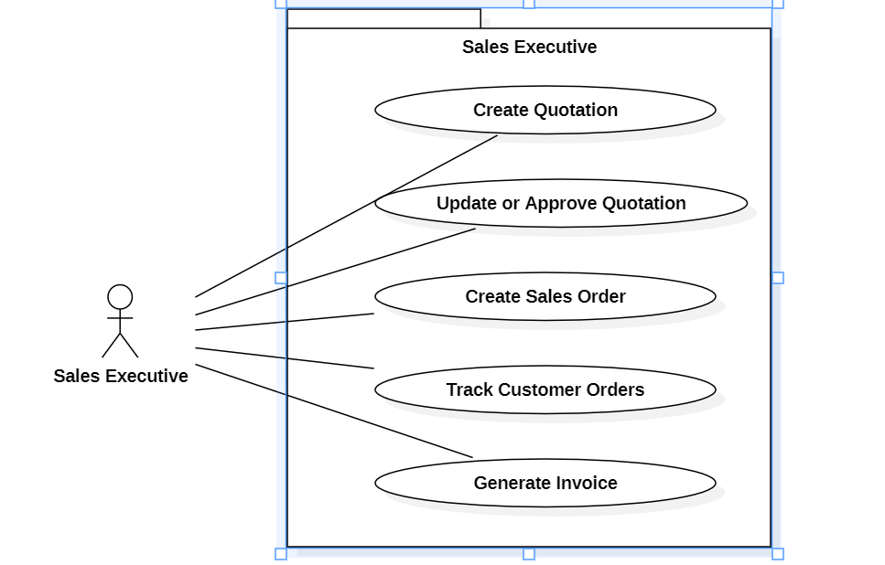

3. Service Engineer Use Case
- View Assigned Service Tasks
- Update Service Status
- Close Service Request
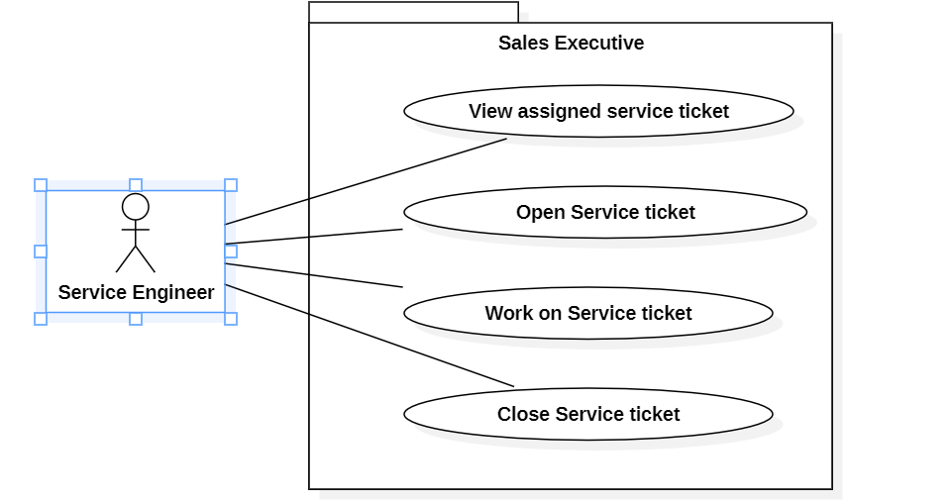

4. Manufacturing Manager Use Case
- View Production Requests / Work Orders
- Plan & Allocate Production Tasks
- Check / Request Raw Materials
- Update Production Status
- Coordinate Quality Inspection
- Approve Equipment for Dispatch
- Monitor Production Metrics
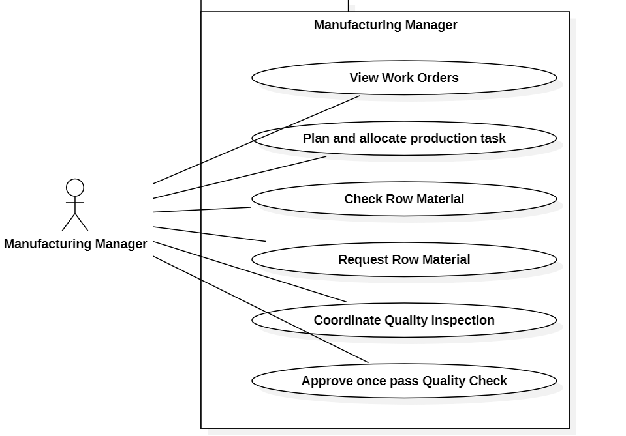

5. Accounts/Admin Use Case
- Functionality of generating invoice for customer.
- Functionality of assigning task to another department.
- Receiving notification (Payment received, task assigned).
- Functionality of creating online quotation.
- Functionality of generating sales & service reports.
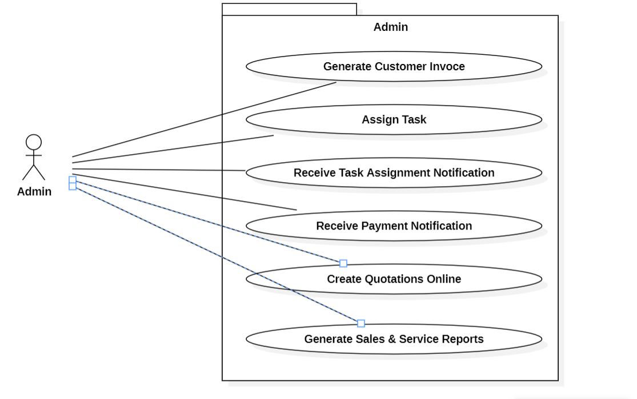

6. Management / CEO Use Case
- View Operational Dashboard
- View Sales & Production Reports
- Monitor Service Performance
- Review Customer Feedback

