**Workflow**

Run the command on cmd to activate Kestra

docker run --pull=always --rm -it -p 8080:8080 --user=root -v /var/run/docker.sock:/var/run/docker.sock -v /tmp:/tmp kestra/kestra:latest server local

**yaml file**

version: “3.8”

services:

Postgres:

    image: Postgres

container_name: Postgres-db

    environment:

      POSTGRES_USER: 'kestra'

      POSTGRES_PASSWORD: 'k3str4'

      POSTGRES_DB: 'postgres-zoomcamp'

    ports:

      - '5433:5432'

    volumes:

      - vol-pgdata:/var/lib/postgresql/data

volumes:

  Postgres-data

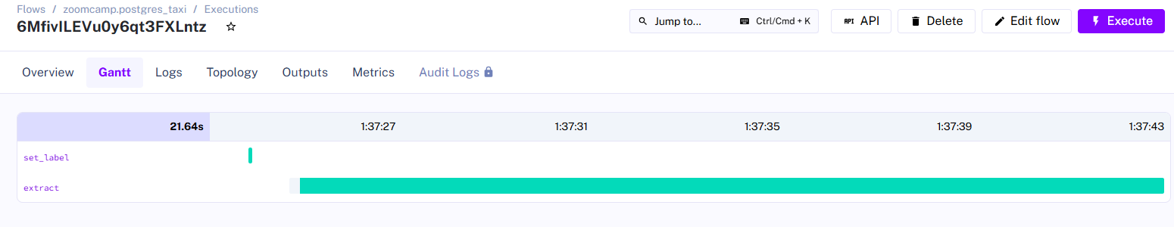

Successful Extracting