- A survey shows the joint distribution of people's choice of beverage and time of day:

Beverage / Time | Morning | Evening | Total
Tea | 20 | 10 | 30
Coffee | 30 | 20 | 50
Juice | 10 | 10 | 20
Total | 60 | 40 | 100
Questions:
- What is the joint probability that someone drinks coffee in the morning?
- What is the marginal probability that someone drinks tea, regardless of time?
- What is the marginal probability that a person drinks anything in the evening?

- In a tech company:
  - 40% of employees work in engineering (E), 35% in marketing (M), and 25% in sales (S).
  - Among engineers, 80% know Python.
  - Among marketers, 30% know Python.
  - Among sales, 10% know Python. Let P be the event "knows Python".
Questions:
- What is the joint probability that a person works in marketing and knows Python?
- What is the marginal probability that a random employee knows Python?
- Given that a person knows Python, what is the probability that they work in engineering?

- A fair coin is flipped 4 times. What is the probability of getting exactly 2 heads?

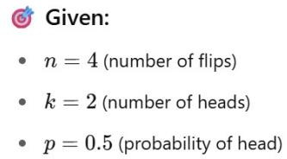

- A student is taking a multiple-choice test with 20 questions, each with 4 choices. The student guesses every answer randomly. What is the probability that the student gets at least 6 answers correct?
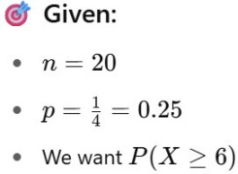

- SpamFilter — Binary Classification
A spam classifier knows:
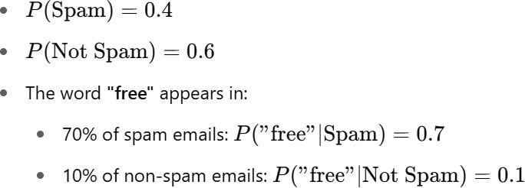
Question:
If an email contains the word "free", what is the probability it's spam?

- Multi-Class Naive Bayes for Document Classification
You have a Naive Bayes classifier that categorizes text as:
  - Class A: Sports
  - Class B: Politics
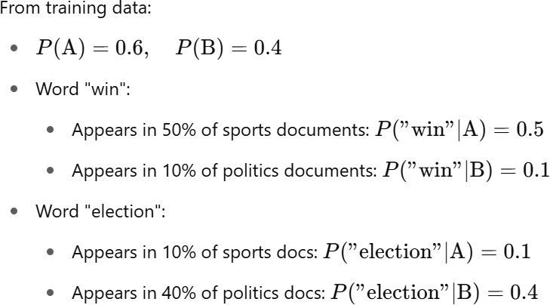

Question:
A document contains both words: "win election". What is the probability it belongs to Class A?

- Analyzing Model Prediction Errors with Quantiles
You train a regression model to predict housing prices. You collect the prediction errors (actual – predicted) across 10 samples:
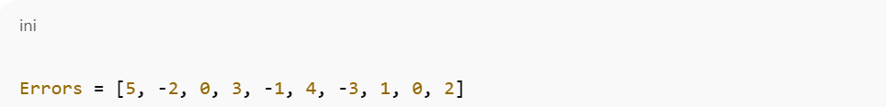
Question:
Find the 25th, 50th, and 75th percentiles (quantiles) of the error distribution.

- Quantile Regression with Asymmetric Loss
You want to predict delivery times (in minutes) for a logistics company. Due to traffic unpredictability, you decide to predict the G0th percentile of delivery time, not just the mean.
You're given the following 5 actual vs predicted delivery times (in minutes):

Question:
Calculate the total quantile loss across all predictions.

- Mean Imputation for Numeric Feature
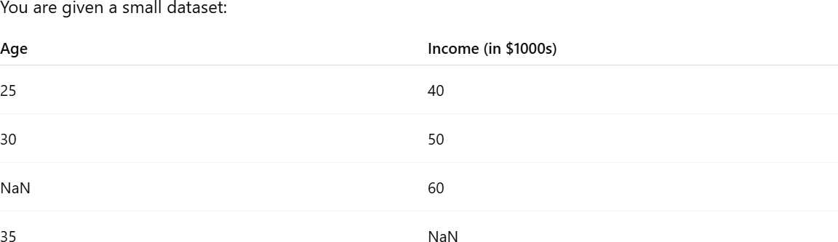

Question:

Impute the missing values in the dataset using mean imputation. What are the imputed values?

- Choosing an Imputation Strategy for ML Pipeline
You’re building a machine learning pipeline on a dataset where:
  - Feature X is numerical, with 25% missing values
  - Feature Y is categorical, with 10% missing values
  - Your model is Gradient Boosting Trees (e.g., LightGBM)
Questions:
- What imputation strategies would you choose for X and Y?
- Would you include missing indicators?
- How does LightGBM handle missing values?

- Spearman vs Pearson Interpretation

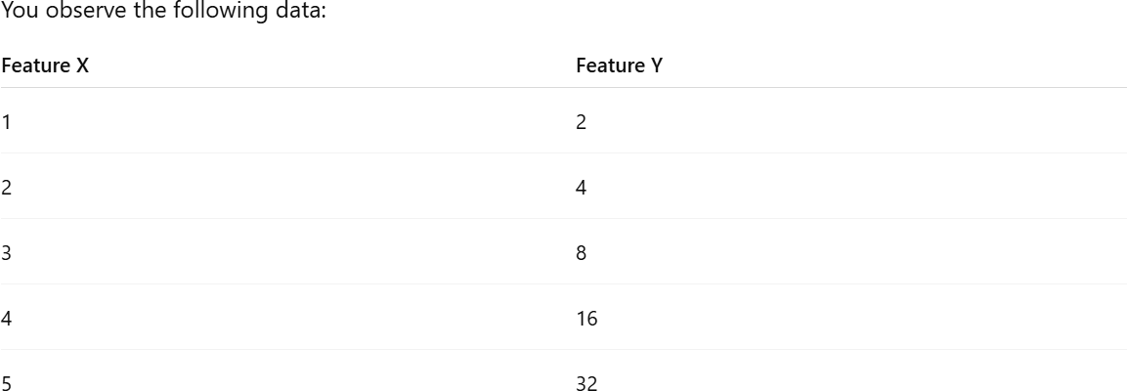

Question:
- What would Pearson and Spearman correlation look like?
- Which one is more appropriate to describe the relationship?

- One-sample t-test on model accuracy
You're testing whether your classification model has better-than-random accuracy. You run the model on 10 test sets and get accuracies:
[0.62, 0.65, 0.61, 0.63, 0.64, 0.60, 0.67, 0.61, 0.66, 0.62]
Question:
Use a one-sample t-test to test if the model's average accuracy is significantly better than random (50%). Use α=0.05

- Chi-square test for model fairness

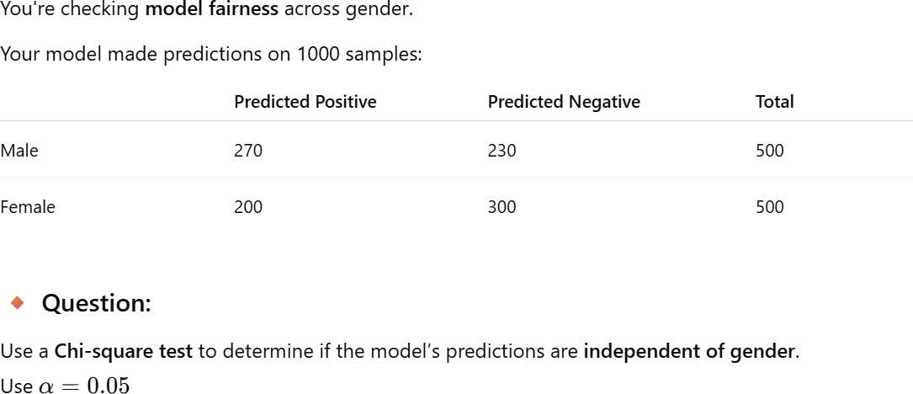

- Jacobian of a Vector-Valued Function (Easy)
Let:
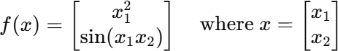

- Derivative of ReLU for Backpropagation (Moderate)
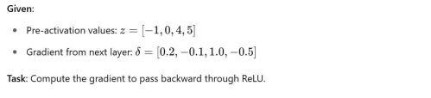
- What mathematical operation is performed at each neuron during the forward pass?

- What is the shape of data as it flows through the network?

- How does data flow during backpropagation?

- Why must activation functions be non-linear for data flow to be effective?

- What happens to data during forward and backward pass in terms of tensors and gradients?

- What is a computation graph and how does it help in data flow?

- Backprop Through ReLU Given:
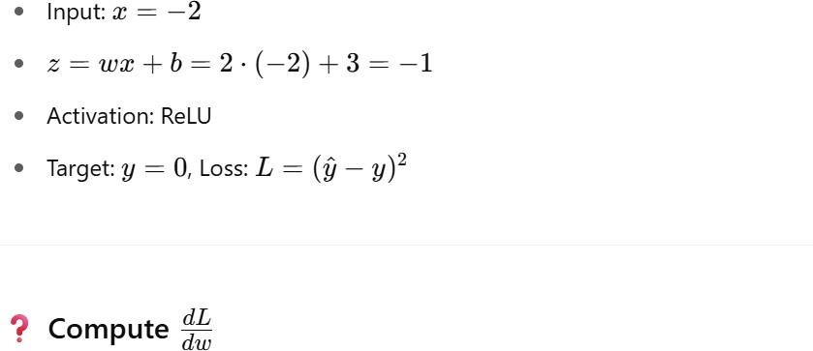

- Two-layer Network (Manual Backprop) (Intermediate) Given:
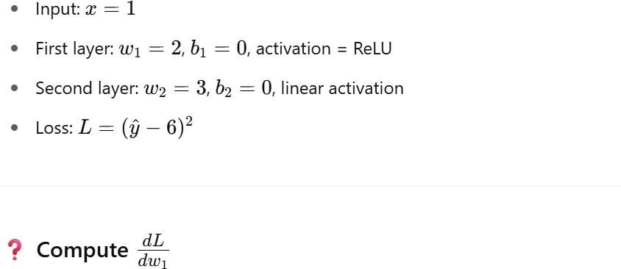

- Manual Forward and Backward Pass

- Adagrad Step Given:
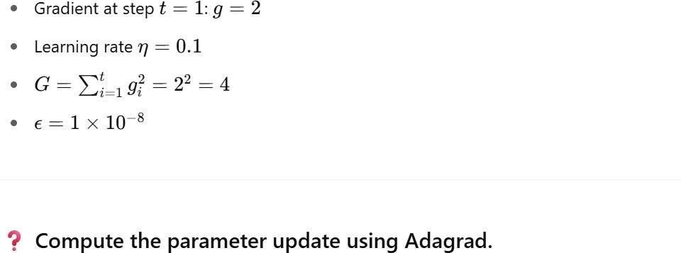

- Adam vs RMSprop
Question:

What makes Adam more stable or better than RMSprop in practice?

- Cross Product of 3D Vectors
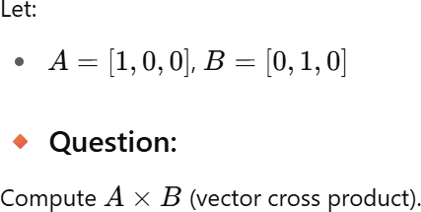

- Kronecker Product of 2 Matrices
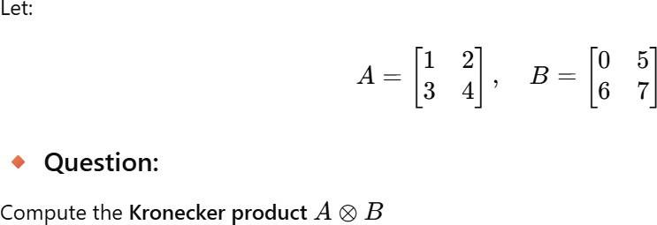

- Find Eigenvalues of a 2×2 Matrix
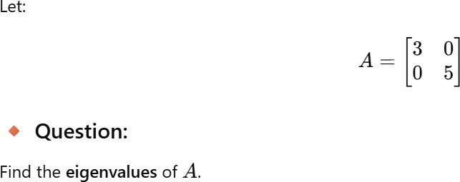

- PCA and Eigenvalues in ML

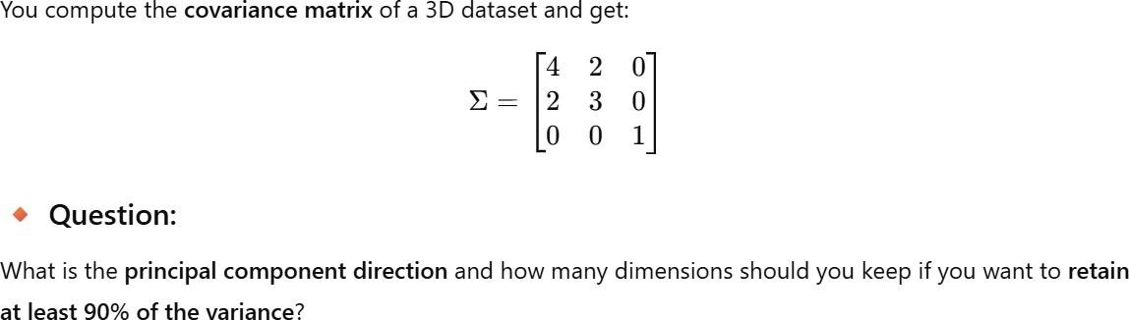

- Matrix Multiplication

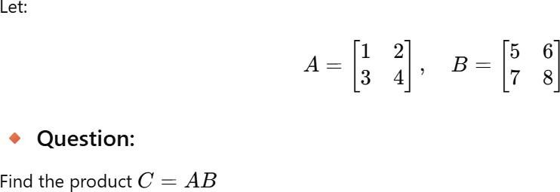

- Inverse of a 2×2 Matrix

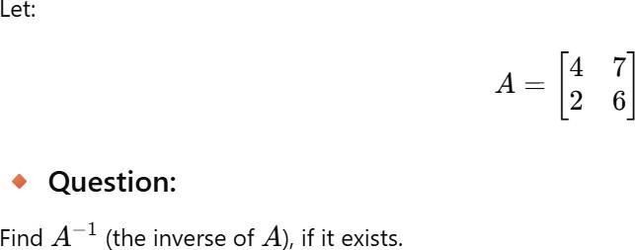

- Rank and Eigenvalues of a 2×2 Matrix
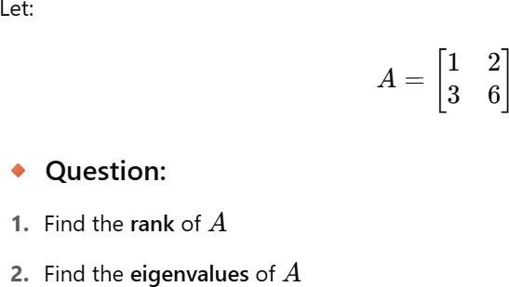

- Rank Deficiency and Eigenvalue Multiplicity
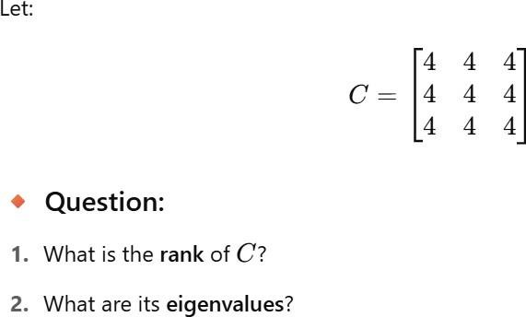

- Mahalanobis Distance with Diagonal Covariance

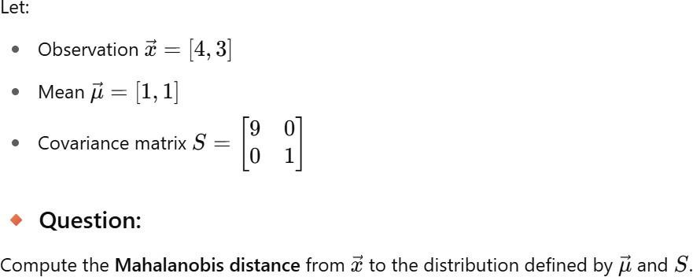

- Mahalanobis Distance in 3D Feature Space
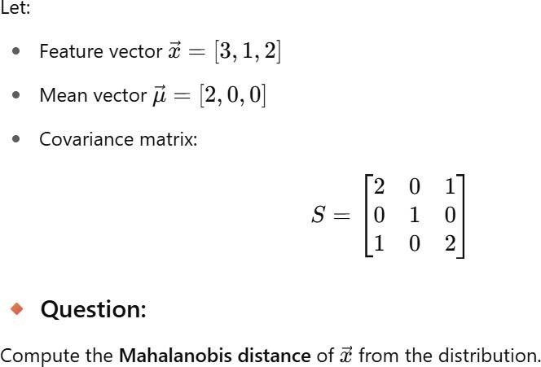

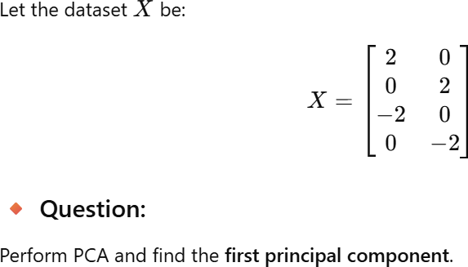

- PCA on a Real-Valued 2D Dataset
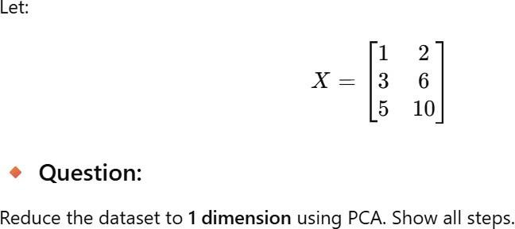

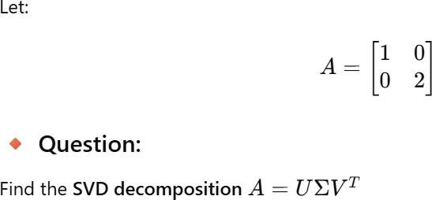
- Compute SVD of a 2×2 Ma

