Assignment#2

Evan O’Toole

Part 1

#a  
str(lynx)

Time-Series [1:114] from 1821 to 1934: 269 321 585 871 1475 ...

head(lynx)

[1] 269 321 585 871 1475 2821

?lynx  
#I used str, head, and ?lynx. the lynx data set is a Time-Series from 1821 to 1934, representing the annual Lynx trappings for each year.  
#b  
years <- seq(1821, 1934)  
#c  
names(lynx) <- years  
#d  
lynx['1867']

1867   
4254

#e  
mean(lynx[1:90])

[1] 1489.633

**PART 2**

#a  
casino <- read.csv('casino.csv')  
#b  
head(casino)

Name BlackJack Poker Slots Roulette Bingo  
1 Andrew 50.46 41.68 262.88 -114.46 106.59  
2 Betty 6.80 4.00 212.70 48.46 890.84  
3 Calum -98.29 -54.82 252.58 -66.82 38.65  
4 Carlos 183.73 59.49 95.19 -115.82 15.20  
5 Charlotte 43.12 38.79 -10.95 -230.82 29.88  
6 Dwayne 49.40 68.40 -389.88 53.92 -577.07

#c  
friends <- (casino[,1])  
#d  
dim(casino)

[1] 10 6

winnings <- as.matrix(casino[,c(2:6)])  
#e  
total <- rowSums(winnings)  
#this vector represents the net loss or earnings for each person/row  
  
#f  
names(total) <- friends  
min(total)

[1] -795.23

max(total)

[1] 1162.8

which.min(total)

Dwayne   
 6

which.max(total)

Betty   
 2

#Dwayne lost the most  
#Betty won the most  
  
#h  
mean(total)

[1] 5.167

#the average amount won was $5.167

**PART 3**

#(a)  
library(ggplot2)  
govn <- read.csv('Government_expenditure_per_student.csv')  
ggplot(govn, aes(x=Value)) + geom_histogram(aes(y= ..density..),binwidth = 2, fill = "skyblue", color = "black") + labs(title = "Govenment expenditure per student each year", y = "Probability", x = "Expenditure") + geom_density(color = "green")

Warning: The dot-dot notation (`..density..`) was deprecated in ggplot2 3.4.0.  
ℹ Please use `after_stat(density)` instead.

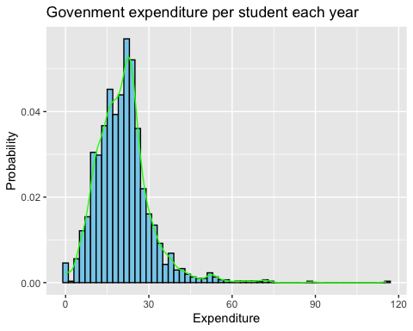

#(b)  
#it right skewed and asymetric

**Part 4**

library(ggplot2)  
data <- read.csv('rawgrades.csv')  
f_grades <- factor(data$Grade)  
t_grades <- table(f_grades) / length(data$Grade)  
pie_data <- data.frame(  
 Grade = names(t_grades),  
 Frequency = as.vector(t_grades)  
)  
ggplot(pie_data, aes(x = "", y = Frequency, fill = Grade)) +  
 geom_bar(stat = "identity", width = 1) + # Bar chart, with identity (not counting)  
 coord_polar(theta = "y") + # Convert to pie chart  
 theme_void() + # Remove background and gridlines  
 labs(title = "Grades Pie Chart") +  
 geom_text(aes(label = scales::percent(Frequency)), # Add relative frequency as labels  
 position = position_stack(vjust = 0.5), # Place labels in the middle of each slice  
 color = "white")

